Data Request to Shionogi

Data relating to susceptibility studies

EEPRU request

We are interested in how susceptibility to cefiderocol varies according to an isolate’s susceptibility to other agents. We are requesting these data for any studies reporting susceptibility that you have access to which report MBL enterobacterales and MBL pseudomonas.
For each study, please supply data separately for MBL enterobacterales and MBL pseudomonas. If possible, provide data for MBL broken down by MBL type, i.e., NDM, VIM and IMP. Please use breakpoints contemporary to the time the isolate was collected/analysed if possible, or indicate what breakpoints were used in the analysis. Please indicate which published study each data set is derived from, or if unpublished please provide patient characteristics such as mean age, gender etc and selection criteria.
We are interested in the following data:
- The proportion of isolates fully susceptible (intermediate resistance being counted as resistant) to cefiderocol amongst those not susceptible to any other drug tested.
- The proportion of isolates fully susceptible to cefiderocol amongst those only fully susceptible to colistin and/or an aminoglycoside and not to other drugs
- The proportion of isolates fully susceptible to cefiderocol amongst those fully susceptible to at least one agent that is not colistin or aminoglycosides.
- The table below indicates how the data might look for a given group e.g., MBL enterobacterales (dummy data for illustration).

Grouping | N isolates | % susceptible to cefiderocol
Isolates not susceptible to any of the non-cefiderocol drugs listed in the following two rows | 30 | 70%
Isolates susceptible to colistin and/or an aminoglycoside but not susceptible to any of the drugs listed below | 100 | 80%
Isolates susceptible to any of the following drugs:  fosfomycin, tigecycline, aztreonam, meropenem | 50 | 90%

We would also ideally like further information on susceptibility to CAZ-AVI in OXA-48 (and separately for OXA-48-like) enterobacterales isolates. The objective of this request is to inform the CAZ-AVI assessment and not the cefiderocol assessment. For any studies reporting OXA-48 CPE susceptibility testing we would like to understand the conditional susceptibility to CAZ-AVI according to the groupings above, with the following change
- The last row should change to read “Isolates susceptible to any of the following drugs: meropenem, fluoroquinolones, tigecycline, fosfomycin, cephalosporins, aztreonam, meropenem”.

Data analysis presentation
In this section, we present the results of the requested data analyses for question 1. An overview is provided, followed by a detailed breakdown of the analyses conducted. The reporting of results is broken down per the rows in the example table provided by EEPRU. This allows the reported data to be more easily compared across datasets and subgroups, and also allows for more succinct discussion.

Overview
EEPRU requested the full data analysis by study in the text of question 1. The following two datasets were analysed separately:
- SIDERO-CR
- SIDERO-WT

The SIDERO-CR (carbapenem resistance) and SIDERO-WT (wild-type) studies have no data overlap, and can therefore be treated as two independent studies informing the analyses presented in Sections 1.3.2 and 1.3.3. In both cases, the global dataset (i.e. no geographical restriction) has been used.
Further to the SIDERO studies of interest is an ongoing surveillance study called SENTRY. This study is still in the early stages of data collection and has not progressed sufficiently to perform data analysis at this time.
Each of these studies includes different data on isolate susceptibility to different agents, includes different identifiers for infection site/pathogen sub-typing, and have different sample sizes.
It is important to note that the presence of MBL and other mechanisms of resistance in the isolates are not mutually exclusive and coexist in the same isolate. It is therefore uncommon for an infection to be exclusively within this category, meaning that including all co-resistance is more indicative of the clinical context in which cefiderocol will be used in clinical practice.
Another consideration is that MBLs are relatively infrequent in pseudomonas species, and that the porin loss and efflux pump mediated resistance mechanisms dominate. Cefiderocol’s role and unique mechanism of cell entry therefore play a key role over and above simply considering MBLs in the case of MDR and XDR pseudomonas in the UK.
The isolates used to report our findings use the currently applicable breakpoints as defined by EUCAST for each of the medicines considered. The temporal analysis for the breakpoints was not possible as some isolates tested were collected by International Health Management Associates (IHMA), the organisation who ran SIDERO on behalf of Shionogi.
In SIDERO-WT, isolates were analysed for susceptibility against Meropenem MIC≥16; Ciprofloxacin ≥0.5; Colistin ≥4 for Enterobacterales and ≥8 for pseudomonas; Ceftazidime/Avibactam ≥16; Cefepime for Enterobacterales MIC ≥2 for pseudomonas MIC≥16, Tigecycline MIC ≥2;
In SIDERO-CR, isolates were analysed for susceptibility against Cefepime for Enterobacterales MIC ≥2 for pseudomonas MIC≥16; Meropenem MIC≥16; Ciprofloxacin ≥0.5; Colistin ≥4 for Enterobacterales and ≥8 for pseudomonas; Ceftazidime/Avibactam ≥16; Tigecycline MIC ≥2. For SIDERO-CR, not all drugs were available from the start of the studies, and therefore not every isolate was tested against the entire list.
32,088 Enterobacterales and 7,708 pseudomonas isolates were tested in SIDERO-WT, whilst 915 Enterobacterales and 255 Pseudomonas isolates were tested in SIDERO-CR.
582 isolates relevant to this data analysis were included in SIDERO-WT. This includes 155 enterobacteralse MBL isolates, 187 pseudomonas MBL isolates, and 240 OXA-48 isolates. Among the SIDERO-WT MBL isolates, 64 are NDM, 255 are VIM, and 23 are IMP. As there are only 23 isolates for IMP MBL infections, it is possible that the statistics produced do not represent the general case.
361 isolates relevant to this data analysis were included in SIDERO-CR. This includes 187 enterobacteralse MBL isolates, 94 pseudomonas MBL isolates, and 80 OXA-48 isolates. Among the SIDERO-CR MBL isolates, 112 are NDM, 160 are VIM, and 9 are IMP. As there are only 9 isolates for IMP MBL infections, it is possible that the statistics produced do not represent the general case.
All results are presented using MIC of 2 and 4. This is to take into account ongoing discussions with EUCast about the breakpoint that should be used for cefiderocol. We would therefore suggest that this represents some structural uncertainty in the decision problem, and that EEPRU should therefore include both MIC levels in scenario analysis to fairly represent this in the evaluation. Breakpoints have relevance to the decision problem. When incorporating these data in wider analyses it is important to note that:
- The current EUCAST guidance (which is applicable also to United Kingdom) is to consider an isolate susceptible top cefiderocol at the MIC 2 mg/L breakpoint
- In CREDIBLE study the breakpoint considered was as defined by CLSI, i.e. MIC 4 mg/L.

The outcomes observed in CREDIBLE are based on the CLSI definition for breakpoint of 4mg/L. When incorporating these susceptibility data into the economic model, it may be more appropriate to maintain consistency and estimate the proportion susceptible using the CLSI breakpoint of MIC 4mg/L. This is particularly important if the CREDIBLE outcomes data are used to estimate the clinical outcomes of patients susceptible to cefiderocol. If the susceptibility percentages with the EUCAST breakpoint of MIC 2 is combined with the CREDIBLE outcomes there will be inconsistency between the two sources and there will be a negative bias in the estimated clinical outcomes of cefiderocol susceptible patients.

For the CAZ-AVI analysis, there were a total of 237 Enterobacterales OXA-48 and OXA-48 ‘like’ isolates in SIDERO-WT. The OXA-48 like beta-lactamases included OXA-162, -181, -232, 244, and 48.
There were a total of 104 OXA-48 or OXA-48 ‘like’ Enterobacterales isolates tested in SIDERO-CR. Included OXA-48 like, were OXA-162, -181, -232, 244, and 48, as per SIDERO-WT. Pooled results are presented as it was not feasible in the timeframe to separate the OXA-48-like from the pure OXA-48 isolates. Finally, as with the cefiderocol SIDERO data, resistance mechanisms are not mutually exclusive. A small number of isolates, for instance, are MBL and OXA-like at the same time. EEPRU should consider that this isolate data includes all cross-resistance mechanisms within each category presented.

Cefiderocol: Isolates not susceptible to any non-cefiderocol antimicrobial
Results per the first row of the exemplar table provided by EEPRU are reported below in Table 1. These describe the isolates which were not susceptible to any non-cefiderocol treatment. The sample is small for most cases, indicating that in most cases, pathogens are susceptible to at least one other compound. However, this does not take into account the pharmacodynamics of those other products, i.e. their ability to permeate to the affected area within a live patient and subsequently treat the infection effectively. For example, as noted in section 1.1.2 of the Shionogi submission Colistin has poor lung, bone and CNS penetration. Nevertheless, in most of the cases where the pathogen is not susceptible to any other treatment, the pathogen is susceptible to cefiderocol. For the pooled MBL Enterobacterales isolates it is above 85% in both databases when assessing susceptibility at the breakpoint used for enrolment to CREDIBLE.
Table 1: SIDERO MBL producing isolates not susceptible to any non-cefiderocol treatment
 | SIDERO-WT |  |  | SIDERO-CR
 | N | MIC2 | MIC4 | N | MIC2 | MIC4
MBL Enterobacterales (All MBLs) | 22 | 64% | 86% | 18 | 50% | 89%
MBL Pseudomonas (All MBLs) | 0 | NA | NA | 0 | NA | NA
NDM Enterobacterales | 10 | 30% | 70% | 16 | 44% | 88%
NDM Pseudomonas | 0 | NA | NA | 0 | NA | NA
VIM Enterobacterales | 12 | 92% | 100% | 2 | 100% | 100%
VIM Pseudomonas | 0 | NA | NA | 0 | NA | NA
IMP Enterobacterales | 0 | NA | NA | 0 | NA | NA
IMP Pseudomonas | 0 | NA | NA | 0 | NA | NA
Key: WT: wild-type; CR: carbapenem-resistant

Cefiderocol: Isolates susceptible to colistin or aminoglycoside, but not to other non-cefiderocol comparators
Results based on the second row of the table provided by EEPRU are reported in Table 2. The sample of isolates susceptible to colistin/aminoglycoside, but not to the other comparators listed in the third row of the exemplar table is larger across all types, save for NDM pseudomonas and IMP enterobacterales, both of which are empty. In the majority of cases, these isolates are also susceptible to cefiderocol. Again, when assessing susceptibility at the breakpoint used for enrolment to CREDIBLE for the pooled MBL Enterobacterales isolates it is above 85% in both databases; for the pooled MBL Pseudomonas isolates 100% are susceptible to cefiderocol.
Table 2: SIDERO MBL producing isolates susceptible to colistin/ aminoglycoside but not to other non-cefiderocol comparators
 | SIDERO WT |  |  | SIDERO CR
 | N | MIC2 | MIC4 | N | MIC2 | MIC4
MBL Enterobacterales (all) | 80 | 60% | 90% | 109 | 56% | 88%
MBL Pseudomonas (all) | 175 | 98% | 100% | 86 | 100% | 100%
NDM Enterobacterales | 52 | 52% | 85% | 79 | 49% | 85%
NDM Pseudomonas | 0 | NA | NA | 3 | 100% | 100%
VIM Enterobacterales | 28 | 71% | 96% | 29 | 72% | 97%
VIM Pseudomonas | 155 | 99% | 100% | 81 | 100% | 100%
IMP Enterobacterales | 0 | NA | NA | 1 | 100% | 100%
IMP Pseudomonas | 20 | 90% | 100% | 2 | 100% | 100%
Key: WT: wild-type; CR: carbapenem-resistant

Cefiderocol: Isolates susceptible to one of the other comparators
The other comparators listed by EEPRU include fosfomycin, tigecycline, aztreonam, or meropenem. The analysis was defined as susceptibility to any one of those treatments. The results of this analysis are presented in Table 3. Again, in most cases the isolates are also susceptible to cefiderocol. When assessing susceptibility at the breakpoint used for enrolment to CREDIBLE for the pooled MBL Enterobacterales isolates it is above 85% in both databases; for the pooled MBL Pseudomonas isolates 100% are susceptible to cefiderocol.

Table 3: SIDERO MBL producing isolates susceptible to fosfomycin, tigecycline, aztreonam, or meropenem
 | SIDERO WT |  |  | SIDERO CR
 | N | MIC2 | MIC4 | N | MIC2 | MIC4
MBL Enterobacterales (all) | 56 | 90% | 98% | 127 | 55% | 88%
MBL Pseudomonas (all) | 12 | 93% | 100% | 8 | 100% | 100%
NDM Enterobacterales | 2 | 50% | 50% | 95 | 46% | 81%
NDM Pseudomonas | 0 | NA | NA | 0 | NA | NA
VIM Enterobacterales | 60 | 90% | 100% | 31 | 74% | 97%
VIM Pseudomonas | 9 | 100% | ? | 8 | 100% | 100%
IMP Enterobacterales | 0 | NA | NA | 1 | 100% | 100%
IMP Pseudomonas | 3 | 67% | 100% | 0 | 100% | 100%
Key: WT: wild-type; CR: carbapenem-resistant

CAZ-AVI: SIDERO OXA-48 isolates not susceptible to any other agent
CAZ-AVI results for the first row of the example table from EEPRU are reported in Table 4. The MIC used for CAZ-AVI is 16. The response rate to OXA-48 generally is high.

Table 4: SIDERO OXA-48 and OXA-48-like isolates not susceptible to any non-CAZ-AVI treatment
 | SIDERO WT |  | SIDERO CR
 | N | MIC16 | N | MIC16
all OXA-48 Enterobacterales | 40 | 95% | 25 | 80%
Key: WT: wild-type; CR: carbapenem-resistant

CAZ-AVI: SIDERO OXA-48 Isolates susceptible to colistin or aminoglycoside, but not to other non-CAZ-AVI comparators
CAZ-AVI results for the second row of the example table from EEPRU are reported in Table 5.
Table 5: SIDERO OXA-48 and OXA-48-like isolates susceptible to colistin/ aminoglycoside but not to other non-CAZ-AVI comparators
 | SIDERO WT |  | SIDERO CR
 | N | MIC16 | N | MIC16
all OXA-48 Enterobacterales | 74 | 88% | 21 | 52%
Key: WT: wild-type; CR: carbapenem-resistant

CAZ-AVI: SIDERO OXA-48 and OXA-48-like Isolates susceptible to one of the other comparators
CAZ-AVI results for the third row of the example table from EEPRU (applying the differences in the comparators listed) are reported in Table 6. Most patients tested responded to CAZ-AVI.
Table 6: SIDERO OXA-48 isolates susceptible to meropenem, fluoroquinolones, tigecycline, fosfomycin, cephalosporins, aztreonam, or meropenem
 | SIDERO WT |  | SIDERO CR
 | N | MIC16 | N | MIC16
all OXA-48 Enterobacterales | 148 | 99% | 0 | NA
Key: WT: wild-type; CR: carbapenem-resistant

Data relating to CRO infected patients

EEPRU request

We would like to request some further analysis of two Shionogi-funded studies (Merrick 2021, Carbar).

2a) Further analysis of Merrick 2021 mortality data

Merrick 2021 presents data on all-cause mortality at 30, 60, 90 days and 1 year in Table 1.
- Please could you supply these data by site (Respiratory tract, Urinary tract, Other). If possible, please report these analyses with time zero as the start of infection.
- Please could you confirm if any patients were lost to follow up during this period and, if so, provide Kaplan Meier estimates by site (Respiratory tract, Urinary tract, Other).

Note: we are interested in patients with HAP/VAP and cUTI. We have selected respiratory tract and urinary tract infection types to approximate these infection sites. However, if there is further information that would enable patients to be classified as HAP/VAP or cUTI, please use this.

2b) Further analysis of Merrick 2021 hospitalisation data

- Merrick 2021 also reports length of stay after infection and length of stay in ICU. As above, please could you supply these data by site (Respiratory tract, Urinary tract, Other). If possible, please only include days of hospitalisation/time in ICU following infection onset.
- Merrick 2021 also reports median total costs. Please could you supply mean total costs by site (Respiratory tract, Urinary tract, Other). If possible, please exclude costs incurred prior to infection onset.

2c) Further analysis of CARBAR mortality data

CARBAR presents data on mortality for infected patients.
- Please could you provide Kaplan Meier curves for all-cause mortality by site (sputum samples, urine samples, other). If possible, please report these analyses with time zero as the start of infection and by bug (three groups: ‘Stenotrophomonas’, ‘Pseudomonas’, ‘other’).

Note: we are interested in patients with HAP/VAP and cUTI. We have selected sputum and urine samples to approximate these infection sites. However, if there is further information that would enable patients to be classified as HAP/VAP or cUTI please use this.

2d) Further analysis of CARBAR hospitalisation data
CARBAR reports length of stay in hospital and length of stay in ICU.
- As above, please could supply these data by site (HAP/VAP and cUTI, or sputum samples, urine samples, other if HAP/VAP/cUTI not available). If possible, please only include days of hospitalisation/time in ICU following infection onset.

If possible, could evidence on length of stay in isolation and percentage requiring ventilator support also be reported by site (sputum samples, urine samples, other).

2e) Baseline characteristics from CARBAR
- Please supply the following baseline characteristics (for infected patients) by site (sputum samples, urine samples, other):
- Mean Charlson comorbidity index score and distribution of scores.
- Proportion of patients with impaired renal function (along with details on how this is defined).
- Mean age.

Data analysis presentation
The authors of the study have confirmed receipt on our request for further analysis, but at this time we have not yet received any data analysis. Please note that Shionogi was the sponsor of this study, however this was under an unconditional grant to the investigational team and institution, and therefore Shionogi has no direct access to the raw data or the analysis itself. Resultantly, it is by the discretion of the authors to provide further analysis.

Question 2a: Further analysis of Merrick 2021 mortality data
A response from the corresponding author of this article was received. However, at this time we have not received any analysis.

Question 2b: Further analysis of Merrick 2021 hospitalisation data
As with question 2a, we have not received any analysis as of this time.

Question 2c: Further analysis of CARBAR mortality data
EEPRU have requested all-cause mortality by site, with the sites being:
- Sputum sample
- Urine sample
- Other
These groupings act as a proxy for infection type, so EEPRU also requested information on different diagnostic sampling methods included in the dataset, for instance bronchoalveolar lavage (BAL) for pneumonia, or bowel samples for cUTI. In the interest of brevity, we have pooled all samples pertaining to the identification of HAP/VAP and cUTI. The site options for sample site included sputum, however there was also the option of ‘other’ which included free hand text. Some of these samples are respiratory samples and indicate to pneumonia. Categories of these samples have been listed below:
- Bronchial sample (eg; BAL, bronchial aspiration)
- Tracheal and endotracheal sample
- Naso-pharyngeal sample (eg; nose/throat swab)
- Pleural drains/effusions
- Respiratory PCR
The following samples are included in the cUTI sample: urine and stool.

Unfortunately, from the CARBAR data it is not currently possible to distinguish between pneumonia more generally and HAP/VAP. The patients in CARBAR are all hospitalised, so this may be a reasonable proxy, but it is not possible to identify whether or not the pneumonia was hospital-aquired. The data available is disaggregated by first infection type, including bloodstream infection, cUTI, Intra-abdominal infection, Osteomyelitis, Pneumonia, Skin, and Other. We therefore present all-cause mortality Kaplan Meier disaggregated using these strata.

EEPRU requested that the index date for each analysis to be the date of infection. As described in our initial response to EEPRU, it is not possible to identify the date that the patients were infected with certainty, as this is unobserved in many cases. Instead, we have used date of blood test being taken as the index date – treating the sample date as a proxy for the date of infection. This allows consistency between analyses. As infections start before blood tests are taken to identify them, this may lead to underestimates if the data is used assuming start of infection is contemporaneous to the infection starting.
Figure 1 shows Kaplan-Meier analysis for overall survival by infection site in CARBAR overall. Figure 2 reports stenotrophomonas survival as requested, whilst Figure 3 shows pseudomonas. This is provided with a risk table to allow more accurate extrapolations. In these figures time to death has been pooled across treatments. Currently, the data provided do not capture the survival benefit associated with reduced time to effective therapy, as discussed in Sections 1.1.2, 2.3.1.2, 2.7, and 3.2.1.3 of the submission dossier.
Figure 1: All-cause mortality by infection site - CARBAR
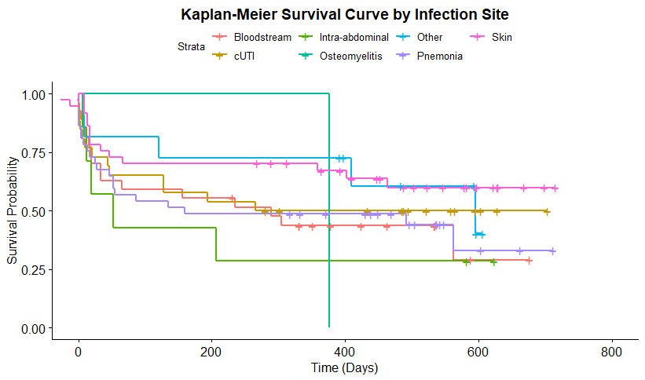
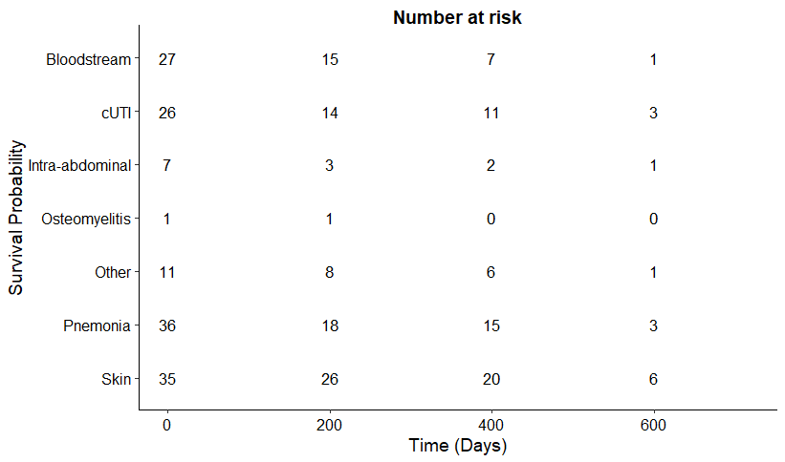
Figure 2: All-cause mortality infections by site (Stenotrophomonas) CARBAR
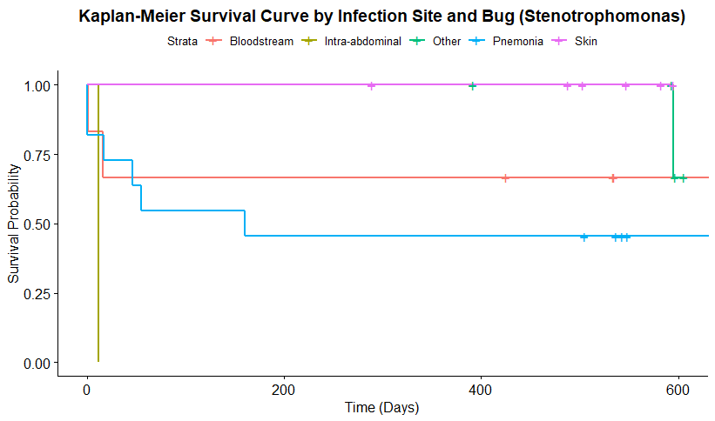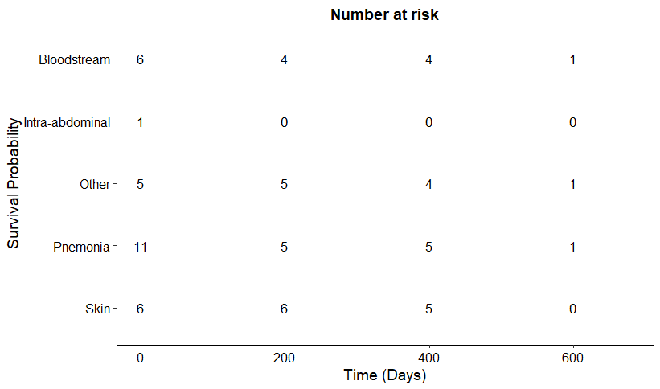

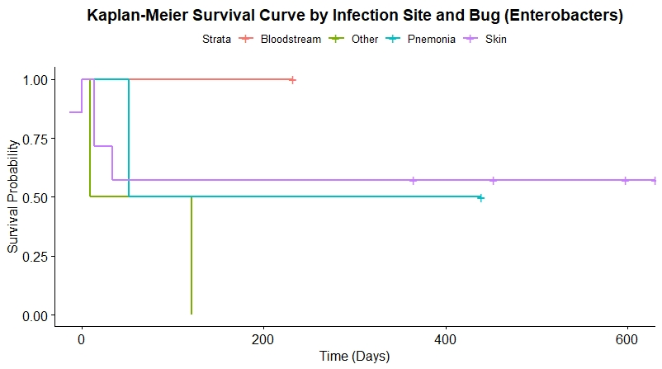
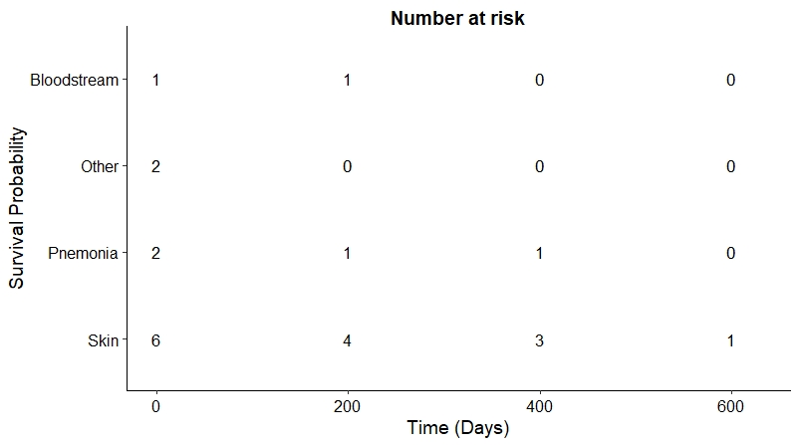
Figure 3: All-cause mortality by infection site (pseudomonas) - CARBAR
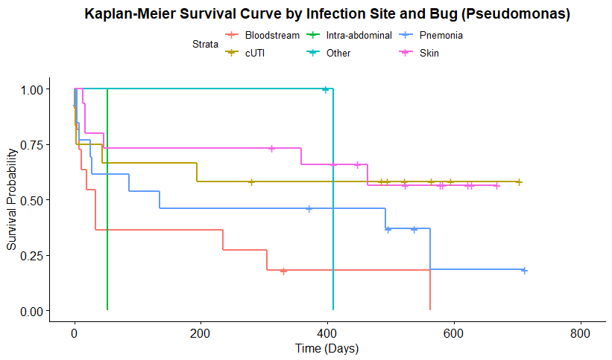
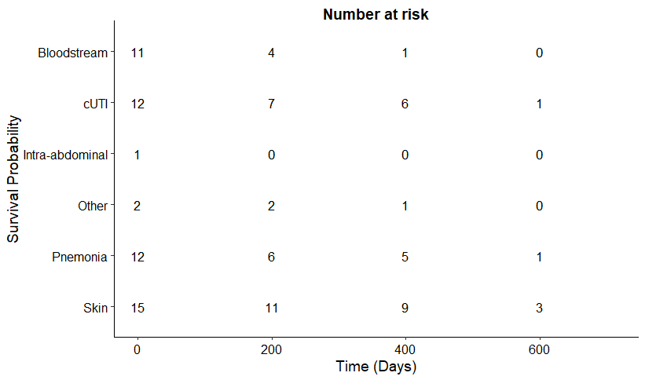

Question 2d: Further analysis of CARBAR hospitalisation data
Unfortunately, it was not possible to produce appropriate Kaplan-Meier analysis in the timeframe, as this would require careful consideration of censoring rules. This is because when using the overall survival and ICU length of stay Kaplan-Meier data in conjunction, death is an event in both, meaning that when treating the two as competing risks, deaths will be double counted in the ICU length of stay data, leading to underestimates. Because of this, the value associated with improved time to effective therapy associated with cefiderocol will be underestimated due to underestimation of the associated cost offsets. Therefore, EEPRU should be cautious when using the below data, as this does not censor for death whilst in the ICU.
There are several data points which may be useful to EEPRU when establishing the resource use and patient outcomes in a cost-effectiveness modelling context. We have provided as much information as we could in the timeframe to assist EEPRU. CARBAR reports length of stay data more generally. This is presented below in Table 7. CARBAR also reports length of stay in the ICU, which is reported below in Table 8.
It should be noted that in the tables below, and contrary to the KM data above, patients can be classified as having more than one infection (for example if they go on to have a secondary infection). For the overall survival data above patients have been classified according to their primary infection site.

Table 7: CARBAR - length of stay
 | Mean | n | SD
Bloodstream infection | 45.89 | 27 | 2.9123
cUTI | 29.11 | 28 | 2.7070
Intra-abdominal infection | 65.25 | 8 | 1.6850
Osteomyelitis | 30.50 | 2 | 2.1213
Other | 42.36 | 11 | 2.0226
Pneumonia | 41.41 | 39 | 2.8741
Skin | 48.88 | 40 | 2.7909
Unknown | 17.50 | 2 | 4.9497

Table 8: CARBAR - length of stay in the ICU
 | Mean | n | SD
Bloodstream infection | 23.88 | 8 | 3.07060
cUTI | 22.67 | 3 | 1.73205
Intra-abdominal infection | 18.00 | 1 | N/A
Osteomyelitis | 7.00 | 1 | N/A
Pneumonia | 29.67 | 15 | 2.68506
Skin | 32.89 | 9 | 2.75882

Question 2e: Baseline characteristics from CARBAR

EEPRU requested the following by sample type:
- Mean Charlson comorbidity index score and distribution of scores
- Proportion of patients with impaired renal function (along with details on how this is defined)
- Mean age

The distribution of the Charlson comorbidity index score in CARBAR is presented in Table 10 below. Note that although the sample size is relatively small, the distribution may not adhere neatly to a normal or lognormal distributional shape, and it appears to differ by infection site. EEPRU should consider this distribution when simulating the patient cohort. Therefore, these have been presented not only as mean and standard deviation (Table 11), but in a frequency table as well to allow variation using a Dirichlet distribution.
It is likely that these three parameters are also strongly correlated, particularly comorbidities index and renal impairment. Therefore, we also provide a variance-covariance matrix for pneumonia and cUTI. These are reported in section 2.3.5.4.

Table 10: Charlson comorbidity score distribution - CARBAR
 | 0 | 1 | 2 | 3 | 4 | 5 | 6 | 7 | 8 | 9 | 10 | 11
Bloodstream infection | 3 (11%) | 3 (11%) | 8 (30%) | 2 (7%) | 2 (7%) | 3 (11%) | 1 (4%) | 0 (0%) | 3 (11%) | 1 (4%) | 1 (4%) | 0 (0%)
cUTI | 6 (21%) | 3 (11%) | 3 (11%) | 6 (21%) | 3 (11%) | 3 (11%) | 1 (4%) | 1 (4%) | 1 (4%) | 0 (0%) | 0 (0%) | 1 (4%)
Intra-abdominal infection | 2 (25%) | 0 (0%) | 2 (25%) | 1 (12%) | 3 (38%) | 0 (0%) | 0 (0%) | 0 (0%) | 0 (0%) | 0 (0%) | 0 (0%) | 0 (0%)
Osteomyelitis | 1 (50%) | 0 (0%) | 0 (0%) | 1 (50%) | 0 (0%) | 0 (0%) | 0 (0%) | 0 (0%) | 0 (0%) | 0 (0%) | 0 (0%) | 0 (0%)
Other | 1 (9%) | 1 (9%) | 4 (36%) | 2 (18%) | 0 (0%) | 2 (18%) | 0 (0%) | 1 (9%) | 0 (0%) | 0 (0%) | 0 (0%) | 0 (0%)
Pneumonia | 8 (21%) | 7 (18%) | 7 (18%) | 4 (10%) | 4 (10%) | 2 (5%) | 2 (5%) | 1 (3%) | 1 (3%) | 2 (5%) | 0 (0%) | 1 (3%)
Skin | 10 (25%) | 3 (8%) | 5 (12%) | 7 (18%) | 0 (0%) | 8 (20%) | 3 (8%) | 0 (0%) | 3 (8%) | 0 (0%) | 0 (0%) | 1 (2%)
Unknown | 0 (0%) | 0 (0%) | 1 (50%) | 0 (0%) | 0 (0%) | 0 (0%) | 0 (0%) | 0 (0%) | 0 (0%) | 1 (50%) | 0 (0%) | 0 (0%)

Table 11: Charlson comorbidity score mean and SD - CARBAR
 | mean | sd | n
Bloodstream infection | 3.59 | 2.91 | 27
cUTI | 3.07 | 2.71 | 28
Intra-abdominal infection | 2.38 | 1.69 | 8
Osteomyelitis | 1.50 | 2.12 | 2
Other | 2.91 | 2.02 | 11
Pneumonia | 2.95 | 2.87 | 39
Skin | 3.18 | 2.79 | 40
Unknown | 5.50 | 4.95 | 2

Renal function and age
Renal function is presented below in Table 11 by infection site. In this case, renal impairment is defined as eGFR of less than 60. Age is presented in Table 12.

Table 11: Renal impairment at index date by infection site - CARBAR
 | RI | No RI
Bloodstream infection | 9 (33%) | 18 (67%)
cUTI | 11 (39%) | 17 (61%)
Intra-abdominal infection | 2 (25%) | 6 (75%)
Osteomyelitis | 1 (50%) | 1 (50%)
Other | 3 (27%) | 8 (73%)
Pneumonia | 5 (13%) | 34 (87%)
Skin | 12 (30%) | 28 (70%)
Unknown | 1 (50%) | 1 (50%)

Table 12: Age at baseline by infection site - CARBAR
 | mean | n
Bloodstream infection | 64.59 | 27.00
cUTI | 67.25 | 28.00
Intra-abdominal infection | 59.38 | 8.00
Osteomyelitis | 73.50 | 2.00
Other | 53.91 | 11.00
Pneumonia | 64.15 | 39.00
Skin | 61.38 | 40.00
Unknown | 69.50 | 2.00

Variance-covariance matrices

As the baseline characteristics requested are correlated, a variance covariance matrix has been provided for each class of diagnostic sampling:

Table 26: correlation between baseline characteristics requested by EEPRU - Pneumonia
 | Age | Renal (EGFR) | Charlson
Age | 194.952381 | 195.0714286 | 38.57142857
Renal (EGFR) | 195.0714286 | 3820.809524 | -47.02380952
Charlson | 38.57142857 | -47.02380952 | 19.14285714

Table 27: correlation between baseline characteristics requested by EEPRU - cUTI
 | Age | Renal (EGFR) | Charlson
Age | 167.7435897 | -101.4871795 | -8.692307692
Renal (EGFR) | -101.4871795 | 31926.64103 | -127.8653846
Charlson | -8.692307692 | -127.8653846 | 8.397435897

Other useful information
CARBAR reports ventilation status for all infection types (Table 9). This may be useful for EEPRU when establishing health care resource use within a cost-effectiveness modelling context. This is because it provides an indication of the utilisation of more expensive resources across all infection types.
Table 9: Patients by ventilation status - CARBAR
 | No | Not known | Yes
Bloodstream infection | 17 (63%) | 3 (11%) | 7 (26%)
cUTI | 20 (71%) | 1 (4%) | 7 (25%)
Intra-abdominal infection | 4 (50%) | 1 (12%) | 3 (38%)
Osteomyelitis | 2 (100%) | 0 (0%) | 0 (0%)
Other | 5 (45%) | 1 (9%) | 5 (45%)
Pneumonia | 14 (36%) | 1 (3%) | 24 (62%)
Skin | 28 (70%) | 3 (8%) | 9 (22%)
Unknown | 2 (100%) | 0 (0%) | 0 (0%)

Mark Sculpher, EEPRU
Mark.sculpher@york.ac.uk
14/6/21

