1. BILD service user focus group report

V.1 Report from the First Meeting of the Service User Expert Group of People with Learning Disabilities held at BILD’s offices in Birmingham, 25 March 2015 1

V.1.1 Themes emerging during the meeting 1

V.1.1.1 Coping with difficult experiences. 1

V.1.1.2 Mental health problems experienced by group members 2

V.1.1.3 Causes of mental health problems. 2

V.1.1.4 Impact of mental health problems. 2

V.1.1.5 Accessing help and support 3

V.1.1.6 Working with Professionals 3

V.1.1.7 Getting the right support 4

V.2 Report from the Second Meeting of the Service User Expert Group of People with Learning Disabilities held at BILD’s offices in Birmingham, 9 June 2015 5

V.2.1 Introduction 5

V.2.2 Themes emerging during the meeting 5

V.2.2.1 Having good mental health 5

V.2.2.2 Having mental health problems 6

V.2.2.3 What is good help and support? 6

V.2.2.4 What helps people to recover and feel good again? 7

V.2.2.5 Initial diagnosis 7

V.2.2.6 On an ongoing basis, who would you ask for help from? 8

V.2.2.7 Being supported by mental health professionals 8

V.2.2.8 Being in hospital 10

V.2.2.9 What helped you recover when you had mental health problems? 10

V.2.2.10 Other issues 11

Addendum V.2.1 – group work discussions 12

Addendum V.2.2 – questions 23

Addendum V.2.3 – videos 25

V.3 Report from the Third Meeting of the Service User Expert Group of People with Learning Disabilities held at BILD’s offices in Birmingham, 29 September 2015 27

V.3.1 Themes emerging during the meeting 27

V.3.1.1 Providing individual and respectful support 27

V.3.1.2 Providing unhelpful support 28

V.3.1.3 Talking therapies 28

V.3.1.4 Technology 29

V.3.1.5 Preparing to work with professionals 29

V.3.1.6 The importance of family and friends 30

V.3.1.7 Speaking up and self-advocacy groups 31

V.3.1.8 Getting the right treatment 31

V.3.1.9 Teaching people about learning disability 31

V.3.1.10 What do people with a learning disability need to know about mental health? 31

V.3.1.11 Advice for GPs 32

Addendum V.3.1 – meeting agenda 33

Addendum V.3.2 – PowerPoint presentation 36

*The British Institute of Learning Disabilities conducted 3 service user orientated focus groups to ensure the views of children and young people were considered in the development of the recommendations.*

* 1. Report from the First Meeting of the Service User Expert Group of People with Learning Disabilities held at BILD’s offices in Birmingham, 25 March 2015

Introduction:

The meeting began with everyone introducing themselves. The meeting facilitator outlined the purpose of the group and explained that there would be:

• Three meetings during 2015

• The guideline would then be circulated for wider consultation

• The final version would be launched in September 2016

It was emphasised that the Guideline Development Group were very committed to listening and addressing the issues raised by the group. All present agreed that this was a good opportunity to make sure that this guideline gets it right for people with learning disabilities and their carers.

The research assistant working on these guidelines shared how NICE guidelines are developed and how their advice provides clear ways of working for the wide range of health and social care professionals. She explained how the guideline is produced and it was helpful to understand that this was like “writing the book” that outlines good practice.

A short presentation followed that gave an overview of how the group was going to work over the three meetings. The facilitator explained that we would share what was discussed at each meeting with the Guideline Development Group (GDG). The details of the first meeting would be shared when the GDG met on Wednesday, April 15th 2015.

* + 1. Themes emerging during the meeting
       1. Coping with difficult experiences.

Taking part and sharing their experiences in the group proved to be a challenging experience for many of the participants. Although they were very keen to contribute and to identify good practice and what needed to be improved, all too often the memories of their experiences rekindled strong emotions and feelings. The group was very mutually supportive and the facilitators and supporters were also able to provide any required support. However, this emphasises the impact of having mental health problems allied to the challenges of obtaining tailored support and understanding from professionals, family and peers.

It was clear that there remains a strong stigma to having mental health problems. In addition, a consistent theme was not only the personal consequences of mental ill health but the impact on the people around whether this was family, friends or other people in shared accommodation.

* + - 1. Mental health problems experienced by group members

These included depression, anxiety, panic attacks and suicidal thoughts. Many in the group talked about how their thoughts and thinking would be “all over the place”. Individuals who had heightened anxiety shared that this often made them scared and would result in them becoming angry and uncooperative.

In addition, the vulnerability of people with learning disabilities and mental health problems means that they can be targeted and groomed by people in their local community. This can lead to financial and/or sexual exploitation, harassment by drug dealers and a wide range of hate and mate crime.

* + - 1. Causes of mental health problems.

The group spent some time talking about what they believed to be the most important causes of mental health problems for them or their friends and peers.

It was clear that a significant issue was the day to day pressures of coping with life when you have a learning disability. This included managing daily routines, coping with change and transitions, other people’s negative attitudes to people with learning disabilities, accommodation and support issues, and all too often, loneliness. In addition people talked about their vulnerability to hate crime and mate crime.

A major factor was conflict and problems with relationships and especially with partners or family. One of the group talked about their experiences of domestic abuse.

Additional causes included drug and alcohol dependency, life events including the death of relatives or close friends, and the additional pressures experienced by people who are gay, bisexual, lesbian or transgender.

* + - 1. Impact of mental health problems.

The group members shared how scared they felt when experiencing mental health problems. They often did not understand what was happening to them and they found it difficult to obtain the information they needed to make sense of their experience.

In addition, they recognised the negative impact on family and friends who can also be scared about what is happening and unclear about what help or support is required. All too often, it is apparent that those closest to an individual experiencing mental health problems can bear the brunt of their anger, lack of communication or changes in behaviour. This can lead to relationship breakdown and a potential need for alternative accommodation. However, it was very clear that many families and friends provide positive support that can help enormously in coping with and overcoming the negative impacts of mental health problems.

For parents with learning disabilities, the onset of mental health problems can lead to increased concerns about their abilities to provide effective parenting. The experience of one group member was that their children were removed and placed in foster care. Their story emphasises the difficulties of balancing their health needs with the potential safeguarding concerns in relation to their children. However, it is very important that the decision making processes include the required expertise in relation to childcare, safeguarding, mental health and learning disability.

* + - 1. Accessing help and support

If a person with a learning disability is known to the local Social and Health Services or is receiving support from a service provider, then they will be more easily referred to the appropriate professional. The experience of group members was that this will normally be linked to community learning disability services.

However, some individuals who were living independently have found it difficult to access support. They had struggled to obtain information and found their local Social Services unwilling to help them, possibly because of the tightening up of eligibility criteria. They felt that no one listened to them and this led to one of the group members taking an overdose and another ending up being compulsorily admitted to hospital. This suggests that having good knowledge about the referral processes and available help and support is an enormous advantage. However, particularly for individuals who are living independently, it can be difficult to know how to access support to prevent a crisis situation.

* + - 1. Working with Professionals

A range of concerns were identified during the first meeting. A consistent issue was that people felt that they were often not listened to by the professionals who were responsible for their treatment and support. GPs were singled out for particular criticism but many other examples were given from a wide range of professionals. In particular, it was felt that little accessible information was provided about the treatment options available and the advantages and disadvantages of each were often not adequately explained. This meant that people feel that they are not involved enough in understanding and determining their treatment.

There was a particular issue in relation to the use of medication. It was reported that many GPs simply prescribe medication without explaining the hoped for impact and what side effects might be anticipated. One person felt that their GP prescribed medication but did not recognise that he had a serious mental health problem.

In relation to medication, people also talked about how sometimes it was difficult for GPs or psychiatrists to identify the best combination and dosage that was required. This was said to be either frustrating or worrying for individuals.

There was considerable discussion about diagnostic overshadowing. Group members strongly emphasised that having the label of learning disability means that professionals just see the learning disabilities and not any underlying mental health issues. This was a consistent theme and it was felt that this often leads to people with learning disabilities receiving a poorer quality of support for their mental health needs. In addition, there was concern that many professionals in mainstream mental health services lack experience and knowledge of working with people with learning disabilities. One person emphasised that sometimes it takes a long time for them to understand information and he did not think that he was given this.

It was clear that when an individual was supported by a linked professional such as a learning disability nurse or an advocate to guide them through the system and challenge any bad practice, then their experience was much more positive.

Working together to make discharge from hospital be a positive process was seen as very important. One person praised the way that their family, support workers, psychiatrist, art therapist and clinical team met together in a team approach. This helped to reduce their anxiety about leaving hospital and provided good support when he returned to their home.

It can also be difficult when a person with learning disabilities acts as a supporter. One of the group members supported their partner with schizophrenia in an appointment with their psychiatrist. They found it difficult when their partner did not truthfully answer the questions they were asked. They did not know whether they should challenge their answers and felt confused. This illustrates how important it is for everyone in clinical meetings to understand their roles and for information to be shared.

* + - 1. Getting the right support

It is clear that tailored support and interventions had a positive impact on a number of the group. The key to this was receiving support from a mental health professional who took time to get to know the person and was able to help them to access the right support for them.

Counselling and talking therapies often provided people with practical strategies to cope better. Examples given included anger management with one person learning to take out their feelings on objects and not people whilst another person benefitted from learning to write things on paper.

The benefit of talking therapies was rooted in people feeling valued, understood and not judged. Being really listened to was also acknowledged as a very positive experience.

Group members talked about how their self confidence increased when they had the right support. This included having the right medication and the opportunity to take part in activities and having positive things to do.

* 1. Report from the Second Meeting of the Service User Expert Group of People with Learning Disabilities held at BILD’s offices in Birmingham, 9 June 2015
     1. Introduction
     2. Themes emerging during the meeting
        1. Having good mental health

Everyone was able to talk about how they felt when they were well and feeling good. People talked about being happy and energetic and being able to have active lives. Sharing experiences with family, friends and pets was very important and there were a wide range of activities, hobbies and interests that were pursued. It was obviously good for people to be “doing stuff and keeping busy” especially being out of the house and in the community.

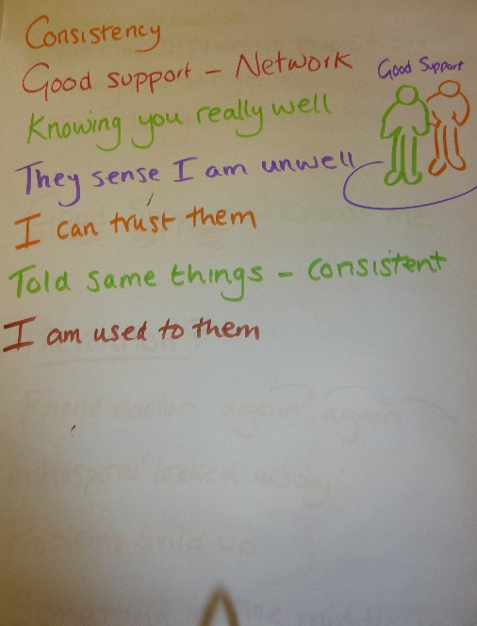People talked about being able to achieve things which was often in stark contrast to their experiences when they were unwell.   
This included people working and providing training to professionals through their self-advocacy organisations and one person who has developed a social enterprise that offers support via social clubs exchanging CDs.

Being able to relate positively to family and friends was consistently seen as an indicator of good health. The importance of being able to have a laugh and a joke, and to be able to talk easily to people was shared by a number of the group.

One person shared that when they were well, they could talk to their family about their mental health problems and how they felt when they were down. It was important to them to apologise for how they behaved when they were not well.

When asked what helps people to have good mental health, the wide range of responses included family, friends, medication, the support of GPs and mental health professionals, advocacy organisations, a home to live in, positive things to do and being valued by the important people in your life.

* + - 1. Having mental health problems

Everyone was able to talk about how they felt when they were having mental health problems and this contrasted starkly to their experience of being well. People described a wide range of negative emotions to describe how they felt when ill and the impact it has on their daily lives.

This included becoming angry easily, feeling down, stressed and not wanting to do anything. Many people talked about wanting to be on their own and not wanting to be around people. This means that people can stay in bed or in their bedroom, not eating and not taking part in conversations with their family and friends.

People talked about feeling isolated and lonely and how their families and friends all too often bore the brunt of their anger and frustration.

We talked about what makes people feel worse when they are having mental health problems. Coping with change was a contributory factor for many people especially when it involved familiar support workers or professionals leaving or moving on. Many of the group talked about their difficulties in developing and emotionally investing in trusting relationships with professionals who are around for a limited time. The high turnover of staff often means that people have to tell their story over and over again.

In addition, receiving poor support from people who do not know you was a major factor for people when they were ill.

Trying to cope with the daily tasks and responsibilities also led to worsening mental health. People mentioned that trying to cope on benefits, having money problems and being in debt caused great anxiety. In addition, people found that social media and texting became stressful when being contacted by other people all of the time.

* + - 1. What is good help and support?

The group were very clear that good support was provided by GPs and mental health professionals who knew them well and therefore were able to understand any early signs. Having regular contact with named professionals where a positive relationship had been developed was seen as positive. Being listened to and understood was very important as was professionals having the time to spend to make sure that everything was communicated in ways that were understood.

The issue of trust came to the fore on a number of occasions. Given the challenges presented by mental health problems, people wanted to be offered support by trusted professionals. The development of trust is dependent on the time spent developing the relationship and there may be additional issues about whether some mental health professionals lack the skills to engage with people with learning disabilities.

People talked about the importance of having the support of family, friends, support workers and/or advocates who would stick by them during episodes of mental ill health. There was a clear recognition that people needed support to find a way through “the system” to get the professional help required. People talked about how helpful it was to be supported when meeting with doctors and psychiatrists or at review meetings.

* + - 1. What helps people to recover and feel good again?

The opportunity to go and talk to someone about what was happening was seen as very important. This could be a family member, friend or support worker but there was a recognition that mental health professionals could provide expert help. However, people emphasised the importance of being able to talk without any fear of being judged. The help they needed was often to be supported to make the choices and decisions that were right for them as individuals.

The use of a diary to map people’s changing moods had been helpful for some of the group. For people who struggled with reading and/or writing, support was needed to complete it. One person talked about how their diary had been adapted to use colours which helped them to be able to use it themselves.

People agreed that the single most important factor in helping recovery was to have a good support network with people who know the person really well and will stand by them. Some of the group had struggled with their mental health problems because they had not had such a support network and had been living isolated lives. Their current involvement with self-advocacy groups and activities has enabled them to develop the peer support and friendships which they did not have previously.

* + - 1. Initial diagnosis

Although it was often friends or family that noticed that people were becoming unwell, it was the GP who often first identified that there was a mental health problem. When people started to feel unwell, they initially turned to their GP for help. Most found their GP to be very helpful but some commented about being asked questions that were hard to answer.

However, there were people who found it very difficult to have their condition diagnosed. They commented that they had to do something negative, hurt themselves or have a breakdown to get help.

When a referral was made to mental health services, many of the group shared that they did not fully understand what was happening. It appears that more information was required about how the system works. This created additional anxiety for people and was exacerbated by having to wait a long time for the first appointment. One person said that they were already feeling better by the time of the first appointment. However, many people found the delays upsetting and difficult to deal with.

People said that they found the appointment letters that they received difficult to understand and full of long words. For people who may not be able to read easily, it was suggested that the letters should be in Easy Read.

* + - 1. On an ongoing basis, who would you ask for help from?

There was a consistent response that people would talk to their family and friends first. In addition, people who were provided daily help from support workers would approach them initially.

People emphasised that they would talk to people who knew them well, who would not judge them but would be alongside them, no matter what happened.

One of the group had been supported by the same support workers for over four years. They knew them really well and were able to identify the early signs when they were beginning to become unwell so could ensure that they received prompt support and help. They spoke very positively of how they supported their choices and decisions and were able to do this because they knew them so well.

Others talked about the difficulties that arise when there is a high turnover of support staff and therefore there is no one who knows people well.

Some commented that when they feel unwell, they contact their GP who tells them to contact their psychiatrist who tells them to contact the crisis team who are not able to respond with any urgency. This process often makes people feel worse and does not seem to address any additional issues linked to their learning disabilities.

One of the group questioned whether there was support that could prevent an episode of mental ill health deteriorating. Their experience was having delays before being able to see the GP and then further delays following a referral to mental health services. This has meant that by the time they receive support, their condition will have deteriorated to the point where they require hospital admission. This means that discharge brings additional problems related to being away from home for an extended period. They wanted something more flexible between help from their GP and being admitted to hospital.

* + - 1. Being supported by mental health professionals

The group was very critical of the support that they had received from mental health professionals. There were examples given of individual professionals who knew people well and provided tailored support. However, this was outweighed by people’s experiences which suggested that there is a lack of understanding of the specific needs of people with learning disabilities.

Many of the issues relate to communication. The professionals often fail to provide good information in ways that will make sense to people with learning disabilities. It appears that assumptions are made about what people can understand and retain. People shared that their illness was not explained to them and all too often, doctors and professionals simply ignored them and talked to each other over their heads. The professionals often use jargon and long words without explaining what they mean. There is very little written information that is accessible or in easy read.

Some of the group shared how it helped them to be supported by an advocate who could explain the information and what was happening. The advocate would also ensure that the person’s views were taken into account so that they could make their own choices and decisions. Others talked about how family members could fulfil this role as well.

People talked about unhelpful attitudes that they had experienced from professionals. Some doctors and psychiatrists made people feel stupid and did not make any attempt to address any issues relating to their learning disabilities. In fact, people questioned whether some of the professionals had any knowledge, experience or skills to work with people with learning disabilities.

The group members recognised that it can be hard when professionals have so many people to see. However, they argued that people with learning disabilities need longer appointment times and to be provided information that is accessible and provided repeatedly.

People said that medication is often provided with little or no explanation. They wanted information to be provided in different formats that would give the name, dosage, when to take it and how, and details of any side effects to look out for and what to do if there are any side effects.

However, the most important issue for people was consistency of support from professionals. Ideally, they wanted to receive the same support from the same professionals each time who could get to know them well and provide consistent advice and support. All too often, people are having to tell their story repeatedly to professionals who are meeting them for the first time. Having to give their story over and over again simply frustrates and angers people. One of the group talked about their frustration that every time they need to see their social worker, they meet a new person because the previous one has left. It can be all too easy to accept this as part of the system but this has a massive (negative) impact. The need to provide consistent support from the same professionals is very important for people with learning disabilities. One of the group complained that they had too many professionals in their life and that it is really difficult “to get the same person from start to finish.”

A number of people had benefitted from the support of crisis teams. However, there were complaints that there are sometimes delays in the teams being able to respond. This meant that people’s mental health problems could increase whilst waiting for access to support.

* + - 1. Being in hospital

There was a mixed response to being admitted to hospital. One person talked about recognising that they needed to be admitted as they were so unwell. Another person felt that their admissions could have been avoided if there had been more timely support available in the community.

One person found that their stay in hospital had an impact on sustaining their accommodation as bills were not paid and they faced increasing debt. Issues about the lack of a planned discharge were also raised. People talked about how scary they had found it being admitted into a strange unknown environment. They wanted there to be an easy read information booklet including photos of the hospital and an explanation about what happens there. The booklet should give explanations about the jargon words that are used and the roles and responsibilities of the people who work there. The provision of such an information booklet would help people to stop being so scared when they are admitted.

* + - 1. What helped you recover when you had mental health problems?

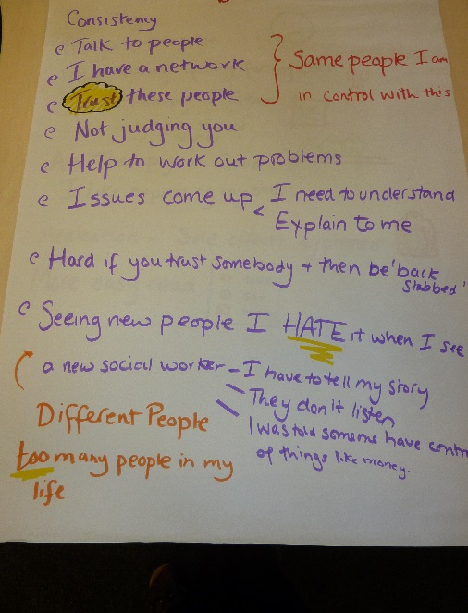People shared a number of different things that helped them as an individual.   
One person benefitted enormously from art therapy which helped them to express their feelings through drawing. Talking therapies helped a number of the group. Some gained much from working in groups whereas others preferred one to one sessions as they found it difficult to talk in front of others. One person talked about how they needed to spend time in hospital as they became so unwell.

It was apparent that each individual benefitted from tailored support which they were involved in designing or agreeing. People’s recovery seemed to be helped by having family and friends offering additional support.

* + - 1. Other issues

People were convinced that having learning disabilities means that mental health professionals are reluctant to engage or offer quality support. The group members were very sure that people saw their learning disability first and not the mental health problems. They feel that they have to battle to access support and that this causes delays which reduces the opportunity to respond to the early signs of problems.

During the group discussions, people consistently raised the impact of budget cuts and austerity measures. This was in relation to the individual impact of potential benefit cuts and the anxiety that this was causing. However, it was also linked to access to services with the raising of eligibility criteria and the closure or reduction in availability of services.

Addendum V.2.1 – group work discussions

Having good mental health – when you are well, what does it feel like?

I feel

* Bossy
* Happy
* Over the moon
* Ecstatic
* Energetic
* Everything feels right
* Mellow
* Doing stuff and keeping busy
* Like taking small steps to go out there

I enjoy

* Telling people what to do
* Watching TV
* Playing music full blast
* Getting up early in the morning with the dawn
* Lying in bed
* Being energetic
* Drawing
* Visiting people
* Going to Whitley Court
* My garden
* Watching the wrestling
* Doing my knitting
* Being with friends
* Shopping
* Going for a walk
* Going for a coffee with someone
* Going to the pub
* Go on trips (e.g. Whitby; the market or the docks)
* Holidays
* Going to the pictures
* Going out for a meal with my fella
* Being with your dog
* Going to work
* Hobbies
* Walking out of the front door
* Going outside in the fresh air
* House cleaning
* Monday and Friday clean the house
* Have a wash, shower, eating
* Pay bills

How do you feel inside?

* Talkative
* Bubbly
* Feel warm
* Safe and secure
* Energetic
* Sing and laugh
* Joking
* You feel good about yourself, you can get out and about
* Positive emotions and a positive mind
* Cope with things better

How do you get on with other people?

* Friendly
* Nice
* Kind
* Depends on how I am
* I treat myself and treat people – spend it on others (treat my friends)
* I go quiet
* Alright – shake hands and give a hug
* Give gifts
* Send them a nice card
* Getting in touch with people
* Happy with my cat
* Seeing the kids (sort of)
* Can argue a bit even if we are in a good mood
* Stroke the dog
* You can have a joke
* You are more focused
* Look for a girlfriend
* Wedding anniversary
* Happy with a partner
* Talk to your friends
* Feel happy
* I may snap at them
* Friends on Facebook
* Got friends
* Happy around people
* Can talk to people easier
* You don’t ostracise yourself from other people like you do when you’re down
* Motivated to do things
* You apologise for hurting people when you have been down

When I am feeling good I

* Go shopping with mum
* Go to the park with the dog
* Do art and craft
* Do a bit of painting on a Tuesday
* Go volunteering with Grapevine’s “H Team” – we talk to doctors, paramedics, social workers, nurses who work with people with learning disabilities. We have won an award for doing this.
* Can do anything
* Do whatever I fancy doing, depending on what side of the bed I get out of
* Play sport – racquet ball
* Help people
* Feel alive
* Feel like I have achieved something
* Try to educate myself about how to prevent becoming ill again

When things are good, how do you get on with those closest to you?

* Really good
* I’m happy to have my family around – it’s important
* I talk about how I felt when I was unwell so that my family and friends can understand – not something you can do when you are down

What helps you to feel good?

* Taking medication
* Having people around
* People
* Dogs
* Good nature around you in the countryside

What is good help and support?

* Makes me feel good
* Doctors, nurses and dentists do it to help you
* They talk to you, explain things to me, share how things are going on.
* I like to see a doctor or nurse regularly
* I want to be left alone until I need them (psychiatrist/doctor)
* I go to see my psychiatrist regularly every 3 months. I am happy that I have been listened to and talk to them
* I go (to see my psychiatrist) when I want to go I don’t talk to their, my CPN talks to their
* When I don’t speak to mine (Psychiatrist), my support speaks
* My supporter knows the doctor. I am happy my support goes with me. I give my permission. I am happy she goes with me. At a review I can have my supporter and my family present
* My mum comes with me. I am happy with this and about sharing information with her

Getting the right support

* Where I live I am safe and secure. I trust them
* I choose where I live. All right
* The Housing chose with me. I was involved but I didn’t understand what they do
* I get support to remind me to do things
* I organise things for myself
* I am supported if I go for an appointment
* I am prompted to do things
* I have no support. I live on my own
* I have someone who knows me well to support me.
* My friends and family are the most important
* The organisation that supports me keeps changing and I find choosing new support workers difficult. I have to tell my story again and again. This is like a bomb about to explode
* Having the right support is good. I have had this for 3 years
* Having the wrong support is a problem
* I had a difficult time when my support was changed
* The right support knows me and what I am like. This is important
* I have to cope with change. Having no social worker to help me because they left. Now a new one has to help me
* The organisation supporting me has changed. The manager had to reapply for their job
* It is important to get the right support and to keep the right support
* New support staff should talk to the people I know well
* Staff are often changing
* Got used to new staff. They listen to me, treat me with respect and talk to the patients

When you have Mental Health problems, how do you feel?

* Sad
* Mad
* Low
* Lost the plot
* Angry and frustrated
* Intense
* Don’t want to be there anymore
* Suicidal sometimes
* Giving up
* Frustrated
* Isolated
* Can’t face any problems
* No one understands
* My head’s very messed up
* Get angry easily
* Can’t think outside of the problem
* You can feel suicidal. A family member committed suicide because doctors didn’t listen to them

Does it affect your daily life?

* I would go on and still do it (sport)
* Feels different
* Depressed
* Nothing’s working
* No showering
* I feel too poorly
* I don’t watch telly
* Turn it all off
* Don’t want to bother with people
* Give up
* People do not understand the issues when you cannot express yourself
* When people can’t see your disability they don’t understand you
* The people closest to you bear the brunt
* You can wake up in a good mood and next thing you can be down

What do you do when you have mental health problems?

* Not bothered
* Feel down
* Feel different
* Not do anything
* Stay in bed
* Ignore people
* Stressed
* Not eat
* Stay in and not go out
* Staying in my room
* Get nasty
* Go quiet
* My support asks if I am alright
* Good friends are there all of the time
* When I go quiet, my support knows that I’m not right
* Just want to be left alone
* Hear voices in my head
* Take tablets/medication
* Throwing things

What helps you to feel good once more?

* Going and speaking to someone like a supporter or doctor. My supporter will ask if I need to talk
* Using a mood diary I write how I feel on each day, whether OK or depressed. I tick the box
* Supporters can write things down when people have complex disabilities
* My supporter writes a diary for me on “what I’ve done today”. This could include in bed all day/shopping/anything I do. What is written in the diary is shared with my other supporters and logged
* It helps to have a diary to remember what happens but I can’t read so I use colours
* You need to believe in yourself and having the right support makes such a difference
* Having that powerful voice to make your own choices makes such a difference
* It’s important to have that trust so people don’t judge you
* Eventually you can work out the trigger by going back a few weeks
* Music helps me to calm down
* People with mental health problems should always be given a choice and have a network of support available
* CDs helped me. They change your whole thinking
* Peer support is helpful too sometimes

What makes you feel worse?

* Change
* Poor/bad support
* Not having enough money to spend. Worrying about money problems
* Being in debt
* Too many people texting me
* People knocking on the door
* Social media such as Facebook. Stressful especially being contacted by people who I do not want to contact me
* Arrogance from the people who support me. I’m not taking the road that they want me to take
* Support workers shouldn’t put people down
* When you’re unwell, weekly appointments are frustrating. I need the help now, not next week. When it gets to the point that you will hurt yourself, that’s when they step in, but it shouldn’t be allowed to escalate to that level

The first time that you had a mental health problem, who noticed and where did you go for help?

* My doctor
* My doctor noticed I was unwell and that I was down
* My mum noticed I was depressed and down. My mum spoke to the doctor. I was in tears. The doctor listened and put me on medication. He said if it does not work, come back to see me, I was asked questions that were hard to answer. I didn’t know what to say to bring things back to normal
* It took me to have a breakdown before I got help
* I couldn’t get help. I had to do something negative to get help
* The Government is shutting services down. Where do you go for help? It’s like a merry go round

Your first appointment

* I waited ages
* I had to wait a long time
* I saw my GP first
* It took I or two weeks to see the GP
* I had to wait to see a specialist
* I was in hospital so I saw the doctor often
* Upsetting
* Daunting
* Weird. I didn’t know what was going on
* Frustrated by waiting
* By the time I got the appointment, I felt better
* I didn’t want to wait. I wanted help

Appointment letter

* They were not in Easy Read
* They had long words

What happens when you become unwell? Who do you ask for help?

* Mum and Dad. I always go to my family
* People can sense it but I shut myself off and don’t ask for help. My support workers always pick it up. They have all known me for a long time and know me really well
* I have a good circle of support
* I ring the doctor who tells me to ring the psychiatrist who tells me to ring the crisis team. I go round in circles
* Sometimes interference from my family isn’t the best. I put a brave face on in front of my wife so I don’t upset her
* I contact the crisis team and CPN to take the pressure off my family and not to burden my mum. I put a mask on a lot of the time.
* The facilities aren’t there. When the crisis team are available, I make sure I stay on the phone – I have to battle on
* I used to get angry at the CPN, now I don’t. I’ve learned how to get help. If I ring the CPN now, they have more respect for me. I feel like I’ve achieved something

Meetings and contact with doctors and professionals

* They didn’t explain what my illness was
* I didn’t hear them clearly. They talked to other doctors. Sometimes they would leave me out.
* I had my advocate with me. I understood some of what was said. They didn’t tell me what my illness was called. They didn’t explain things to me. They gave me medication but didn’t explain what it was for. My advocate explained what was said. It is a good thing to have an advocate.
* On the special ward, sometimes they used words and pictures to explain when my medication changed.
* The doctor was not talking to me
* They made me feel stupid
* The doctor puts me down and says I won’t achieve anything.
* They needed to tell me that I need to take medication when I am depressed, one in the morning and one at night. They need to explain the name of the medication and what it will do
* We need more easy read information about tablets
* We cannot read or understand the leaflets included in the boxes of tablets
* We need to have any possible side effects explained to us so that if they happen, we could ask for the tablets to be changed
* It would help to have easy read leaflets to explain any side effects
* I feel better now that the medication worked. It took some time
* I’m not under control yet. It takes a long time
* If you put me in a room with a professional who doesn’t understand me, I could change their opinions
* The best way is to challenge a mental health problem in a positive way, not with medication
* I was unwell and the crisis team took nine hours to visit and said it would be four days until I could go to a crisis house. Eventually they let me stay but only because I complained
* I hate new assessments. It’s always a new social worker who hasn’t met me before and I have to give them all my history again. They never read up on your notes
* Social workers need to have experience of mental health problems themselves
* I hate telling social workers about my past
* They should focus on the here and now, not the past
* I never see the same doctor
* I have a friend who had to get an emergency appointment with the psychiatrist who upped their meds. The psychiatrist noticed where he was living was a problem. Having a routine and safe environment is so important
* I always have a different GP who goes through my history again. It’s complicated and when you ring the crisis team, you have to wait. Then the CPN doesn’t have any idea about your history
* Social workers always change. There is no one to help
* It feels like you’re a new “claimant” all the time. You never get the same answers twice or any consistency
* They all just fill in forms
* Professionals need to listen, understand and have empathy
* It’s a tick box system and you must conform to what they want
* It’s really difficult to get the same person from start to finish
* You never speak to the same person twice
* They don’t talk to you, they talk behind you. I think “why don’t you ask me the questions?” but they don’t
* Professionals talk to each other, not to me. The questions aren’t geared towards you
* To get the help, you have to resort to something drastic. Managers come in with new ideas written in a book, it’s like trying to teach an old dog new tricks. It causes problems

Going to hospital

* Saw me at home and then referred me to hospital
* Scary going to hospital for the first time. I got upset
* The staff and people at the hospital were friendly with good manners
* I had a list of food so I could choose my meals
* There were words used in hospital that I did not understand like “special ward”
* It would have been good if there had been an information booklet with pictures and words that had a photo of the hospital; an explanation of what they do at the hospital; lots of new words to understand; the people who work at the hospital and what their jobs are. All of this information would stop you being scared
* You need to try and make friends as soon as you can, it’s about
* self-worth
* When you’re in hospital, they treat you as if they’re in charge
* You get worried about bills if you are in hospital and you could be at risk of homelessness. This makes your mental health problems even worse.
* There is no support when you leave hospital unless you use a charity group

How do other people react when you’re not well?

* My family gets worried
* People don’t trust you
* They treat you like a leper, they act scared
* They have negative perceptions and jump to the worst conclusion but what is normal?
* When people are unwell, they have a learned behaviour and their behaviour gets more extreme
* People get scared which comes down to ignorance. They think you’re violent and panic
* My advocacy worker would never judge us. We can always go to there and speak to them

What helps you when you have mental health problems?

* Art therapy and drawing. Very good for me. I liked it but stopped doing it
* Drawing. I drew the people who helped me; the people who loved me and are important to me. At the end, I felt better, I felt happy and I understood things
* I drew what was in my head
* Talking helped me
* Talking groups such as a men’s group
* I found it difficult to say things in front of other people. I did say about myself and I heard what others said
* One to one. This was better
* I only had one to one sessions. He took time to listen to me.
* Going into hospital. I needed to go and I was happy to go as there was help there. I was treated good and with respect. Nobody talked about each other. My details were kept private when I was on a special ward for people with learning disability
* Having people around me
* A big word is trust

Prevention

* You often have to phone the doctor again and again
* You can end up locked away in hospital
* Problems build up. Help is needed when this happens
* There needs to be something in the middle between help from the GP and being admitted to hospital

Other issues

* When lots of people (supporters) go away at the same time. It should be organised around me
* I’m on my own. I feel alone. No one to go to. I’d rather be on my own locked in my house. Sometimes I have someone checking up on me (CPN) when they can be bothered
* Is it to do with having a learning disability and not just mental health problems that means we are fobbed off?
* They talk jargon rather than talking normal
* People struggle with mental health. It’s equal with learning disability
* People can see the learning disability first, not the mental health issue
* Some people are good at talking to people with a learning disability
* People do listen. They do not ignore me
* Write a book
* Visiting an institution made me realise how lucky I was
* Austerity and budget cuts has meant that all we are fighting for has gone down the pan. Attitudes have changed for the worse
* People aren’t trained and never know how to recognise mental health problems. They have no empathy
* Hospitals and crisis teams are being closed
* The law has changed so they can’t put people in police cells but if there are no hospital beds, there’s nothing you can do
* Benefit cuts have an impact on your mental health

Recapping the important things that we talked about

* Talk to the professionals
* We have to give the same information over and over and over
* There needs to be more transparency from professionals. They need to share, have better links and pass on issues
* Not having the right people available causes distress and slows things down
* It has taken 20 years to get the right help and support
* The problems have not changed now that I’ve got older
* I am helping others now
* Consistency of support is very important
* You need to have a good support network with people who know you really well. They can then sense when I am unwell. I can trust them. I am told the same things. Consistent. I am used to them.
* Good communication
* It is hard when you have lots of different people to see
* Things change
* It’s scary
* Good support knows me and provide consistency
* I can talk to people in my support network and trust them. They are the same people and I am in control with them. They do not judge you but help to work out problems
* If issues come up that I need to understand, they will explain them to me
* It can be hard if you trust somebody and then are “backstabbed”
* Coping with all of the different people. I have too many people(professionals) in my life
* I find it hard to see new people. I hate it when I see a new social worker as I have to tell my story (again) they don’t listen and I was told that someone has to have control of things like money
* It’s upsetting as it brings up the past
* Talking helps me. Getting things off my chest
* You need good support when you come out of hospital that knows the person

Addendum V.2.2 – questions

What does it mean to have good mental health?

* When you are feeling good, what emotions do you feel?
* How do you feel inside?
* How do you get on with other people?
* How do you get on with those closest to you – your family, friends, partner, boyfriend, and girlfriend?
* What would you be doing during a typical day when you are feeling good?
* What would you be looking forward to?
* What helps you to have good mental health? (prompts: being surrounded by people who care about me; positive things in my life; right support; somewhere to live that I choose; positive things to do that I choose; right support from health team esp. GP and learning disability nurse?; medication)

What does it mean to have a mental health problem?

* When you have a mental health problem, how do you feel?
* What emotions do you feel?
* How do you feel inside?
* How does it make you behave?
* Can you control how you behave?
* How do you get on with other people?
* How do you get on with those closest to you? – Your family, friends, partner, boyfriend or girlfriend?
* What would you do during a typical day when you have a mental health problem?
* What would you be looking forward to?
* What has caused you to have a mental health problem?
* What makes you feel worse?
* With people that you know that have mental health problems, what causes it for them?
* What makes them feel worse?
* How do other people react when you are having a mental health problem? What makes you feel better?

Assessment and diagnosis

* When you developed a mental health problem, did you know that you were becoming unwell?
* Did you ask for help? Who from?
* What help was given?
* Did someone else notice that something was wrong with you? Who was there?
* Did they talk to you about it?
* What did the other people around you do at first?
* Who did you go to see when you knew you had a mental health problem?
* Was it your GP, social worker, learning disability/mental health nurse, psychiatrist, psychologist?
* Had you seen them before in relation to your mental health?
* Did you take someone with you or did you want to go alone?
* If you went with someone, who was this?
* Was it easy to make an appointment?
* Did you do this on your own or did someone help you to make the appointment?
* Did you have to wait a short time or a long time for an appointment?
* If you had to wait for an appointment, did this make any difference to your mental health problem?
* Was it clear where you had to go for your appointment and when? How was this communicated to you? If by letter, was it in Easy Read?
* When you arrived for your appointment, did you feel comfortable being there? Why? Why not?
* When you sat down to talk to the Doctor/nurse, did it feel good to talk with them or not? Why?
* Did you feel that they listened to you?
* Did the person ask you questions that you could understood and could answer?
* Did they ask about the best ways to talk/communicate with you?
* Did you have enough time to talk and explain how you felt?
* Were you given choices about what to do next? Were the choices explained to you?
* When you left the appointment, did you understand what was going to happen next?
* How was this communicated to you? How did they make sure that you would remember what was agreed?
* What could have made it better?
* What happened next?
* Did you go to a hospital or clinic or did someone see you at home?
* How did you feel about this? How many different people did you see? Who was the most helpful? Why?
* Was everyone that you saw helpful?
* Did you always see the same person or different people? Was this a problem?

Diagnosis

* Professionals use lots of words to describe mental health that are new to us. They need to explain what these words mean or use words that are easier to understand.
* Did your team do this?
* Did you understand what they were talking about when they were telling you about your mental health problem?
* A diagnosis means giving your mental health problem its proper name. Did someone talk to you about your diagnosis? Did they explain what it meant?

Addendum V.2.3 – videos

Video 1 – The group sharing issues at the end of the meeting

Link: [removed for data protection reasons]

This includes:

* Concerns about having to tell your story again and again to get the right support and services
* Wanting professionals to share the information that they have about you so that you do not have to explain over and over again. People do not pass information on even if they are working in the same trust
* Having to repeat your story to new professionals all the time slows things down
* It can make people feel anxious, frustrated and distressed
* The importance of having consistency. One person shared how the support workers can pick up the early signs of feeling unwell
* The importance of receiving consistent advice each time from the same people.
* The importance of being able to trust those who offer support
* It is hard to understand what all of the different mental health professionals do
* It is hard to deal with lots of different professionals, especially if you are unwell
* One person wishes there was an approach to prevention that could respond to early signs and offer a flexible short stay if required. Their experience is having to wait to see the GP and then further delays until a hospital admission for a month. This means that discharge brings extra problems related to being away from home for an extended period
* It is important to have a network of support from family and trusted friend
* The importance of professionals enabling people to have control of their life.
* The benefits of group and art therapy
* The need for clear information about medication and any side effects
* The importance of information being available in Easy Read
* Good support being very important on discharge from hospital provided by support workers who know you and listen to you

Video 2 – interview 1

Link: [removed for data protection reasons]

This includes:

* The importance of receiving emotional support and understanding
* Their support workers have been providing this for 4 years and can tell the early signs when he is becoming unwell
* “I can trust them – they won’t judge me”

Video 3 – interview 2

Link: [removed for data protection reasons]

This includes:

* “Having been in the system”
* Concerns about how psychiatrists, psychologists and CPNs work
* Then importance of access to advocates
* The impact of budget cuts. People waiting longer to be heard, seen, diagnosed and helped
* “I think we’ve got a long way to go”
  1. Report from the Third Meeting of the Service User Expert Group of People with Learning Disabilities held at BILD’s offices in Birmingham, 29 September 2015

Introduction:

To recap the previous 2 meetings, the key messages that were talked about included:

* Talking about people’s experiences brought back painful memories for some
* There is still a stigma about mental health
* Mental health professionals do not always understand about learning disability
* It is very important to get help when you know that you are not well
* It is good to get help from the same people who know you and who you can trust
* You need to have a good support network
* You need access to good easy to understand information
* You need the right treatment
  + 1. Themes emerging during the meeting
       1. Providing individual and respectful support

Everyone provided examples of when they had been supported well and when the support offered had failed to meet their individual needs.

A consistent theme was the importance of being supported by people who know each person well and have a good relationship with them. This then means that they are likely to recognise the early signs of mental ill-health and be able to support the need for any assessment or treatment.

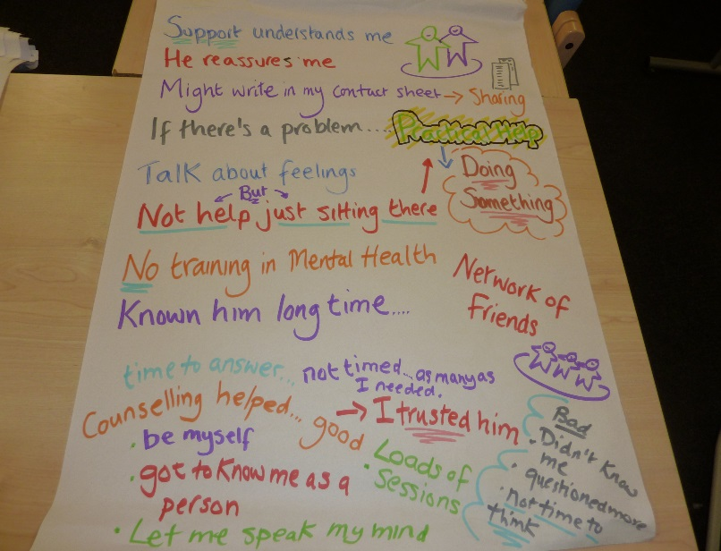One person shared that when beginning to feel unwell, the support worker will ask whether s/he is alright and will provide time and space. The support worker will find out any relevant background information and will speak to other support workers and friends to work out what has been happening. He always gets the person’s consent to ask other people and often comes back with the knowledge of what has been the trigger.

In addition, the support worker will write down what is happening in the person’s contact sheets so that other people providing support will know. This is always done with the permission of the person being supported.

In addition, the support worker does not simply talk about feelings but will also identify practical steps and actions that can be taken to address the issues that have acted as a trigger. For example, a housing issue that was causing concern was resolved by going out and finding potential solutions together. The combination of opportunities to talk about problems and practical help provided positive benefits. This respectful approach provides real reassurance and lets the person being supported know that others understand and know what they are going through.

* + - 1. Providing unhelpful support

One of the group shared the challenges of receiving support in a supported living environment. When having a hard time, the staff do not provide respectful support. They often ask lots of questions about the past which seem irrelevant and the staff do not appear to listen to or understand the answers that are given. They do not understand that there are times when the person wants to be quiet and needs their own space.

One of the most important issues for this person is to understand the roles and relationships of the people who are important. This person has a very supportive family who provide great support alongside a network of friends from a local self-advocacy organisation. In addition, this person has a very positive relationship with their social worker. These are the people who offer the support that is needed. However, the support received from the staff at home is intrusive and pressurising and does not recognise any need for respect and privacy. This means that there can be difficult and angry interactions with staff which do not take into account the person’s point of view and leaves a feeling of being powerless and having no control.

Another member of the group lives alone and has support funded by a personal budget. This person shared how the support staff do not turn up sometimes which has a bad effect as having company is important. It can be difficult if any changes are made to the support arrangements without the involvement of the individual being supported. This person shared how it is important to have a backup plan of somewhere to go, people to meet and something to do in case the support staff do not turn up.

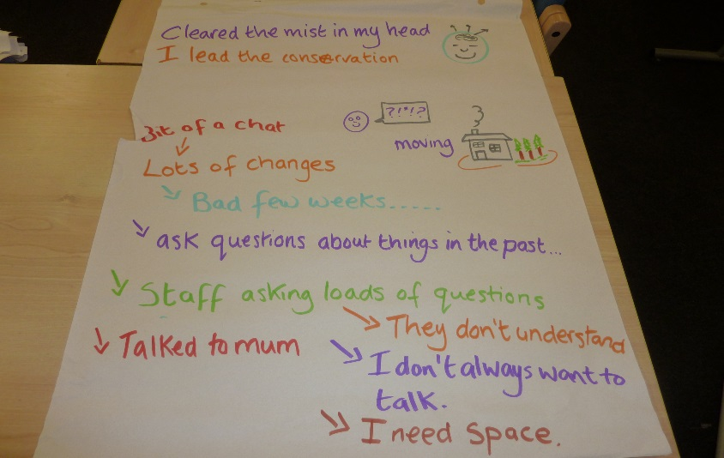This person tends to keep any feelings private and finds it irritating if support staff ask lots of questions. In fact, it is conversations with work colleagues that are helpful. In addition, having planned activities that are recorded on a calendar helps to reduce any anxiety or agitation. Having something planned for every day and written down provides the reassurance that this person requires. The group members agreed that having appointments and arrangements written down in a diary or on a calendar is a helpful and positive approach.

* + - 1. Talking therapies

The group members were very positive about talking therapies having helped them. However, it is clear that this works best when the professional is able to adapt their approach to meet the needs of a person with learning disabilities and is seen as someone who can be trusted and cares.

One of the group was able to compare and contrast the approach of two counsellors. One was found helpful because:

* He was very laidback
* He provided practical things to think about
* He gave time for the person to think before answering
* The input was not restricted – there could be as many sessions as were needed
* The person was allowed to lead the conversation
* The person was able to be natural, say anything and swear (if necessary)
* The counsellor was not shocked by anything that was said and did not judge the person
* The counsellor helped the person to put things into perspective
* The counsellor learnt to know about the person and could be trusted

The other counsellor was seen as unhelpful because:

* He did not seem to want to know the person
* He asked questions all of the time and did not give thinking time for the answers
* Only provided a set number of sessions that were time limited
* Kept cancelling and rearranging the appointments

Other group members talked about the need to have time to think about and prepare for counselling sessions. The importance of continuity and trust was consistently raised during our discussions. Group members were very clear that they could only share their experiences and feelings with people that they trust and like. Changes in known professionals such as GPs and social workers can have a massive impact. This can be further reinforced if the professional gives the impression that they have not prepared for meeting someone with a learning disability and does not understand them or their life experience.

* + - 1. Technology

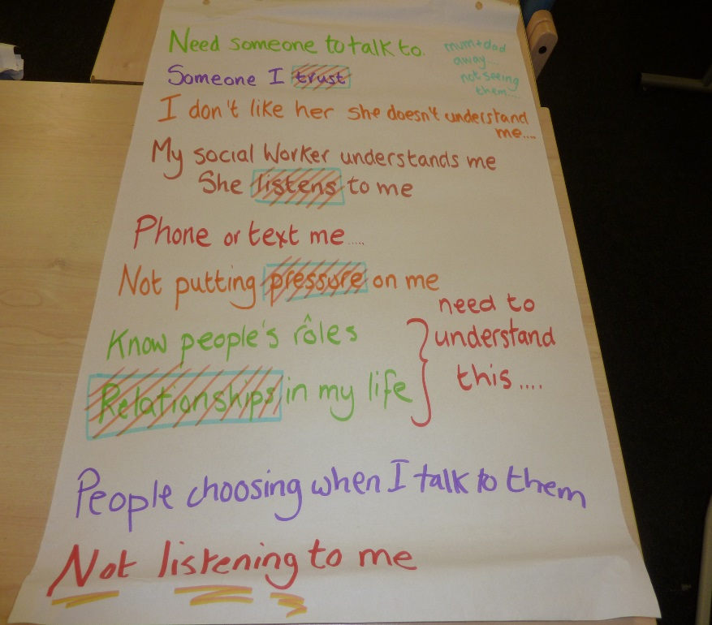The group discussed whether obtaining support over the telephone or internet would meet their support needs. The group were unanimous in wanting to have direct support through personal contact when this was needed. Seeing someone was seen as very important and whilst the use of technology could supplement direct support, it was felt that it could not replace it.

* + - 1. Preparing to work with professionals

The group talked about the importance of preparing for meetings with professionals. Group members talked about writing down what they wanted to say and welcomed the opportunity to practice with their support staff, family or friends. This helped them to manage their anxieties and to make sure that they have some control over the discussion.

The group discussed how when they were well, it was important to ensure that they developed information that they would want to share with professionals. Ideally, this would be as a one page profile/plan that was easy to understand, quick to read but contained what were the most important things to know about the person. This should also include the signs to look for when having a good day and the signs to look for when having a bad 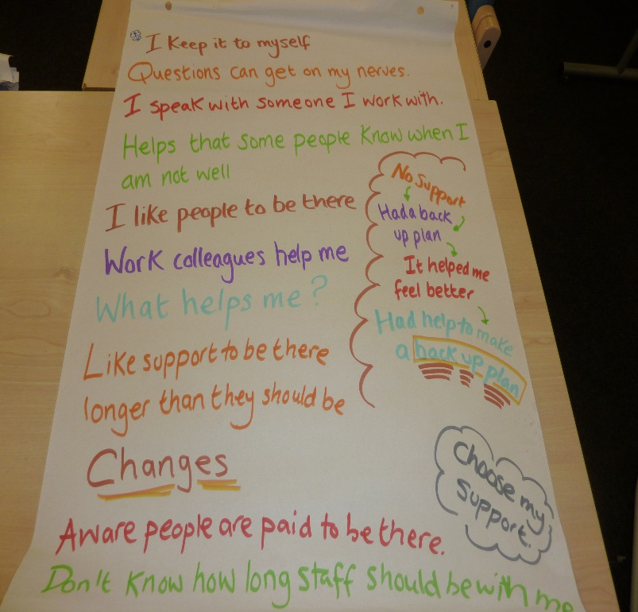day. It should also outline what would be the agreed actions to be taken if/when a person became mentally unwell.

* + - 1. The importance of family and friends

Whilst much of the discussion focused on professional support, a consistent theme was how family and friends provided very important support.

Families often identified the early signs and provided real support to obtain the best treatment options. They often provided ongoing care and support and stood alongside their son/daughter as the expert in terms of their knowledge and experience. It was clear that sometimes families were not always encouraged to be involved by professionals or direct care staff.

The group talked about how they benefitted by not living with their immediate family but gained from living close enough to spend time with them on a regular basis and especially for support. There was a clear appreciation of the freedom offered by people living in their own home and living their own lives.

Some of the group members talked about how they had developed five or six very strong friendships as a result of being part of a local self-advocacy organisation. Such friendships had grown because of the many things that they have in common with each other including their mutual experiences of having learning disabilities. They can look out for each other, make sure that people do not feel isolated and ensure that their physical, emotional and mental health needs are addressed. They talked about recently planning a 40th birthday party which provided a real life project which gave them all a sense of responsibility and achievement.

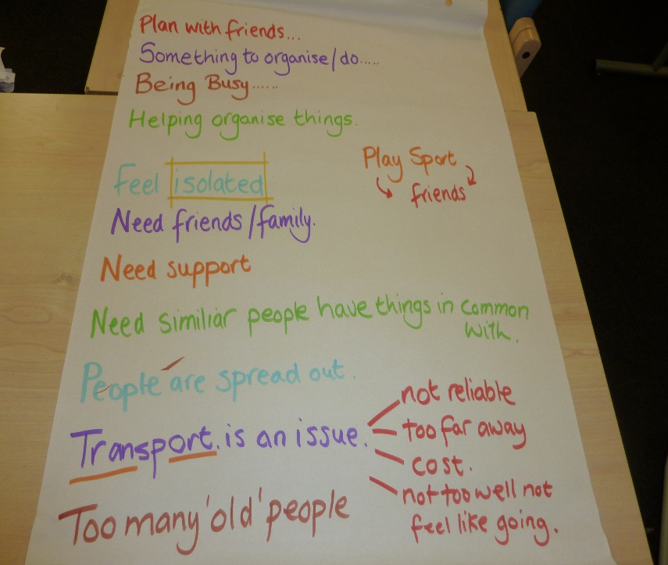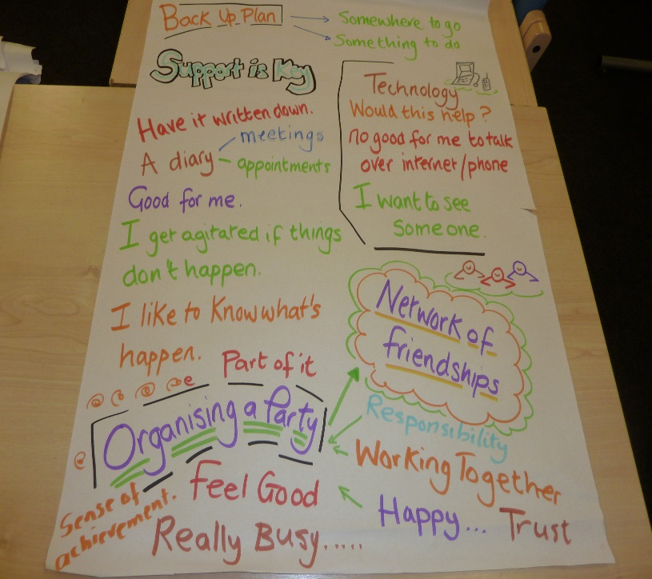The group also talked about the difficulties of finding friends if you live in a rural area where there are less opportunities to meet and where getting anywhere is dependent upon unreliable and costly transport. Isolation needs to be addressed in individual care plans including practical ways of developing friendships and relationships in the local community.

* + - 1. Speaking up and self-advocacy groups

The group members talked very positively about the difference that being active members of self-advocacy groups had made to their lives. In addition to the sustaining friendships that had been made, people talked about how the groups had proved very important for their mental health as their self-confidence and self-belief had grown. They had the opportunity to talk about a wide range of issues that affect their lives on a daily basis and to practice “speaking up.” This has meant that they are more confident and this has a direct impact on sustaining their mental health. It also means that they can cope better and talk more confidently to mental health professionals if they have to.

* + - 1. Getting the right treatment

The group members talked about the importance of having a range of treatment options that includes medication and counselling/talking therapies but also includes lifestyle choices including diet, exercise, activities and the opportunity for group work.

In terms of practical support, group members talked about getting the right balance of family, friends, paid support and other support including community links and self-advocacy. The challenge is to get all of these to fall into place at the right time.

* + - 1. 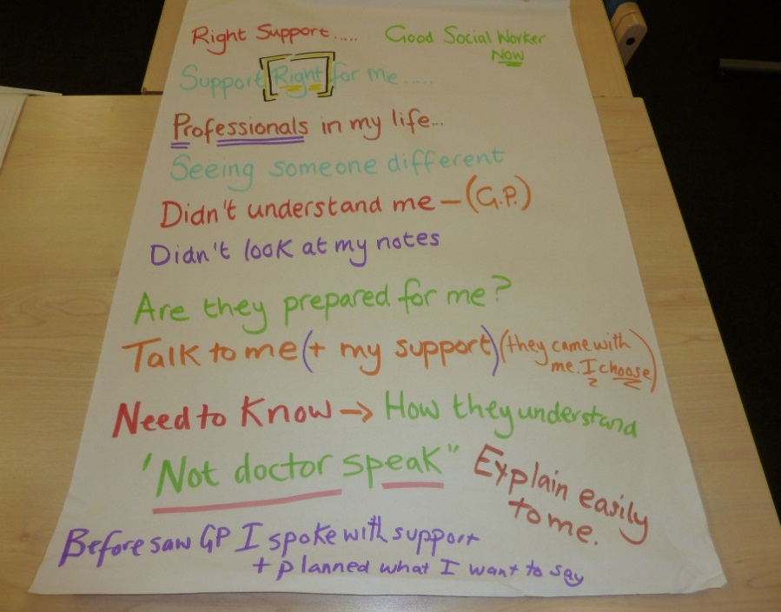Teaching people about learning disability

The group members felt that there is a need to raise awareness and understanding about learning disability throughout the mental health system and including the police. In particular, they want issues about communication addressed so that professionals know how to explain things better and to provide accessible information.

* + - 1. What do people with a learning disability need to know about mental health?

Everyone agreed that there needs to be a wider education about mental health and that this needs to be addressed in schools and colleges. One of the most important questions to be answered is how do you know if you have a mental health problem?

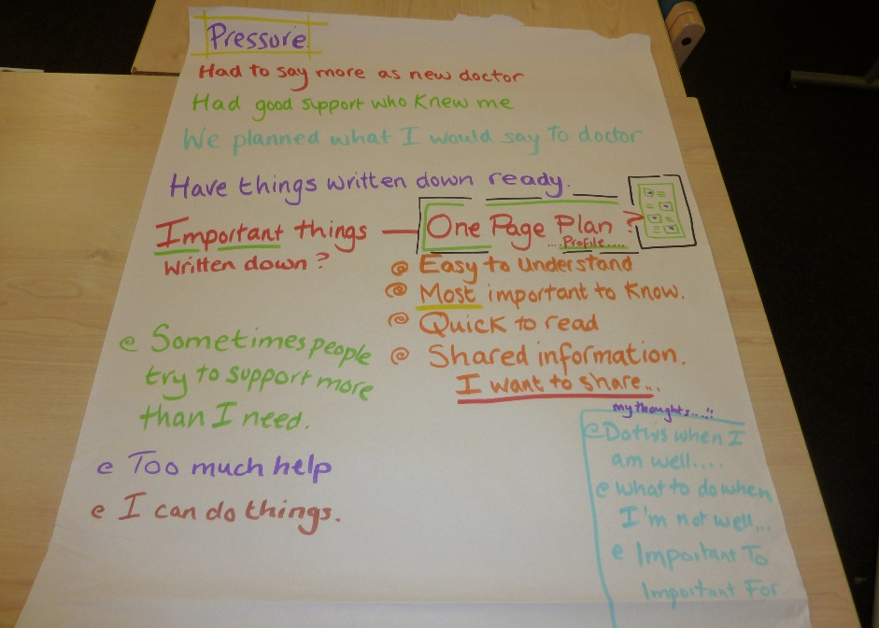Group members wanted people to know about how it feels to be unwell, what to do and where to go to get help and support. One of the group said that people should not be frightened of crying.

It was recognised that most people would start by visiting their GP. It was felt that a simple information leaflet should be available that contains the contact numbers. People should understand that they could ask to see a male or a female doctor and also that they could have someone accompanying them. It is important that people feel as comfortable as possible when they visit their GP and it would be good if their doctor had a copy of the person’s one page profile/shared information included in their medical notes.

* + - 1. Advice for GPs

The group members recognised that not all GPs are experienced in working positively with people with learning disabilities. There can be a danger that they miss the mental health symptoms because they are concentrating on the learning disabilities. It was felt that specific questions should be asked about a person’s mental health each time they visited their GP.

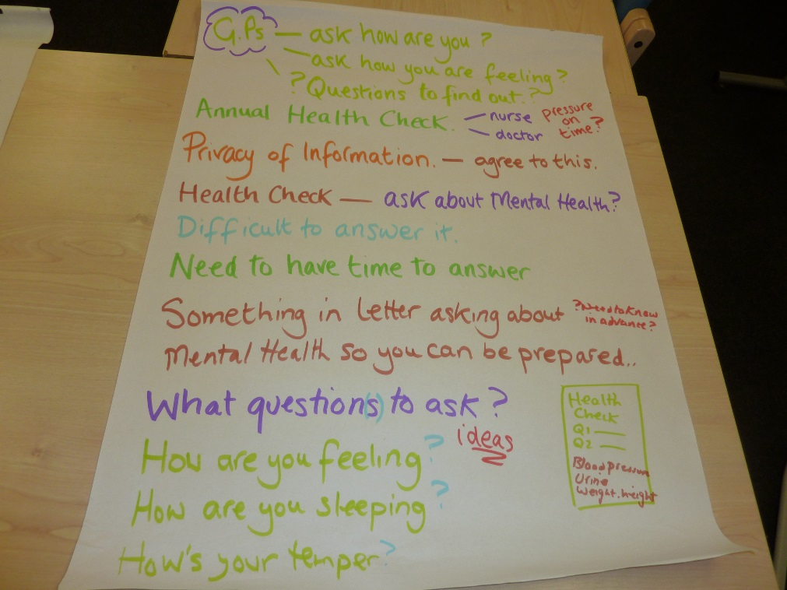Group members felt that the annual health check offered an opportunity to ask about mental health issues. There was some concern as to whether time pressures would allow this to happen. It was felt that people should come prepared to answer questions about their mental health so this would need to be mentioned in the invitation letter for the annual health check.

Group members suggested that possible questions for GPs to ask could include “how are you feeling?”, “how are you sleeping?” and “how is your temper?”

The group members stressed that it was very hard to admit to having a mental health problem and that their experience was that even if this was shared with the GP, then there were long waiting lists for support and treatment.

Addendum V.3.1 – meeting agenda

Developing the NICE Clinical Guideline for Mental Health Problems and Learning Disabilities, 29 September 2015

Agenda

|  |  |  |
| --- | --- | --- |
|  |  | Arrival – Coffee and refreshments |
|  |  | Welcome and introductions |
|  |  | Recapping the key points from the first two meetings |
|  |  | Group Discussion – Treatment, becoming well and staying well |
|  |  | Group Discussion –  What do mental health staff need to know about people with learning disabilities? |
|  |  | Group Discussion – What are the most important things for older people with learning disabilities to know about mental health? |
|  |  | Lunch |
|  |  | Sharing what has been discussed |
|  |  | Any other things to say? |
|  |  | What happens next? |
|  |  | Thank you and goodbye |

Between 2 and 2.30, there will be a chance to for people to share their views as a video diary.

Addendum V.3.2 – PowerPoint presentation

