Appendix O: Clinical evidence – forest plots for all studies

A.1 Measures to assess mental health needs among people with learning disabilities 4
A.1.1 General measures of mental health 4
A.1.1.1 Mood and Anxiety Semi-Structured Interview (MASS) 4
A.1.1.2 Psychiatric Assessment Schedule for Adults with Developmental Disabilities (PAS-ADD) – Interview 6
A.1.1.3 Psychiatric Assessment Schedule for Adults with Developmental Disabilities (PAS-ADD) – Checklist 7
A.1.1.4 Psychiatric assessment schedule for adults with developmental disabilities (PAS-ADD) – Mini 8
A.1.1.5 Comparison between different tools used to identify mental health problems in adults with learning disabilities 10
A.1.2 Dementia 12
A.1.2.1 Dementia Screening Questionnaire for Individuals with Intellectual Disabilities (DSQIID), Dementia Questionnaire for Mentally Retarded (DMR) and Down Syndrome Dementia Scale (DSDS) 12
A.2 Psychological interventions 14
A.2.1 Mixed mental health problems 14
A.2.1.1 Mild to moderate learning disabilities 14
A.2.2 Substance misuse 16
A.2.2.1 Unclear level of learning disabilities 16
A.2.3 Anxiety disorders 16
A.2.3.1 Anxiety symptoms 16
A.2.3.1.1 Mild to moderate learning disabilities 16
A.2.3.1.2 Moderate to severe learning disabilities 17
A.2.3.2 Social anxiety symptoms 18
A.2.3.2.1 Mild to moderate learning disabilities 18
A.2.3.3 Post-traumatic stress disorder 19
A.2.3.3.1 Mild learning disabilities 19
A.2.4 Depressive symptoms 19
A.2.4.1 Mild to moderate learning disabilities 19
A.2.5 Sexually inappropriate behaviour 22
A.3 Parent training interventions aimed at reducing and managing behaviour that challenges 22
A.3.1 Parent training versus any control 22
A.4 Pharmacological interventions for prevention and/or treatment 23
A.4.1 Attention deficit hyperactivity disorder in children and young people 23
A.4.2 Dementia 27
A.5 Other interventions 30
A.5.1 Annual health checks 30
A.5.2 Dietary interventions 31
A.5.2.1 ADHD 31
A.5.2.2 Unclear level of learning disabilities 31
A.5.2.3 Dementia 32
A.5.2.3.1 Mild to moderate learning disabilities 32
A.5.3 Exercise interventions 33
A.5.3.1 Anxiety symptoms 33
A.5.3.1.1 Mild to moderate learning disabilities 33
A.5.3.2 Depressive symptoms– mild to moderate learning disabilities 34
A.5.3.2.1 Mild to moderate learning disabilities 34
A.6 Organising health care services for people with intellectual disabilities 34
A.6.1 Innovative intensive support services model versus standard model of service delivery 34
A.6.2 Assertive community treatment versus standard model 35
A.6.3 Specialist liaison worker model versus no liaison worker 36
A.7 Interventions aimed at improving the health and well-being of carers of people with learning disabilities 37

Abbreviations
AAMD American Association for Mental Deficiency (now American Association on Intellectual and Developmental Disabilities)
ABA applied behaviour analysis
ADHD attention deficit hyperactivity disorder
A-PS assertiveness training, followed by social problem solving
BDI Beck Depression Inventory
CBT cognitive behavioural therapy
CI confidence interval
DC-LD Diagnostic Criteria for Psychiatric Disorders for Use with Adults with Learning Disabilities/mental Retardation
DMR Dementia Questionnaire for Mentally Retarded
DSDS Down Syndrome Dementia Scale
DSM-IV Diagnostic and Statistical Manual of Mental Disorders (4th edition)
DSQIID Dementia Screening Questionnaire for Individuals with Intellectual Disabilities
FN false negatives
FP false positives
GHQ30 General Health Questionnaire (30 item)
ICD-10 International Statistical Classification of Diseases and Related Health Problems (10th edition)
IV Inverse variance method
MASS Mood and Anxiety Semi-structured Interview
M-H Mantel-Haenszel method
NADIID Neuropsychological Assessment of Dementia in Intellectual Disabilities
PAS-ADD Psychiatric Assessment Schedule for Adults with a Developmental Disability
PS-A social problem solving, followed by assertiveness training
QoL quality of life
RCT randomised controlled trial
ROC receiver operating characteristic
SAS-ID Zung Self-rating Anxiety Scale for Adults with Intellectual Disabilities
SD standard deviation
SDQ Strengths and Difficulties Questionnaire
SE standard error
SF-12 Short Form Health Survey
SIB-R Severe Impairment Battery – Revised
SNAP-IV Swanson, Nolan and Pelham Questionnaire (version 4)
SSTP Stepping Stones Triple-P
STATE-A state anxiety
TAU treatment as usual
TN true negatives
TP true positives
TRAIT-A trait anxiety
VABS Vineland Adaptive Behaviour Scales
  - Measures to assess mental health needs among people with learning disabilities
    - General measures of mental health
      - Mood and Anxiety Semi-Structured Interview (MASS)
Figure 1: Sensitivity and specificity of the MASS for the detection of mental health problems among adults with learning disabilities
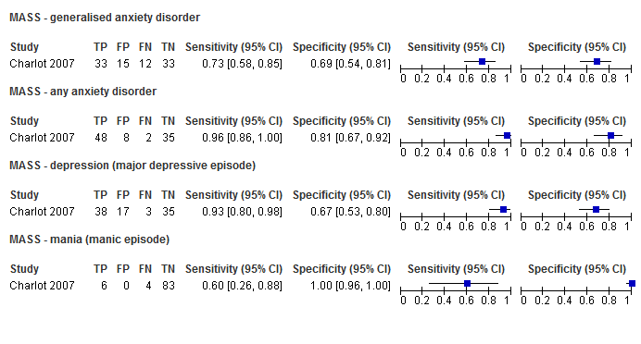

Figure 2: : ROC curve for MASS (DSM-IV reference standard)
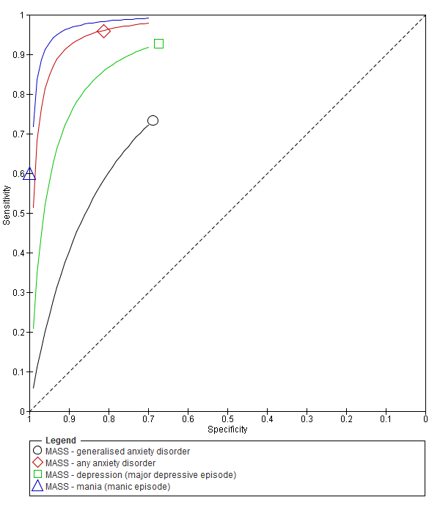

      - Psychiatric Assessment Schedule for Adults with Developmental Disabilities (PAS-ADD) – Interview
Figure 3: Sensitivity and specificity of the PAS-ADD Interview for detecting mental health problems in adults with learning disabilities
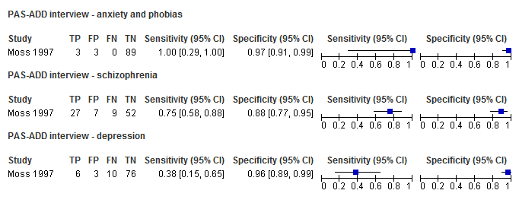

Figure 4: ROC curve for the PAS-ADD Interview (unclear reference standard)
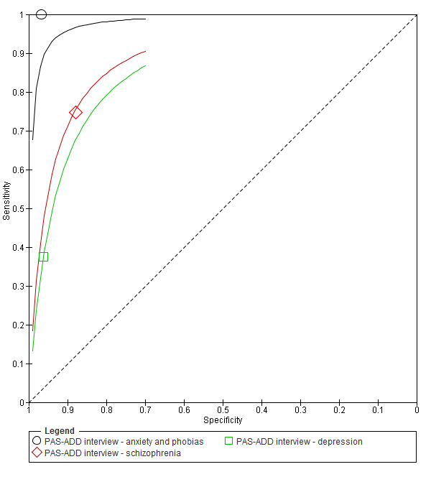

      - Psychiatric Assessment Schedule for Adults with Developmental Disabilities (PAS-ADD) – Checklist
Figure 5: Sensitivity and specificity of the PAS-ADD Checklist for the detection of mental health problems among adults with learning disabilities

Figure 6: ROC curve for the PAS-ADD Checklist (psychiatric [unspecified] reference standard)
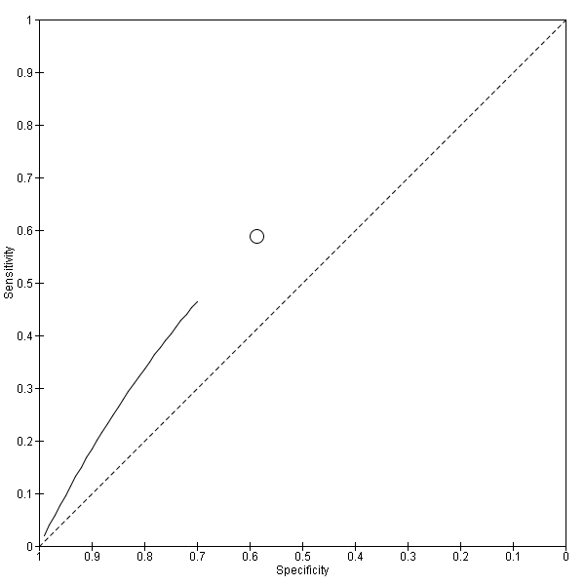

      - Psychiatric assessment schedule for adults with developmental disabilities (PAS-ADD) – Mini
Figure 7: Sensitivity and specificity of the Mini PAS-ADD for the detection of mental health problems in adults with learning disabilities
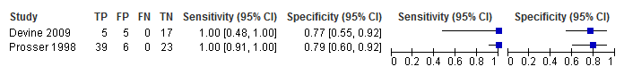

Figure 8: ROC curve for the Mini PAS-ADD (psychiatric diagnosis [unspecified] reference standard)
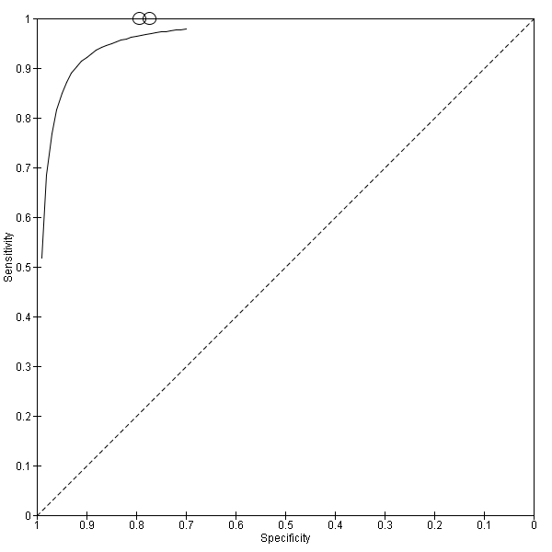
      - Comparison between different tools used to identify mental health problems in adults with learning disabilities
Figure 9: Sensitivity and specificity of different tools used to identify mental health problems in adults with learning disabilities
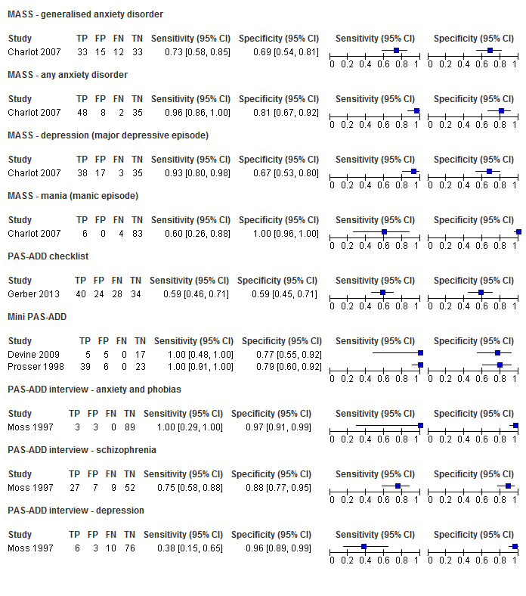

Figure 10: ROC curves for instruments designed to identify mental health problems in adults with learning disabilities
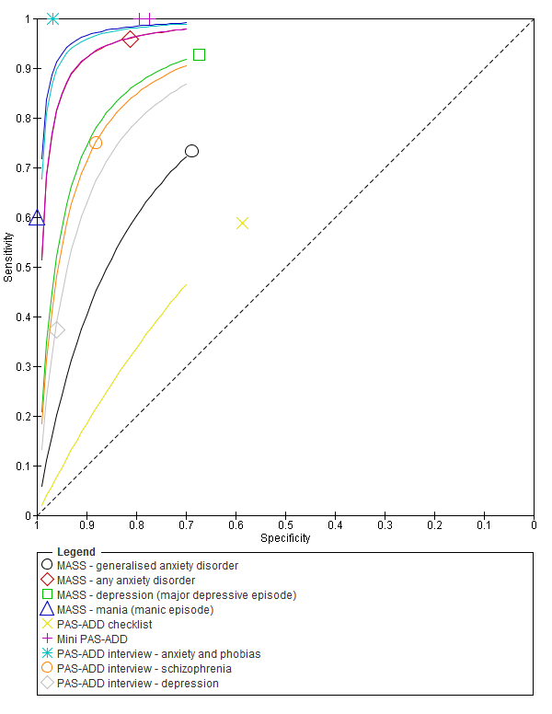

    - Dementia
      - Dementia Screening Questionnaire for Individuals with Intellectual Disabilities (DSQIID), Dementia Questionnaire for Mentally Retarded (DMR) and Down Syndrome Dementia Scale (DSDS)
Figure 11: Sensitivity and specificity of the DSQIID, DMR and DSDS for detecting symptoms of dementia in people with learning disabilities
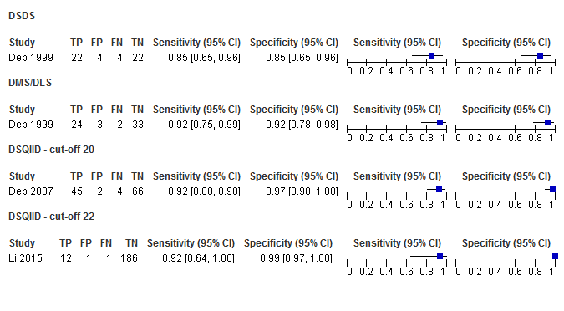

Figure 12: ROC curve for the DSQIID, DMR and DSDS (ICD-10 and DC-LD reference standards)
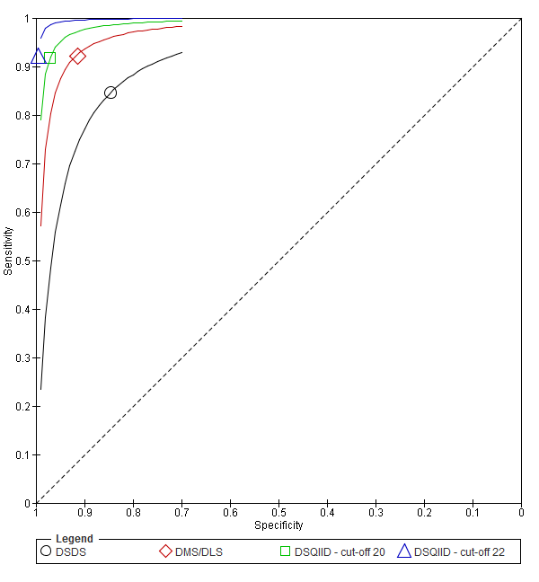

  - Psychological interventions
    - Mixed mental health problems
      - Mild to moderate learning disabilities
Figure 13: Psychological intervention versus control – mental health measured with various scales (RCTs) (after mean 13.25 weeks of treatment)
Various scales used including Overall fear rating, Nurses' Observation Scale for Inpatient Evaluation (NOSIE-30), Brief Symptom Inventory; random-effects model used because of unexplained heterogeneity

Figure 14: Psychological intervention versus control – mental health (Brief Symptom Inventory: Global Severity Index) (controlled before-and-after studies) (after 12 weeks of treatment)

Figure 15: Psychological intervention versus control – low problem behaviour ( Role-play test of anger arousing situations) (after 10 weeks of treatment)
Figure 16: Psychological intervention versus control – maladaptive functioning (Adaptive behaviour scale - revised - part II (carer) (after 10 weeks of treatment)
Figure 17: Psychological intervention versus control – adaptive functioning -interpersonal skills (Social performance survey schedule) (after 18 weeks of treatment)
Figure 18: Social problem solving then assertiveness training versus assertiveness training followed by social problem solving – mental health (Brief Symptom Inventory) (after 3 months’ follow-up)
Figure 19: Social problem solving then assertiveness training versus assertiveness training followed by social problem solving – maladaptive behaviour (Adaptive Behavior Scale-Revised) (after 3 months’ follow-up)
Figure 20: Social problem solving then assertiveness training versus assertiveness training followed by social problem solving – adaptive behaviour (problem-solving task) (after 3 months’ follow-up)
Figure 21: Social problem solving then assertiveness training versus assertiveness training followed by social problem solving – low problem behaviour (role-play test of anger arousing situations) (after 3 months’ follow-up)
    - Substance misuse
      - Unclear level of learning disabilities
Figure 22: Psychological intervention versus control – alcohol abuse (after 34 weeks’ follow-up)
Figure 23: Assertiveness versus modelling – alcohol abuse (after 34 weeks’ follow-up)
    - Anxiety disorders
      - Anxiety symptoms
        - Mild to moderate learning disabilities
Figure 24: Any psychological intervention versus control – anxiety symptoms (various scales) (RCTs) (42 weeks follow-up)
Various scales used – modified Beck’s anxiety inventory and modified Zung anxiety scale; random-effects model used because of unexplained heterogeneity

Figure 25: Any psychological intervention versus control – anxiety symptoms (Brief Symptom Inventory: anxiety symptom dimension) (controlled before-and-after study) (12 weeks follow-up)

Figure 26: Any psychological intervention versus control – in employment after treatment (16 weeks after treatment)

Figure 27: Any psychological intervention versus control – hours per week in paid employment after treatment (16 weeks after treatment)
Figure 28: Any psychological intervention versus control – hours per week in voluntary work after treatment (16 weeks after treatment)

        - Moderate to severe learning disabilities
Figure 29: Group relaxation training versus control – anxiety symptoms on various scales (after treatment – 2.29 weeks or unclear)
Various scales used – Behavioural anxiety scale and modified Zung anxiety scale; SMD estimated from t-value for Lindsay 1989

Figure 30: Individual relaxation training versus control – anxiety symptoms on Behavioural anxiety scale (after treatment – 2.29 weeks)
SMD estimated from t-value; random-effects model used because of unexplained heterogeneity.

      - Social anxiety symptoms
        - Mild to moderate learning disabilities
Figure 31: Dating skills programme versus control – mental health (social anxiety symptoms) (24 weeks’ follow-up)
Figure 32: Dating skills programme versus control – mental health: significant change in anxiety symptoms (20 weeks’ follow-up)
      - Post-traumatic stress disorder
        - Mild learning disabilities
Figure 33: CBT versus applied behavioural analysis – mental health/problem behaviour/adaptive behaviour (teacher-rated Achenbach subscale); unclear follow-up
    - Depressive symptoms
      - Mild to moderate learning disabilities
Figure 34: CBT versus control – depressive symptoms (BDI) (from 6 to 42 weeks)

Figure 35: CBT versus control – depressive symptoms (various scales) (from 12 to 46.7 weeks)
Various scales used including BDI, GDS-LD, and depression subscale on Brief Symptom Inventory Source

Figure 36: CBT versus control – at least small improvement in depressive symptoms (on BDI) (RCT) (12 weeks)
Figure 37: CBT versus control – problem behaviour (SIB-R) (controlled before-and-after) (23 weeks)

Figure 38: CBT versus control – social skills (adaptive functioning) (Social comparison scale) (RCT) (6-12 weeks)
Figure 39: CBT versus control – social behaviours (adaptive functioning) (controlled before-and-after) (23 weeks)
Figure 40: CBT versus behavioural strategies only – depressive symptoms (BDI) (38 weeks)
Figure 41: CBT versus behavioural strategies only – improvement in those with clinical depression at baseline (reduced score on Beck Depression Inventory II) (38 weeks)
Figure 42: CBT versus behavioural strategies only – recovery in those with clinical depression at baseline (score 13 or less on Beck Depression Inventory II) (38 weeks)
Figure 43: CBT versus cognitive strategies only – depressive symptoms (BDI) (38 weeks)
Figure 44: CBT versus cognitive strategies only – improvement in those with clinical depression at baseline (reduced score on Beck Depression Inventory II) (38 weeks)
Figure 45: CBT versus cognitive strategies only – recovery in those with clinical depression at baseline (score 13 or less on Beck Depression Inventory II) (38 weeks)
    - Sexually inappropriate behaviour
Figure 46: Psychodynamic psychotherapy versus no treatment – recidivism

  - Parent training interventions aimed at reducing and managing behaviour that challenges
Figure 47 was amended from the challenging behaviour guideline and has therefore been included in this appendix. However for all other forest plots relating to the effectiveness of parent training please refer to the appropriate appendix in the challenging behaviour guideline.
    - Parent training versus any control
Figure 47: Mental health (severity) (various scales)– post-treatment
Various scales included DBC-total score, CBCL – total score, Parent Symptom Questionnaire, SDQ – total score, Home Situations Questionnaire (severity), ECBI – problem subscale, 2 studies did not report a total score on the DBC so the disruptive behaviour score was used; <Insert Source text here>

  - Pharmacological interventions for prevention and/or treatment
    - Attention deficit hyperactivity disorder in children and young people
Figure 48: Methylphenidate versus placebo – mental health (ADHD at 16 weeks measured with the Conners ADHD Index)

Figure 49: Methylphenidate versus placebo – mental health (hyperactivity at 16 weeks measured with the Conners hyperactivity scale)

Figure 50: Methylphenidate versus placebo – mental health (hyperactivity at 16 weeks measured with Aberrant Behavior Checklist)

Figure 51: Methylphenidate versus placebo – mental health (‘improved' or 'better' on Clinical Global Impressions scale at 16 weeks)
Figure 52: Methylphenidate versus placebo – side effects (weight loss at 16 weeks in kg)
Figure 53: Methylphenidate versus placebo – side effects (trouble falling asleep at 16 weeks)
Figure 54: Methylphenidate versus placebo – side effects (poor appetite at 16 weeks)
Figure 55: Methylphenidate versus placebo – side effects (looks sad/miserable at 16 weeks)

Figure 56: Methylphenidate versus placebo – side effects (crying at 16 weeks)
Figure 57: Methylphenidate versus placebo – side effects (looks anxious at 16 weeks)
Figure 58: Methylphenidate versus placebo – side effects (meaningless repetitive behaviour at 16 weeks)
Figure 59: Methylphenidate versus placebo – side effects (talks less with other children at 16 weeks)

Figure 60: Clonidine versus placebo – mental health (ADHD symptoms on Conners ADHD Parent scale at 6 weeks)

Figure 61: Clonidine versus placebo – mental health (ADHD symptoms on Clinical Global Impression Scale at 6 weeks)
Figure 62: Clonidine versus placebo – mental health (much or very much improved ADHD symptoms on Clinical Global Impression Scale at 6 weeks)
Figure 63: Risperidone versus methylphenidate – ADHD symptoms (measured on SNAP-IV total score at 4 weeks)
SMD estimated from F-value

Figure 64: Risperidone versus methylphenidate – side effects (measured on Barkley’s Side Effects Rating Scale at 4 weeks)
SMD estimated from F-value

Figure 65: Risperidone versus methylphenidate – side effects (vomiting) (4 weeks)

Figure 66: Risperidone versus methylphenidate – side effects (galactorrhea) (4 weeks)

    - Dementia
Figure 67: Donepezil versus placebo (prevention) – cognitive abilities (Severe Impairment Battery; 12 weeks)

Random-effects model used as significant unexplained heterogeneity
Figure 68: Donepezil versus placebo (prevention) – behavioural problems (various scales; 12 weeks)
Various scales used included Scales of Independent Behavior-Revised (SIB-R) and Vineland Adaptive Behaviour Scale
Figure 69: Donepezil versus placebo (prevention) – adverse events (12 weeks)

Figure 70: Donepezil versus placebo (treatment) – cognitive abilities (Severe Impairment Battery; 24 weeks)
Figure 71: Donepezil versus placebo (treatment) – behavioural problems (24 weeks)
Figure 72: Donepezil versus placebo (treatment) – global functioning (proportion with improved impression of QoL) (24 weeks)

Figure 73: Donepezil versus placebo (treatment) – adverse events (24 weeks)

Figure 74: Memantine versus placebo (prevention or treatment) – cognitive abilities (various scales, 16-52 weeks)
Figure 75: Memantine versus placebo (prevention or treatment) – behavioural problems (various scales, 16-52 weeks)
Figure 76: Memantine versus placebo (prevention or treatment) – adverse events (16-52 weeks)
Figure 77: Simvastin versus placebo (prevention or treatment) – cognitive abilities (NADIID battery; 52 weeks) –
Figure 78: Simvastin versus placebo (prevention or treatment) – cognitive abilities (NADIID battery; 52 weeks) (adjusted for baseline and stratification values)
Figure 79: Simvastin versus placebo (prevention or treatment) – adaptive functioning (52 weeks)
Figure 80: Simvastin versus placebo (prevention or treatment) – adaptive functioning (52 weeks) (adjusted for baseline and stratification values)
  - Other interventions
    - Annual health checks
Figure 81: Annual health checks versus treatment as usual – Identification of mental health needs (all levels of learning disabilities) (Mental health) (39 weeks)
Figure 82: Annual health checks versus treatment as usual – Newly detected health issues (all levels of learning disabilities) (Quality of life) (range 39 to 52 weeks)
Overall OR reported rather than RR as one study only reported the OR only and the RR was not calculable
Figure 83: Annual health checks versus treatment as usual – Newly detected health monitoring and health promotion needs (all levels of learning disabilities) (Quality of life)
(39 weeks)
Overall OR reported rather than RR as one study only reported the OR only and the RR was not calculable
Figure 84: Annual health checks versus treatment as usual – Obesity (Identification of health needs; all levels of learning disabilities) (Quality of life) (39 to 52 weeks)
Random-effects model used because of unexplained heterogeneity.
    - Dietary interventions
      - ADHD
      - Unclear level of learning disabilities
Figure 85: L-acetylcarnitine versus placebo for the treatment of ADHD in children with Fragile X syndrome – ADHD symptoms (mental health; Conners’ Parents; 52 weeks)
Figure 86: L-acetylcarnitine versus placebo for the treatment of ADHD in children with Fragile X syndrome – ADHD symptoms (mental health; Conners’ Teachers; 52 weeks)
Figure 87: L-acetylcarnitine versus placebo for the treatment of ADHD in children with Fragile X syndrome – adaptive functioning (VABS – full scale; 52 weeks)
Figure 88: L-acetylcarnitine versus placebo for the treatment of ADHD in children with Fragile X syndrome – adaptive functioning (VABS – socialisation scale; 52 weeks)

      - Dementia
        - Mild to moderate learning disabilities
Figure 89: Antioxidant versus placebo for the treatment of dementia in people with Down’s syndrome – cognitive abilities (mental health; 2 year follow-up)
Direction of effect not reported in study (only the mean difference in change scores) and author not contactable so the direction of effect was assumed. However, the paper reported that there was no significant difference between groups on these measures.
Figure 90: Antioxidant versus placebo for the treatment of dementia in people with Down’s syndrome – adaptive functioning (2 year follow-up)

Figure 91: Antioxidant versus placebo for the treatment of dementia in people with Down’s syndrome – Any serious adverse events (incapacitation and/or inability to sustain daily activities: 2 year follow-up)
Assuming no events among missing data (intention-to-treat analysis).

    - Exercise interventions
      - Anxiety symptoms
        - Mild to moderate learning disabilities
Figure 92: Exercise versus painting control – Trait anxiety (self-report; TRAIT-A, 12 weeks)
Figure 93: Exercise versus painting control – State anxiety (self-report; STATE-A, 12 weeks)
Figure 94: Exercise versus painting control – Anxiety symptoms (self-report; Zung anxiety SAS-ID, 12 weeks)

      - Depressive symptoms– mild to moderate learning disabilities
        - Mild to moderate learning disabilities
Figure 95: Exercise versus painting control – Depressive symptoms (Zung self-rating depression scale, 12 weeks)
Figure 96: Exercise + education versus no treatment – Depressive symptoms (Child depression inventory; 12 weeks)
Figure 97: Exercise + education versus no treatment – Community participation and meaningful occupation (Community Integration Scale; 12 weeks)
Figure 98: Exercise + education versus no treatment – Quality of life (Life Satisfaction Scale; 12 weeks)

  - Organising health care services for people with intellectual disabilities
    - Innovative intensive support services model versus standard model of service delivery
Figure 99: Impact on maladaptive behaviour (AAMD scale)

Figure 100: Impact on adaptive behaviour (AAMD scale)

Figure 101: Impact on maladaptive behaviour (Michigan maladaptive behaviour scale)

Figure 102: Effect on a move to more staff intensive day or residential programming
    - Assertive community treatment versus standard model
Figure 103: Global assessment of function (symptomatology) – follow-up
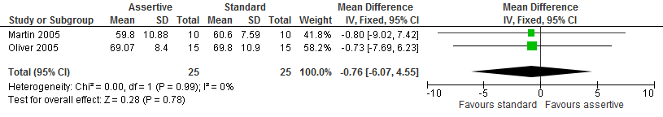

Figure 104: Global assessment of function (Disability) – follow-up
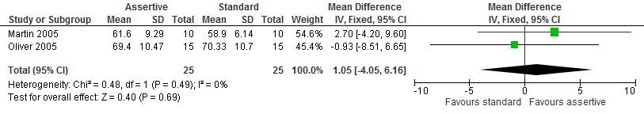

Figure 105: Carer uplift or burden – follow-up
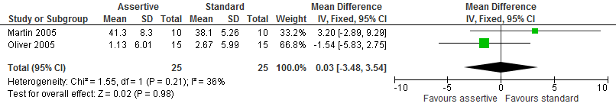

Figure 106: Quality of life – follow-up
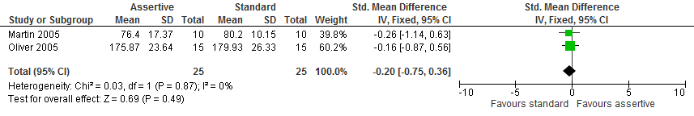
    - Specialist liaison worker model versus no liaison worker
Figure 107: Mental health (SDQ score) – follow-up
SMD estimated from p-value
Figure 108: Carer quality of life (SF12-physical score; ANOVA) – follow-up
SMD estimated from p-value

Figure 109: Carer quality of life (SF12-mental health score) – follow-up
SMD estimated from p-value

Figure 110: Carer mental health (GHQ30 score) – follow-up
SMD estimated from p-value

Figure 111: Frequency of contact with services – follow-up
SMD estimated from p-value

  - Interventions aimed at improving the health and well-being of carers of people with learning disabilities
For all forest plots relating to the effectiveness of interventions aimed at improving the health and well-being of carers of people with learning disabilities please refer to the appropriate appendix in the challenging behaviour guideline.

