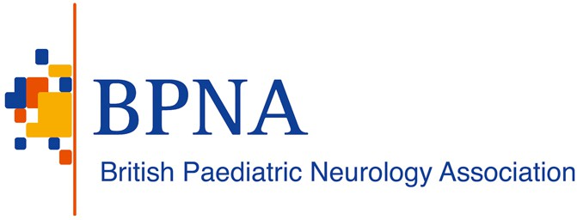

2 May 2024

Dr Mark Chakravarty
Lead Non-executive Director NICE Appeals – Technology Appraisals and Highly Specialised Technologies
National Institute for Health and Care Excellence 2nd Floor
- Redman Place London
E20 1JQ
Dear Dr Chakravarty,

Re: Final Appraisal Determination – Fenfluramine for treating seizures associated with Lennox-Gastuat Syndrome in people 2 years and over (ID1651)
The British Paediatric Neurology Association (BPNA) would like to appeal against the Final Appraisal Determination for the above mentioned technology appraisal on the following grounds:

Ground one: In making the assessment that preceded the recommendation, NICE has either:
- failed to act fairly
- exceeded its powers
Ground two: The recommendation is unreasonable in the light of the evidence submitted to NICE.

Ground 1a: In making the assessment that preceded the recommendation, NICE has: failed to act fairly

1a.1 Large unmet need in patients with Lennox-Gastaut syndrome
The majority of patients with LGS have pharmacoresistant epilepsy and fail to respond to current standard of care antiseizure medication and non- pharmacological therapies such as ketogenic diet and vagus nerve stimulation (VNS). They continue to have disabling seizures resulting in injuries (due to drop seizures), need for emergency rescue medication and frequent hospital visits for seizure management, having a huge impact on their quality of life. This is in addition to the increased risk of sudden unexpected death in epilepsy (SUDEP). There is

therefore an urgent need for newer therapeutic options for seizure management to improve quality of life and reduce the risk of SUDEP. Cannabidiol with clobazam has recently been recommended by NICE as an option for treating seizures associated with Lennox–Gastaut syndrome in people aged 2 years and older.
However, a large proportion of people will continue to have disabling seizures and treatment options are necessary for those who do not respond to and/or tolerate cannabidiol with clobazam. The data from RCTs suggest that the efficacy and tolerability to fenfluramine is comparable to cannabidiol with clobazam. Therefore, not recommending fenfluramine for treatment of seizures in LGS raises concerns about inequality to access effective therapies in these patients with already limited treatment options and compromised quality of life.

We would also like to highlight that the British Paediatric Neurology Association (BPNA), a key stakeholder, was not given an opportunity to contribute to the discussions, despite repeated requests.

Ground 2: The recommendation is unreasonable in the light of the evidence submitted to NICE

The Appraisal Committee’s refusal to recommend the use of fenfluramine for treatment of seizures in patients with Lennox-Gastaut syndrome cannot reasonably be justified in the light of the evidence submitted

While the Appraisal Committee acknowledges that evidence from a clinical trial shows that people who have fenfluramine have fewer drop seizures per month than people who have standard care without cannabidiol plus clobazam, it deems this evidence insufficient to make a recommendation because there is no direct comparison between fenfluramine and cannabidiol plus clobazam. We are uncertain about the feasibility of such a comparative randomised controlled trial. As clinicians, we find the data from clinical trials suggest the efficacy and tolerability of fenfluramine and cannabidiol plus clobazam comparable. We are uncertain about robustness and conclusion of indirect comparison of data from different RCTs between fenfluramine and cannabidiol plus clobazam and making a recommendation on the basis of this conclusion. We are concerned the committee may have overlooked nearly 60% reduction during the clinical trial and nearly 50% during OLE in the frequency of generalised tonic-clonic seizures, a key risk factor for SUDEP and impairing quality of life. We are also encouraged by the maintenance of comparable reduction in the frequency of drop and non-drop seizures during OLE. The data also shows clinically meaningful improvements in Clinical Global Impression of Improvement (CGI-I) scores during the clinical trial and OLE. Thus overall, the evidence suggests that the efficacy and tolerability of fenfluramine is comparable to that of cannabidiol plus clobazam in treatment of seizures in patients with LGS, and therefore would be a welcome treatment option for these patients with intractable epilepsy. In addition, unlike cannabidiol, fenfluramine does not need co-administration of clobazam, which can have its own tolerability issues.

Conclusion
In summary, the British Paediatric Neurology Association (BPNA) strongly recommends that Fenfluramine for treating seizures associated with Lennox-Gastuat Syndrome in people 2 years and over (ID1651) goes before a third NICE committee meeting with the specific aim of identifying a route for patients to access this treatment.

Sincerely,

XXXXXXXXXXXX XXXXXXXXXXXXX

XXXXXXXXX XXXXXXXXXX
Chair President
British Paediatric Epilepsy Group British Paediatric Neurology Association

