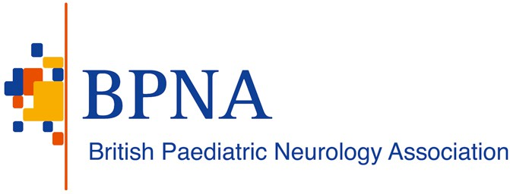

24 May 2024

Dr Mark Chakravarty
Lead Non-executive Director NICE Appeals – Technology Appraisals and Highly Specialised Technologies National Institute for Health and Care Excellence
2nd Floor
2 Redman Place London E20 1JQ

Dear Dr Chakravarty,

Re: Final Appraisal Determination – Fenfluramine for treating seizures associated with Lennox-Gastuat Syndrome in people 2 years and over (ID1651)

Thank you for your letter dated 10th May 2024 with comments on British Paediatric Neurology Association (BPNA) appeal against the Final Appraisal Determination for the above mentioned technology appraisal. Pleas find below our response to your comments:

Ground 1(a): In making the assessment that preceded the recommendation, NICE has failed to act fairly Appeal point 1(a).1: Large unmet need in patients with Lennox-Gastaut syndrome
I am not minded to refer this appeal point to the Appeal Panel.
I note all that you say regarding the large unmet need in patients with Lennox-Gastaut syndrome. In order to refer an appeal point to the Appeal Panel for determination, however, I need to be satisfied that the Committee has arguably failed to act fairly. The fact of there being an unmet need does not, per se, meet that test. I invite the BPNA to explain in its response, how in your view, the Committee acted unfairly in reaching its negative recommendation. You may find it helpful to refer to NICE's Guide to the technology appraisal and HST appeal process, which explains in section 4.3 what is required under Ground 1(a), as follows:
NICE is committed to following a fair process throughout the technology appraisal and highly specialised technologies process. An appellant who believes that an evaluation was not fair may appeal on this ground. This ground relates only to the fairness of the process followed and not to the content of the final draft guidance. It should be noted that if an appellant does not agree with final draft guidance this does not make it unfair. For example, although it is unfair to exclude relevant data from the technology appraisal and

highly specialised technologies evaluation process, it is not unfair to consider the relevant data but then reach a view with which the appellant did not agree.
This ground of appeal does not cover an argument that it is 'unfair' in a general sense, for example, that it is 'unfair' to patients not to recommend a treatment.
Unspecific allegations of unfairness, for example, an alleged inability to understand a conclusion, will not be accepted as a valid appeal point. Details and evidence must be provided in every case.
NICE requires appellants to explain what steps they took to promptly resolve any unfairness when they first became aware of it. The appeal panel may interpret the absence of any such steps, without sufficient reason, as evidence that there was in fact no such unfairness, or potentially as a reason not to refer guidance back to the committee or to request changes to guidance.
I also note with concern your statement that the BPNA "was not given an opportunity to contribute to the discussions, despite repeated requests".
NICE's Manual for health technology evaluations explains that NICE invites stakeholders including organisations representing healthcare professions to participate in technology evaluations. The BPNA was so invited and participated in this evaluation as a consultee. The Manual further explains (at 1.2.18 and 1.3.13) that professional organisations who are consultees should be invited to submit evidence and nominate clinical, patient and commissioning experts for the evaluation.
BPNA response:
It would be helpful for BPNA, a key stakeholder for matters relating to the management of children with neurological problems, to have clarity from NICE on how BPNA can participate in technology evaluations. Indeed, BPNA received an email from NICE to sign up to participate in technology evaluation for ID1651. One of BPNA members, an experienced Consultant Paediatric Neurologist with expertise in complex epilepsies, was nominated and completed the necessary paperwork, but was not given the opportunity to contribute. They received an email from NICE saying, “Whilst we acknowledge that you meet the criteria to be a clinical expert, we received multiple clinical expert nominations who were also qualified and nominated by other bodies. As we received more clinical expert nominations that would normally be invited to a committee meeting, we were unable to everyone who was nominated.” We can also confirm that the nominated expert was not asked to give written advice/evidence before the first meeting. The BPNA therefore has not had the opportunity to participate in this evaluation.
While BPNA appreciates NICE has to consider cost-effectiveness, comparable efficacy and tolerability of fenfluramine to that of cannabidiol plus clobazam, in a condition refractory to other medication, warrants further consideration. In particular, nearly 50% reduction in the frequency of generalised tonic-clonic seizures, a key risk factor for SUDEP and compromising quality of life, with fenfluramine during OLE, would justify fenfluramine as a treatment option for LGS patients refractory to other therapies.
In summary, the British Paediatric Neurology Association (BPNA) strongly recommends that Fenfluramine for treating seizures associated with Lennox-Gastuat Syndrome in people 2 years and over (ID1651) goes before a third NICE committee meeting with the specific aim of identifying a route for patients to access this treatment.
Sincerely,

XXXXXXXXXX XXXXXXXXXX

XX XXXXXXXXXXXX XXXXXXXXXXXXXX
Chair President
British Paediatric Epilepsy Group British Paediatric Neurology Association

