Important advice to staff supporting people with a learning disability or autistic people
Clinical guide for staff supporting patients with a learning disability, autism or both during the COVID-19 pandemic

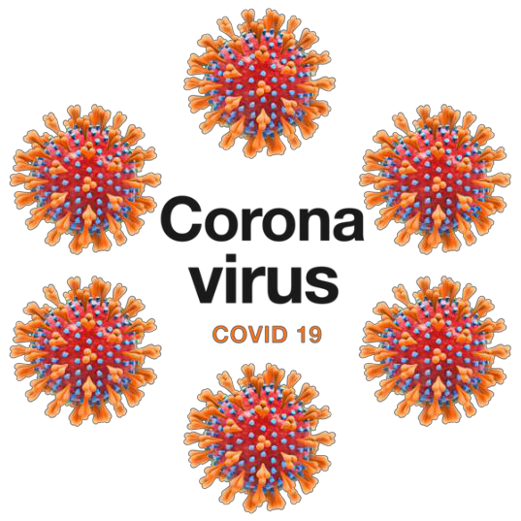 | COVID-19 is a new illness. Lots of people call it coronavirus.  It can affect your lungs and your breathing.
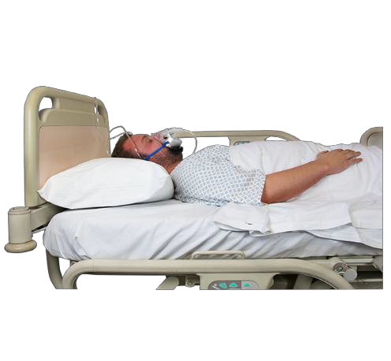 | There are some people who are very ill with coronavirus
 | They are being looked after in hospital by the NHS

This is making hospitals very busy but the NHS wants to keep everyone safe.

It is really important that everyone gets all of the right care and treatment they need at this time.

Lots more staff, including doctors, and volunteers are starting to work in the NHS to help make this happen.
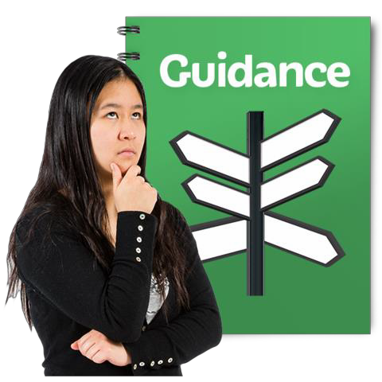 | The NHS has written a document to help all staff know more about supporting people with a learning disability or autistic people.

1. Staff should make sure they know the difference between your illness and your learning disability or autism.

This is to make sure you get the right treatment for your illness.
 | 2. Staff must follow the information on your hospital passport (if you have one).
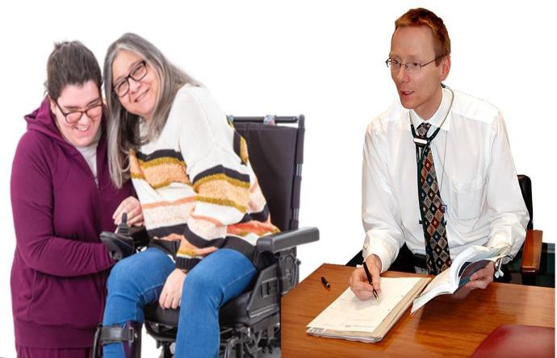 | 3. Staff should listen to you and your family and any carers who know you well.

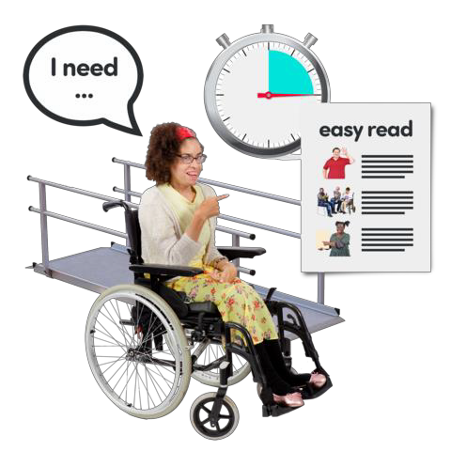 | 4. The law says that staff must make any changes you need to make sure you get the right care and support.  This is called making reasonable adjustments.
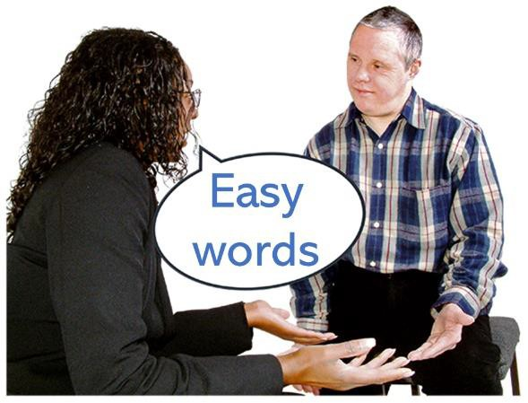 | 5. Staff should find out the best way to communicate with you.  They should use your hospital communication passport if you have one).  They should not use jargon or long words.
6. Staff need to make sure they know what you do when you are in pain or uncomfortable.

They should know how this is different from how you are normally.

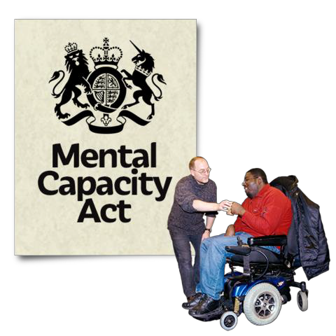 | 7. Staff must involve you in all decisions about your care or treatment unless it is clear that you cannot do this.  They must follow the law called the Mental Capacity Act.
8. Staff should ask for help from other doctors if they need it.

This includes working with a learning disability liaison nurse if there is one in the hospital.

9. Staff should make sure that they support you in the right way if you are upset or scared.

They should help you stay calm and relaxed.
All of these are things you should expect from all health staff (including doctors).

