Specialty guides for patient management during the COVID-19 pandemic

ICON for midwives during the coronavirus pandemic

“Babies cry, you can cope”
November 2020

To be read in conjunction with the letter to midwives on safeguarding infants during the coronavirus pandemic: the ICON programme, and the ICON leaflet/poster.
The coronavirus pandemic and the associated social isolation will put huge pressures on families who will remain in a confined space. This will be a very stressful time for the parents of new babies.
Abusive injury of babies is most common in the 6 to 12 weeks of life when it is normal for babies to cry a lot. The injury is caused by a parent, most often the male partner/carer.
Simple, clear advice from midwives, health visitors and other healthcare professionals in the first days and weeks of a baby’s life can make a real difference by helping parents cope with the stress of crying. This has been proven to reduce the number of serious injuries and deaths in babies.
The aim is to acquaint all new parents with the ICON message, particularly targeting the male partner/carer involved, and signpost them to resources they can access when they need help.
Please print the attached leaflet/poster and add local contact information in the appropriate area.
The proposed actions are:
- If possible, talk to both parents. Involving the partner/carer is very important.
- Read through the ICON leaflet with them and point out key messages (see below).
- Encourage them to photograph the leaflet so they have the image on their phone.
- Point out the website information and social media links that they may find useful in time.
Below is a script that provides a useful example of how to have the conversation. This conversation takes an average of 6 minutes.
Many thanks for your involvement.
ICON: babies cry, you can cope.
The National Major Trauma Network

Hospital-based intervention: key talking points
This intervention should last no longer than 6 minutes of professional talking time. Obviously different parents will have different questions and the intervention may take longer with some than with others.
This is the most important time to discuss this topic with male partners. Every effort should be made to deliver this short intervention when the male partner is present before discharge home from the postnatal ward, making sure they are as involved as possible and that questions are directed to them as well as to the mother.
You will need:
- The ICON leaflet (poster).

Step 1: Infant crying is normal and it will stop
Start with: “Hello my name is…. Before you go home with your baby, I just want to spend 5 minutes chatting with you about why and when babies cry and give you some information to take home with you”.
Ask what the parents/partners know about why babies cry and whether they knew that increased crying between 2 and 8 weeks is normal.
Go through the leaflet starting at the beginning and emphasising that it is normal for babies to cry more frequently from 2 weeks, reaching a peak at 6 to 8 weeks, then starting to cry less and less each week.
Acknowledge that a baby’s cry is designed to get your attention and can be frustrating and worrying.
Highlight that if they are worried their baby is not well or need some reassurance, they can talk with their health visitor, midwife or GP.

Step 2: Comfort methods can sometimes soothe a baby and the crying will stop
Talk about ways to comfort a crying baby. Ask what methods the parents/partners have tried or thought about trying to comfort a crying baby? If they are an experienced parent, ask what methods they have tried in the past and what they find works. Talk through the techniques referred to in the leaflet.
Again, remind the parent that if they are worried that the crying won’t stop, it’s OK to check it out with a health professional/provider (midwife, health visitor, GP, NHS 111).
Mention that sometimes, a baby will continue to cry for no obvious reason, and their job as a parent/carer is to learn how to cope with it.

Step 3: It’s OK to walk away if you have checked the baby is safe and the crying is getting to you
Refer to the leaflet and provide reassurance that not being able to stop a baby crying does not mean a parent/carer is doing anything wrong or that they have a ‘bad’ or ‘naughty’ baby.
Discuss ways a parent/carer might take their mind off the crying. Ask what they think might work for them and refer to the leaflet for some examples.
Make sure you emphasise that the parent/carer must make sure the baby is safe before walking away and that they go back to check on the baby after a few minutes when they can feel themselves calming down.
Emphasise the need for parents to find time for themselves to help them cope through what can be a really stressful time for all parents/carers.

Step 4: Never ever shake or hurt a baby
Suggest to the parents that it is really important that they share this information with everyone who looks after their baby as it’s not only parents who get frustrated by a baby’s cry.
Refer to the leaflet ‘What not to do’ and point out how parents and people looking after babies can sometimes get so angry and frustrated with a baby’s cry, they lose control and shake their baby – which is highly dangerous, leading to lifelong injuries and potentially death.
Suggest to parents/carers that they check that caregivers understand about how to cope with crying before leaving their baby with them.

Finally: ICON – babies cry, you can cope!
Go to the ICON logo at the back of the leaflet and run through the acronym to reiterate everything you have just said. Point to the section of the leaflet about information and support.
Ask parents if they have any questions.
The ICON message is summarised below, and a graphic showing the ‘crying curve’ is proven as a powerful tool in emphasising the normality of infant crying.
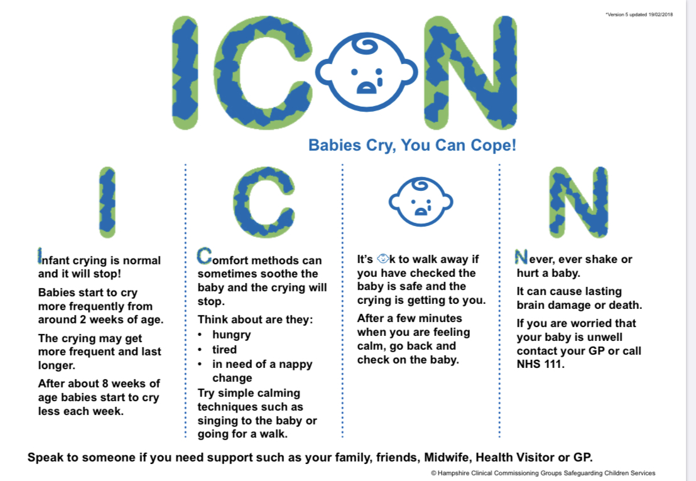
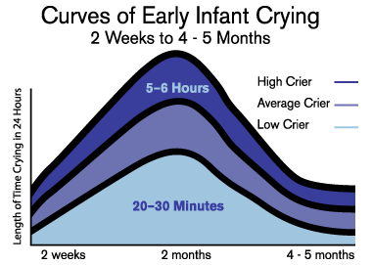
Barr RG, Hopkins B, Green J A (2000) Crying as a sign, a symptom and a signal: clinical, emotional and developmental aspects of infant and toddler crying. London: MacKeith Press.

Supporting families to cope with infant crying
ICON: Babies cry, you can cope!

Abusive head trauma (AHT): key points
- is child abuse and 100% preventable
- results in catastrophic injuries
- often triggered by caregiver’s lack of ability to cope with a crying baby
- 70% of babies who are shaken are shaken by a male caregiver/father
- risk is increased at times of stress within families
- there is an association between economic hardship and the incidence of AHT.
Challenges of COVID-19
  - Massive time of stress
  - Loss of income
  - Self-isolation with children and potentially at-risk adults
  - Social distancing restrictions on activities that might enhance support
ICON: Babies cry, you can cope!
- ICON is an AHT prevention programme
- Delivered antenatal and first 6 to 8 weeks of baby’s life.
- Evidence from similar programmes shows a reduction of serious injury by up to 70%
The coronavirus response
- The advice and support that underpins ICON is being made available for all health and social care professionals to ensure the message is provided to all families with babies.
Hospital-based prevention
Midwives are key to ensuring the message reaches men. Having a conversation with both parents/carers after the baby has been born and before they leave hospital is an important time to deliver this message.
Community
- Proactive contact to repeat the message between 2 and 8 weeks, when the crying will start to increase and reach its peak.

Update information
November 2020: hyperlinks in this document were updated when the suite of guidance was moved from NHS England to NICE.
2 April 2020: version 1 published.

