- Shows all the NICE guidance selected by the trust as relevant to its business

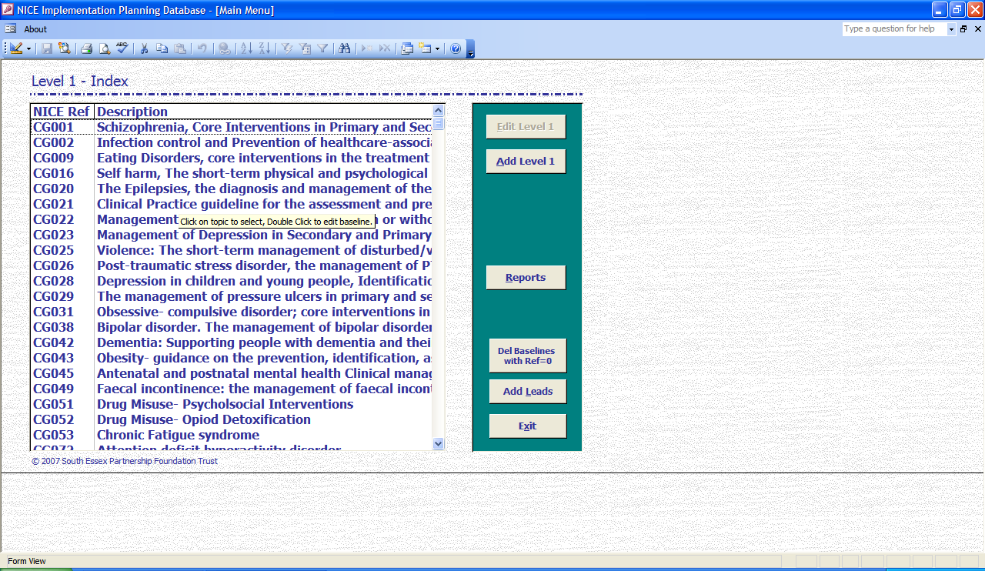

- Shows all recommendations for a single piece of NICE guidance

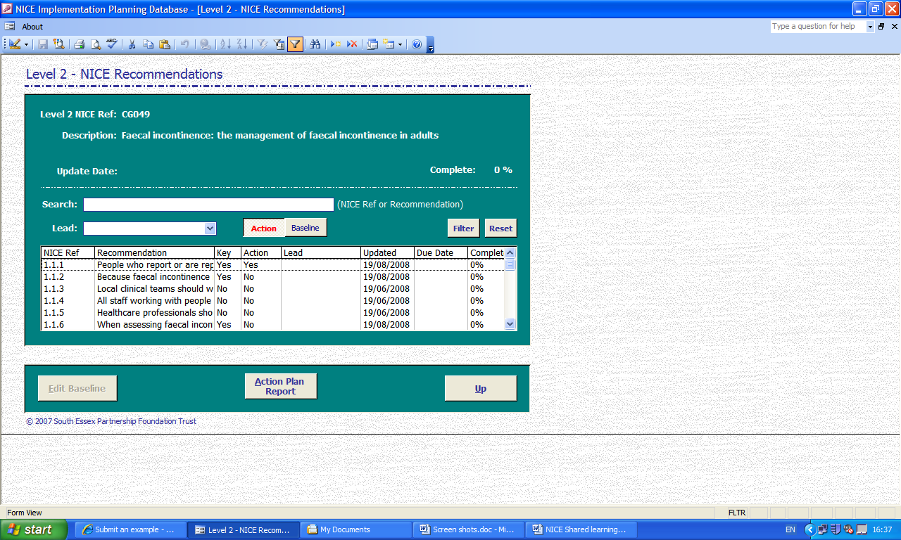

- Shows a single NICE recommendation with the trusts baseline assessment and action plan (if necessary). This screen also shows if the recommendation is a NICE key priority and if there is an action it’s risk rating, due date and named lead

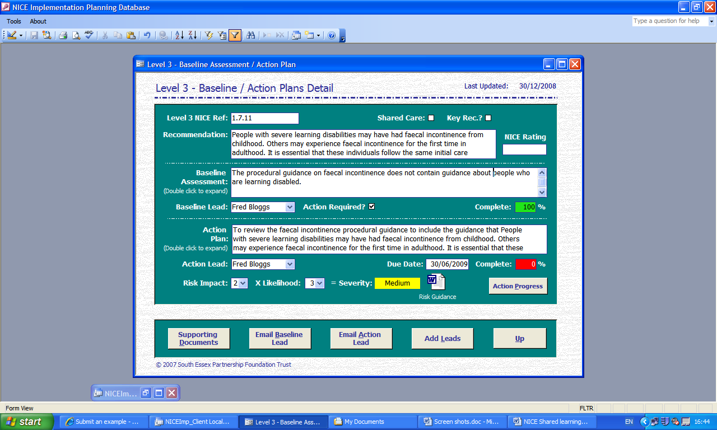

- Shows progress update notes

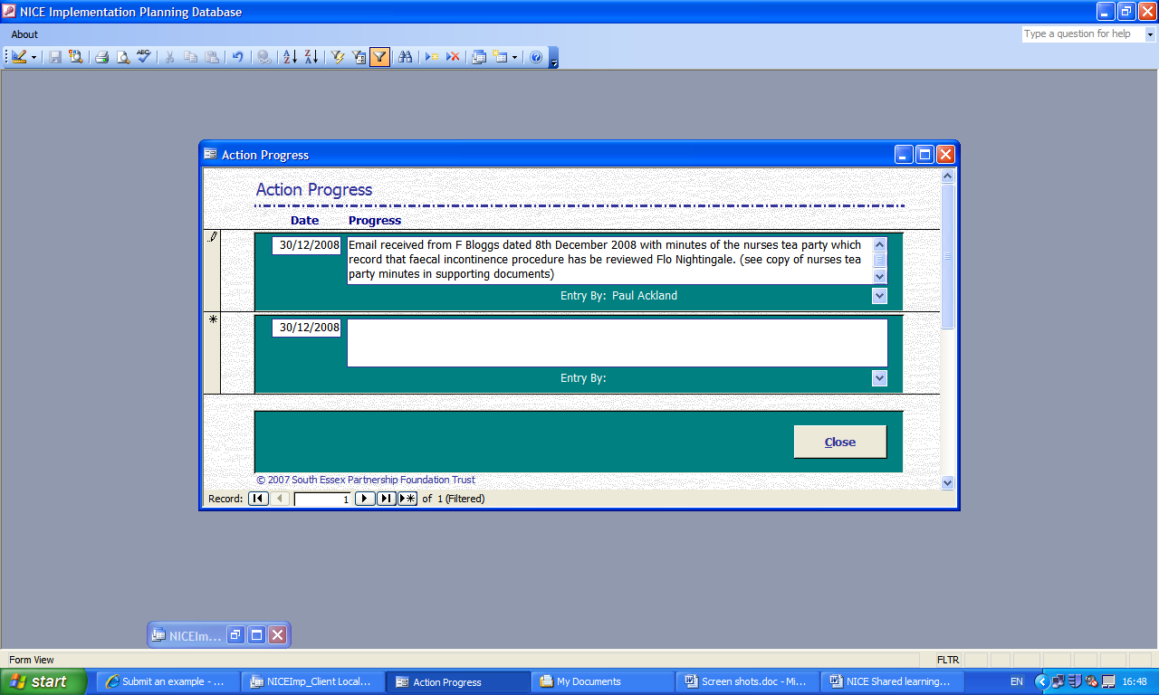

- Shows documents linked to the baseline/action

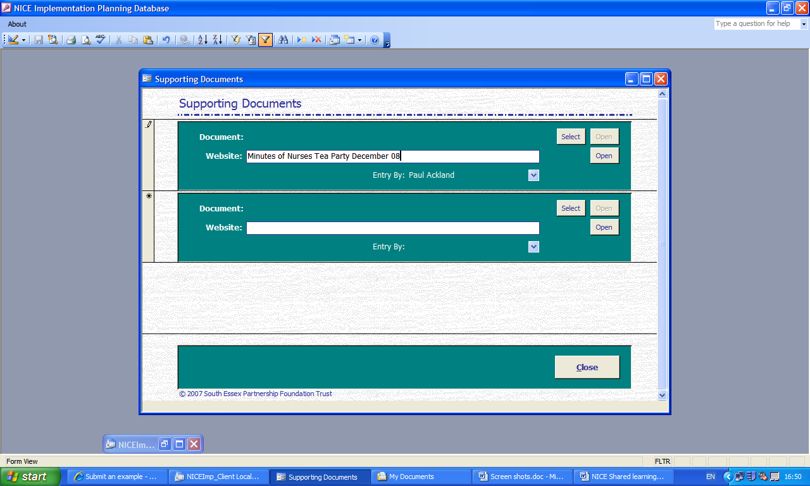

- Shows an action report



