Supporting Documents
Addressing Unmet needs: A multidisciplinary group clinic for people with Parkinson's disease and their carers.
King's College Hospital London
Clinic pictures
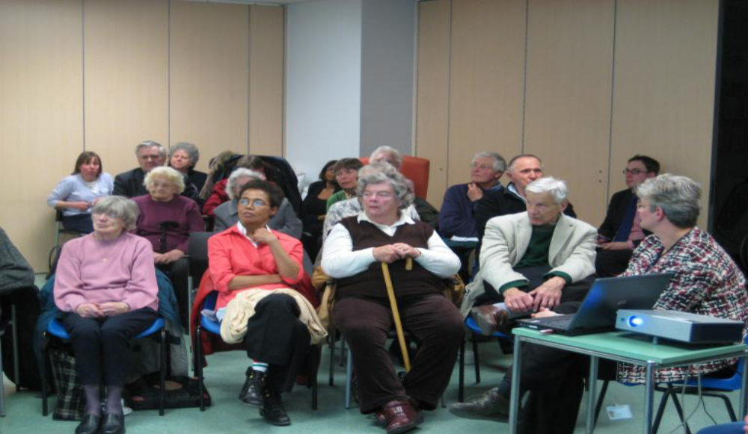
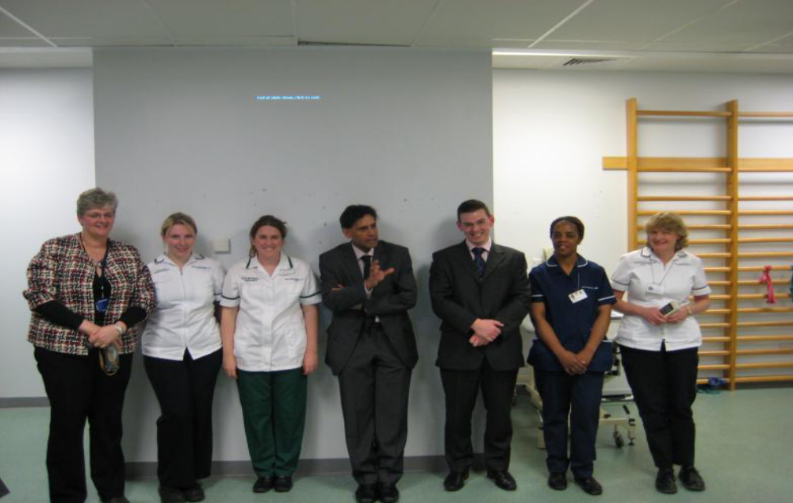
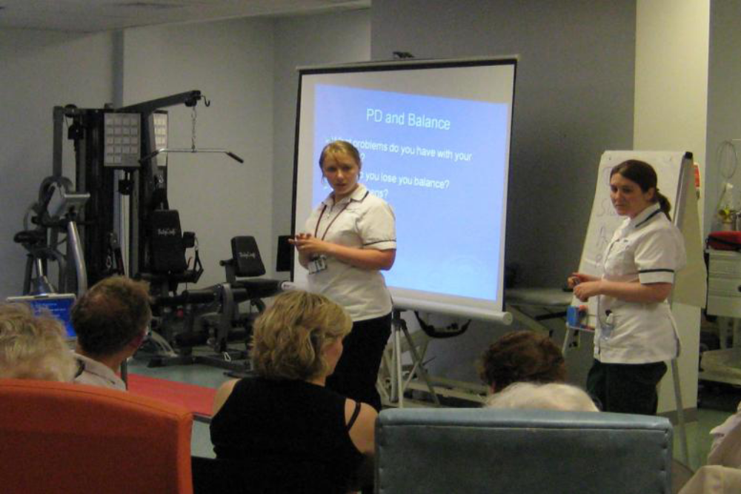

Results from feedback from the clinic
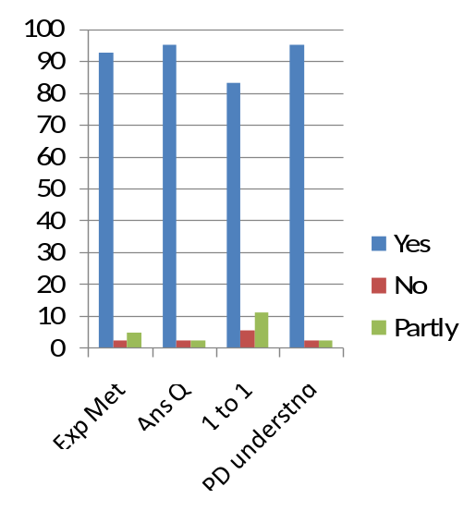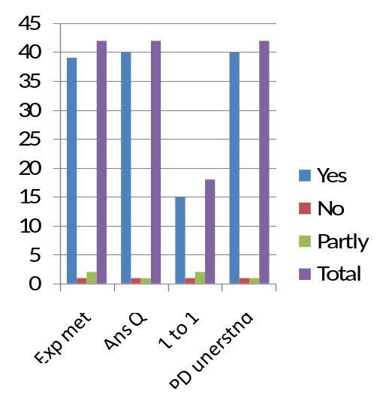
Response assessment of patients/caregivers
Exp met = expectations met, Ans Q = Questions answered, 1 to 1 = one to one consultation, PD undersnd = Improved understanding of PD
PD understnd = Help understanding of Parkinson’s disease
Total no of responses
Percentage responding

Comments made by attendees:
- All Presentations gave excellent information without being too technical. Congratulations to the whole team. I am so grateful for the excellent care and attention you always give me.
- All speakers were most informative as well as friendly! Very worth while.
- Very good session. I learned a lot. Extremely valuable.
- Very informative, answered all my questions. Speakers were excellent.
- All the Kings team were/gave excellent presentations. It was an enjoyable, stimulating informative meeting.

