Putting ADHD NICE Guidelines into Practice – this brochure outlines, for key NHS stakeholders, what the ‘Making Sense of NICE’ campaign comprises and how the tools can support progress, at each step of the way, towards implementing the recommended ADHD NICE guidelines.
Artwork of gate-folded brochure: first visual shows front page (far right), back page (middle) and folded inside page (far left)
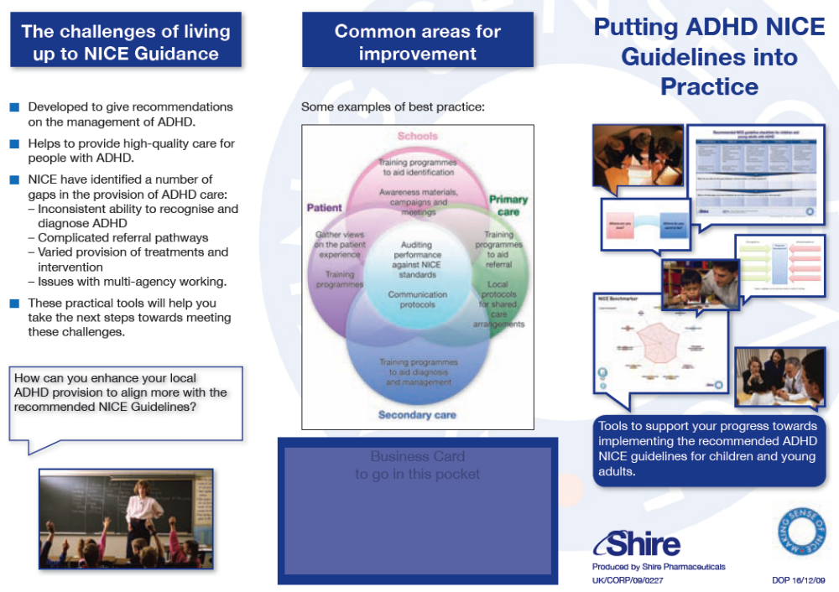

Second visual shows internal pages of brochure:


