

The CLAHRC Chronic Kidney
Disease Collaborative:
Improving care for people with Chronic Kidney Disease

Report on Phase 1 of the CKD Collaborative
September 2009 – September 2010

Foreword
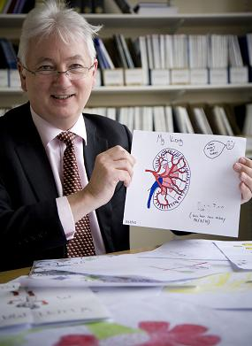
Kidney disease is silent but deadly. We know that it affects between one in 10 and one in 15 adults and increases vascular risk. We also know what to do – control blood pressure and reduce proteinuria. When kidney care is optimised outcomes are improved. However, knowing what good practice should be and being able to make that best practice a reality in the complex, resource-constrained, fast-moving environment of the NHS is far from easy.
This report outlines the first twelve months of a project to tackle the gap between the ‘know what’ and the ‘know how’ in relation to the management and identification of chronic kidney disease (CKD) in primary care. Undertaken as part of the Greater Manchester Collaboration for Leadership in Applied Health Research and Care (CLAHRC), the project has involved 19 general practice teams working together as a Collaborative, over a period of a year, to implement new ways of managing CKD.
I have often heard Sir Muir Gray, chief knowledge officer of the NHS, say that ‘knowledge is the enemy of disease’. This has certainly been the case within the CLAHRC CKD Collaborative. The Knowledge Transfer Associates, working with the practices, have analysed data and turned it into information. By discussing the information with general practitioners, practice managers, nurses and people with kidney disease, the uncertainties in how we manage CKD have been surfaced. The poignant stories of individual cases have pricked our collective conscience about the missed opportunities for prevention and mitigation of the impact of kidney disease.
The teams within practices and within PCTs have worked both together and in healthy competition to improve the care for their patients. A total of 1,324 new patients have been added to CKD registers and 74% of those patients on the registers are now being treated to NICE blood pressure targets, which represents a tremendous improvement in a period of just one year.
However, there is no hint of complacency, no desire to say “job done” and move on. Many lessons have been learned along the way and are captured in this report. Together we have moved from thinking the answer is simply education to understanding the importance of collective learning and support, audit and feedback of data, clinical leadership and building confidence.
The CKD CLAHRC Collaborative is a work in progress – we cannot judge its success yet. The scale of the challenge of CKD – affecting 7-10% of the population, end-stage renal failure growing at 6% per annum, a significant financial cost for the Health Service – should not deter us. Indeed CKD is a classic long term condition. We can use the same principles we use in other long term conditions to improve outcomes. The measures of success of the CLAHRC project will be establishing clinical leadership to integrate care and support, transforming the outcomes for people with kidney disease and ensuring engagement with our patients and populations such that the experience of care ensures dignity, respects values and adds life to years. I look forward to seeing continued progress and improvement over the coming years.

Dr Donal O’Donoghue
National Clinical Director for Kidney Care
September 2010
Contents

Foreword 2
Chronic Kidney Disease matters 4
The CLAHRC for Greater Manchester and the CKD Collaborative 5
What has been achieved to improve care for patients? Successes so far 7
What practices did to achieve change and improvement 10
Summary 15

Chronic Kidney Disease matters
Chronic kidney disease (CKD) is common, harmful and treatable. It affects about 7-10% of adults in the UK and greatly increases a person’s risk of suffering a stroke, heart attack, renal failure or death¹. A 2003 retrospective analysis of all patients newly diagnosed with CKD in Southampton found that 35% had died after 5 years, 46% of which were cardiovascular related². However, diagnosing the condition early and managing patients’ wellbeing is vitally important for their health; a study in Lincolnshire that identified and subsequently treated 483 CKD stage 4 and 5 patients estimated that in doing so they had prevented a total of 28 deaths³. Through earlier identification and then treating patients to slow disease progression they also estimated a saving of 97 dialysis years over 5 years; a projected cost of £2.7 million and in human terms – priceless.
In the majority of cases, CKD can be managed easily in primary care. There is a lot of advice available to clinicians about treating patients with CKD (e.g. NICE guidelines¹ or www.ckdonline.org), with the key points being to identify patients early and make sure that their blood pressure is well managed. However, we know that thousands of people are not receiving the best possible care as recommended in the NICE guidelines. It has been estimated that prior to the start of the Collaborative there were around 41,000 people with undiagnosed CKD in Greater Manchester – and QOF data showed that about 15% of diagnosed patients were not receiving appropriate care; i.e. they had poor blood pressure management or had not been given relevant tests⁵.
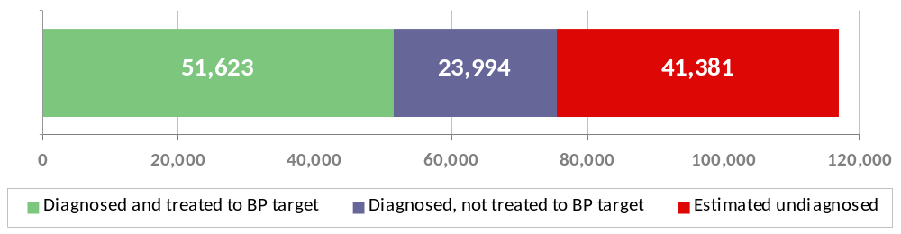
This graph shows the proportion of the estimated CKD population of Greater Manchester receiving good care in April 2009*.

The CLAHRC for Greater Manchester has been working with practices to help them improve care for CKD patients. Individual cases have highlighted further the need for improvement:
In one practice, 63 of their registered hypertensives had no record of an eGFR – this patient group is at particularly high risk of kidney damage
In another practice one man who suffers from hypertension was found to have no previous kidney tests. Subsequent blood tests showed that he has stage 3 CKD – at only 41. Without careful monitoring and optimal management he could easily be the kind of person who in the past ended up on dialysis in their 60s.

These two practices, along with the other 17 involved in the Collaborative, have all made significant changes to the way they diagnose and care for CKD patients. The way they have achieved this and the achievements they have made are detailed in the following pages.
The CLAHRC for Greater Manchester and the CKD Collaborative
The CLAHRC for Greater Manchester is one of nine CLAHRCs, which are initiatives of the National Institute for Health Research (NIHR). It is a partnership between Manchester University and all the NHS trusts in Greater Manchester, with a five year mission to improve healthcare and reduce inequalities in health for people with cardiovascular conditions (diabetes, heart disease, kidney disease and stroke). You can find out more about the CLAHRC at http://clahrc-gm.nihr.ac.uk.
The CLAHRC implementation team that works to improve care for patients with kidney disease began a CKD Collaborative in September 2009. This ran for 12 months and involved improvement teams of three people (a GP, a nurse and a practice manager) from 19 practices from NHS Ashton, Leigh and Wigan, NHS Bolton, NHS Salford and NHS Stockport.
The Collaborative is supported and advised by a group of experts in primary care, CKD and quality improvement – our Expert Faculty – as well as senior sponsors from each of the four PCTs, who provide local knowledge and support the Collaborative work in their area.
The 19 practices all worked to achieve the following aim:
To halve the gap between recorded and expected prevalence and to ensure that 75%* of all patients have blood pressures managed to the NICE recommended targets (140/90 for those without proteinuria and 130/80 for those with proteinuria). *No exceptions

The Collaborative methodology
The CKD Collaborative uses a method called the Breakthrough Series from the Institute of Healthcare Improvement in the USA. This method draws on two main principles: rapid cycle change using Plan-Do-Study-Act (PDSA) cycles and collaboration between participants for shared learning.
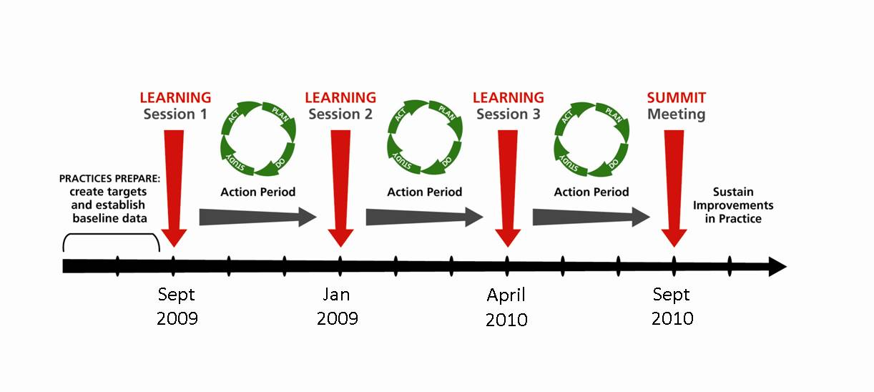
There are three learning sessions, where all teams share and discuss their experiences and the challenges of improvement work. In the intervening action periods, teams test changes in their own organisations in order to make improvements. Everyone is encouraged to continue collaborating during these action periods to share knowledge and overcome challenges together.

PDSA cycles: Plan, Do, Study, Act
The use of PDSA cycles has been really useful as it has given us the chance to reflect on how successful any changes have been for the practice and what we have learned.
Helen Prendiville, Practice Nurse, Mosslands Medical Practice
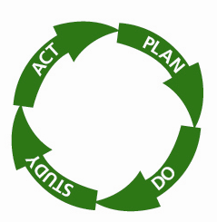
One of the key elements of the Breakthrough Series is the use of PDSA cycles. This is a simple tool that helps teams test a change on a small scale and assess whether it has been a worthwhile change.
Adapt, adopt, abandon? Practices reflect on the effectiveness of a change and may then decide to abandon it altogether and test something completely different, adapt it slightly for refinement or to adopt the change as a new way of working. However, initial PDSAs often involve just one member of staff testing a change on a small group of their patients for a short time, so the adopt stage – rolling out the improvement to all staff and all patients – can be a challenge in itself.

The practices were supported during the action periods through regular visits from Knowledge Transfer Associates (KTAs). They helped practices assess changes and consider what could be tried next. They also acted as a conduit to share knowledge and lessons learnt from successful changes between practices, so that improvements could be quickly spread across the whole Collaborative.
The CLAHRC has helped keep us motivated and not lose momentum. The methods of knowledge sharing between practices has been fantastic and very beneficial.
Amanda Logan, GP,
Monton Medical Centre (ex-Mosslands Medical Practice)
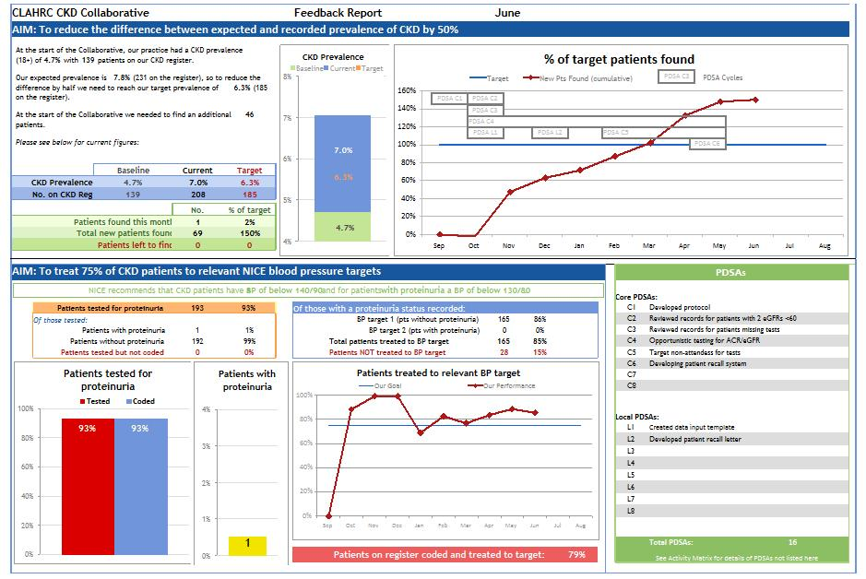
The CLAHRC collected data from practices on a monthly basis and created feedback reports for the practices to help them understand the progress they were making (Figure 1).
Figure 1: Example practice feedback report
Working within the Collaborative has improved my knowledge of CKD and highlighted the awareness of screening for the disease. I’ve found it has helped to improve our communication and teamwork skills within the practice. It has provided a good networking environment with other practices.
Maria Crosbie, Practice Nurse,
Springfield Surgery
The KTAs also helped practices to understand and improve their practice context. A team’s working environment can have a strong influence on the success of improvement work and understanding how it blocks or enables change can be very beneficial. We used simple questionnaires to look at things like the quality of teamwork, communication and decision-making and then worked with practice teams to make changes where appropriate.

What has been achieved to improve care for patients? Successes so far
If the 1.2% prevalence increase that the Collaborative has achieved was seen in all the Greater Manchester practices, this would equate to finding 26,000 patients†.
This is the first large scale CKD improvement project from inception to reporting in the UK. When we started out, our Expert Faculty was tasked with setting the bar high – making the aim a stretch but achievable. Despite the vagaries of NHS life, such as swine flu which took priority in Q4 2010, the CKD Collaborative has demonstrated excellent success in the first 12 months.
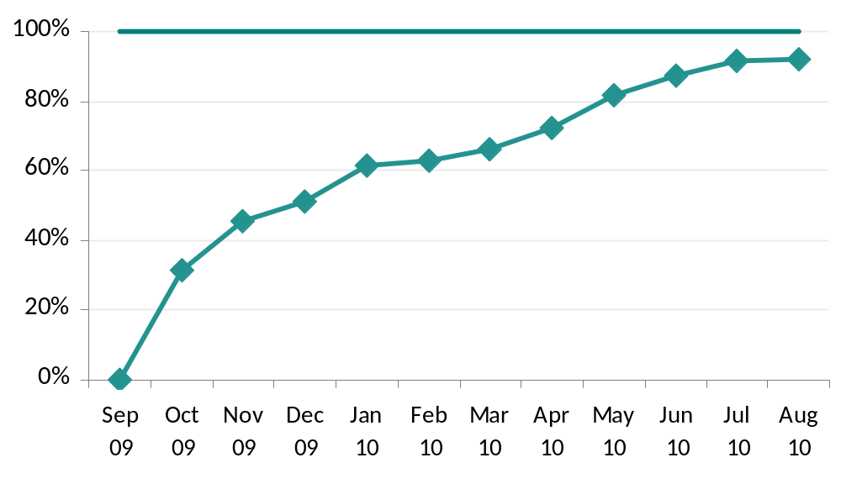
An impressive 1,324 additional patients have been added to the CKD registers by the 19 Collaborative practices. This is 92% of our overall aim (Figure 2) and an aggregate increase in prevalence across the nineteen practices of 1.2%.
1,324 pts found
92% of target
Figure 2: Achievement against patients to find target, for the whole Collaborative
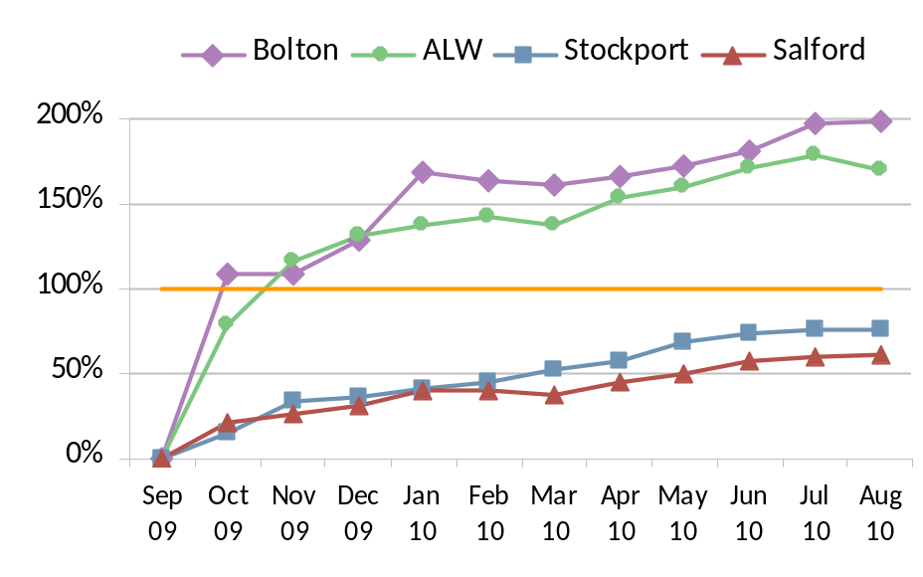
Different practices faced different challenges with meeting the aim. For example, the range of patients to find was 5-251, making the logistics pretty challenging for some practices. Overall the 4 PCTs achieved between 61-199% of their aim (Figure 3).

Figure 1: Achievement against patients to find target, per PCT

Ten of the 19 practices achieved their target of halving the prevalence gap (Figure 4) and four of the 19 made an excellent achievement in reaching over twice their original aim.
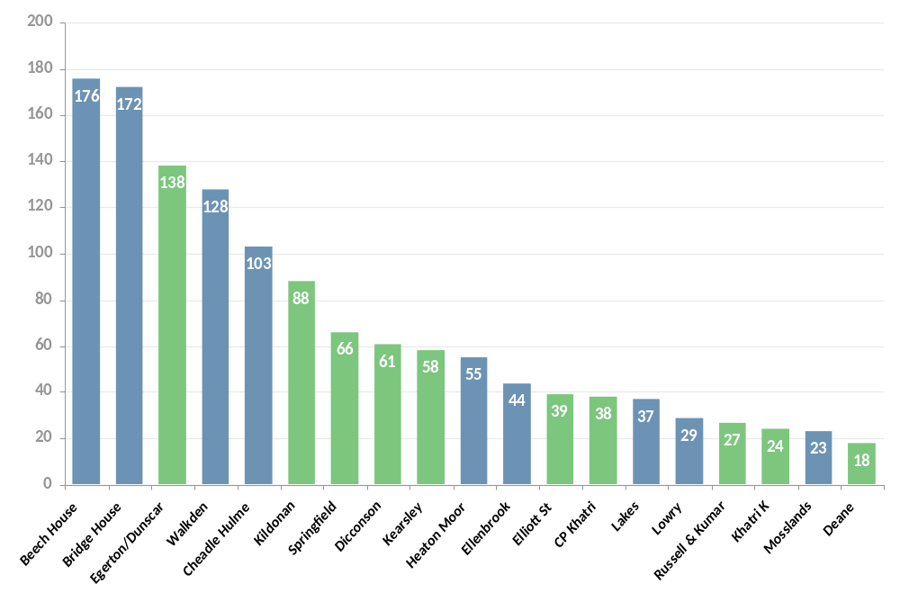

Figure 2: Number of patients found by each practice, those in green achieved their target

The second part of the aim was to treat blood pressure to be within one of two set ranges, determined by the presence or absence of significant proteinuria. Practices had experience of proteinuria testing and interpretation in diabetes – but it was a new challenge linked with kidney disease.
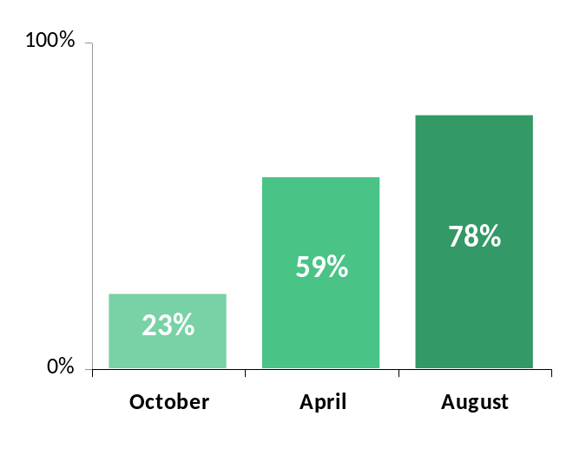
Confusingly at first, two different tests were available with completely different significance thresholds when compared to diabetes. Consequently, there was a big piece of work to do upskilling staff and developing robust systems to ensure all patients had their urine tested. At the start of the Collaborative, only 23% of patients had been tested – now 78% have been checked (Figure 5). This is a fantastic achievement as it has entailed completing over 3,000 ACR tests. The practices also put a lot of time into making sure that all test results were appropriately clinically interpreted and properly coded so that each patient got the best treatment for them individually.
People with CKD are roughly twenty times more likely to die from cardiovascular disease than progress to end stage renal failure. The all causes mortality rate in CKD is 30 to 60 times higher than in the general population⁶.
Proteinuria even at low levels (microalbuminuria) has been shown to predict harm. In 1 study of >2000 patients followed over 10 years its presence more than doubled the predictive effect of conventional atherosclerotic risk factors like smoking or cholesterol for development of IHD⁷.

Figure 5: Increase in percentage of CKD registers being tested for proteinuria, October 2009 to August 2010

Accurate data on blood pressure has been difficult to obtain due to inconsistent Read coding and the teams’ lack of experience in running searches on practice systems. In November 2009, practices reported that only 34% of patients had blood pressure managed to NICE recommended targets. The data from August showed a huge increase to 74% (Figure 6), with nine practices achieving their target of having over 75% of patients to target (Figure 7). In actual patient numbers, this indicates that a fantastic 1816 patients have their blood pressure more carefully managed as a result of the Collaborative work.
Improvements in blood pressure can make a huge difference – reducing systolic BP by 10mmHG and diastolic BP by 5mmHG can reduce the relative risk of CHD events by ¼ and of stroke by ⅓⁸.
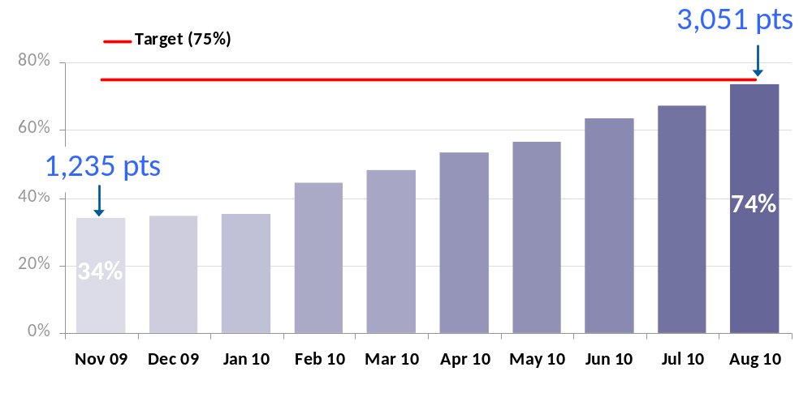
Figure 6: Improvement in recorded blood pressure management, November 2009 to August 2010

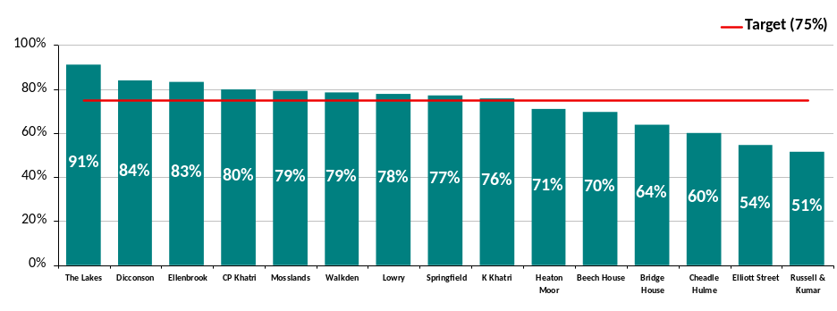
Figure 7: Achievement in treating patients to NICE recommended blood pressure targets per practice

Other benefits of taking part in the Collaborative
Clearly, involvement in the CKD Collaborative has led to direct benefits for patients within the practices involved. However, wider benefits have also been observed within the participating practices. Staff have become more confident in managing CKD in primary care, resulting in a reduced number of referrals to secondary care. The skills gained in managing CKD also have wider applicability to other long term conditions. For example, practices have improved skills in auditing data, validating registers and patient review systems – all of which are transferable to the wider management of disease registers for long term conditions. More generally still, practice staff have developed skills and knowledge in change management, teamwork and improvement methods that are applicable to all aspects of their work.

What practices did to achieve change and improvement
The 19 practices involved with the first phase of the CKD Collaborative made a number of common changes to bring about improved care for their patients. In particular, they focused on four key building blocks to implement more evidence-based ways of identifying and managing patients with CKD in primary care, namely:
- Creating a foundation for improvement
- Identifying patients with CKD
- Introducing optimal management of patients with CKD
- Ensuring that improvements are sustained
Each of those core building blocks involved a number of different activities, as described in more detail below. In all of the practices, these different steps were not introduced in a simple, sequential way. More typically, practices had to think about several of the steps at the same time and go back to look at some aspects of the process again if things did not go according to plan. In other words – it was pretty organic!
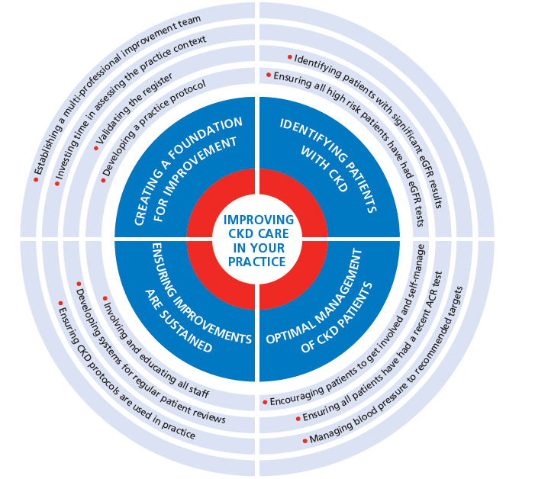
Creating a foundation for improvement
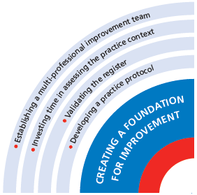

Having a solid foundation for improvement work is vital if changes are to be introduced as smoothly as possible and sustained over the longer term. We have probably all experienced projects where after the initial burst of enthusiasm, interest begins to wane and it is difficult to keep people engaged. Some key steps that were taken in the CKD Collaborative to create a firm foundation for improvement included:

Establishing a multi-professional improvement team
Each practice designated a team to lead the improvement work, consisting of a GP, a nurse and a practice manager. This reduced the reliance on one individual to lead the project at a local level and also ensured that a range of different professional perspectives were represented when discussing possible improvements. The improvement team undertook activities to assess their team dynamics and strengths and this helped them work more efficiently and effectively together.

Investing time in assessing the practice context
The organisational context – or ‘the way things are done around here’ – has been shown to be a major factor that influences the successful implementation of improvement initiatives in healthcare. Context can be affected by a variety of factors, such as the leadership style of key individuals within the organisation, the way in which work is organised and managed, the level of trust and responsibility that exists amongst the team and the commitment to reflecting on practice and learning about how to do things better. We used a simple questionnaire, derived from the literature on organisational behaviour, to assess individual practices. Findings from this assessment were fed back to practices and used to help them identify areas where they might need to focus attention to create a more receptive context for change.

Validating the register
Having an accurate register at the start of the project was important to make sure that the baseline was a true measure of the number of patients with CKD in the practice. The practices checked all the patients on their existing CKD registers to be sure that everyone was diagnosed correctly, following appropriate tests. Patients with incorrect diagnoses were removed from the records and a note was made to follow them up with further tests as necessary. A valuable spin-off from this exercise was that it helped to identify areas where staff knowledge was weak or lacking, for example by highlighting where test results had been misinterpreted or patients were not receiving the best available care.

Developing a practice protocol
Protocols are one way of providing more standardised care for all patients. Practices created protocols that staff could follow to identify and treat patients with CKD, using existing guidelines such as those from NICE or the Map of Medicine, and localising them to suit their individual needs.

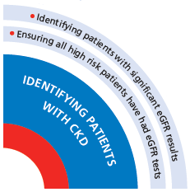
Identifying patients with CKD

The first part of the Collaborative aim involved identifying patients with CKD. Two key steps that practices took to aid this identification involved checking for patients with significant eGFR results and making sure that all high risk patients had an eGFR test.

Beech House in Stockport searched for all patients with eGFRs of 60 or less who were not already on the CKD register. They found over 1,000 patients so decided to search for patients with eGFRs of 59 or less to break the task down into manageable chunks. They checked 400 records and found 134 CKD patients in the first month.

Identifying patients with significant eGFR results
The majority of the patients that practices identified already had results on their records showing one or two eGFRs <60ml/min/1.73m². The practices searched for these records and were able to add some patients to the register straightaway and identify others that only needed one further test to confirm the diagnosis.

Ensuring all high risk patients have had eGFR tests
Following NICE recommendations, the practices ensured that anyone at high risk of CKD, particularly those with hypertension, diabetes or cardiovascular disease, had had an eGFR test in the last 12 months. They also looked for patients with a family history or associated conditions such as prostatic hypertrophy, structural renal tract disease or renal calculi and haematuria and proteinuria. Practices used the opportunity of concurrent health campaigns, such as their annual health reviews or flu clinics, to test patients that would otherwise not be coming into the surgery. This is smart quality improvement work – hitting on things efficiently.
Walkden Medical Centre in Salford searched for all patients who had six or more prescriptions of NSAIDs in the last two years – 44 patients were identified and 21 of them were found to need an eGFR test.

Optimal management of CKD patients
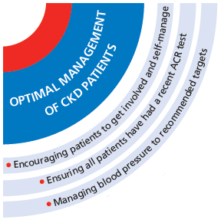

The second part of the aim involved managing patients’ blood pressure to the targets recommended by NICE¹. This involved testing for proteinuria and then using appropriate interventions to reduce and maintain blood pressure.

Dicconson Surgery in Wigan hugely increased the number of ACR tests done. At the start of the Collaborative they only had 36% of their register tested. By August 2010 they had tested 91% – an additional 229 patients tested. They had difficulty getting some patients tested and asked their healthcare worker to follow up as many as possible, including doing home visits to those who struggled to reach the surgery.

Ensuring all patients have had a recent ACR test
Proteinuria indicates a significantly increased risk of cardiovascular illness and CKD progression, so it is important to make sure all patients on the CKD register are tested regularly. Many practices ran clinics specifically for this purpose or took advantage of opportunities such as flu vaccine clinics to get everybody tested whilst they were in the surgery. Practices realised that many patients were tested but the result had not been coded on their records. This was where having a practice protocol could help to make sure that all staff were recording results appropriately.

Managing blood pressure to recommended targets
Patients without proteinuria should have a blood pressure below 140/90mmHg and patients with proteinuria should have a blood pressure below 130/80mmHg¹. Practices ran searches to identify any patients on their registers not meeting these targets and called them in for appointments to discuss strategies for improving blood pressure control, for example, through changing or adjusting medication and discussing self-management of blood pressure.
Several practices have reported that it can be difficult explaining a new diagnosis of CKD to patients without scaring or upsetting them. At Bridge House Surgery in Stockport they are using the time when patients come in for tests to educate them about blood pressure and healthy lifestyles – that way they are promoting self-management and preparing fertile ground for co-creating a management plan should they subsequently be diagnosed.
Encouraging patients to get involved and self-manage
As with other long-term conditions, self-management is an important strategy for improving the management of CKD, for example, through educating patients to monitor and maintain their own blood pressure. Practices have encouraged patients to make changes to their lifestyles in order to improve their general health and promote the local community groups that patients can join for support. This is one area where relatively fewer improvements were introduced in the first phase of the Collaborative and one where we will be focusing more attention as the project moves forward into the next phase.

Ensuring improvements are sustained
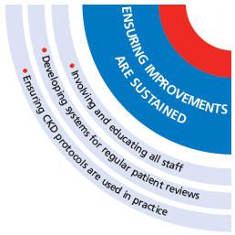
Sustaining improvement is not easy. Once the initial flurry of excitement and activity relating to a new project has passed, it is easy for it to be forgotten as new priorities come onto the agenda or the day-to-day pressure of work takes over. Planning for longer-term sustainability is essential. Key steps that have been undertaken within the Collaborative to address the issue of sustainability include spreading learning and involvement to the wider practice team, developing systems for regular patient review and introducing measures to enhance the use of the CKD protocol.

Involving and educating other staff
Although the improvement teams were responsible for leading the changes in each practice, it was important to make sure that the CKD project was not just confined to the immediate improvement team. The new systems and changes had to be adopted by all staff in the practice to be successful. Improvement teams typically used practice meetings to introduce new ideas about identifying and managing CKD, including the development of protocols and making sure that staff knew how to follow them.
There can be a lot of work involved in running searches and getting patients in for tests. At Mosslands Medical Centre in Salford they made sure no member of staff was overburdened. The improvement team lead the work but they involved all staff to ensure everyone had a manageable workload. This helped them achieve their targets but also helped educate everyone about CKD so they can continue to improve patient care together.

Developing systems for regular patient review
Many practices have established recall systems to ensure that all patients on their CKD registers are reviewed on a regular and ongoing basis. In some cases they have used ‘monitoring’ Read codes to identify patients who have not been reviewed in a certain time frame and elsewhere they have created reminders to call patients in for appointments.

Ensuring CKD protocols are used in practice
Many practices in the Collaborative has set up systems to make sure their good work continues.
These systems can be as simple as a diary reminder to run audits on the register and check for missed test results. The practice manager at K Khatri’s surgery in Wigan now regularly audits their diary date system, looking for patients who should have been flagged for review but have been missed. This way she can be sure that all patients are getting the reviews they need.
Improvement teams quickly became aware that simply telling all staff about the protocol was not sufficient to make sure they used it. In addition to discussions about the protocol at staff meetings, some teams have set up reminder systems to routinely check for missed diagnoses or poorly managed patients. This regular audit and review of their data helps them to assess how well the protocol is working and identify where there are still problems to be resolved.

Summary

Implementing evidence-based improvement in practice is vital to ensure that patients receive clinically and cost-effective care. However, achieving such improvement is neither straightforward nor easy, as previous endeavours in healthcare have demonstrated. That the 19 practices in the first phase of the CLAHRC CKD Collaborative have made such impressive improvements in just 12 months is a testament to their hard work, determination and a very real commitment to improving the quality of care.

All of us involved in this first phase of the work have experienced at first-hand the challenge of closing the gap between evidence and practice – something that takes time, perseverance, ingenuity and an investment of time and support. This is just the first part of the journey. The practices that have given so willingly of their time and energy in the first phase of the project will continue to implement improvements in both CKD and other long-term conditions. The experiences and learning that are documented in this report will form the basis of a more detailed Improvement Guide that will be used to support a new group of practices taking part in the second phase of the CKD Collaborative. Through this ongoing programme of work, we aim to engage a greater number of practices in improving the identification and management of CKD, and work towards further closing the gap between evidence and practice for the population of Greater Manchester.

Acknowledgements

The CLAHRC CKD Collaborative has been made possible thanks to the support and funding from the National Institute of Health Research and all of the Greater Manchester Primary Care Trusts. Our thanks to the Expert Faculty for their advice and support throughout the course of the project and thanks to Dr Simon De Lusignan of the QICKD study for his assistance in providing adjusted estimated prevalences for the practices. Finally we would like to thank all the practices participating in the Collaborative for their hard work and determination to make the project a success.
References
- National Institute for Health and Clinical Excellence Chronic Kidney Disease, “National clinical guideline for early identification and management in adults in primary and secondary care” 2008 London, National Institute for Health and Clinical Excellence,
- Drey N, Roderick P, Mullee M et al. “A population-based study of the incidence and outcomes of diagnosed chronic kidney disease.” American Journal of Kidney Disease. 2003; 42(4):677–684
- Whitfield, M., and Holmes, M. “A cost and clinical effectiveness evaluation of a “disease management programme” for Chronic Kidney Disease (CKD)”. 2007 School of Health & Related Research (ScHARR) University of Sheffield, Sheffield
- De Lusignan, S., Tomson, C., Harris, K., et al. “Creatinine Fluctuation Has a Greater Effect than the Formula to Estimate Glomerular Filtration Rate on the Prevalence of Chronic Kidney Disease.” Nephron Clinical Practice 2011, 117:213–224
- Quality and Outcomes Framework 2007/8; available online from http://www.ic.nhs.uk/statistics-and-data-collections/audits-and-performance/the-quality-and-outcomes-framework
- NHS Employers, “Chronic kidney disease frequently asked questions” 2010 Leeds, NHS Employers
- Borch-Johnsen, K., Feldt-Rasmussen, B., Strandgaard, S., Schroll, M., Jensen, J.S. “Urinary albumin excretion. An independent predictor of ischemic heart disease”. Arteriosclerosis, Thrombosis and Vascular Biology 1999;19(8):1992-1997.
- Law, M., Morris, J., and Wald, N. “Use of blood pressure lowering drugs in the prevention of cardiovascular disease: meta-analysis of 147 randomised trials in the context of expectations from prospective epidemiological studies” British Medical Journal 2009, 338;b1665

These figures are based on comparisons of estimated prevalences from De Lusignan et al 2011⁴ against QOF CKD register sizes 2007/2008⁵.
This calculation is based on a 1.2% increase in prevalence from QOF CKD register sizes 2007/2008⁵.
Deane Medical Centre’s target was in fact zero patients to find, as under the QICKD targets their baseline register was larger than their expected prevalence.
We are using data submitted in November 2009 as our baseline figures for blood pressure management as there were too many inaccuracies in the data submitted by practices prior to that date.
The four practices from NHS Bolton chose to focus on improved blood pressure management in the second phase of the Collaborative, therefore no data on blood pressure is available from these practices.

