


Perinatal Clinical Audit

A re-audit of admissions to a mother & baby unit in Sussex over a 19 month period (April 2010 to November 2011)

January 2012

Dr Brian Solts, Clinical Lead for Specialist Services; Consultant Clinical Psychologist
Anna Zinkiewicz, Project Lead; Assistant Psychologist

Authors: Brian Solts, Anna Zinkiewicz
Contributors: Rachel Denny, Team Leader, Perinatal Mental Health Service, Hilary Haynes, Specialist Services Administrator; Olly Ainsley & Carol Whatford, Secondary Commissioning Team

Contents

Executive Summary 3

1. Section 1
1.1 Background Information 4
1.2 Aims & Objectives 4
1.3 Standards 6

2. Section 2
2.1 Sample 6
2.2 Overall Results 6
2.3 Data Collection 7

3. Section 3
3.1. Results 7

4. Section 4
4.1 Conclusion 11
5. References 12

6. Appendices
6.1 Summary table and figures of data 13
6.2 Perinatal Audit Tool 21
6.3 Clinical Audit Registration Form 28
6.4 Specialist Perinatal Mental Health Service Document 33

Executive Summary

This report focuses on Sussex mothers and babies admitted to specialist inpatient services over a 19 month period. Data from 2010 to 2011 is compared, wherever possible, with a previous audit also reporting on admissions across a 19 month period from 2007 to 2008. All of these women have severe mental health problems and evidence suggests that these admissions were appropriate. Of note, nearly half of these admissions were of women who reported domestic violence, now or in the past. Implications for future audits are discussed below.

- Admissions to these units continue to be low compared with national data and statistics. This suggests that mainstream psychiatric services may be preventing admissions by providing interventions within the community. Although this was not investigated here, future audits should try to address why Sussex has such a low number of admissions, looking at mothers known to mainstream psychiatric inpatient units and crisis teams and explore how these manage to avoid mother and baby admissions and how this impacts on the developing relationship between mother, baby and family. There is a substantial research base dating back to Bowlby (see Holmes, 1993) documenting the importance of early secure attachment relationships on the developing baby, and the implications for future mental health problems when this is significantly disrupted.

- The target that no admission should be for longer than 6 weeks was not met for 12/26 (46%) of admissions, the longest admission being over 10 weeks. The Perinatal Mental Health Service should focus on this standard.

- The data gives us useful outline demographic characteristics of the mothers, their babies and the context surrounding admission, and in both audits this is comparable. These studies provide a baseline against which any future service changes can be measured.

- Domestic violence was indicated on risk assessments for 12 of the 25 women in this more recent sample, though it was not recorded on the risk assessment for 8/25 women. Research suggests that pregnancy can trigger or exacerbate domestic abuse (Mezey, 1997), so this is an important risk factor to consider. However, data also showed the presence of supportive relationships for most women. We would recommend further investigation of this within community team samples and whether practitioners are comfortable asking questions about domestic violence and its potential risks during and after pregnancy. Future audits should focus more on this area.

- Future audits should include other social factors recognised by NICE (2010) as complicating access to appropriate maternity services (substance misuse, migrants & refugees, and pregnant women under 18 years).

- The PNMHS is established in East and West Sussex (not substantive). Future audits focussing on admissions and community treatments should focus on the impact this team is having on the women and their families, as well as clinical practice promoting recovery for these women at this critical transitional point in their lives and the future lives of their babies and families.
Section 1

  - Background Information
A previous audit report published in January 2009 (Denny et al., 2009) concluded that, in relation to its overall population size, there was a lower than expected demand for inpatient perinatal services in Sussex compared with national averages and recommendations provided by the National Institute for Health and Clinical Excellence (NICE, 2008). Over a 19-month period from April 2007 until November 2008, there were only 21 identified admissions to a specialist mother and baby inpatient unit across Sussex. Best evidence (NICE, 2008) suggests that in an average primary care trust with a population of 300,000, around 140 women per year (40 per 1000 deliveries) will require referral to a specialist perinatal mental health service and of these about 15 (approximately 1.5%) will require admission to a mother and baby unit. Detailed birth statistics for England and Wales (see Office for National Statistics, reported by Stoddard, 2010) calculated 671,058 live births in England & Wales, with 17,404 (2.6%) of these within Sussex. A detailed breakdown of live births in Sussex during 2009 is shown in the Table below. Based on the total number of live births, statistically we would have expected approximately 26 admissions across Sussex (approx 1.5% of total live births) in any one year. In a 19-month period, this equates to approximately 41 predicted admissions. Sussex admission figures continue to be well short of this prediction. Any admissions should be for no longer than six weeks, any longer is recognised as potentially detrimental to the developing attachment relationship between mother and baby.

Natural community | Number of live births | Further area breakdowns | Number of live births
Brighton & Hove | 3274
East Sussex | 5203 | Eastbourne | 1167
 |  | Hastings | 1146
 |  | Lewis | 898
 |  | Rother | 750
 |  | Wealden | 1242
West Sussex | 8927 | Adur | 682
 |  | Arun | 1435
 |  | Chichester | 1131
 |  | Crawley | 1576
 |  | Horsham | 1368
 |  | Mid Sussex | 1479
 |  | Worthing | 1256
Total | 17404

Table: Breakdown of live births for Sussex 2009

Since the publication of the previous audit, the commissioning of services in Sussex for women who have severe mental health problems related to pregnancy has changed, in line with recommendations made by NICE (National Collaboration Centre for Mental Health, 2007) for the development of clinical perinatal networks that are closely integrated with community-based mental health services to ensure continuity of care and minimum length of stay should a mother and baby admission be necessary. Although only relatively small numbers of women have serious mental disorders during pregnancy and the postnatal period, those who do need specialist care. This includes access to knowledge about the risks of psychotropic medication, specialist inpatient beds and additional intrapartum care. Managed clinical networks may be a way of providing this level of care in a cost effective and clinically effective way by allowing access to specialist care for all women who need it, whether or not they live near a specialist perinatal team.
A newly commissioned East Sussex and West Sussex (one year only to be reviewed) Specialist Perinatal Mental Health Service (SPMHS) opened to referrals on 1st of July 2011. The Service has five consultant psychiatrists with a special interest in perinatal psychiatry and three part time mental health practitioners. The service provides a coordinated specialist approach for women who develop severe mental health problems related to pregnancy, mothers with post natal mental illness and those with pre-existing psychiatric conditions who become pregnant. The SPMHS works with women throughout their pregnancy until one year post childbirth, and also takes referrals of young mothers under the age of 18. The service offers direct clinical work in the form of telephone advice, information and signposting, outreach assessment and follow up from the practitioners; access to specialist consultant psychiatry time for those appropriate for the service; and indirect work such as teaching, training, consultation and advice to other healthcare professionals, in particular to primary care and acute medical trusts. The service provides weekly clinics and community outreach across East and West Sussex, usually in collaboration with other teams / services as required.

This audit is unable to detail the impact of the newly formed SPMHS as audit data only overlapped with the first 4 months of their existence. They did however become involved with 3 admissions during this period. It is hoped that future audits will be able to demonstrate the impact that this team is making on admissions to the mother and baby unit in Sussex and associated practice with others who remain in the community. This present audit will allow us to build on our picture of admissions prior to the existence of Clinical Perinatal Networks in Sussex, which should inform future audits and standard setting for the new team.

1.2 Aims & Objectives

The aim of this study is to audit all admissions to a mother and baby unit in Sussex over a 19-month period spanning 2010 to 2011. This will be compared with a previous audit undertaken over a similar 19-month period spanning 2007-2008. As with the previous audit, this study will collect and evaluate data about:

- The mothers and babies using the service including general demographics, information about diagnosis and background information
- The community services involved in the lives of these women at admission, including referral data and information about who was involved in their care at the time of admission
- The overall costing of admissions and length of stay in the unit

1.3 Standards

This re-audit of admissions data was developed according to standards set by NICE Guidelines, Sussex Partnership NHS Foundation Trust Policies and Procedures around mother and baby admissions, and in conjunction with the previous Perinatal Admission Audit (Denny et al., 2009).

Section 2

2.1 Sample

This re-audit focuses on all admissions to a specialist mother and baby inpatient unit, Eastbourne Clinic, between April 2010 and November 2011. This provides a comparable period of 19 months against which the previous audit can be compared.

The total number of admissions during this 19 month period was 26, although one woman had two admissions, so this represents 25 mothers with associated mental health problems related to pregnancy and/or the postnatal period. This number is comparable with the 2009 published audit (23 admissions of 21 women). However, once again this falls well short of a national prediction of approximately 41 admissions for a 19 month period given the live birth rates in Sussex.

2.2 Overall Results

Results are summarised in Section 3 and detailed figures and tables presented as Appendices. Admission results were based on number of admissions but data relating to age group, ethnicity, relationship status, other children, mental health status and domestic violence were based on the actual number of women. The results will be presented to Service Leads in SPFT and will provide information for Commissioners. This data will also be used to inform the development of our new service, SPMHS, to guide good practice in both inpatient and community settings, as well as providing a potential baseline against which future team activity can be measured.
2.3 Data Collection

A re - audit tool was devised by the authors (see Appendix). It was based on the previous audit tool (Denny, 2009) but also contained some additional questions. A section relating to the Specialist Perinatal Mental Health Service was added. The perinatal audit tool was completed in all cases by the Project Lead. All audit forms were anonymised, so for monitoring purposes PIMS (Patient Information Management System) numbers were used in the data collection stage rather than names. Retrospective data was collected from patient files held by the perinatal inpatient provider, Eastbourne Clinic, as well as the electronic data system used by the Trust (eCPA). Additional data was provided from finance specialists based within the Secondary Commissioning Team of the Trust. Data was transferred onto a spreadsheet before being analysed and is represented in table and graph format (see Appendices). All comparable data from these two audits has been presented whenever possible.

The go ahead for this audit was approved by the Governance Support Team (see Appendix).

Section 3

Results
A summary of the total number of admissions by Sussex locality is presented in the table below. During the re-audit period 2010/11, 60% of admissions were from West Sussex, which has a greater population (over 750,000) and numbers of live births, so would be expected to have more admissions. This is compared with 32% of admissions coming from East Sussex (with a population over 500,000), which in turn has higher overall population numbers compared with Brighton & Hove (over 250,000). Brighton & Hove had fewer admissions in the latest audit, constituting only 8% of the total admissions in Sussex during this period (2 women).

Sussex locality | Number of admissions 2007-2008 | Percentage | Number of admissions 2010-2011 | Percentage
Brighton & Hove | 5 | 24% | 2 | 8%
East Sussex | 4 | 19% | 8 | 32%
West Sussex | 12 | 57% | 15 | 60%
Total | 21 |  | 25
Table: Comparison of the number of admissions during the two 19-month audit periods
For ease of presentation, further results from the audit are divided into three sections below. First, there is an overview of the mothers and babies admitted to the unit, thinking about what the data tells us about these women, their mental health and their lives at the point of admission. Second, there is an overview of the community services surrounding these women and the referrals that led to an admission. Finally, there is a presentation of data about overall cost of admissions by Sussex locality and the length of admissions.

PART 1: The mothers and babies
In general, the re-audit does not suggest that the general characteristics and demographics of the women have changed. Sample sizes remain small (n=21 2007/8; n=25 2010/11) compared with what might be expected from national statistics (approximately 41 admissions predicted). Most of these women are in the 26-35 years age group, and there are no admissions of women below 18 and only one woman over 45 years was admitted in 2010/11. Once again, these women are predominantly white-British (81% in 2007/8 and 84% in 2010/11). Of those admitted in 2010/11, for the majority, 16/25 women (64%) this was their first child.

The majority of these women were in a relationship in the 2010/11 sample (19/25; 76%) though 5 were living alone and one woman appeared to lose her relationship following the admission. There was evidence of the presence of supportive relationships in the social circumstances recorded in case notes around admission, which included partners, husbands, parents and in-laws, and for one woman the church. Evidence of supportive relationships could not be found for one woman, and was not recorded for another.

The two audits were roughly the same in terms of the age of the baby at the time of admission. 10/23 (43%) were within the first month of life in 2007/8 compared with 12/26 (46%) in 2010/11. Where a woman was admitted more than once, the baby’s age is recorded for each separate admission. Interestingly, two admissions in 2010/11 took place before the baby was born, which did not occur in the previous audit. In both samples, less than 10% of admissions occur after the baby is over 25 weeks of age (2/23 or 9% in 2007/8; 2/26 or 8% in 2010/11).

Both of these audits highlight postnatal depression or puerperal psychosis as the predominant diagnostic category on admission. Further, for the 2010/11 sample, 18 of these mothers (72%) had pre-existing mental health problems and were known either currently or in the past to mental health services. It is probably significant to remember, however, that for 7 of these women (28%) this is their first ever contact with secondary mental health services. Data suggests that a greater proportion of women were admitted informally during the 2010-2011 period, with only 20% of admissions in 2010/11 involving the Mental Health Act, compared with 29% in 2007/8.
The 2010/11 audit focused for the first time on data about domestic violence. NICE (2010) discusses various social factors that complicate the process of women accessing appropriate services during pregnancy of which domestic violence is one such factor and is important to raise in risk assessments. Evidence from national data and research suggests that around 30% of domestic violence starts or worsens during pregnancy (Mezey, 1997).
The pie chart below shows that there was indeed evidence in case notes that 12 of these mothers (48%) had experienced domestic violence. Data was not, however, recorded in the case notes or risk assessments for 8 mothers (32%) in the 2010/11 sample.
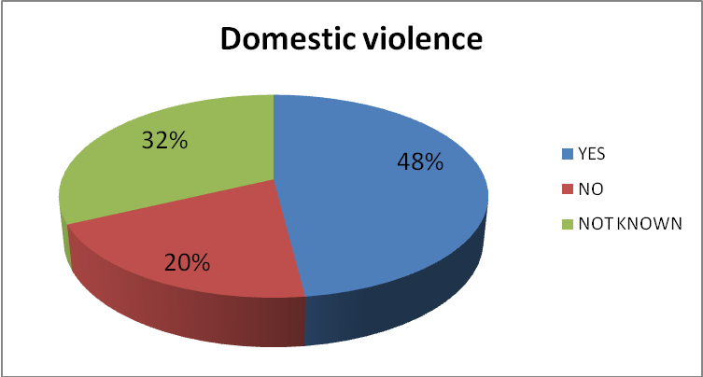
Figure: 2010/11 data recorded about the presence of domestic violence for women admitted to the mother & baby unit

PART 2: The community services around the mothers & babies
As noted above, in 2010/11 the majority of admissions (18/26; 69%) were already known to secondary mental health services. Of these admissions, the figure below shows the number of admissions per Sussex locality. The highest number of admissions stemmed from Northern West Sussex (Horsham/Crawley/Mid-Sussex) and Eastbourne & Wield. Both of these areas have local well established perinatal clinics.
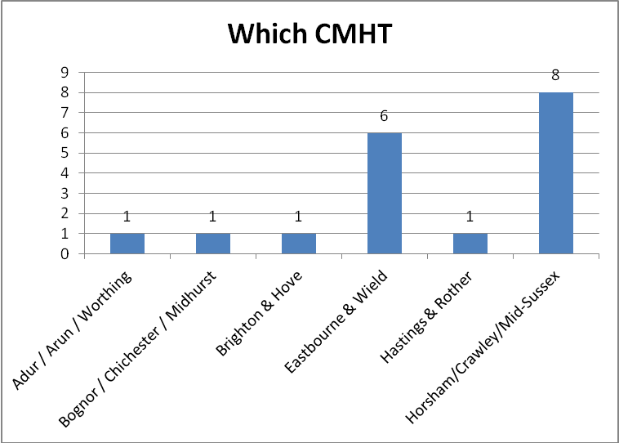
Figure: The number of admissions originating from each locality area in Sussex in the 2010/11 sample (where a CMHT is involved)
For the majority of admissions, mothers came from their own homes, and this is consistent across both audits (13/23; 56% in 2007/8; 15/26; 58% in 2010/11). Data suggests that in 2010/11, all referrals originated from services with responsibility for emergency, crisis or acute psychiatric conditions (16/26; 62%) or from secondary care, including an Assertive Outreach Team (for one mother) (8/26; 31%). Of the remaining 2 referrals, 1 came from an Access Team (which tend to straddle the boundary between primary and secondary mental health) and 1 from the Specialist Perinatal Mental Health Service, which was early on in this new team’s existence.
Most women who already had a Care Coordinator were in contact with them prior to admission, and remained in contact with them during their time at the mother and baby unit. During admission, most women who did not have Care Coordinators did have one identified by the time of discharge, which suggests that the CMHTs took a proactive stance to engaging women not previously in receipt of secondary mental health care at admission.
For 13 of these women, non-mental health services were also involved in their care, including Social Services for all 13 and a combination of Social Services and police (4), a domestic violence service (1), a transition team (1) and the Early Intervention in Psychosis Team (1).

PART 3: Cost and length of the admission
A breakdown of the total cost of admissions divided by Sussex locality is presented in the table below summarising data for both audits. As can be seen from the data, change in spend over time is not consistent across Sussex. Costs in Brighton & Hove have dropped dramatically; West Sussex remains about the same; whilst in East Sussex costs have pretty much doubled (as have number of admissions).

Cost of perinatal admissions by locality | 1st April 2007 - 15th Nov 2008 | 1st April 2010 - 16th Nov 2011
East Sussex | 103,540.50 | 224,246
Brighton and Hove | 114,435.00 | 55,011
West Sussex | 361,421.25 | 358,984
Total Cost Trust wide | 579,396.75 | 638,241
Table: Comparison of total cost of mother and baby admissions during the two 18-month audit periods by locality
The Table below compares the two time samples against length of admission in weeks. It can be seen from this that in 2009, where there were 23 admissions of 21 women, 9/23 (39%) of these went beyond the target 6 weeks compared with 12/26 (46%) more recently. In terms of the target that no admission should be for longer than 6 weeks, it can be seen that this was met in only 14/26 (54%) of cases; whereas 12/26 (46%) of admissions went beyond this target, the longest admission being over 10 weeks. There was an association between length of stay and Mental Health Act status of the mothers; where a mother was on Section, the admission was longer.
Length of admission in weeks | 2007/2008 number of women | Percentage | 2010/2011 number of women | Percentage
1-2 weeks | 1 | 4.35% | 2 | 7.69%
2-3 weeks | - | - | 3 | 11.00%
3-4 weeks | 1 | 4.35% | 1 | 3.85%
4-5 weeks | 1 | 4.35% | - | -
5-6 weeks | 2 | 8.70% | 2 | 7.69%
6 weeks | 9 | 39.13% | 6 | 23.08%
6-7 weeks | 3 | 13.04% | 2 | 7.69%
7-8 weeks | 2 | 8.70% | 1 | 3.85%
8-9 weeks | 2 | 8.70% | 2 | 7.69%
9-10 weeks | 1 | 4.35% | 6 | 23.08%
10-11 weeks | - | - | 1 | 3.85%
11-12 weeks | - | - | - | -
12-13 weeks | 1 | 4.35% | - | -
Table: Comparison of length of stay in the mother and baby unit in the two audit samples

Section 4
4.1 Conclusion
This re-audit has been successful in its aims of providing data about all admissions to a mother and baby unit for women with severe mental health problems in Sussex. The number of admissions remains much less than would be nationally predicted, so future audits might want to focus on what it is that we are doing in Sussex, within our community, acute & crisis teams, that is preventing admissions and enabling women to remain within their local community. However, where a mother is admitted alone into a psychiatric unit, we should focus on the standards of care that enable families to manage this separation. Services need to remain mindful of the potential longer term implications of early separation of mother and baby if not well managed, yet at the same time weigh this up against the potential harm of a very ill mother remaining within her family. A useful piece of work for the new Perinatal Service would be to work with our community services to help develop good standards for community care of these mothers and their families.

Of the women who were admitted, data suggests they were all of appropriate severity and in some cases domestic violence was noted as a risk factor. It would be useful to focus on complicating social factors (NICE, 2010), such as domestic violence, drug misuse, migrants & refugees, and younger women under 18, in future audits, as these factors are known to affect how these women gain access to services. Some proactive local project work might help us think about how well we manage to engage women with complex and complicating social factors as well as severe mental health problems.
Although funding for the new PNMHS is not consistent, nor is it secure, across the whole of Sussex, the next audit should look at opening out the data sample to community referrals. This would be able to evidence whether or not the new Clinical Network of practitioners and psychiatrists is impacting on the clinical management of severe mental health disorders during pregnancy and after birth. Key clinical outcomes for SPMHS includes the early detection and prediction of women who may be vulnerable to serious and risky mental health problems as a consequence of pregnancy and giving birth; specialist medical advice, signposting and assessment; community follow up; consultation and advice to community teams and other professionals; interfacing with primary care and acute medical settings, particularly around training; and gate keeping, monitoring and follow up of mothers and babies admitted to specialist mother and baby inpatient facilities. This lends itself well to future audits,

5. References

Denny, R., Delves, E. and McLaren, P. Perinatal Admissions Audit. Unpublished audit, January 2009, Sussex Partnership NHS Foundation Trust.

Holmes, J. (1993). John Bowlby & Attachment Theory. London: Routledge.

Mezey, G C. (1997). Domestic violence in pregnancy. In S Bewley et al. Violence against women. p 121. London: RCOG.

National Collaboration Centre for Mental Health (2007). Antenatal and postnatal mental health: The NICE guideline on clinical management and service management. Published by the British Psychological Society and the Royal College of Psychiatrists.

NICE (2008). Antenatal and postnatal mental health: Clinical management and service guidance. National Institute for Health and Clinical Excellence: London. Reissued April 2007. http://www.nice.org.uk/media/242/1D/AntenatalPostnatalMentalHealthServicesCommissioningGuide.pdf

NICE (2010). Pregnancy and complex social factors: A model for service provision for pregnant women with complex social factors. National Institute for Health and Clinical Excellence: London.
http://www.nice.org.uk/nicemedia/live/13167/50822/50822.pdf

Stoddard, K. (2010). Birth statistics: Birth and fertility rates across England and Wales. http://www.guardian.co.uk/news/datablog/2010/may/25/birth-rate-statistics-england-wales#data posted 25th May 2010

Appendix 6: Summary tables and figures of audit data

Admissions to mother and baby unit by PCT locality
Sussex locality | Number of admissions 2007-2008 | Percentage | Number of admissions 2010-2011 | Percentage
Brighton & Hove | 5 | 24% | 2 | 8%
East Sussex | 4 | 19% | 8 | 32%
West Sussex | 12 | 57% | 15 | 60%
Total | 21 |  | 25
Table: Comparison admission rates across the two 19 month audit periods by locality

PART 1: The Mother and Babies

Mother’s Age Group
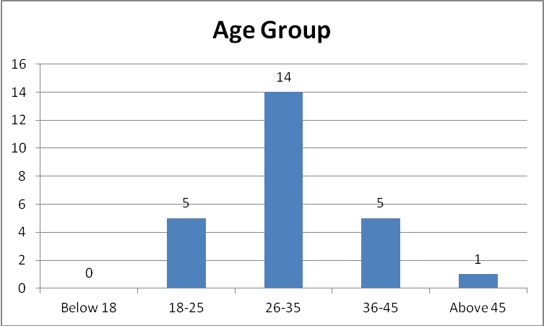
Figure: Admissions to the mother and baby unit by age group 2010-2011

Age group | Number admitted 2007-2008 | Percentage | Number admitted 2010-2011 | Percentage
Below 18 | - | - | - | -
18-25 | 7 | 33% | 5 | 20%
26-35 | 10 | 48% | 14 | 56%
36-45 | 4 | 19% | 5 | 20%
Above 45 | - | - | 1 | 4%
Total | 21 |  | 25
Table: A comparison of the age groups of mothers admitted to a specialist mother and baby unit during the two 19 month audit periods
Ethnicity

Ethnic group | 2007-2008 | Percentage | 2010-2011 | Percentage
White - British | 17 | 81% | 21 | 84%
White - Any other white background | 1 | 5% | 1 | 4%
Black or Black British - African | 2 | 9% | 1 | 4%
Asian or Asian British - Pakistani | 1 | 5% | 1 | 4%
Any other ethnic group | - | - | 1 | 4%
Total | 21 |  | 25
Table: A comparison of the ethnicity of all mothers admitted to a specialist mother and baby unit during the two 19 month audit periods

Relationship status of mothers admitted during this period
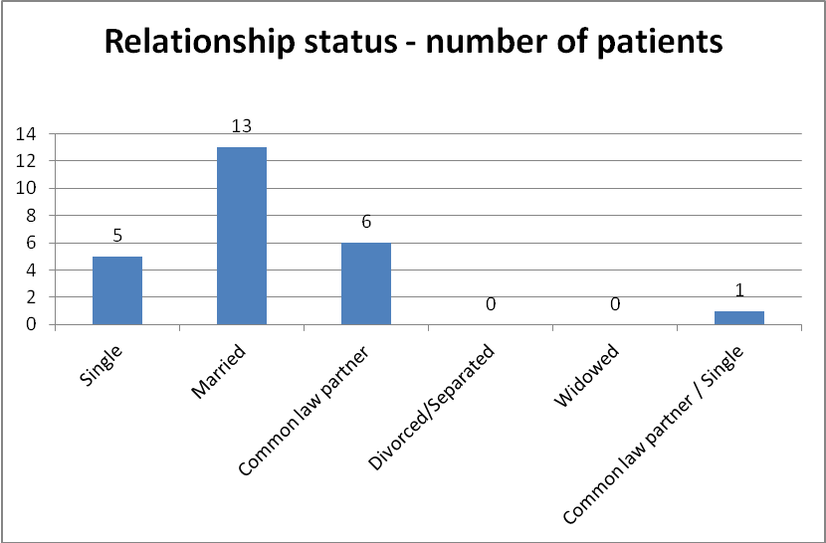
Figure: Breakdown of the relationship status of admitted women over 19 months between 2010 and 2011

Other children in the household
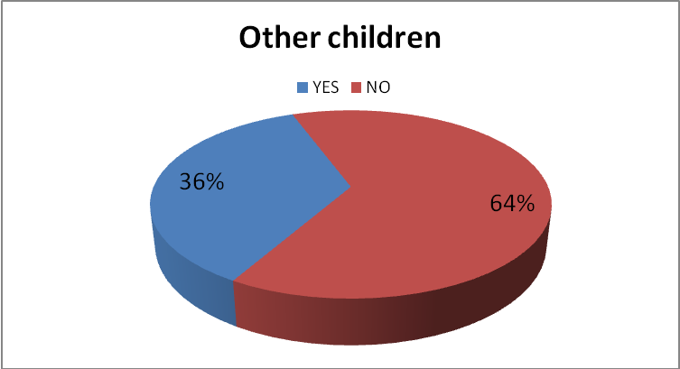
Figure: Summary of the percentage of women with more than one child at the time of admission to the mother and baby unit

Diagnostic grouping of the 2010 to 2011 admissions

Diagnosis on admission | 2007-2008 | 2010-2011
Postnatal depression | 10 | 10
Puerperal psychosis | 6 | 10
Bipolar affective disorder | 2 | 2
PTSD | 1 | -
Paranoid schizophrenia | 1 | -
Persistent delusional disorder | - | 1
Schizoaffective disorder | - | 2
Other | 1 | -

Table : A comparison of the diagnostic categories by number of women on admission in the two audit samples

An overview of the baby at admission

Age of baby on admission | 2007-2008 Number | Percentage | 2010-2011 Number | Percentage
Admission before birth | - | - | 2 | 7.69%
0 -1 month | 10 | 43% | 12 | 46.15%
1 - 2 months | 4 | 17% | 5 | 19.23%
2 - 3 months | 2 | 9% | 2 | 7.69%
3 - 4 months | 2 | 9% | 2 | 7.69%
4 - 5 months | 2 | 9% | - | -
5 - 6 months | - | - | - | -
6 - 7 months | 1 | 4% | 1 | 3.85%
More than 25 weeks | 2 | 9% | 2 | 7.69%
Total | 23 |  | 26
Table: A comparison of the age of the baby at admission for the two audits

Circumstances surrounding the admission: Mental Health Act

Mental Health Act status | 2007-2008 number | 2007-2008 percentage | 2010-2011 number | 2010-2011 percentage
Informal | 15 | 71.43% | 20 | 80%
Section 2 | 3 | 14.29% | 4 | 16%
Section 3 | 3 | 14.29% | 1 | 4%
Total | 21 |  | 25
Table: A comparison of the Mental Health Act status at admission for the two audits

What proportion of these women had pre-existing mental health problems in the 2010-2011 sample?
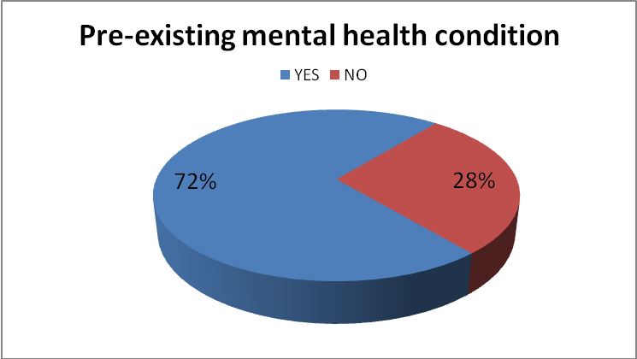
Figure: Percentage of women known to have pre-existing mental health problems prior to admission to the mother and baby unit

Additional risk factors: Domestic violence

Figure: Percentage of women who had experienced domestic violence

PART 2: The community services around the mother and babies

Where did referrals originate from?
Place prior to admission | 2007 to 2008 Number | Percentage | 2010 to 2011 Number | Percentage
Home | 13 | 56% | 15 | 58%
A& E | 2 | 9% | 5 | 19%
Psychiatric Hospital | 7 | 30% | 5 | 19%
Section 136 suite | - | - | 1 | 4%
Maternity | 1 | 5%
Total | 23 |  | 26
Table: A comparison of where the mother was residing prior to admission for the two samples

Figure: The number of admissions originating from each respective CMHT for the 2010/11 sample (where a CMHT is involved)

Contact with CMHT Care Coordinators

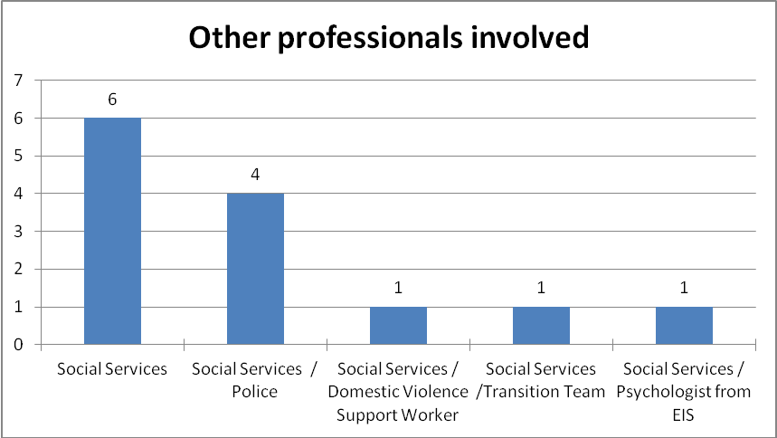
Figure: Overview of non-mental health teams involved for 13 women from the 2010/11 cohort of admissions

PART 3: Cost & length of the admission

Total cost of admissions to the mother and baby unit by locality for the two audits
Cost of perinatal admissions by locality | 1st April 2007 - 15th Nov 2008 | 1st April 2010 - 16th Nov 2011
East Sussex | 103,540.50 | 224,246
Brighton and Hove | 114,435.00 | 55,011
West Sussex | 361,421.25 | 358,984
Total Cost Trust wide | 579,396.75 | 638,241
Table: Comparison of total cost of mother and baby admissions during the two 18-month audit periods by locality

Length of the admission
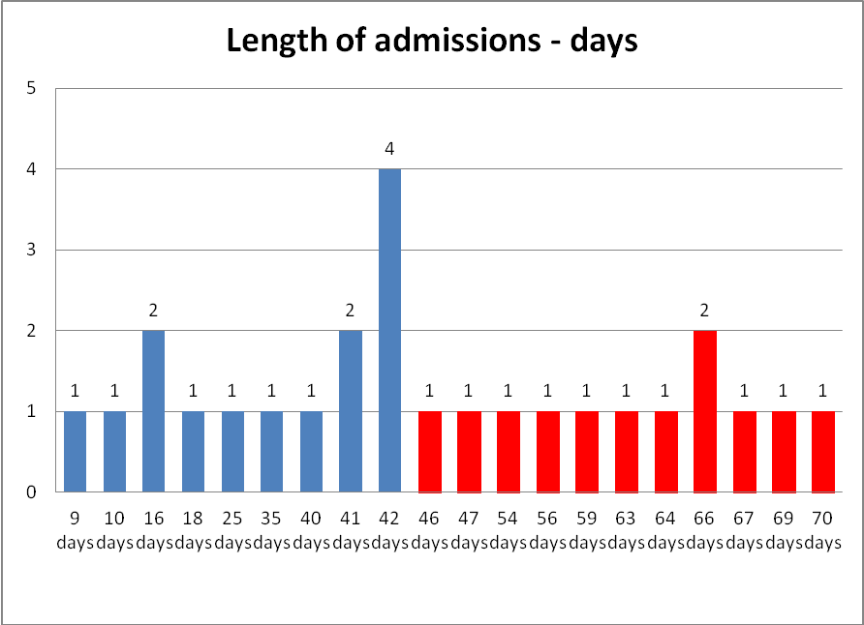
Figure: Length of admission in days for the 2010 to 2011 sample

Length of admission in weeks | 2007/2008 number of women | Percentage | 2010/2011 number of women | Percentage
1-2 weeks | 1 | 4.35% | 2 | 7.69%
2-3 weeks | - | - | 3 | 11.00%
3-4 weeks | 1 | 4.35% | 1 | 3.85%
4-5 weeks | 1 | 4.35% | - | -
5-6 weeks | 2 | 8.70% | 2 | 7.69%
6 weeks | 9 | 39.13% | 6 | 23.08%
6-7 weeks | 3 | 13.04% | 2 | 7.69%
7-8 weeks | 2 | 8.70% | 1 | 3.85%
8-9 weeks | 2 | 8.70% | 2 | 7.69%
9-10 weeks | 1 | 4.35% | 6 | 23.08%
10-11 weeks | - | - | 1 | 3.85%
11-12 weeks | - | - | - | -
12-13 weeks | 1 | 4.35% | - | -
Table: Comparison of length of stay in the mother and baby unit in the two audit samples

Appendix 6.2

Perinatal Audit Tool

PIMS ID: ………………………………………...

PCT (Locality)
- West Sussex
- East Sussex
- Brighton & Hove

Age Group
- Below 18 (please specify): ………….
- 18 – 25
- 26 – 35
- 36 – 45
- Above 45 (please specify): …………

Ethnicity:

White
- British
- Irish
- Any other white background

Black or Black British
- African
- Caribbean
- Any other Black background

Asian or Asian Births
- Indian
- Pakistani
- Bangladeshi
- Any other Asian Background

Chinese or other ethnic group
- Chinese
- Any other ethnic group

Mixed
- White and Black Caribbean
- White and Black African
- Any other mixed background

Relationship status
- Single
- Married
- Common law partner (living with father of child)
- Divorced/Separated
- Widowed

Living conditions
- Living alone
- Living with others (please specify):
………………………………………………………………………………………………………………………………………………………………………………………………………………

Has this person got other children?

- No
- Yes (please specify any information known about other children):
………………………………………………………………………………………………………………………………………………………………………………………………………………

Diagnosis as specified in the notes:
……………………………………………………………………………………………………………………………………………………………………………………………………………………….

Is this person known to have a pre-existing mental health condition?
……………………………………………………………………………………………………………………………………………………………………………………………………….………………

Is there a known history of domestic violence?

- No
- Yes
- Not known

- Admission / Length of stay

  - Date of admission: ………………………………….
  - Time of admission: .................................................
  - Date of discharge: …………………………………..
  - Length of stay (weeks): ……………………………

- Mental Health Status during admission

- Section 2
- Section 3
- Informal
- Other (please specify): ………

- Reason for admission

Brief summary of information from case notes leading up to admission:
……………………………………………………………………………………………………………………………………………………………………………………………………………………………………………………………………………………………………………………………………………………………………………………………………………………………………………………………………………………………………………………………………………………………………………………………………………………………………………………………………………………………………………………………………………………………………………………………

- Person making the referral

  - Specify professional group of person making the referral (e.g. GP, psychiatrist, general nurse, psychiatric nurse, social worker etc): :…………………………………………………………………………………………………………………………………………………………………………………………………………

  - Specify where this person works? (e.g. A&E/Maternity/CMHT/GP surgery etc): …………………………………………………………………………………………………………………………………………………………………………………………………………

- Place residing immediately prior to admission

- General hospital
- Psychiatric hospital
- Home
- Other (please specify): ………………………………………………………………………….

- Known to Psychiatric CMHT/Recovery Team

- No (if ticked go to 8)
- Yes (if ticked go to 7)

- Which CMHT area is patient from?

- Adur /Arun/Worthing
- Bognor/Chichester/Midhurst
- Horsham/Crawley/Mid-Sussex
- Brighton & Hove
- Eastbourne & Wield
- Hastings & Rother
- Unsure (note area from address):
………………………………………………………………………………………………………………………………………………………………………………………………………………

- Care co-ordinator and contact with care co-ordinator

  - Has there been an identified care co-ordinator before admission?
- No
- Yes

  - Has there been any mental health contact with the patient prior to admission?
- No
- Yes

  - Has there been any contact during admission?
- No
- Yes

  - Please specify form of contact with patient by psychiatric team during admission:
- CPA review
- Discharge planning meeting
- Phone
- Visit to placement
- Letter contact

  - Any other professional(s) involved?
- No
- Yes (please give details): ………………………………………………………………………………………………………………………………………………………………………………………………………………

- Contact with specialist perinatal MH service (SPMHS)

  - Has there been contact with SPMHS?
- No
- Yes
- Service not in place

  - Type of contact
- Inpatient
- Phone
- Outreach
- Community Perinatal Clinic
- Other (please specify): …………………………………………………………………………..

- Social situation

Is there support from family/extended family/others?
- No
- Yes (please give details): ……………………………………………………………………………………………………………………………………………………………………………………………………………………………………………………………………………………………………………………………………………………………………………………………………………………………………………………………………………………………………………………………………….

- Baby

  - Age of baby on admission: ……………………………………………………………………..

  - Is it the first admission?
- No
- Yes

  - If no, was there planning in pregnancy to support mother post natally?
- No
- Yes

  - Reason for admission if baby over 6 months (please give details): ………………………………………………………………………………………………………………………………………………………………………………………………………………………………………………………………………………………………………………

- Treatment plan while inpatient
Please give details (include ECT, medication, psychological therapy etc.): ………………………………………………………………………………………………………………………………………………………………………………………………………………………………………………………………………………………………………………………………

- Discharge destination

  - Mother’s discharge destination
- Home
- Psychiatric facility
- Other (please give details): ……………………………………………………………………………………………………………………………………………………………………………………………………………………

  - Baby’s discharge destination
- With mother
- Other (please give details): ……………………………………………………………………………………………………………………………………………………………………………………………………………………
- Future admissions following mother & baby placement

- No
- Yes (please give details): ………………………………………………………………………………………………………………………………………………………………………………………………………………

- Cost of placement

£……………………………….




Appendix 6.3 CLINICAL AUDIT REGISTRATION FORM

All clinical audit projects should be registered before they start with the Governance Support Team. Please forward your proposal to the Governance Support Team for approval.(see www.sussexpartnership.nhs.uk/staff-pages/corporate-services/health--social-care-governance/audit-and-effectiveness-department for contact details).

Your Details: Audit Lead

Name: Dr Brian Solts
Base: Specialist Services, 79 Buckingham Road, Brighton BN1 3RJ
Position / Job Title: Clinical Lead / Consultant Clinical Psychologist
Care Group (e.g. OPMH):Specialist Services
Team / Unit (e.g. CMHT or Ward): Perinatal Service
Tel: 07920 283 854
Email: brian.solts@sussexpartnership.nhs.uk

Who will be involved in the audit and their responsibilities? (please tick)

Audit Team |  | Responsibilities
Service users |  |  | Refer to Trust PALS Team if need to find representative
Carers |  |  | Refer to Trust PALS Team if need to find representative
Medical staff
Social Services
Nursing Staff
Psychology | √ | Brian Solts- Supervisor
Managers
Other (please specify) | √ | Anna Zinkiewicz – Conducting Audit

Is the audit? (please tick)

Trust wide |  | Care Group |  | Other | √

Is it? (please tick)

An initial audit |  | Re-audit | √ | Baseline audit

Introduction (brief outline of why audit needs to take place) (please tick)

High risk | √ | Complaints |  | Publication of new guidance |  | Publication of new policy
High cost | √ | High priority |  | High volume service |  | Local concern
Other (please specify)
Further details:

It is essential to monitor the use of Mother and baby inpatient beds and evaluate the impact of the new Perinatal
Service on admissions.

What are the standards against which you’ll be measuring? (please tick)

NICE Guidelines | √ | Trust Policy / Procedure | √
Service user views |  | Local Guidelines / Policies
Literature Searches |  | Other (please specify) Previous audit of service | √

If there are no existing standards, is it your intention to set standards as a result of this audit
√

YES NO Not applicable

How will you be collecting the six equality strands data?(race, disability, gender, age, sexual orientation, religion and belief)?

Data Collection Tool YES NO
√
If no, you will need to highlight what support you require to collect equality related data

Further information on standards and standard setting:

Audit aims & objectives
To collect and evaluate data regarding Perinatal inpatient admissions

- To look at demographic trends in admissions
- To gain perspective on the types of illness that precipitate a mother and baby admission
- To gather data on recovery
- To collect data on the impact of the specialist perinatal mental health service on perinatal occupied
Bed days.

Methodology
Data collection (how will the information be collected) (please tick)
Record keeping / file audit | √ | Staff questionnaire
Service user / carer questionnaire |  | Other (please specify)
Further methodology details:

Ethical considerations (have ethics been discussed and implications considered)

Yes- ongoing team discussions of findings should difficult issues emerge from the data
Allocated time in clinical supervision group to discuss this with the honorary research assistant, Anna Zinkiewicz
Although Anna is doing this in her own time, she is a permanent member of the Trust working at Langley Green, undertaking this audit to gain experience under supervision.

All data recorded will be anonymous and files/ notes will remain stored securely at the inpatient clinic.

How will the information collected be kept securely?

Time-scales / action plan

Proposed audit start date: August 2011
Do you have an action plan for carrying out the audit? YES NO
√

If yes, please outline (if NO, please see note 4 on page 5)

May 2011: Following request from commissioners, it was agreed that one of the service standards for the
funding of the perinatal team was continuous audit against national standards. Also, we are responsible for the out of area budget, so need to gather this data routinely to ensure value for money for tax payers. Roles agreed: Brian would support and supervise Anna.
June 2011: Revisited previous audit and Brian and Anna (alongside Team Leader, Rachel Denny) update the previous audit questions and develop new schedule based on previous year.
July to November: Planned data gathering, unfortunately Anna had period of sickness which pushed back this period of data gathering.
November to December 2011: Analysis of data
December to January 2012: Presentation of data in report and dissemination to Specialist Services Management Team and report to go out to Commissioners.

What assistance is required from the Governance Support Team? (please tick)

Advice or support with tool design |  | Advice or support with data analysis
Advise or support with report writing |  | Advice or support with action planning
Other (please specify |  | None | √

Has this project been agreed by your line manager? (please tick)

YES | √ | NO

Notes

- The audit data and results are the property of Sussex Partnership NHS Foundation Trust and not the
audit lead. Once you have submitted your audit proposal you will be contacted by the Governance Support Team
to discuss and approve the audit.

- Please attach any other documents relevant to the audit (e.g. audit tools, surveys).

- If you do not have an action plan for conducting the audit, please ensure that when you do have an
action plan you forward it to the Governance Support Team.

- Please ensure that all audit data collected remains anonymised and that all audit reports contains
anonymised results.

You need to forward the completed report with a summary of the findings to the Governance Support Team. You can find the contact details on the trust website, or go straight to:
www.sussexpartnership.nhs.uk/staff-pages/corporate-services/health--social-care-governance/audit-and-effectiveness-department

- Please see the Governance Support Team website for study guides and further information
http://www.sussexpartnership.nhs.uk/staff-pages/corporate-services/health--social-care-governance/audit-
and-effectiveness-department
or follow the link from the Intranet:
Corporate services > Health & Social Care Governance > Audit & Effectiveness Department

Signature:  Date: 5.10.11

APPENDIX 6.4
Specialist Perinatal Mental Health Services
Sussex Partnership has been commissioned in East Sussex to provide a Specialist Perinatal Mental Health Service (SPMHS).

The service will target antenatal women who develop mental health problems related to pregnancy, women with post natal mental illness and women with pre existing psychiatric disorder. The SPMHS will work with women throughout their pregnancy until one year post childbirth. The team will accept referrals for women who are experiencing severe mental health problems, but will also offer telephone advice, information and signposting for health professionals working with women with less severe presentations.

The SPMHS aims to improve detection and recovery outcomes for this group, as well as reducing the risk of the individual needing crisis intervention and reducing the need for hospital admissions.

SPMHS is going to be providing weekly clinics across East Sussex, and from the end of July will be offering these in Bexhill and Eastbourne. The clinics will offer assessment and follow up treatment from Consultant Psychiatrists and Mental Health Practitioners. The mental health practitioners will also work in the community and in collaboration with other teams/ services as required.

Who to refer (see pathway on reverse for Health Visitors and Midwives), Mental Health services can refer direct:
Women with….
- Presence or history of puerperal psychosis
- History of/current schizophrenia or bi-polar disorder
- Previous severe depression that warranted hospital admission and or multiple presentations of mental health difficulty
- Current severe depression

Our community service can not take referrals for anyone needing urgent psychiatric attention- this is not an emergency service and they should be directed to usual emergency care routes. Should an inpatient mother and baby admission become necessary, the SPMHS should be contacted as we arrange and monitor admissions and work with women, their families and care teams to promote recovery and safe discharge home.

How to refer
Complete the referral form (attached) but soon to be available on line and send to: The Specialist Perinatal Mental Health Services (SPMHS) Highmore Western Road Hailsham East Sussex BN27 3DY (Fax: 01323 446069)

Please feel free to call for advice or to discuss potential referrals:

Trisha Clark- Perinatal Team Administrator Tel: 01323 446065 extn 270 Fax: 01323 446069 (safehaven) trisha.clark@sussexpartnership.nhs.uk

Melissa Johnson Specialist Perinatal Mental Health Practitioner- East Sussex
Tel: 07825 114383 melissa.johnson@sussexpartnership.nhs.uk

Rachel Denny Specialist Perinatal Service Team Leader Tel: 07826 953 872 rachel.denny@sussexpartnership.nhs.uk

This service was not commissioned for people residing in Brighton & Hove
Consultant Psychiatry time comes from existing resource and forms part of agreed planned activity; additional funding provides 0.6wte Band 7 and 1.4wte Band 6 of practitioner time plus secretarial time

