Implementing alcohol screening and brief intervention (ASBI) into the routine practice of a hospital endoscopy outpatient department.
Service Evaluation

Draft Protocol

January 2013

Gill O’Neill
Public Health Specialty Registrar
Newcastle University: Institute of Health and Society
Background
Policy context
NICE (2010) public health guidance (24) identifies the importance of NHS professionals routinely carrying out alcohol screening as an integral part of practice. Where screening the whole population is not feasible, professionals should focus on groups that may be at increased risk of harm from alcohol, such as those with gastrointestinal symptoms. Adults who have been identified as ‘hazardous’ or ‘increasing risk’ drinkers should be offered a brief intervention from staff who have been trained.
The Government’s Alcohol Strategy (HO 2012) endorses the NICE guidance and supports the embedding of alcohol use identification and brief advice (IBA) in a variety of settings, including secondary care.
Environmental context
Newcastle Upon Tyne Hospitals (NUTH) Foundation Trust hosts a multi-disciplinary Public Health Trust Group (PHTG) chaired by Frances Blackburn. The remit of this group is to ensure health improvement targets are systematically integrated into the structure and function of the hospital setting through a coordinated action plan. As alcohol is one of the PHTG’s priority areas they are committed to the proposed service evaluation and are keen to consider recommendations emerging from the work.
Earlier in 2012 NUTH participated in a rapid service improvement pilot to implement alcohol screening and brief advice into their pre-anaesthetic admissions clinic. This was a public health led intervention and demonstrated the feasibility of including alcohol screening and brief advice into a busy outpatient clinic. The initial results of the rapid pilot indicated that staff’s knowledge about the health effects of alcohol increased through the completion of the Alcohol Learning Centre e-learning module. Staff’s confidence to hold conversations with patients about alcohol also increased. When staff were asked if it was achievable to include a conversation about alcohol in their general patient assessment 8 out of 10 staff stated that it was achievable.
Alcohol screening and brief intervention (ASBI) is now in the process of being included into NUTH pre-anaesthetic admissions standard documentation. Learning from this small pilot has enabled the second wave of implementation to be progressed. Lead clinicians within NUTH, such as Dr Steve Masson, were keen to participate in a more methodologically robust project which could be published in order to share learning.
Within NUTH e-learning is the preferred medium to implement staff continued professional development. Whilst e-learning is not always a popular choice with staff, as borne out in the first pilot, NUTH utilise e-learning as a standard mechanism for training and so it is essential to accommodate corporate policies and procedures into this service evaluation.
Rationale
Alcohol Consumption and interventions

Approximately two billion people worldwide consume alcoholic beverages and over 76 million people have alcohol use disorders (Rehm et al, 2009). Alcohol is responsible for about 2.3 million premature deaths worldwide (Boffetta et al, 2006).

Whilst males and females in the North East of England tend to drink to a similar frequency as that of the national population when they drink, they drink more. Both males and females in the North East had the highest average unit consumption on any day in the last week. For males the average was 9.3 units compared to 7.7 nationally, whilst for females the average was 6.5 units compared to 5.0 nationally. Both these figures were the highest of any of the SHAs in England (Health Survey England 2012).

Hazardous (increasing risk) and harmful (higher risk) drinking is a major contributor to ill health, not just dependant drinking (McQueen et al 2011). There are over 60 different diseases associated with alcohol consumption, not all of which require admission to hospital (Babor et al, 2001). Whilst there are mechanisms to monitor the impact alcohol has on hospital admissions through the wholly and partially attributable codes (Jones et al, 2008), outpatient appointments could also be triggered due to risky alcohol consumption. It is therefore of importance to screen patients who attend outpatient appointments with conditions possibly associated with risky alcohol consumption.

Recent national research (Kaner et al 2013, Newbury-Birch et al, 2009; Coulton et al, 2009) has highlighted the beneficial impact of screening the adult population for risky alcohol consumption and providing feedback/brief advice, resulting in the subsequent reduction of alcohol consumption in one in seven people. Whilst the evidence demonstrates impact within the primary care setting as well as accident and emergency departments and probation, little work has been undertaken within the context of hospital outpatient departments. When considering which outpatient department to focus on, the published literature on the epidemiology of alcohol and associated diseases was reviewed. In partnership with key stakeholders at NUTH, endoscopy was deemed to be an appropriate department due to the association between moderate to heavy alcohol use and gastrointestinal disease, including various types of cancer. Within an endoscopy appointment there is a health improvement opportunity to discuss alcohol consumption and prevent/reduce ongoing damage caused by risky drinking.
Alcohol and gastrointestinal disease
A causal link has been established between risky alcohol consumption and cancers of the oral cavity, oesophagus, colon, rectum, liver, larynx and breast. For other cancers a causal association is suspected (Fedriko et al 2011, Parkin, 2011, Parry et al, 2011 Boffetta et al 2006).
Fedirko et al (2011) conducted a dose response meta-analysis to consider the association between alcohol consumption and colorectal cancer risk. The study found a 7% increased risk with consuming as little as 10g of ethanol a day (aprox one drink). The risk increased to 21% for moderate drinkers consuming 2 - 3 drinks per day (12.6 – 49.9g ethanol per day) and 52% increased risk for those drinking heavily of more than 4 drinks per day (≥50g ethanol per day).
Alcohol consumption can interfere with the function of all parts of the gastrointestinal tract (Bode & Bode, 1997). Teyssen & Manfred (2003) cite a mixed evidence base for the association between alcohol and gastro-oesophageal reflux disease symptoms (heart burn and regurgitation). More recent studies however have highlighted statistically significant associations between increased alcohol consumption and gastro-oesophageal reflux disease which affects approximately 10 - 21% of the Western population (Akiyama et al 2008, Mohammed et al 2005;).
Oesophageal bleeding, Gastritis, stomach lesions, intestinal problems such as irritable bowel syndrome (IBS) and Diverticulitis have all been associated with frequent alcohol consumption but with a mixed underlying evidence base (Helium 2012).
Aim
The aim of this service evaluation is to assess the extent to which it is feasible to implement alcohol screening (10 question AUDIT) and brief intervention into a busy endoscopy outpatient department as a part of routine hospital clinical practice.
Objectives
- To undertake a rapid review of the literature regarding how to implement evidence based practice into routine hospital care
  - Outcome: An in-depth overview of implementation theory will aid understanding in how to develop the most practical way to embed alcohol screening and brief advice into endoscopy outpatient dept

- To provide a brief epidemiological summary of the relationship between alcohol consumption and gastrointestinal disease (including colorectal cancer)
  - Outcome: Sharing knowledge on the association between alcohol and gastrointestinal disease will ensure intervention can be tailored to nurse specialist interest

- To ensure regular communication is maintained throughout the period of the project through the development of a time limited stakeholder steering group
  - Outcome: Stakeholder steering group will ensure ownership of project

- To undertake a brief ethnographic study of a patient’s journey for both bowel screening and symptomatic referral to assess where in the patient’s pathway alcohol screening and brief advice should take place
  - Outcome: To identify the best opportunity to include alcohol screening and brief advice into mainstream assessment paperwork

- To plan, develop and roll out training for staff teams through the development of a standardised toolkit
  - Outcome: Feedback on training will provide a mechanism to develop an ‘off the shelf’ template to other outpatient departments

- To develop, pragmatically pilot and utilise a data collection template
  - Outcome: A pragmatic data collection process that is user friendly with a minimum dataset is more likely to be completed

- To develop, facilitate the delivery of and analyse a pre and post training and post three month pilot staff questionnaire and focus groups to ascertain attitudes, values and beliefs for implementing alcohol screening and brief advice in a routine hospital outpatient setting
  - Outcome: Pre and post questionnaires can demonstrate a change in knowledge, attitudes, values and beliefs for staff group engaged. Focus group will draw out the more in-depth feelings on barriers and facilitators to implementation

- To provide regular feedback and engagement from clinical champions to maintain motivation for project
  - Outcome: Review the ‘added value’ of audit and feedback loop as part of the three month pilot to assess if this should be part of implementation intervention

- To administer a three month pilot of whole nursing team delivering alcohol screening and brief intervention (ASBI) to all patients with regular feedback to nurses on initial data outcomes built in
  - Outcome: Pilot will highlight some barriers and facilitators to implementing alcohol screening and brief advice in a hospital outpatient department

- To undertake data analysis to complete process evaluation
  - Outcome: Data analysis will measure outputs and outcomes

- To develop recommendations to enable NUTH’s Senior Management Team to make informed decisions regarding how to implement alcohol screening and brief advice as part of routine care
  - Outcome: Final report presented to NUTH PH Trust Group

Theoretical Perspective
The purpose of this service evaluation is not to ascertain if alcohol screening and brief advice is effective because this has been proven in other published studies (Kaner 2007). Instead, the purpose of this evaluation is to assess the extent to which it is feasible to implement alcohol screening and brief advice into a busy outpatient department as part of routine hospital practice.

Implementation science is the study of methods to promote the systematic uptake of research findings and other evidence based practices into routine practice. It includes the study of influences on health care professional and organisational behaviour (Eccles et al 2009). Behaviour change interventions are typically complex, involving many interactive components (Michie et al 2011). A significant part of successful implementation of professional behaviour change is to have an appreciation of the perceived and real barriers and enablers to embedding evidence based practice into routine care. EPOC (Effective Practice and Organisational Care) have completed numerous systematic reviews assessing the effectiveness of tools/techniques to enable professional behaviour change. It is plausible that by combining some of these tools/techniques professional behaviour change may be more achievable (Grimshaw et al 2012). For the purpose of this service evaluation the following tools/techniques will be applied:

Enablers | Application within evaluation
Educational meetings (Forsetlund et al 2009) | Attending staff team meeting to inform team of pilot  Face to face training input pre and post e-learning module
Local opinion leaders (colleagues that are educationally influential) (Flodgren et al 2010) | Endorsement of pilot from Head of Nursing, Liver Consultant and Alcohol Liaison Nurse Specialists  Key opinion leaders to be part of steering group to progress project
Taylored interventions (Baker et al 2010) | Pre and post e-learning face to face sessions will focus on relevance to endoscopy and gastrointestinal diseases
Audit and feedback (Jamtvedt et al 2010) | Three month pilot will be an audit of implementing alcohol screening and brief advice. Monthly feedback will be provided to staff
Education leaflets (Farmer et al 2011) | Information packs with patient leaflets will be provided for staff to utilise in their patient consultations

Grimshaw et al (2012) summarise some of the identified barriers professionals’ state which can prevent behaviour change. The table below identifies how these barriers will be managed within the service evaluation.

Barriers | Solutions within service evaluation
Poor information management | Pilot will be well managed with all staff aware of process and expectations
Clinical uncertainty | Face to face training, e-learning module and monthly feedback should alleviate any clinical uncertainty
Sense of competence | As above
Perceptions of liability | Essential staff have understanding of local alcohol care pathway to appropriately refer patients when necessary
Patient expectations | Within face to face training staff will be informed of previous studies demonstrating patients’ expectations of being asked about alcohol as part of a general lifestyle overview
Standards of practice | Reinforce NICE guidance
Financial disincentives | Not applicable
Administrative constraints | This needs to be assessed as part of the evaluation for broader implementation

Behavioural sciences have developed and operationalized theories concerned with the determinants of behaviour change. These can be applied to close the gap between evidence and practice (French et al, 2012; Ramsay et al 2010). There are numerous behaviour theories which purport to explain and predict behaviour which renders the selection of one single theory limiting.

Two tools will be utilised within this service evaluation:

- The shortened alcohol and alcohol problems perceptions questionnaire (SAAPPQ) (Anderson et al, 2004) is a validated tool designed to assess the extent to which role security and therapeutic commitment impact upon the effectiveness of training and support to implement alcohol screening and brief intervention (Anderson et al, 2004). The pre and post questionnaires will utilise the 10 questions from this tool to enable comparison to published literature at the end of the service evaluation.

- The theoretical domains framework (TDF) was developed with the aim to simplify and integrate a plethora of behaviour change theories and make theory more accessible (Cane et al 2012). The focus group topic guide will be designed around the TDF 14 domains. The TDF focus groups will assist understanding the barriers to behaviour change and will measure any changes to the perceived barriers once all the enablers have been implemented.

Methods
This service evaluation builds upon the foundations of professional behaviour change theory and implementation science which has been briefly outlined above. A public health intervention such as alcohol screening and the provision of brief advice can be defined as a ‘complex intervention’: numerous components combined within a single programme, generating multiple projected outcomes, necessitating a more complex evaluation process (Craig et al, 2008).
Craig et al (2008) summarise the Medical Research Council’s (MRC) framework for developing and evaluating complex interventions into four main components. It should be noted that the first three phases are iterative processes and do not require a linear progression (Campbell, 2007).
- Development
- Feasibility/piloting
- Evaluation
- Implementation - should be undertaken once the first three phases have been completed

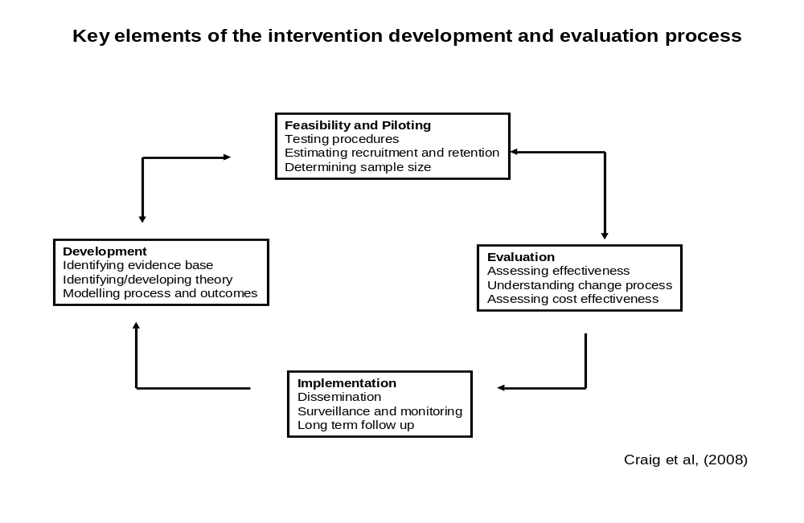
For the purpose of this service level evaluation stages one, two and three will be the focus of attention. Whilst the project is classified as a service level ‘evaluation’ the scope is insufficient in size to demonstrate true ‘effectiveness’. However, the pilot is designed to explore the change process for professionals to embed alcohol screening and brief advice into every day clinical practice. Assessing the feasibility of implementing alcohol screening and brief advice within a busy hospital outpatient department will enable the development of recommendations to NUTH regarding roll out and wider implementation.
The implementation of alcohol screening and brief advice within an endoscopy outpatient department can be evaluated using the MRCs framework alongside Donabedian’s (2005) structure, process outputs and outcome measurements.
Study Design
A service evaluation is to be conducted to determine if alcohol screening and brief advice can be implemented within a busy endoscopy outpatient setting, adhering to evidence based tools and techniques. Whilst the endoscopy nursing staff are the focus of the service evaluation, patient measures are also being collated to assess the extent of implementation.
Structure of service evaluation
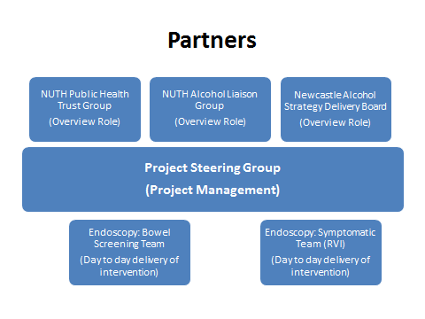
A multi-disciplinary stakeholder steering group will be established to provide a time limited project management function to the service evaluation. Members will include:
- Gill O’Neill, Public Health Specialty Registrar
- Dorothy Newbury-Birch, Alcohol Team Manager, Institute Health and Society
- Dr Steve Masson, Consultant Haematologist, Freeman Hospital, NUTH
- Jill Doyle, Sister Grade Endoscopy, RVI, NUTH
- Elaine Stoker, Advanced Nurse Practitioner National Bowel Screening Programme, NUTH
- Lesley Bewick, Alcohol Liaison Nurse, Freeman Hospital, NUTH
- Helen Rutherford, Alcohol Liaison Nurse, RVI, NUTH
Recruitment of participants
This service evaluation is endorsed by senior management of NUTH. Two nurse leads managing teams will recruit staff teams into service evaluation.
Bowel Screening Team
Context: Newcastle Hospitals Trust and Northumbria HealthCare Trust. RVI, Hexham General, North Tyneside District
Participants:
1x Advanced Nurse Practitioner - lead contact Elaine Stoker
6 x nurses
Symptomatic Endoscopy
Context: RVI endoscopy unit
Participants:
2 x sister grade nurse – lead contact Jill Doyle and Helen Wright
19 x endoscopy nurses

Process of Service Evaluation
Process pathway
- Informal meetings with staff teams
(Early January 2013)
Develop relationships and set parameters for project
2. Establish Steering Group
(January 2013 and hold bi-monthly)
Performance manage the project. Maintain involvement of key stakeholders
3. Observe patient pathway
(January 2013)
Identify when to administer AUDIT questionnaire and nurse to provide feedback/brief advice
4. Pre training questionnaire
(February 2013) Staff to complete SAAPPQ style questionnaire to capture knowledge, attitudes, values and beliefs
5. First Focus Group
(February 2013)
Topic guide to explore perceived barriers and facilitators to implementing alcohol screening and brief advice in routine clinical practice
6. Delivery of face to face training
(Early March 2013)
30 minute face to face training input on:
What the e-learning entails, How the pilot project will run, Confidentiality, What paperwork to use and when, Where to file paperwork, Leaflets/resources to give to patients, Intervention tool for patients, Data collection tool, Storage of data collection tool, Sticker for patient notes, Monthly feedback to team
7. Staff to complete e-learning module
(March 2013) 2.5 hours to complete
8. Second face to face training input
(March 2013)
Pick up on outstanding questions
9. Post training questionnaire
(March 2013)
10. Three month pilot to implement alcohol screening and brief advice (Audit of activity)
(April – June 2013) Provide feedback to patient on AUDIT score and give intervention as required:
Score: 0 – 7 reinforce benefits of low risk drinking
Score: 8 – 15 – provide 2 – 3 minutes structured conversation using brief intervention tool and give patient C4L leaflet
Score 16 – 19 - provide 2 – 3 minutes structured conversation using brief intervention tool and give patient C4L leaflet and signpost to consider other services
Score 20+ - provide 2 – 3 minutes structured conversation using brief intervention tool and give patient C4L leaflet. Confirm care pathway for patients to be referred on to
11. Regular Feedback to staff on progress (Monthly) Collect data sheets on weekly basis for data input
12. Post three month pilot questionnaire
(End of June 2013)
13. Post three month focus group
(End of June/early July 2013)
14 Data Analysis
(July/August 2013)
15. Writing up (July/August 2013)

Patient Involvement
Whilst there is to be no follow up on patient data a minimum dataset of patient demographics is required. This is to assess whether nurses are systematically conducting alcohol screening and brief advice or if there are any patient variables altering implementation.
Patient involvement

Structure | Process | Outputs  (Activity)
PPI engagement  Present pilot project plans to patient/ service user groups pre and post intervention  Patient participants:  All patients attending two endoscopy clinics during the three month pilot  National Bowel Screening patients  Patients who have screened positive from a home test for faecal occult blood and invited in for an investigative colonoscopy  Symptomatic referral patients  Patients referred from primary care or from within hospital setting. This patient group is varied in its symptomology and could require endoscopy or colonoscopy | Patient data:  Gender  Age  Ethnicity  Reason for referral to endoscopy  10 questions Alcohol Use Disorders Identification Tool (AUDIT) – self completed by patient  Patient to receive feedback on AUDIT score from nurse –  Intervention received based on score:  0 – 7 positive reinforcement  8 -15 brief advice + leaflet  16 – 19 brief advice + leaflet + signposting  20+ brief advice + leaflet + referral  Reason for not completing AUDIT or conducting intervention | Screening rate:  Number of patients screened ÷ number of patients seen x 100  Brief intervention (BI) rate  Number of patients scoring 8+ on AUDIT and receiving BI ÷ number of patients scoring 8+ on AUDIT x 100  What proportion of patients:  Completed the self-completion AUDIT questionnaire  Received feedback on AUDIT score  Received a leaflet  Received a brief intervention and leaflet  Received signposting/referral to other services  Did not complete AUDIT questionnaire and recorded reason why  Declined a leaflet  Declined a brief intervention  Declined signposting to other services

Comparator
Currently the endoscopy department do not systematically screen patients for alcohol using a validated tool. As part of a general lifestyle conversation alcohol may be discussed informally with patients or their weekly consumption may be asked. It is therefore not possible to quantify the baseline activity.
Data Collection (appendix one)
Questionnaire: Based on validated SAAPPQ questionnaire, a template has been developed to capture the demographic profile of patients screened / not screened, reason for patient referral to endoscopy, AUDIT score of patient and intervention given (feedback/leaflet/brief advice/signposting/declined) – See appendix x. Data will be collected by GON on a weekly basis to be input into SPSS database.
Focus Groups: Based on the Theoretical Domains Framework (TDF) the topic guide will draw out staff’s perceived barriers and facilitators to implementing alcohol screening and brief advice. Written consent will be sought from nurses participating in focus groups as discussion will be recorded to aid data accuracy.
Data Analysis (Outputs)
Descriptive statistics will be used to provide a summary of:
Proportion of staff:
- Completing pre questionnaire
- Participating in pre and post pilot focus group
- Attending face to face training
- Completing full e-learning module
- Attending face to face training
- Completing post training questionnaire
- Participating in three month pilot
- Attending feedback meetings
- Completing post pilot questionnaire
Questionnaires
An analysis of the three time period questionnaires to consider the proportion of staff whose knowledge, attitudes, values and beliefs have changed throughout the implementation process.
Focus Groups
The focus groups will be analysed using a simple framework analysis model (Rabiee, 2004). Focus groups will be compared pre and post pilot to assess if there have been any changes to attitudes, values and beliefs regarding barriers and facilitators to implementing ASBI in the endoscopy outpatient department.

Risk Assessment
Risk | Likelihood  (low, med, high) | Impact  (low, med, high) | Mitigation
Timescales are too short to meet deadline | Med | High | Tight project management with regular reviews on progress
Bowel screening component is with older population (60+) which has question marks over validity of AUDIT tool – could render AUDIT score unreliable as a measure of alcohol use disorders | Med | Med | Review literature on validated tools and older population  Incorporate into staff training to potentially lower AUDIT scores to account for changes in metabolism/ multi drug use etc.
Low commitment from staff teams as this could be seen as an initiative driven from senior management | Low | High | Regular communication with staff team to keep open dialogue about concerns  Factor in sufficient time for training
E-learning module did not evaluate positively in a previous pilot – could hinder successful implementation | Med | High | Factor in sufficient time to complete e learning module  Recommend staff do e-learning in pairs  Boost e learning with pre and post face to face input
No financial resources to develop bespoke materials for project could leave project vulnerable to poor quality materials | Low | Med | Utilise free resources from DH  Design in house materials based on previously developed alcohol teams materials
SAPPQ and TDF are the two chosen theoretical frameworks which are complex models. It is recommended to seek support from a health psychologist to use TDF but no funding will limit health psychologist input | High | High | Seek informal communications with health psychologist within IHS.  If looking too complicated revert to SAPPQ only to inform staff questionnaire design
Statistical analysis will require initial statistician support until project lead is competent on SPSS. No funding will limit input from statistician | Low | Low | Project lead to improve SPSS skills to become autonomous to apply appropriate statistical test

Resources and materials
- NHS Change for Life ‘Don’t let drink sneak up on you’ leaflet for all patients
- Adaptation of brief advice intervention tool – based on SIPS primary care tool
- Development of data collection template – adapted from OHDIN tally sheet
- Stickers for patients notes to prevent duplicate alcohol screening
- Development of training toolkit for future roll out

Project management and scrutiny
A Public Health Specialty Registrar (Gill O’Neill) is to lead the project as part of a Newcastle University placement. Governance of the project is with the alcohol team situated within the Institute of Health and Society, Newcastle University
The NUTH Alcohol Liaison Team will take an overview role to ensure the project is linked into wider alcohol reduction work taking place across the hospital.
The NUTH Public Health Group have a senior management commitment to receive the recommendations to come out of the process evaluation
A multi-disciplinary stakeholder steering group will be established to provide a time limited project management function to the service evaluation.
Timeline
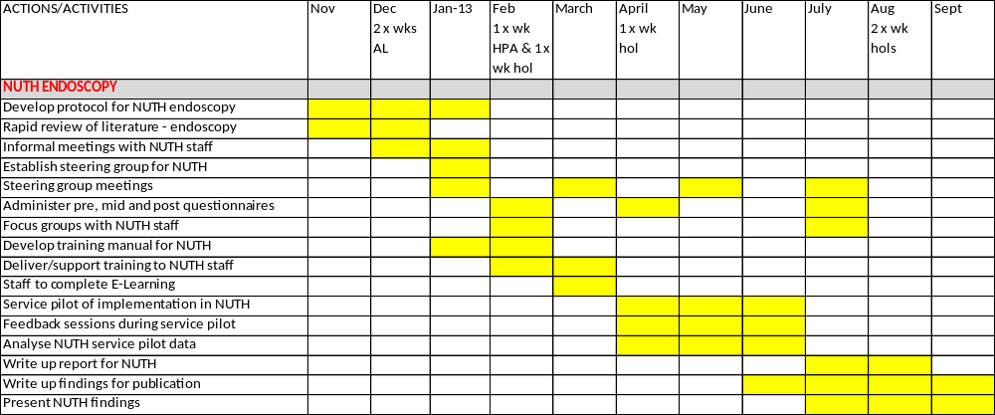

References
Akiyama, T., Inamori, M., Iida H. et al (2008) Alcohol consumption is associated with an increased risk of erosive esophagitis and Barrett's epithelium in Japanese men. BMC Gastroenterology, 8:58 doi:10.1186/1471-230X-8-58
Anderson, P., Kaner, E., SONIA Wutzke, S. et al (2004) Attitudes and managing alcohol problems in general practice: an interaction analysis based on findings from a who collaborative study. Alcohol & Alcoholism Vol. 39, No. 4, pp. 351–356
Babor, T., Higgins-Biddle, J., Saunders, J. et al (2001) AUDIT The Alcohol Use Disorders Identification Test: Guidelines for Primary care 2nd Ed. WHO
Baker, R., Camosso-Stefanovic, J., Gillliss, CL., et al (2010) Tailored interventions to overcome identified barriers to change: Effects on professional practice and health care outcomes. Cochrane Database Syst Rev CD005470
Boffetta, P., Hashibe, M., La Vecchia, C., et al (2006) The burden of cancer attributable to alcohol drinking. Int. J. Cancer: 119, 884–887
Bode, C. & Bode, C. (1997) Alcohol’s role in gastrointestinal tract disorders. Alcohol Health and Research World: 21:1
Campbell, N., Elliott, A., Sharp, L. et al (2007) Designing and evaluating complex interventions to improve healthcare. BMJ 334: 455-9
Cane, J., O’Connor, D. and Michie, S. (2012) Validation of the theoretical domains framework for use in behaviour change and implementation research. Implementation Science, 7:37
Coulton S., Bland, M., Cassidy, P., et al (2009) Screening and brief interventions for hazardous alcohol use in accident and emergency departments: a randomised controlled trial protocol. BMC Health Services Research 9:114
Craig, P., Dieppe, P., Macintyre, S. et al (2008) Developing and evaluating complex interventions: The new medical research council guidance. BMJ 337:a1655
Donabedian (2005)
Eccles, M., Armstrong, D., Baker, R. et al (2009) An implementation research agenda. Implementation Science, 4:18 doi:10.1186/1748-5908-4-18
Farmer A.P., Legare F., Turcot L., et al (2011) Printed educational materials: effects on professional practice and health care outcomes. Cochrane Database Syst Rev, :CD004398.
Flodgren G., Parmelli E., Doumit G., et al (2010) Local opinion leaders: effects on professional practice and health care outcomes. Cochrane Database Syst Rev :CD000125.
Forsetlund L., Bjorndal A., Rashidian A., et al (2009) Continuing education meetings and workshops: effects on professional practice and health care outcomes. Cochrane Database Syst Rev :CD003030
French, S., Green, S., O’Connor, D. et al (2012) Developing theory-informed behaviour change interventions to implement evidence into practice: a systematic approach using the Theoretical Domains Framework. Implementation Science, 7:38
Grimshaw, J., Eccles, M., Lavis, J. et al (2012) Knowledge translation of research findings. Implementation Science, 7:50
Health Survey England 2012 Information centre for health and social care. NHS
Home Office (2012) The Government’s Alcohol Strategy. Crown Copyright
Jamtvedt G., Young J.M., Kristoffersen D.T., et al (2010) Audit and feedback: effects on professional practice and health care outcomes. Cochrane Database Syst Rev, :CD000259
Jones, L., Bellis, M., Dedman, D. et al (2008) Alcohol attributable fractions for England. NWPHO
Kaner, E., Dickinson, H., Beyer, F. et al (2007) Effectiveness of brief alcohol interventions in primary care populations (Review) Cochrane Database Syst Rev CD004148
Kaner, E., Bland, B., Cassidy, P. et al (2013) Effectiveness of screening and brief alcohol intervention in primary care (SIPS trial): pragmatic cluster randomised controlled trial. BMJ ; 346:e8501 doi: 10.1136/bmj.e8501
Michie, S., Abraham, C., Eccles, M. et al (2011) Strengthening evaluation and implementation by specifying components of behaviour change interventions: a study protocol. Implementation Science, 6:10
Mohammed, I., Nightingale, P. & Trudgill, N. (2005) Risk factors for gastro-oesophageal reflux disease symptoms: a community study. Aliment Pharmacology Therapy; 21: 821–827
McQueen, J., Howe, T., Allan, L., (2011) Brief interventions for heavy alcohol users admitted to general hospital wards (Review). Cochrane Database Syst Rev : CD005191
Newbury-Birch D., Bland M, Cassidy P, et al (2009) Screening and brief interventions for hazardous and harmful alcohol use in probation services: a cluster randomised controlled trial protocol. BMC Public Health, 9:418
NICE (2010) Preventing alcohol use disorders: Public Health Guidance (24) NICE
Parkin, D. (2011) Cancers attributable to consumption of alcohol in the UK in 2010 British Journal of Cancer, 105, S14–S18; doi:10.1038/bjc.2011.476
Parry, C., Patra, J. & Rehm, J. (2011) Alcohol consumption and non-communicable diseases: epidemiology and policy implications. Addiction, 106, 1718–1724
Rabiee, F. (2004) Focus Group Interview and Data Analysis. Proceedings of the Nutrition Society 63: 655-660
Ramsay, C., Thomas, R., Croal, B. et al (2010) Using the theory of planned behaviour as a process evaluation tool in randomised trials of knowledge translation strategies: A case study from UK primary care. Implementation Science, 5:71
Rehm, J., Mathers, C., Popova, S. et al. (2009) Global burden of disease and injury and economic cost attributable to alcohol use and alcohol-use disorders. Lancet, 373(9682): 2223–2233.
Teyssen, S. & Manfred, V. (2003) Alcohol-related diseases of the oesophagus and stomach. Best Practice & Research Clinical Gastroenterology Vol. 17, No. 4, pp. 557–573,

Appendix one: data collection template (draft)
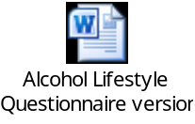

Appendix two: Brief advice tool (To be finalised)
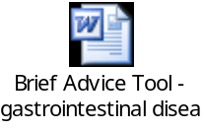
Appendix Three: Pre and post questionnaires (to be completed)

Appendix four: Focus Group topic guide (to be completed)

