An audit of the knowledge of 5 key National Institute of Health and Clinical Excellence (NICE) clinical guidelines relevant to Health Visiting and School Nursing practice- 2012/13 (436)

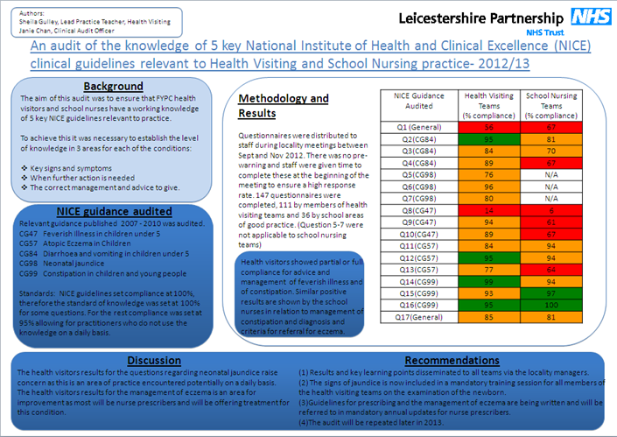

Sheila Gulley, Lead Practice Teacher – Health visitor
Janie Chan, Clinical Audit Officer
Audit Period: September 2012-November 2012
Report Date: February 2013

Executive Summary

Why the audit was undertaken
The overall aim of this audit was to ensure that health visitors and school nurses in FYPC have a working knowledge of 5 key NICE guidelines relevant to practice that have been published between 2007 and 2010. In order to achieve this it was necessary to establish the level of knowledge in 3 areas for each of the conditions:
- Key signs and symptoms
- When further action is needed
- The correct management and advice to give.
A similar audit had been undertaken in the previous county organisation which highlighted concerning gaps in knowledge, although this was considered to be a new baseline audit as it used a different tool and methodology, and was carried out over a new organisation.

How the audit was carried out
A questionnaire was designed with questions around each of the above areas of knowledge, asking for one response per question. Staff were asked to complete the questionnaire at professional meetings, where attendance was expected to be high. They had no prior warning of the audit.

Key findings
A number of areas of concern were identified, with compliance being rated as minimal in accordance with LPT clinical audit policy (dated April 2012) Some of these need addressing as they indicate practice which is contrary to that recommended in the NICE guidance as well as in the Standard Operating Procedures for health visitors. Full analysis of the results was made difficult by the high number of multiple responses. It also became clear that for the school nurses, compliance was below that originally expected for some conditions, but as these related to situations they would not meet on a regular or frequent basis it could be argued that these should not have been included. However, a surprisingly low number of staff said they were aware of where to access NICE guidelines, despite all having access to the internet.

Key actions
The key recommendations arising from the results of the audit of the health visitors are around education and raising awareness of correct diagnosis and management of jaundice and of eczema. Some actions, such as training and circulation of new operating procedures, have started to take place and will go some way towards addressing the knowledge gaps in these areas. Further learning points will be disseminated by line managers to individual teams and discussed at reference group meetings.

Re-audit date
The audit will be repeated between September and November 2013.

Contents
Page Page

Executive Summary 2
Why the audit was undertaken 2
How the audit was carried out 2
Key findings 2
Key actions 2
Re-audit date 2
Contents 3
Abbreviations 3
Background 4
Aim 4
Objectives 4
Criteria & standards 4
Method 5
Sample & data source 5
Audit type 6
Service areas / teams included 6
Findings 6
Responses received 6
Audit findings 6
Comments 10
Areas of good practice 10
Areas for improvement 10
Lessons learnt 11
Where results to be presented or discussed 12
Recommendations 12
References 12
Appendix 1 Audit tool 13
Appendix 2 Distribution list 17
Appendix 3 Action plan 17

Abbreviations
LPT Leicestershire Partnership NHS Trust
NMC Nursing and Midwifery Council

NICE National Institute for Health and Clinical Excellence

UHL University Hospitals of Leicester NHS Trust

Background
Between 2007 and 2010 there were a number of guidelines published by NICE that were relevant to the clinical practice of Health Visitor and School Nursing Teams. These guidelines were disseminated to all members of staff by the senior nurse via locality managers. Health visitors, school nurses and registered nurses have a professional responsibility to keep up to date with current knowledge in order to ensure they are using evidence based practice (NMC 2008). An audit was carried out of health visitor and school nurse teams in the former county localities in 2011 which highlighted gaps in the knowledge of key issues within these NICE guidelines. A re-audit was recommended for 1 year following this, and additional recommendations were made about the design of the audit tool.

There has been an unpublished audit also carried out in 2011 by Dr Forster, consultant paediatrician at UHL, showing that referral rates for prolonged jaundice screens to the children’s day ward had increased. This suggested that staff were more aware of the recommendations of CG98 Neonatal jaundice, although it also identified unexpectedly low referral rates for babies of African-Caribbean ethnicity. It was suggested that there was a reliance on skin colour for diagnosis rather than colour of the sclera or gums, both of which are key features in the identification of jaundice in many of the ethnic groups which comprise a significant proportion of the local population.

This new baseline audit measured Health Visitor and School Nursing team members’ knowledge of key areas within the 5 NICE guidelines across Health Visitor and School Nursing teams in the county and city. It was considered to be a new audit as it used new questionnaire as the audit tool, and was carried out across city and county localities within a new organisation.

Prior to the audit the quick reference guide for each of the 5 guidelines were circulated by email to all staff via the senior nurse and locality managers. The aim of this was to remind staff of their professional responsibilities to read and be familiar with the content. They were sent out over 5 months, one per month, in order to avoid overloading staff with too much information at one time. This was in line with the recommendations from the audit carried out in 2011.

Aim
The overall aim of the audit is to ensure that health visitors and school nurses in the city and county localities have a working knowledge of 5 key NICE guidelines relevant to practice.

Objectives
The objectives are:
- to establish whether health visitors and school nurses are aware of the key signs and symptoms of the condition specified in each guideline.
- to establish whether they can identify when further action is needed.
- to establish whether they are aware of the correct management and advice to give.

Criteria & standards
The following NICE guidance were audited:

National Institute for Health and Clinical Excellence
CG 47 Feverish Illness in children under 5 (May 2007)
CG57 Atopic Eczema in Children (December 2007)
CG84 Diarrhoea and vomiting in children under 5 (April 2009)
CG98 Neonatal jaundice (May 2010)
CG99 Constipation in children and young people (May 2010)

None of the above is in the process of being updated, although CG47 is scheduled for review in May 2013.

Table 1 - Criteria and standards
Criteria | Standards
Health visitors and school nurses can correctly identify what NICE stands for, and where to access the clinical guidelines.  Questions 1 and 17. All participants in the audit are registered nurses and should be aware of current guidelines and where to access them as part of their professional code of conduct. | The expected standard is 100%.
Health visitors and school nurses can make a correct diagnosis, identify when further action is needed and identify what the correct management advice is for the following 4 conditions: diarrhoea and vomiting in children under 5, feverish illness in children under 5, atopic eczema and constipation.  Questions 2,3,4and 8-16, | The expected standard is 95%.
Although this is less than the 100% compliance expected for each of the guidelines, this will allow for practitioners who do not use this knowledge on a daily basis and may need to seek further advice themselves before offering advice to clients. It will also allow for practitioners who are new in post and who will not have received emails raising awareness of NICE guidelines over recent months.

Health visitors can correctly identify key clinical signs of prolonged neonatal jaundice, when further action is needed and what the correct management is.  Questions 5,6 and 7, | The expected standard is 100%.
As the NICE guideline audit tool sets compliance at 100% then the standard of knowledge must also be 100%. This is an area of practice which health visitors could encounter on a daily basis while visiting children at home, so a sound working knowledge is essential.

The following rating was applied to the results to highlight any particular areas of concern, which is consistent with the trust agreed approach and the recommendation of the Clinical Audit Support Centre.

 | Full compliance  $x$ ≥ 95 (or 100)% |  | Partial compliance  70%≤ $x$ <94(or 99)% |  | Minimal compliance  $x$ < 69%

Method
Questionnaires were completed by staff during professional locality meetings from September to November 2012. The audit was listed as an item on the agenda for team meetings as NICE but there was no pre-warning about the audit. Staff were given time to complete the questionnaire at the beginning of the meeting, ensuring a high response rate, and handed them straight back to the manager who sent them to the audit team for analysis. Locality and team meetings are seen as a priority for all health visiting and school nursing staff so a high representative sample should have been achievable. Completed audit forms were returned to the audit office and were inputted and analysed using Excel.

Sample & data source
A minimum target of 160 would have given a confidence level of 95% with a 5% error margin. The total population is approximately 270.

Audit type
This is a new baseline audit.
See Appendix 1 on p.13 for a copy of the audit tool.

Service areas / teams included
The audit was carried out on teams from health visiting and school nursing across all localities in the city and the county. It had been aimed at qualified members of the team (i.e. nurses registered with the NMC) but some were completed by assistants within the teams and by staff with nursery nurse qualification. It was decided to exclude these results from the final analysis as the expected compliance for this group of staff would be different, due to the differing roles and responsibilities. Registered nurses working within health visiting teams were included.
Although the questionnaire asked for locality to be identified this proved to be problematic when analysing the results due to differing terminology used. For example there are two North West and two South teams, one each in the county and the city. It was decided therefore to analyse results without taking locality or neighbourhood into account as the expected compliance was the same across the whole area

Findings

Responses received
A total of 147 questionnaires were received from qualified staff, 111 from health visiting teams and 36 from school nurse teams. This was lower than expected but could be accounted for by anecdotal reports of team managers not being informed about the audit, lack of mutually convenient times for the audit team to attend the team meetings, and some teams declining to participate. Two questionnaires were returned with all answers blank, and were therefore excluded, as were those which did not indicate which professional group they belonged to. Some questionnaires were completed by community nursery nurses but these were not included in the analysis as the audit was looking at the knowledge of NMC registered nurses. This response rate still gives a confidence level of 95% with a margin of error of 7.15%.

Audit findings
Although it had originally been planned for the questionnaires to be electronically analysed on FORMIC this proved to be problematic due to the high numbers of staff ticking more than one box for the answer. Each question then had to be looked at to decide clinically whether to count the answer as right or wrong, depending which boxes were ticked. For example, in question 7, if someone ticked A or B as well as the correct answer, C, then they would be counted as correct, because the advice in A and B could also form part of the overall management, but would not be correct on their own. Similarly, if someone ticked an answer which was definitely incorrect as well as the correct one then they would be marked wrongly

Table 2 Audit results for health visiting teams (in comparison with thresholds of compliance)
Criteria | Expected standard | Number answered correctly | Compliance
Question 1:  NICE stands for National Institute for Health and Clinical Excellence | 100% | 62 | 56%
Question 2:  Gastroenteritis alone should be suspected if there is a sudden change to loose or watery stools. | 95% | 106 | 95%
Question 3:  Which if the following children with gastroenteritis can be safely managed at home?  An 18 month old child who has had diarrhoea for 6 days. | 95% | 93 | 84%
Question 4:  Which of the following is the correct advice to a mother of a 1 year old with gastroenteritis, no risk factors and no signs of dehydration?  Encourage breastfeed/other milk feeds and fluid intake, advice about Red Flag symptoms and how to get immediate help if they develop. | 95% | 99 | 89%
Question 5:  Which of the following is NOT a sign of prolonged jaundice?  Yellow colouration of blanched skin in a term baby aged 10 days. | 100% | 84 | 76%
Question 6:  Which of the following will raise your concern about a baby with jaundice?  Dark urine which stains the nappy. | 100% | 107 | 96%
Question 7:  If a baby has prolonged jaundice at the primary visit which of the following described the correct management?  Contact children’s day ward at the LRI to make a referral, arrange the appointment and inform the parent(s). | 100% | 89 | 80%
Question 8:  Which of the following can be used to diagnose a feverish illness?  Parental report of a fever. | 95% | 15 | 14%
Question 9:  Which of the following is a Red Flag symptom in a child with feverish illness (which would cause you to refer to a paediatric specialist urgently)?  Weak or high pitched cry. | 95% | 104 | 94%
Question 10:  Which of the following is a correct piece of advice for parents of a child with a fever (with no red or amber symptoms)?  Look for signs of dehydration, non-blanching rash, encourage more fluids than usual and to seek further advice if they feel the child is getting worse. | 95% | 99 | 89%
Question 11:  A diagnosis of atopic eczema can be made when a child has an itchy skin condition and which of the following?  History of dry skin in the last 12 months, visible flexural dermatitis involving skin creases and allergic rhinitis. | 95% | 94 | 84%
Question 12:  A referral to specialist dermatological advice is necessary if:  Atopic eczema is associated with severe or recurrent infections. | 95% | 106 | 95%
Question 13: Which of the following describes the correct management for a 2 year old with dry skin, and occasional appearance of red patches of itchy skin behind the knees?  Emollients, mild topical corticosteroids only where and when the skin is red and itchy, and continue with emollients even when fully resolved. | 95% | 85 | 77%
Question 14:  Which of the following children is constipated?  A 3 year old who passes 2 hard large stools per week, straining to do so and who has had constipation in the past. | 95% | 110 | 99%
Question 15:  When assessing a child, which of the following findings is a Red Flag indicating an underlying disorder rather than idiopathic constipation?  Ribbon-shaped stool and abdominal distension with vomiting. | 95% | 103 | 93%
Question 16:  Which of the following describes the most appropriate dietary and lifestyle advice for parents of a 5 year old child with idiopathic constipation (in addition to management with laxatives)?  Fluid intake of at least 1200ml as drinks daily, recommend foods such as fruit and vegetables, high-fibre bread and wholegrain cereals, daily physical activity and negotiated follow-up and support. | 95% | 105 | 95%
Question 17:  Are you aware of where to access the NICE guidelines quick reference guides?  Yes | 100% | 94 | 85%

Table 3 Audit results for school nursing teams (in comparison with thresholds of compliance)
Criteria | Expected standard | Number answered correctly | Compliance
Question 1:  NICE stands for National Institute for Health and Clinical Excellence | 100% | 24 | 67%
Question 2:  Gastroenteritis alone should be suspected if there is a sudden change to loose or watery stools. | 95% | 29 | 81%
Question 3:  Which if the following children with gastroenteritis can be safely managed at home?  An 18 month old child who has had diarrhoea for 6 days. | 95% | 25 | 70%
Question 4:  Which of the following is the correct advice to a mother of a 1 year old with gastroenteritis, no risk factors and no signs of dehydration?  Encourage breastfeed/other milk feeds and fluid intake, advice about Red Flag symptoms and how to get immediate help if they develop. | 95% | 24 | 67%
Question 8:  Which of the following can be used to diagnose a feverish illness?  Parental report of a fever. | 95% | 2 | 6%
Question 9:  Which of the following is a Red Flag symptom in a child with feverish illness (which would cause you to refer to a paediatric specialist urgently)?  Weak or high pitched cry. | 95% | 22 | 61%
Question 10:  Which of the following is a correct piece of advice for parents of a child with a fever (with no red or amber symptoms)?  Look for signs of dehydration, non-blanching rash, encourage more fluids than usual and to seek further advice if they feel the child is getting worse. | 95% | 24 | 67%
Question 11:  A diagnosis of atopic eczema can be made when a child has an itchy skin condition and which of the following?  History of dry skin in the last 12 months, visible flexural dermatitis involving skin creases and allergic rhinitis. | 95% | 34 | 94%
Question 12:  A referral to specialist dermatological advice is necessary if:  Atopic eczema is associated with severe or recurrent infections. | 95% | 34 | 94%
Question 13: Which of the following describes the correct management for a 2 year old with dry skin, and occasional appearance of red patches of itchy skin behind the knees?  Emollients, mild topical corticosteroids only where and when the skin is red and itchy, and continue with emollients even when fully resolved. | 95% | 23 | 64%
Question 14:  Which of the following children is constipated?  A 3 year old who passes 2 hard large stools per week, straining to do so and who has had constipation in the past. | 95% | 34 | 94%
Question 15:  When assessing a child, which of the following findings is a Red Flag indicating an underlying disorder rather than idiopathic constipation?  Ribbon-shaped stool and abdominal distension with vomiting. | 95% | 35 | 97%
Question 16:  Which of the following describes the most appropriate dietary and lifestyle advice for parents of a 5 year old child with idiopathic constipation (in addition to management with laxatives)?  Fluid intake of at least 1200ml as drinks daily, recommend foods such as fruit and vegetables, high-fibre bread and wholegrain cereals, daily physical activity and negotiated follow-up and support. | 95% | 36 | 100%
Question 17:  Are you aware of where to access the NICE guidelines quick reference guides?  Yes | 100% | 29 | 81%

How compliance was calculated

Comments

Areas of good practice
The advice and management of feverish illness and of constipation have either green or amber ratings for health visitors. This is positive as these are typical areas of concern encountered in child health clinics, home visits or in telephone calls from parents. Similar positive results were seen in the school nurses responses regarding management of constipation, and with the diagnosis and reason for referral for eczema, again common areas of practice.

Areas for improvement
There are a number of areas rated as red in the results, some of which are more concerning than others. The very low compliance with question 8 could initially appear alarming, but when examined more closely it does not really reflect practice, as staff community staff do not generally have access to any of the 3 thermometer types suggested. They would in practice rely on parental report alone, ask further assessment questions and give advice accordingly. This is supported by the compliance with the following questions being green for health visitors who are more likely to encounter this type of problem. What is more concerning is that 8 qualified nurses indicated that tepid sponging would be an appropriate method of managing a fever (Question 10) when the NICE guidelines clearly state it is not.
The questions about the management of neonatal jaundice raise some concerns, especially as correct referral criteria and processes were circulated to all staff in the city 2 years ago and all health visitors trained up until last year had a tutorial specifically on this subject. The audit carried out by Dr Forster at UHL highlighted that community staff may not be aware that yellow colourations of the sclera or gums may be used to diagnose jaundice. This is supported by the amber rating for these questions, and the relatively large number (20) of health visiting staff who answered that yellow colouration of the gums was NOT a sign of jaundice. These questions should have a much higher compliance given that this is an area of practice potentially encountered on a daily basis. However, this result may have been skewed by the inclusion of children’s nurses with the health visitors, as they would not be expected to diagnose neonatal jaundice or make a referral.
The amber rating achieved by the health visiting teams for Question 13 about the management of eczema is an area in need of improvement, as most health visitors are practicing nurse prescribers and the children’s nurses commonly do work with children with this condition. However, annual clinical update sessions for nurse prescribers are now mandatory, and it has been reported anecdotally that guidelines about eczema treatments are in the process of being produced for nurse prescribers.

Lessons learnt
The questionnaire design made giving multiple answers very easy, and as some answers formed part of the correct management this was a common occurrence which made inputting of results very time-consuming. The original design for the questionnaire had a single box for the participant to write the letter of their answer in, which would have eliminated multiple responses but was not compatible with electronic analysis.
While inputting the results there was evidence that some teams of staff had completed the questionnaires as a group, sometimes with all giving a wrong answer, which led to inaccuracies when measuring individual knowledge bases. This could be eliminated in future by having clearer and more consistent instructions from the member of staff administering the questionnaires at the team meetings, as anecdotally some teams were encouraged to work together. Alternative methods of questionnaire distribution would be equally problematic, with potentially low response rates and the opportunity to complete the form with colleagues or look up the answers if sent electronically or via internal mail.
In retrospect it would be more useful to audit school nurse and health visiting teams separately and audit different areas of knowledge more in keeping with their day to day areas of practice. The questions about neonatal jaundice were excluded for school nurses (although written instructions stated not to do so there were a number who did complete this section). Other areas such as the management of fever and diarrhoea and vomiting are not usually part of the school nursing role, demonstrated by the red and amber ratings of all questions in these areas. It will need to be considered however whether a working knowledge of these areas is necessary. If this is not the case then to include school nurses in the re-audit would be unnecessarily demoralising.
Some answers were surprising but not clinically significant; for example registered nurses could perhaps be expected to know what NICE stands for but the options given were not too dissimilar from the correct response. Also, the correct response rate for the final question about accessing the guidance was surprisingly low, given that they are freely available on the internet. It is possible that staff thought they may have hard copies of the documents in their offices (as with some other documents) and therefore could not be sure where they were.

Where results to be presented or discussed
The results will be presented at the LPT Clinical Audit and Quality Improvement event in poster format. This will also be discussed at the Health Visitor and School Nurse reference group meetings and implications for practice will be shared from these groups to the wider teams.

Recommendations
In order to address the poor compliance regarding the management of neonatal jaundice, staff need to be reminded of the correct criteria for referral and of the ways to diagnose jaundice when skin colour will not give a true indication. This is included in the training session covering examination of the new born and spinal muscular atrophy. This session is mandatory for all members of the health visiting team and is delivered to all health visitor students during training.
Information about the correct referral route has been included as an appendix in the Standard Operating Procedures for the Family Health Visiting Health Child Programme for FYPC, which has recently been printed and is in the process of being circulated to all health visiting teams.
A summary of findings and key learning points for discussion will be circulated to locality managers for inclusion in locality meetings and/or clinical team leaders meetings, as well as being emailed to all staff. Although the original audit proposal suggested a re-audit starting in April 2013 it is not anticipated that this sharing of learning and information could be achieved across the whole organisation by this date, as some locality meetings only take place every 3 months.
Other recommendations for practice may arise from discussion at the relevant reference group meetings and will be implemented accordingly.
It is suggested that the re-audit takes place between September and November 2013 to allow for most staff to have accessed the training on examination of the new born and to have received, read and digested their copies of the Standard Operating Procedures, while avoiding the summer holiday period when attendance at meetings is lower than usual. Consideration will be given to focusing the re-audit on health visitors if it is felt that most of the information in these NICE guidelines is not relevant for school nursing or for children’s nurses who may not need to have the same level of first hand knowledge for daily practice.

References
Nursing and Midwifery Council (NMC) (2008) The Code: Standards of conduct, performance and ethics for nurses and midwives.
- Audit tool
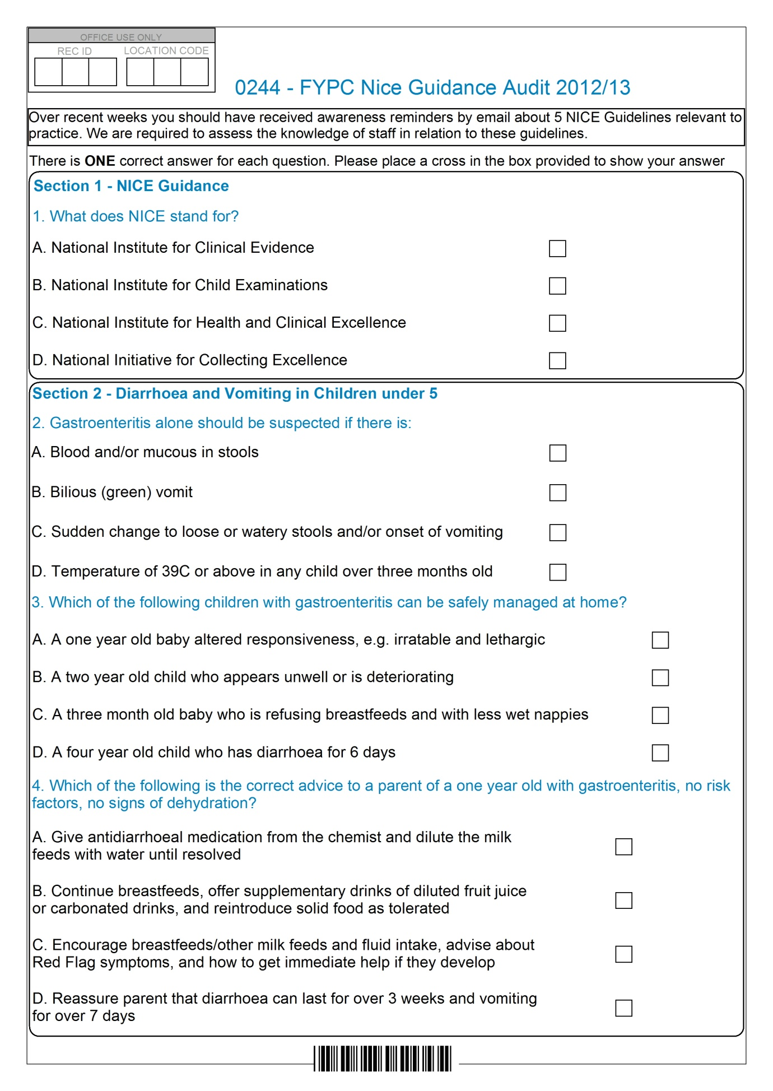

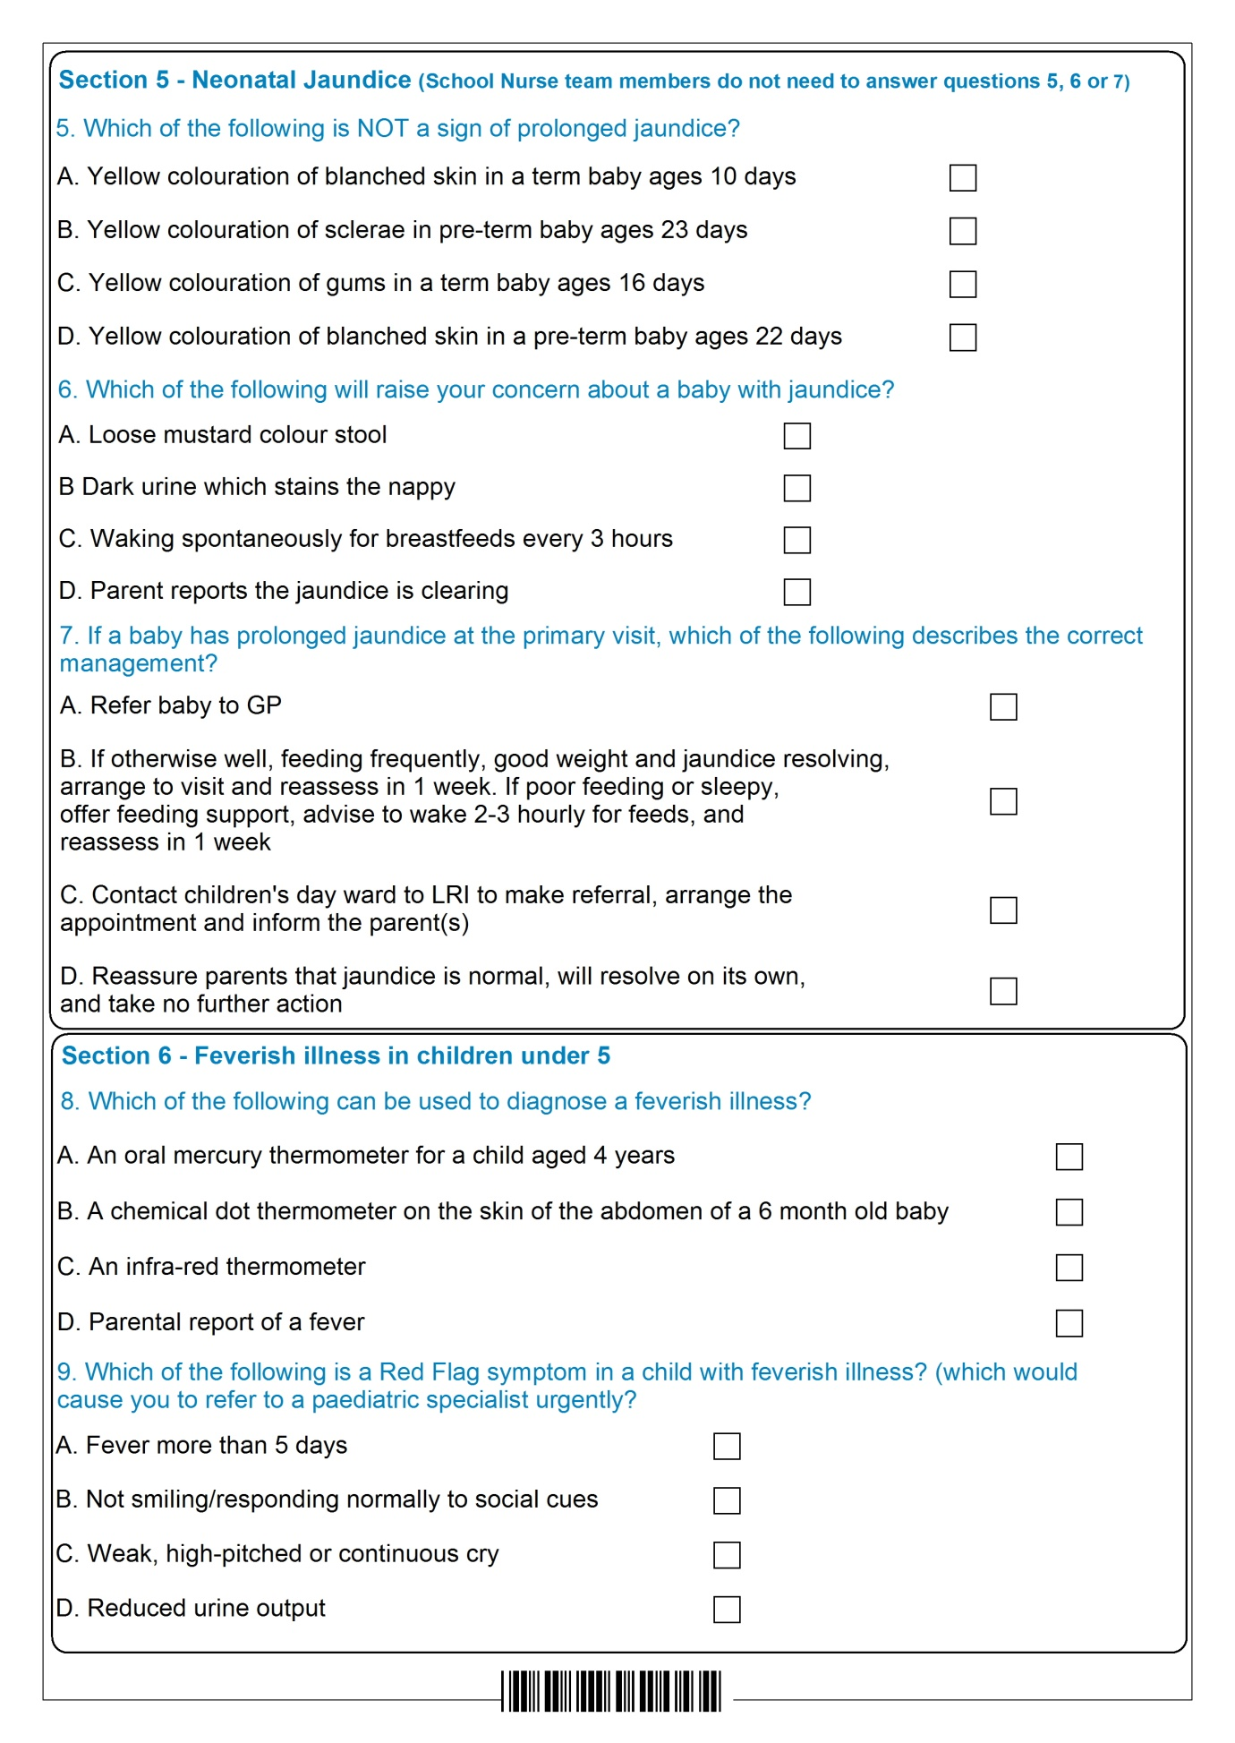

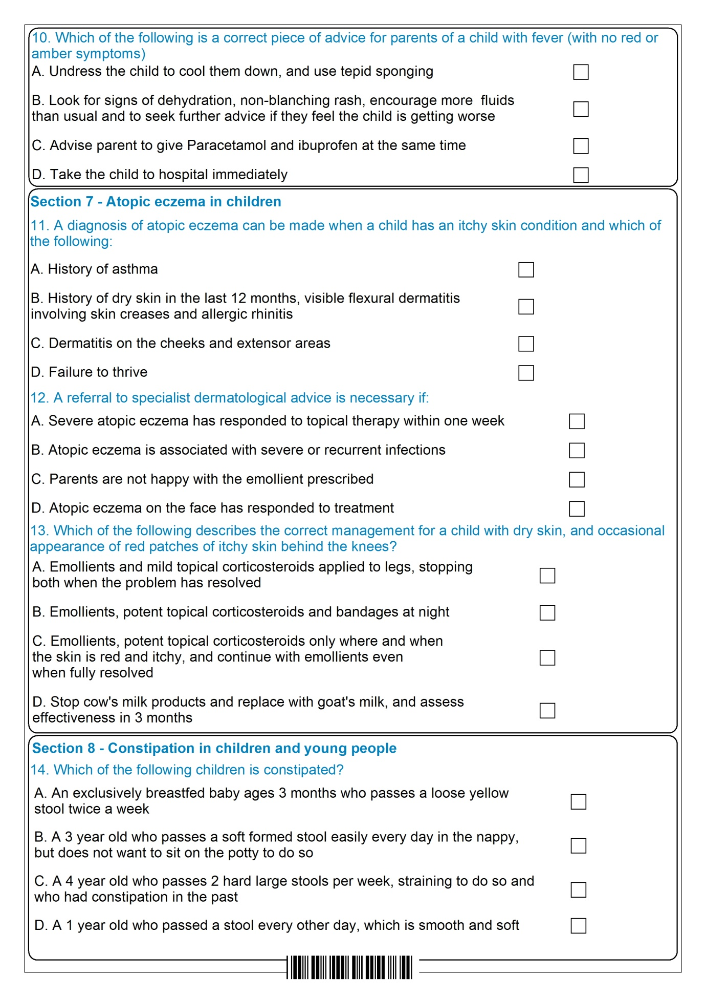

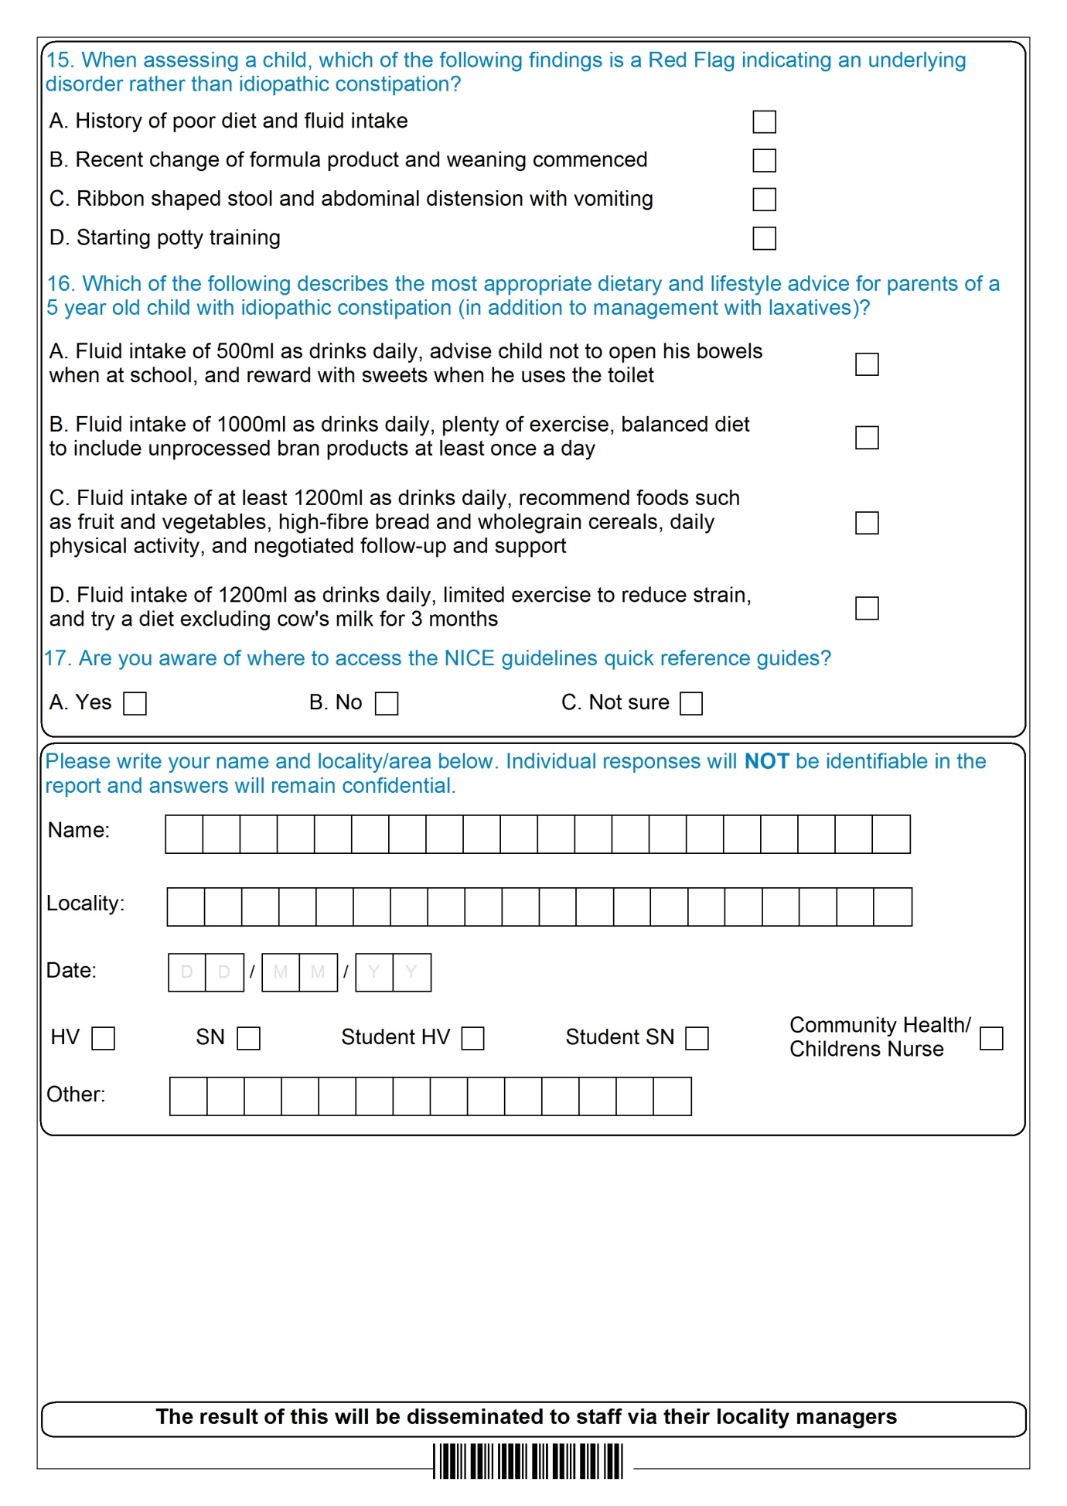

- Distribution list

Target audience | To (for action)
Senior Clinical Quality Group | For information
FYPC Clinical Audit Group | For approval

- Action plan

Objective | Level of Risk  L|M|H | Agreed Action | By Whom | By When
Improve knowledge of the diagnosis of neonatal jaundice | M | Staff to be reminded of the correct criteria for referral & of the ways to diagnose jaundice in the mandatory training session.  Summary of key learning points to be circulated to managers  Key learning points, along with recommendations about advice to parents, to be recirculated by team leaders, who will provide evidence that this has been done. | Practice educators  Sheila Gulley & Nicy Turney  Sheila Gulley and Nicy Turney | To be included in mandatory training for new starters as from February 2014  April 2013  March 2014
Improve compliance regarding the management of neonatal jaundice | M | Information about the correct referral route included as an appendix in the Standard Operating Procedures for the Family Health Visiting Health Child Programme, document to be circulated to HV team | Team leaders | Circulated by team leads in March 2013 – action complete
Improve compliance in the management of fever (Question 10) | L | To be included in key learning points to be circulated at team meeting & email out by team leaders  Training programme for Health Visitors to include session on the management of minor ailments, will cover management of fever and of diarrhoea and vomiting. | Team leaders  Facilitated by practice educators. | April 2013  On new starter induction programme starting September 2013 and for all staff starting October 2013.
Improve compliance in the management of eczema | L | Guidelines about eczema treatments to be included in annual clinical update sessions for nurse prescribers 2013 | Chris Brooks, Clinical team leader & Lead Pharmacist | Already on training programme

