

Audit of the Use of Fresh Frozen Plasma in the
East Midlands Region
2013

Acknowledgements

Dr Hafiz Qureshi
Consultant Haematologist
NHSBT/Leicester Royal Infirmary

Dr Robert Webster
Consultant Haematologist
NHSBT

Ms Kath Hearnshaw*
Patient Blood Management Practitioner
East Midlands Regional Transfusion Committee (EMRTC)

Ms Hayley Bond
Lead Transfusion Practitioner
Blood Transfusion Department
NUH NHS Trust

Ms Marie Browett
Lead Transfusion Practitioner
Leicester Royal Infirmary

Ms Joanne Shorthouse
Patient Blood Management Practitioner
East Midlands Regional Transfusion Committee (EMRTC)

Ms Odette Colgrave
East Midlands RTC Administrator

Hospital Transfusion Practitioners, EM RTC Region
(Appendix 4&5 list of contributors and participating sites)

* Ms k Hearnshaw has retired

Contents

Section | Pages
Executive Summary | 4-5
Introduction | 5
Methods | 5-6
Results | 6-13
Discussion | 13-14
References | 15
Appendix 1 – Clinical Data Collection Form | 16-20
Appendix 2 – Organisational Data Collection Form | 21-22
Appendix 3 – FFP Dosage Chart | 23
Appendix 4 - Participating Sites | 23
Appendix 5 – Transfusion Practitioners  G  lossary | 24-25

Abbreviation | Meaning
APPT | Activated Partial Thromboplastin Time
APPTR | Activated Partial Thromboplastin Time Ratio
ATR | Acute Transfusion Reaction
BCSH | British Committee for Standards in Haematology
DIC | Disseminated Intravascular Coagulopathy
ECMO | Extra Corporeal Membrane Oxygenation
EMRTC | East Midlands Regional Transfusion Committee
FFP | Fresh Frozen Plasma
g | Grams
HTC | Hospital Transfusion Committee
INR | International Normalised Ratio
MBFFP | Methylene Blue Fresh Frozen Plasma
mg | Milligrams
NHSBT | National Health Service Blood and Transplant
RBCs | Red blood cells
SDFFP | Solvent Detergent Fresh Frozen Plasma
TTP | Thrombotic Thrombocytopenic Purpura

Glossary

Executive Summary

A previous audit in the East Midlands region into FFP use demonstrated that there was continued use of FFP for warfarin reversal, under dosing with poor weight recording and transfusion of FFP with normal pre-transfusion coagulation continued (8). Following a meeting of the East Midlands regional transfusion committee, it was decided to repeat an audit of FFP use across all hospitals in the region.

An online survey to elicit information regarding the use of FFP in the region was constructed. Local governance arrangements were adhered to.

Main findings
- The NCA 2009 reported that FFP was used to reverse warfarin in 14% of cases audited. In our audit this figure was 3%, indicating a significant improvement in this region.
- This audit also shows a significant variation in the dose of FFP transfused. There was evidence of both under- and over-transfusion based on the dosage recommended in the BCSH guideline.
- Pre transfusion coagulation parameters were reported for the vast majority (98%) of cases. However post-transfusion coagulation parameters were reported for 62% of cases, and of these only 37 % had coagulation checked within 3 hours following the completion of FFP transfusion.
Recommendations

- Hospitals should have locally agreed, speciality specific, guidelines for the use of FFP. As a minimum, specific local guidelines should address the use of FFP in liver patients, cardiac surgery, trauma, Intensive Care Units and Neonatal units.
- These guidelines should define appropriate dose (mls /Kg) of FFP.

- Hospitals should have local guidelines on the reversal of anticoagulation with warfarin and other vitamin K antagonists. This guideline should clearly define exceptions where the use of FFP may be appropriate in addition to vitamin K, when Prothrombin Complex Concentrates (PCCs) are contra-indicated.

- Clinicians who prescribe FFP should be familiar with the guidelines for their specialty.

- Each high user clinical specialty should perform regular (annual) audits of compliance with local guidelines. The audits findings and action plans should be disseminated to all clinicians within the specialty, and presented to the Hospital Transfusion Committee.

- Use of FFP for the treatment of bleeding should be guided, wherever possible, by appropriate laboratory or point of care tests of coagulation before and after transfusing FFP.

- The East Midlands Regional Transfusion Committee, in collaboration with HTTs, should organise regional and local educational events on evidence based use of FFP.

Introduction

Earlier investigations have indicated that that Fresh Frozen Plasma (FFP) may be associated with high rates of inappropriate transfusion with some studies indicating rates of up to 50% non compliance with established guidelines(1). The current British Committee for Standards in Haematology (BCSH) guidelines on the use of FFP aim to reinforce the message regarding avoidance of its inappropriate use (2).

A systematic review of published randomised clinical trials involving FFP found an overall lack of evidence to support benefit in all clinical areas apart from TTP (3).

FFP is not without risk and indeed may be amongst the most ‘high risk’ of all blood components in relation to transfusion reactions (the 2012 SHOT report indicates FFP in 29/372, 8% of ATRs)

The Health Service Circular Better Blood Transfusion: Safe and Appropriate Use of Blood (HSC 2007/001) promotes the appropriate use of all blood components including FFP with avoidance of unnecessary transfusion (5).

In addition, increasing use of solvent detergent FFP and methylene blue treated FFP for specific groups of patients and children introduce new areas for vigilance.

There have been several previous audits into the use of this product. An audit of FFP use in 2007 in the South Central region revealed that FFP was used for warfarin reversal in 26% of the cases audited (6). FFP weight related dosage was poorly implemented with weight being recorded in only 32% of cases. A large scale audit of FFP use undertaken in 2009 as part of the National Comparative Audit programme indicated that FFP continued to be used for warfarin reversal and was frequently given where there was no evidence of actual bleeding. Liver disease also accounted for a significant degree of FFP use. An audit of FFP use in the South West in one large hospital found that following a period of intensive educational measures, appropriate use of FFP improved dramatically particularly with respect to use for warfarin reversal (7).

A previous audit in the East Midlands region into FFP use demonstrated that there was continued use of FFP for warfarin reversal, under dosing with poor weight recording and transfusion of FFP with normal pre-transfusion coagulation continued (8). Following a meeting of the East Midlands regional transfusion committee, it was decided to repeat an audit of FFP use across all hospitals in the region.

Methods

A consensus approach was adopted to conduct the audit. The regional transfusion practitioners elected to undertake the data collection using a hard copy data collection form. The form was a modification of a developed audit form used by Leicester Royal Infirmary. In addition, an organisational audit was undertaken and issued once to each site. Copies are given as appendices XXXXX and XXXX.

Appropriate governance arrangements were implemented and approval to participate in the audit obtained. Caldicott Guardians in each participating site were also informed.

Each site that elected to participate in the audit was asked to collect information on FFP use for a total of 20 cases per site. A pragmatic time frame was adopted which was later extended. Data collection was undertaken by local transfusion practitioners and took place during the summer of 2013 until November of the same year. Completed forms were returned to the RTC data analyst and audit facilitator. Information was manually entered into an Excel spreadsheet and analysed proportionately (n, %). Data anomalies were discussed at a subsequent RTC meeting before final analysis. No overt identifying patient details were taken and hospitals have been anonymised in this report.

Results

Organisational Survey

14 hospitals (8 Trusts) make up East Midlands RTC with 1 independent site. 9 sites responded to the organisational questionnaire. Of these:-

- 8/9 had an FFP use policy for all areas (paediatrics). 1 site had a policy for adults only

- 9/9 had a policy for over coagulation with Warfarin

8 organisations who responded used FFP variants for children under the age of 16 years. Table 1 indicates the type of product that is used.

Table 1

Organisation | What plasma do you use for children < 16 years?
A | MB FFP
B | Paediatric MB FFP or Octaplas
C | Octaplas
D | MB FFP
E | Octaplas
F | MB FFP
G | Octaplas
H | Octaplas

Results - Case Audit

Standards

- FFP should be used in appropriate situations as defined by BCSH guidelines

- FFP dosage should be based on the weight of the patient

- Coagulation screening should be performed pre and post transfusion

Demographics

Individual case data was submitted by transfusion staff working in each hospital.
One hospital trust was unable to participate in the audit. In total, 12 hospitals from all remaining NHS Trusts contributed data.

177 datasets were completed on 167 patients (multiple submissions on one case of thrombotic thrombocytopenic purpura). 2 sites submitted a full compliment of 20 cases with 8 contributing 15 or more cases. The dataset indicated a mean age of 52 years (1 – 99 years), 85 (48%) female, 90 (51%) male, 2 no gender submitted.

Type of FFP used was documented in 166/167 (99%) cases. Methylene blue FFP was used in all cases where infants were involved and solvent detergent used in cases of TTP and Plasma Exchange.

Reasons for FFP Transfusion

Details of admission were provided in 166/167 (99%) of cases. As in previous audits, the principle reasons for FFP use were massive bleeding, cardiac surgery and liver disease. In some cases, massive bleeding was also indicated in conjunction with gastrointestinal bleeds and liver disease so cases directly attributable to liver disease may be an underestimate. Details are provided in table 2.

Table 2

Principle Reasons for FFP Use | Numbers
Massive Bleeding* | 49
Pre Procedure/Surgery plus Abnormal Coagulation No Bleeding | 29
Liver Disease plus Abnormal Coagulation | 21
Abnormal Coagulation No Bleeding No Procedure | 12
Cardiac Surgery | 11
TTP (see glossary) | 1
Pre Procedure Surgery plus Abnormal Coagulation with Bleeding | 9
Plasma Exchange | 6
Warfarin/Heparin Reversal | 5
DIC (see glossary) | 2
Factor Deficiency | 2
Post Op Bleed | 2
Deranged TEG results | 1
ECMO (see glossary) | 1
Melena | 1
No details given (not in notes) | 1
Plasminogen Deficiency | 1
Vascular surgery with surgical bleed | 1
Total | 155
Other Reasons
Unknown | 5
Deranged TEG Results | 1
Blank | 6
Final Total | 167
*15% cases of FFP use in massive bleeding associated with gastrointestinal bleeding

Table 3 indicates the principle process aspects of documentation unrelated to laboratory information.

Table 3 – Documentation of FFP Transfusion

Audit Question | Field Completed N, (%) | Comments
Date of First Transfusion episode Recorded | 162/167 (97)
Time of 1st Unit Transfusion Recorded | 163/167 (98)
Weight of Patient Recorded | 142/167 (85)
Total Volume of FFP Transfused Recorded | 131/167 (78)
Type of FFP Used Recorded | 166/167 (99)
Reason for FFP Transfusion Documented | 161/167 (96)
Bleeding/Not Bleeding Documented | 167/167 (100)
Bleeding Features Documented | 90/90 (100) | Denominator = bleeding (n)
Appropriate Vit K Use Documented | 21/21 (100) | Denominator = 21 (group designated for Vit K)
Dose Vit K Documented | 34/38 (89) | Denominator = total receiving Vit K
Route Administered Documented | 36/38 (95) | Denominator = total receiving Vit K
Date Procedure Documented | 63/67 (94) | Denominator = those having a procedure (n)
Time Procedure Documented | 44/67 (66) | Denominator = those having a procedure (n)
Consent to Transfusion Documented | 41/167 (26)
Date of Consent Documented | 32/41 (78) | Denominator = “yes” to consent

Summary Box 1
- 100% of organisations had policy documents in relation to FFP transfusion
- Age of FFP recipients may be decreasing
- Principle reasons for FFP use are massive bleeding, cardiac surgery and liver disease
- Recording of volume of FFP transfused and recording of consent to transfusion may have room for improvement
- Units recorded as “mls” and “number of units”
- Use of idiosyncratic notation (dot) to denote “unit”

The decision to use FFP should be related to coagulation data and this component should not be used for warfarin reversal although pragmatic decisions will have to be made in emergency situations.

Table 4 indicates laboratory parameters recorded for this dataset in relation to FFP transfusion.

Table 4 – Recording of Pre and Post FFP Transfusion Laboratory Parameters

Audit Question | Field Completed N, (%) | Comments
No of patients receiving warfarin | 15/167 (9%) | 5/167 (3%) stated use of FFP for warfarin reversal
No of patients receiving heparin | 11/167 (7%) | 3 also indicated as being on warfarin as well
Evidence of pre Tx INR or PT? | 147/167 (88)
Result documented | 147/167 (88)
INR > 10 documented (y/n) | 3/147 (2)
PT range provided where PT used | 135/138 (98)
PT time documented | 138/167 (83)
Evidence of APTTR | 86/167 (51)
APPTR documented | 62/86 (72) | Denominator = APPTR documented
APPT result documented | 132/167 (79)
APPT ref range given | 129/167 (77)
Evidence of TEG documented (y/n) | 9/167 (5) | Includes ROTEM
TEG results given | 3/9 (33) | Denominator = TEG clients
Post Transfusion Results
Evidence of INR or PT within 3 hours | 62/167 (37) | 37% had post transfusion coagulation tests within or equal to 3 hours
Result INR/PT | 104/167 (62) | No of results exceed 3 hour rule
APTT or APTTR documented | 64/104 (62) | Denominator = results (n)
Post Tx TEG documented | 3/167 (2)
Benefits of FFP documented | 35/167 (21)
Adverse Effects Documented | 0/167 (0)

Summary Box 2

Pre transfusion coagulation data present in a maximum of 98% of patients (INR, APTT or PT)
Post transfusion coagulation data present in a maximum of 62% of patients (INR, APTT, or PT)
Low level of use of thromboelastography
Where thromboelastography used, results often reported as “normal” rather than show actual values
Post transfusion coagulation results (< 3 hours) 37% completion
Overall post transfusion coagulation results 62% completion
Benefits of FFP documented in 21% of cases
No adverse effects documented

Data Exploration

Laboratory Reference Ranges

Figure 1 indicates the variation in APTT laboratory reference ranges and frequency of use (hospital dependent) used in relation to client data submitted for this audit. Figure 2 shows similar information for reference ranges in relation to the prothrombin time. For this audit, the following ranges were used to define abnormal results.

INR > 1.5 or
APTTR 1.5 or
Prothrombin Time > 18 seconds or
APTT > 45 seconds or
Prolonged “R” time >
9 minutes (TEG*)
Prolonged intem or extem MCF > 72mm on ROTEM

Fig 1

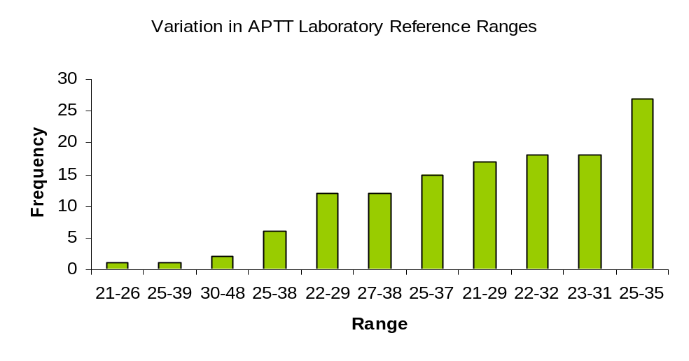
11 different reference ranges are used for APTT

Fig 2

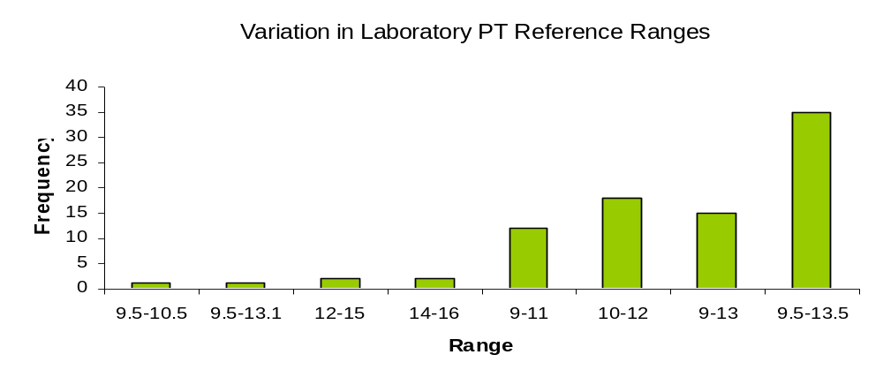
8 different reference ranges are used for PT

Although caveats will apply, FFP should be used in conjunction with a review of recent coagulation results in the context of the clinical presentation.

For the purpose of this audit, abnormal coagulation is defined as an INR in excess of 1.5, and/or a prothrombin time >18 seconds or an APTT >45 seconds. Recently, the results of any thoromboelastographic measurements are also taken into consideration. Not all sites measure INR and some indicate both. Pre FFP transfusion results for the whole cohort are shown in table 5

Table 5 - FFP Use Outside Recommended Laboratory Ranges (n = 167)

Pre Transfusion Coagulation  Results (includes  bleeding patients) | No of  Cases  Out of Range
INR < 1.5 | 32/83 (39%)
PT < 18 | 73/138 (53%)
APTT >45 | 97/132 (71%)

The same data is indicated in table 6 but only for those patients where no bleeding was indicated

Table 6 - FFP Use in Patients where no Bleeding Documented

Pre Transfusion Coagulation Results | No of  Cases  Out of Range
INR < 1.5 | 11/44 (25%)
PT < 18 | 22/60 (37%)
APTT <45 | 35/57 (61%)

In the NCA audit of 2009, 43% of adults audited had no evidence of bleeding. In this audit 77/167 (46%) had no evidence of bleeding. In the NCA of FFP, pre transfusion coagulation parameters were within normal range for an average of 39% of non-bleeding patients who received FFP. In this audit, this figure was 31%

Vitamin K

38/167 (23%) of patients received vitamin K intravenously. All were 10mg doses apart from a 0.6 mg given to a child. 17/38 (45%) received vitamin K where there was no stated evidence of bleeding although 31/38 (82%) mentioned abnormal coagulopathy in the presentation. 10 patients with evidence of liver disease did not receive vitamin K.

Summary Box 3

- There is a wide range of laboratory reference ranges used across the region.
- In 46% of cases, FFP was transfused in the absence of any bleeding. The NCA in 2009 reported this figure as 43%, indicating no improvement in clinical practice.
- FFP is used where there is little or no evidence of abnormal coagulation in over 30% of cases and these figures have not changed substantially since the NCA in 2009
- There has been a substantial reduction in the use of FFP for warfarin reversal compared to the NCA FFP audit (14% to 3%)
- 10 patients with evidence of liver disease did not receive vitamin K

Dosing

FFP has optimal value when transfused at the appropriate dose; the recommended adult therapeutic dose of FFP is 12-15 ml/kg and should be at least 10 ml/kg. While it is difficult to provide an exact volume of a single unit of FFP a volume of 271ml per unit, taken from recent NHSBT recommendations, has been used to calculate the estimated correct dose of FFP from the patient weight provided in this sample (appendix 3).

Figure 3 indicates the actual dose received plotted against the recommended doses where weight data was available.

Fig 3
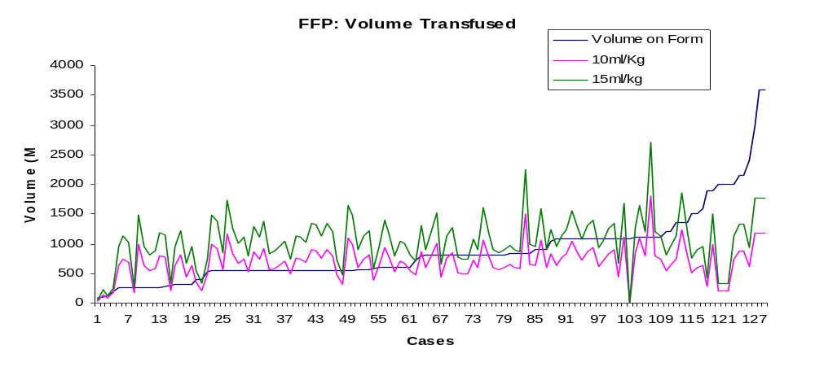

While caution is advised when using FFP in overweight patients, there is evidence of both under and overdosing in this group.

Figure 4 shows weight plotted against the volume of FFP used in bleeding patients in this group.

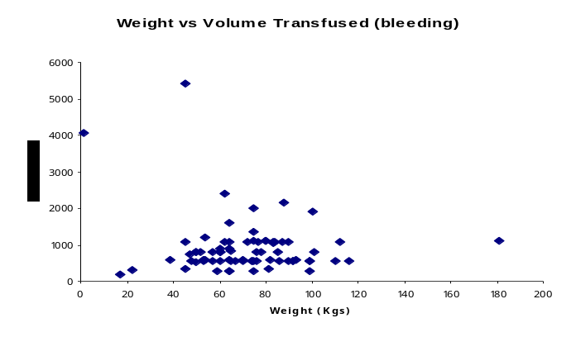
Fig 4

Summary Box 4

- FFP is under dosed and does not appear to be used in relation to the weight of the patient in a large proportion of the cases (fig 4)

- There is also evidence of overdosing in some patients

Discussion
The primary objective of this regional comparative audit was to evaluate use of FFP by comparison to current BCSH guidelines, and to evaluate current practice in our region, in comparison with the earlier, national comparative audit of the use of FFP, carried out in 2009 (NCA 2009). This audit presents analysis of data from 177 FFP transfusion episodes from 10 hospitals in the East Midlands Region of England. The audit sample is considered sufficiently representative; however audit results should be interpreted in the context of usual limitations of retrospective data collection.
The NCA 2009 showed that 43% of cases audited, FFP was transfused in the absence of bleeding. This figure in our regional audit is 46%, indicating very little or no improvement in clinical practice in our region. In these cases where FFP was transfused in the absence of bleeding, there was no evidence of a significant abnormality of coagulation in 31% of cases. This figure for the NCA 2009 was 39%.
It is therefore clear that FFP continues to be frequently transfused in the absence of bleeding or significant coagulopathy, as defined by laboratory parameters of coagulation in this audit. This audit effectively shows no improvement in this area of clinical practice since the earlier national comparative audit of 2009.
The NCA 2009 reported that FFP was used to reverse warfarin in 14% of cases audited. In our audit this figure was 3%, indicating a significant improvement in this region.
This audit also shows a significant variation in the dose of FFP transfused. There was evidence of both under- and over-transfusion based on the dosage recommended in the BCSH guideline.
Pre transfusion coagulation parameters were reported for the vast majority (98%) of cases. However post-transfusion coagulation parameters were reported for 62% of cases, and of these only 37 % had coagulation checked within 3 hours following the completion of FFP transfusion.
In summary, this audit shows that FFP continues to be frequently used in the absence of bleeding and / or evidence of abnormal coagulation, and thus highlights the need for concerted efforts in the education of clinicians who prescribe FFP.

Recommendations

- Hospitals should have locally agreed, speciality specific, guidelines for the use of FFP. As a minimum, specific local guidelines should address the use of FFP in liver patients, cardiac surgery, trauma, Intensive Care Units and Neonatal units.
- These guidelines should define appropriate dose (mls /Kg) of FFP.

- Hospitals should have local guidelines on the reversal of anticoagulation with warfarin and other vitamin K antagonists. This guideline should clearly define exceptions where the use of FFP may be appropriate in addition to vitamin K, when Prothrombin Complex Concentrates (PCCs) are contra-indicated.

- Clinicians who prescribe FFP should be familiar with the guidelines for their specialty.

- Each high user clinical specialty should perform regular (annual) audits of compliance with local guidelines. The audits findings and action plans should be disseminated to all clinicians within the specialty, and presented to the Hospital Transfusion Committee.

- Use of FFP for the treatment of bleeding should be guided, wherever possible, by appropriate laboratory or point of care tests of coagulation before and after transfusing FFP.

- The East Midlands Regional Transfusion Committee, in collaboration with HTTs, should organise regional and local educational events on evidence based use of FFP.

References

- National Comparative Audit of the use of Fresh Frozen Plasma 2009. http://hospital.blood.co.uk/library/pdf/Audit_of_FFP_Elsewheres2009.pdf

- British Committee for Standards in Haematology, 2004. Guidelines for the use of Fresh Frozen Plasma, Cryoprecipitate and Cryosupernatant. British Journal of Haematology 126, 11-28BCSH guidelines
- Yang L, Stanworth S, Hopewell S, Doree C, Murphy M 2012. Is fresh-frozen plasma clinically effective? An update of a systematic review of randomized controlled trials. Transfusion Aug;52(8):1673-86
- SHOT 2012 annual report. www.shotuk.org
- DoH, HSC 2007/001. http://www.transfusionguidelines.org.uk/uk-transfusion-committees/national-blood-transfusion-committee/better-blood-transfusion
- South Central Regional audit of FFP. http://www.transfusionguidelines.org.uk/uk-transfusion-committees/regional-transfusion-committees

- South West Regional audit of FFP. http://www.transfusionguidelines.org.uk/uk-transfusion-committees/regional-transfusion-committees

- East Midlands regional audit of FFP. http://www.transfusionguidelines.org.uk/uk-transfusion-committees/regional-transfusion-committees

Appendix 1 – Case Data Collection Form

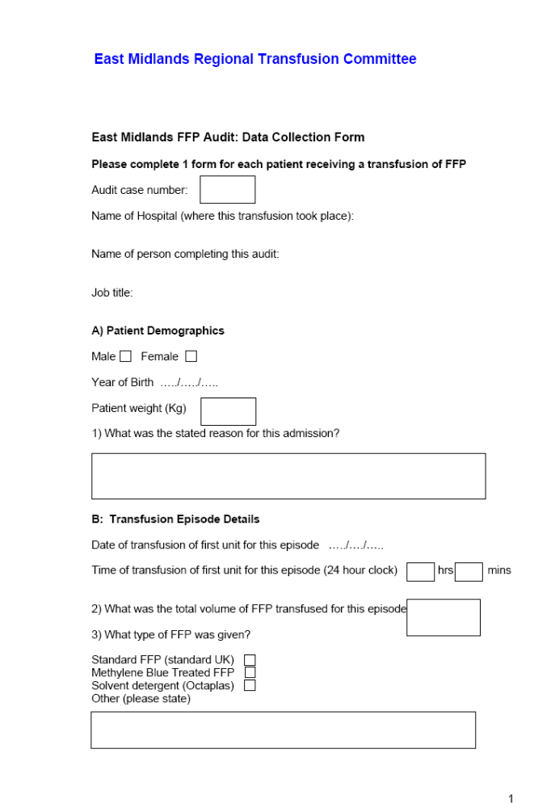

Appendix 1 contd..

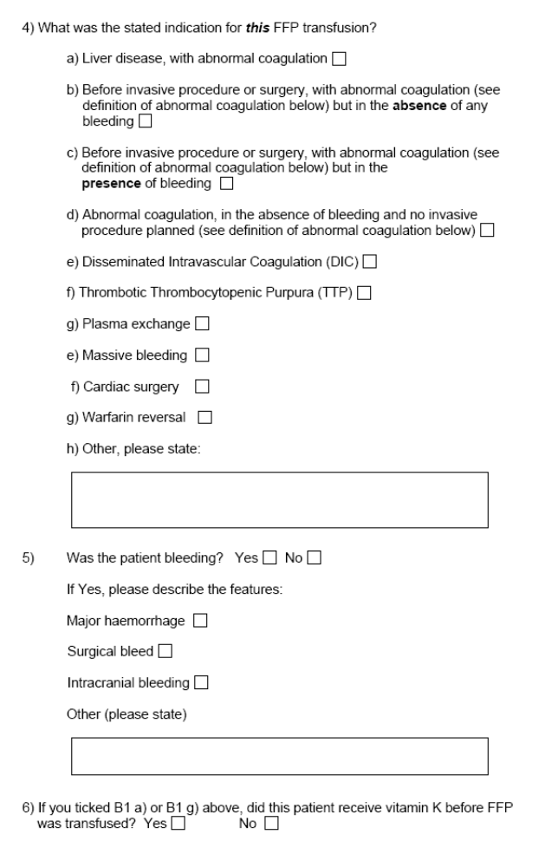

Appendix 1 contd

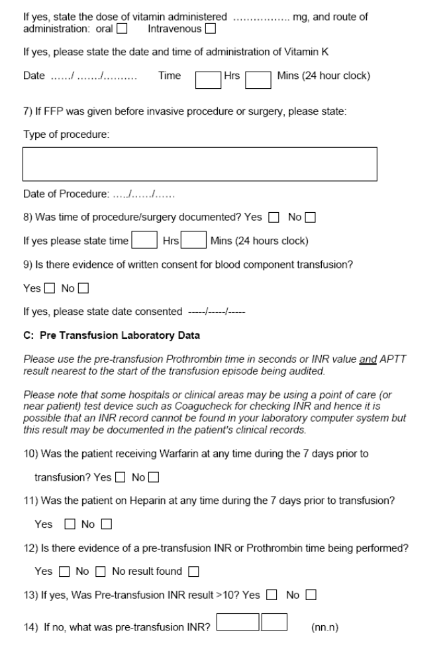

Appendix 1 contd…..

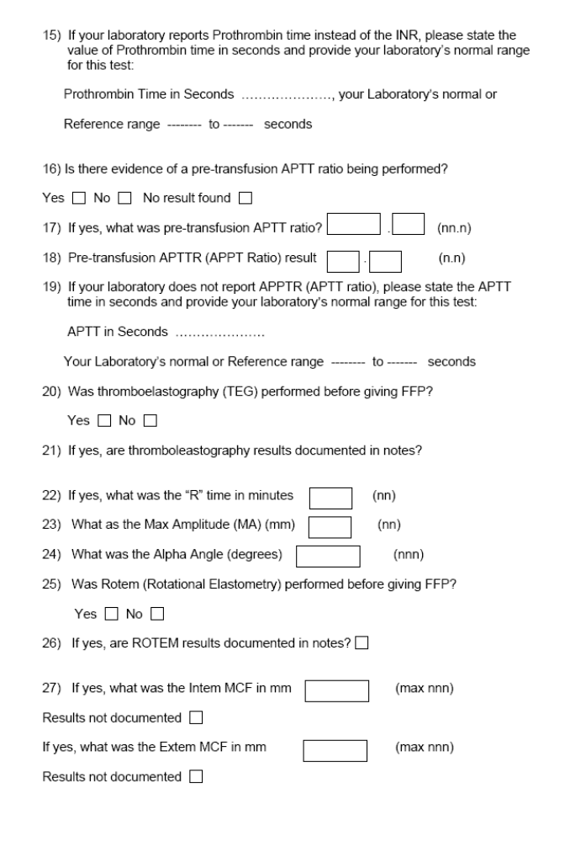

Appendix 1 contd….

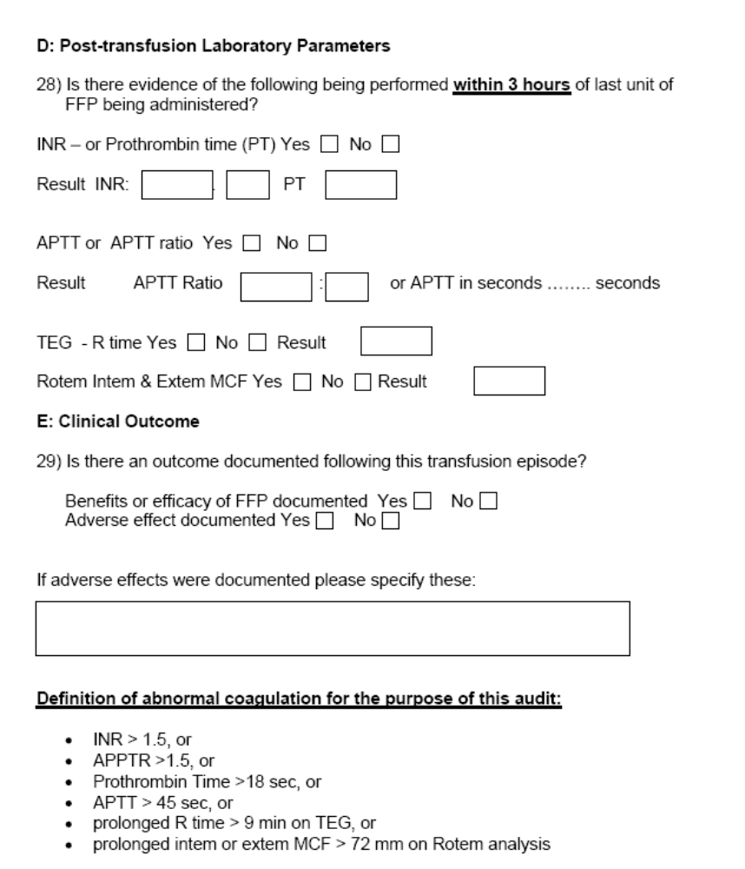

Appendix 2 – Organisational Survey (taken from NCA)

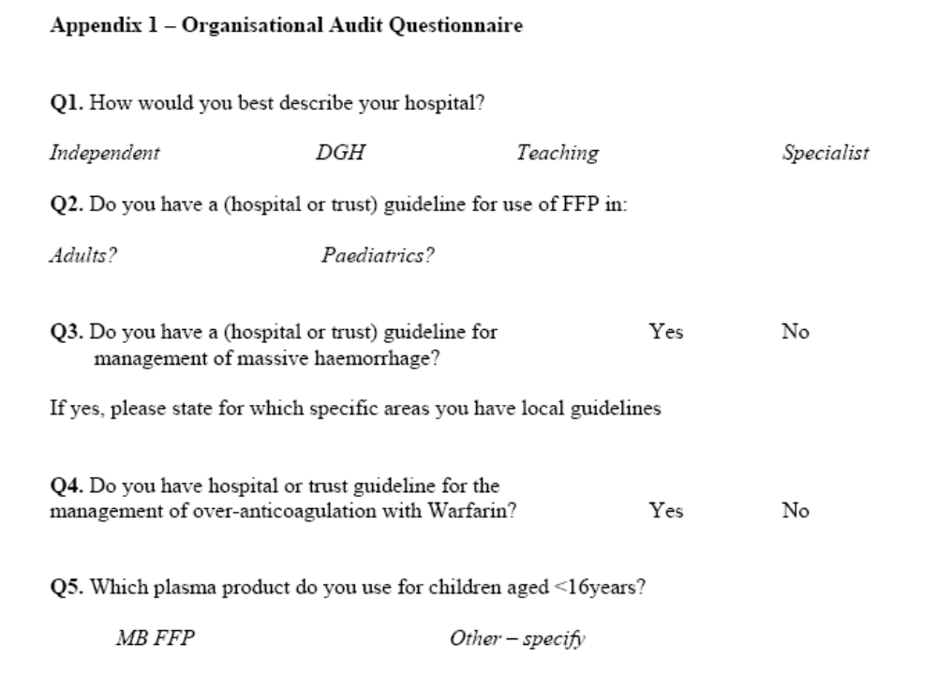

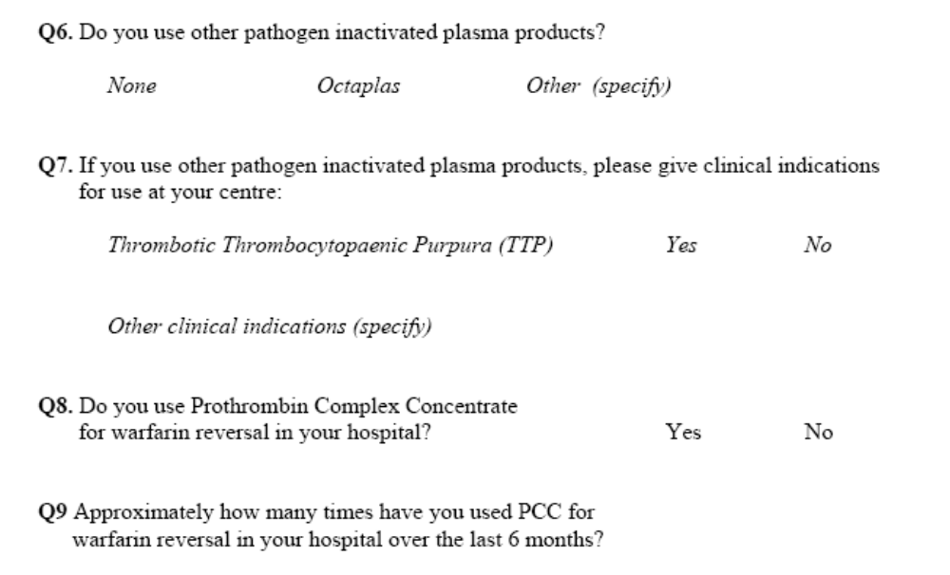

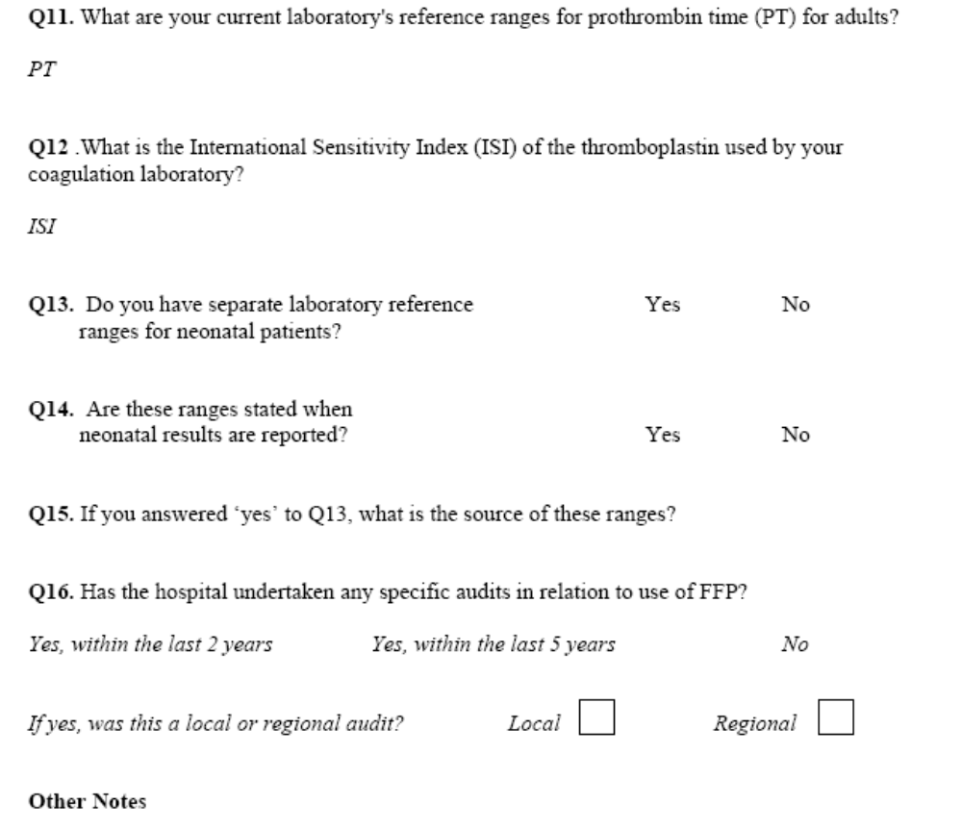

Appendix 3 – FFP Dosage (© NHSBT)

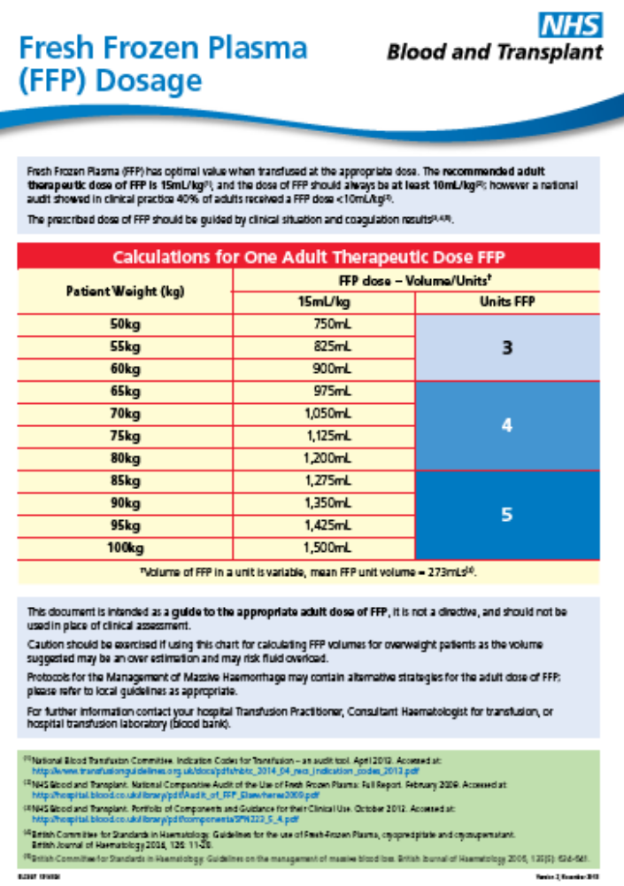

Appendix 4 – Participating Trusts

Participating Trusts
Chesterfield Royal Hospital NHS Foundation Trust
Derby Hospitals NHS Foundation Trust
Kettering General Hospital NHS Foundation Trust
Nottingham University Hospitals NHS Trust
Sherwood Forest Hospitals NHS Foundation Trust
United Lincolnshire Hospitals NHS Trust
University Hospitals of Leicester NHS Trust

Appendix 5 – Transfusion Practitioners

Transfusion Practitioners I the East Midlands Region without whose help this audit would not have been possible

Name | Job Title | Hospital
Phillipa Cheshire | Transfusion Practioner | Nottingham University Hospitals
Ant Jackson  (Scientist) | Transfusion Practitioner | Pilgrim Hospital
Carol Richardson  (Nurse) | Transfusion Practitioner | Lincoln County Hospital
Debra Davis  (Nurse) | Transfusion Practitioner | Royal Derby Hospital
Judy Beale  (Scientist) | Transfusion Practitioner | Royal Derby Hospital
Joy Murphy  (Nurse) | Transfusion Practitioner | Northampton General Hospital
Angela Houston  (Nurse) | Transfusion Nurse Specialist | Kettering General Hospital
Caroline Lowe  (Scientist) | Transfusion Practitioner | Kettering General Hospital
Janice Smith  (Nurse) | Matron Transfusion Specialist | Chesterfield Royal Hospital
Nicky Rollings  (Nurse) | Transfusion Competency Assessor | Chesterfield Royal Hospital
Virginia Pearson  (Nurse) | Transfusion Competency Assessor | Chesterfield Royal Hospital
Jane Walden  (Scientist) | Transfusion Practitioner | Kings Mill Hospital
Pavlina Sharp  (Nurse) | Transfusion Practitioner | Glenfield General Hospital
Fiona Waller  (Nurse) | Transfusion Practitioner | Leicester Royal Infirmary
Malcolm Chambers  (ODP) | Transfusion Practitioner | Glenfield General Hospital
Lindsay Duffin  (Nurse) | Group Transfusion Nurse Specialist | Nuffield Hospitals  National Post  (use home address for post)
Roz Rowe  (Nurse) | Transfusion Nurse | Spire Hospital Leicester

For copies of this report or any queries concerning this audit please contact:

Brian Hockley
Data Analyst and Audit Manager
Sheffield Blood Centre
Longley Lane
Sheffield
S5 7JN
Brian.Hockley@nhsbt.nhs.uk
Tel - 01143584836
Mob - 07764280404

