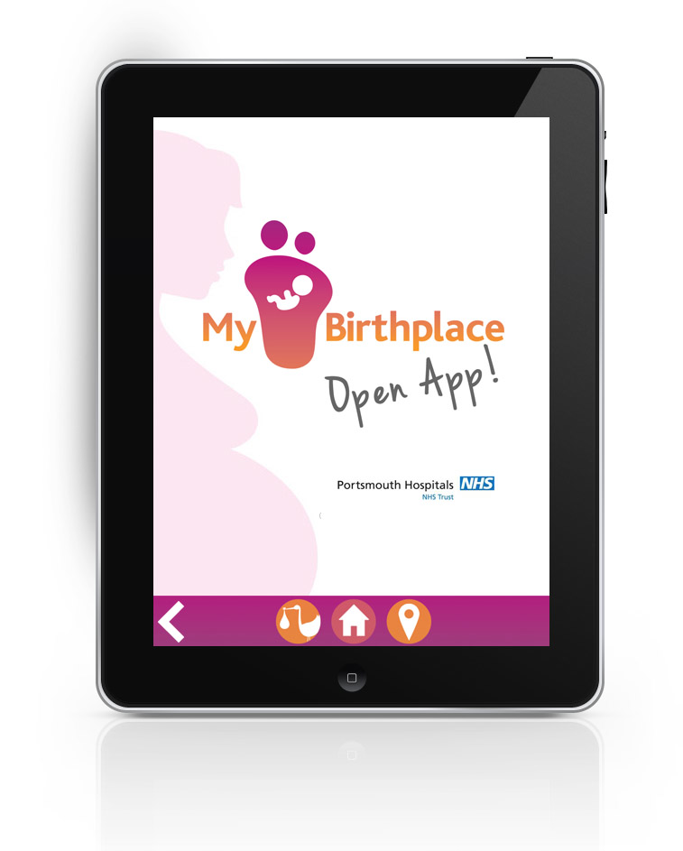

My Birthplace®: A computerised place of birth decision support tool for women and midwives

Greta Westwood, Head of Nursing, Midwifery and AHP Research, Portsmouth Hospitals NHS Trust and University of Southampton
Gill Walton, Director of Midwifery, Portsmouth Hospitals NHS Trust,
Emily Gaskell, My Birthplace® Project Manager, Portsmouth Hospitals NHS Trust,
Sarah Barton, Maternity Services Liaison Committee, Portsmouth Hospitals NHS Trust

Recent policy has encouraged birth out of hospital for women at low risk of intervention (low risk women). However until 2011 robust research outcome data were limited to underpin this recommendation and at that time only 8% of births nationally and 10.9% of births in Portsmouth were out of hospital. A cohort study of 79,774 low risk women, published by Hollowell et al in 2011, identified that giving birth is very safe in all settings, with lower intervention rates and higher likelihood of a normal birth when labour starts out of hospital.

Portsmouth Hospitals NHS Trust Maternity Service is in the third year of a major transformation programme, ‘Nurture’ its priority is to provide one to one midwifery care in labour, achieved by a flexible integrated midwifery model, to support birth in and out of hospital. Portsmouth offers a full range of options for place of birth; home, 3-standalone midwifery led units (FMU), an integrated midwifery led unit (AMU) and a traditional consultant led labour ward (OU).

Information about choices for place of birth is widely available via the internet, local NHS websites and midwives give written information to all pregnant women. Limited and potentially subjective information about risk and the outcomes of place of delivery has been inconsistent between midwives and across maternity services. Women in Portsmouth have complained to midwifery managers that this information is not personalised to meet individual preference and risk.

This apparent lack of information may contribute to a low level of a decisive birthplace preference. Just over half of women in Portsmouth (59%) make a birthplace decision at 12 weeks of pregnancy and the midwife, throughout the pregnancy, does not revisit this again. This creates unnecessary hospital births for low risk women linked with increased interventions and inefficiencies in workforce planning. Hollowell identified considerable savings for birth out of hospital calculated by comparing unit overheads and staffing and the costs associated with reduced maternal morbidity.

Using technology to improve health outcomes is increasing and Smartphone technology is changing the face of health information. However the use of this technology is limited in maternity services with a reliance on paper information, professional subjective opinion and lack of consistent information. Hollowell’s research gives clear information about neonatal and maternal mortality and morbidity associated with place of birth that this could be was used to develop a decision support tool to help women and their partners explore their personal risk and preference with their midwife.

The aim of My Birthplace® service development project, funded by a 2012 Shine Health Foundation award was to develop, with maternity service users and Hollowell’s evidence, a computerised tool to support birthplace decision-making. It was an iterative process with midwives and maternity service users engagement at all stages of development. Each stage was checked with them for usability and applicability and each stage incorporated their feedback to refine the end product. The tool, My Birthplace® was designed as an application (app) adapted for Smartphone or tablet technology from a web based platform. It uses standardised and evidence based information about outcomes for each birth setting using national and local data to support women as partners in decision making. Birth data between October and November 2012 were used as the project baseline data; 59% of women had made a decision about place of birth at 12 weeks of pregnancy. Data were not recorded on place of birth preference at 36 weeks.

Thirty midwives, covering 4 distinct geographical areas were trained to use My Birthplace® app and training also included the theory of shared decision-making. These pilot midwives identified 250 eligible women who would deliver between October and November 2013. Their initial preference for place of birth was documented in the maternity notes at 12 weeks of pregnancy. It was planned the midwives would test the prototype app with women and their partners from 25 weeks of pregnancy. Women were able to use the app at home and then complete the exercise together with their midwife in the antenatal clinic. The final birthplace preference was documented at 36 weeks of pregnancy using digital pens and specifically designed digital forms within the handheld maternity notes. Individual interviews were held and surveys undertaken with women and midwives to understand the utility, applicability and acceptability of My Birthplace®.

Midwives used the app with 236 women expected to give birth between October and November 2013. Of these, 163 (69%) had expressed a birthplace preference at both 12 and 36 weeks. Seventy-three women (31%) had either delivered before or after the pilot dates or their notes contained incomplete birthplace preference data at 12 or 36 weeks so were not included in the final results (Figure 1). Of 163 women, 73 (45%) had decided a preferred place of birth at their 12 week appointment and this increased to 143 women (88%) at 36 weeks of pregnancy, 23 (14%) had moved out of the area (other). Full interview and survey data will be reported elsewhere but initial data indicates the use of this app is acceptable to women and midwives and both groups valued the evidence-base information.

“For me, I think that the thing that has worked really well is having an app designed by local women for local women and their families”
(Sarah Barton, Maternity Services Liaison Committee)

My Birthplace® app developed by maternity service users appears to influence preference for place of birth. It uses research data that enables midwives to have evidence based discussions with women and their partners when choosing place of birth. It has the ability to assist in planning maternity services so that midwives with the right skills are in the right place for the right women, safeguarding birthplace preference. The acceptability and utility of My Birthplace® is now the subject of a midwifery PhD study. My Birthplace® is now ready to be launched and implemented across all local maternity services with plans to reach into national maternity services.

Figure 1: Place of Birth Preferences at 12 and 36 Weeks of Pregnancy (%)

