TAB | DESCRIPTION OF DATA ENTRY
Workflow Type

This screen relates to:

- Consultation date
- Seen by
- Workflow type

Indication selected will navigated the user to the appropriate workflow for data entry.

Management

This screen relates to:

- Date entry
- Seen by
- Date treatment started

Biologic Therapy

This screen relates to:

- Diagnosis
- Preferred drug
- Clinical notes

Document data on clinical notes as it has option to create a correspondence or simply save on timeline

Medication

This screen relates to:

- Previous therapies
- Start & Stop Date
- Reason for stopping
- Dose
- Currently on drugs

Pre-Biologics Screening

This screen relates to:

- Blood screening
- Medical history
- TB screening & x-rays
- Patient information on Anti-TNFa

Rheumatoid Arthritis

This screen relates to:

- Visit type
- Initial
- Second
- Review e.g. at months 3, 6, 9,12, 24 etc.

DAS scores are calculated using either ESR / CRP.

Data is pre-populated onto the Outcome Report.

Funding Section  This screen relates to:  - Funding requests  - Funding approval  - Switches between Anti-TNFa  - Start dates | 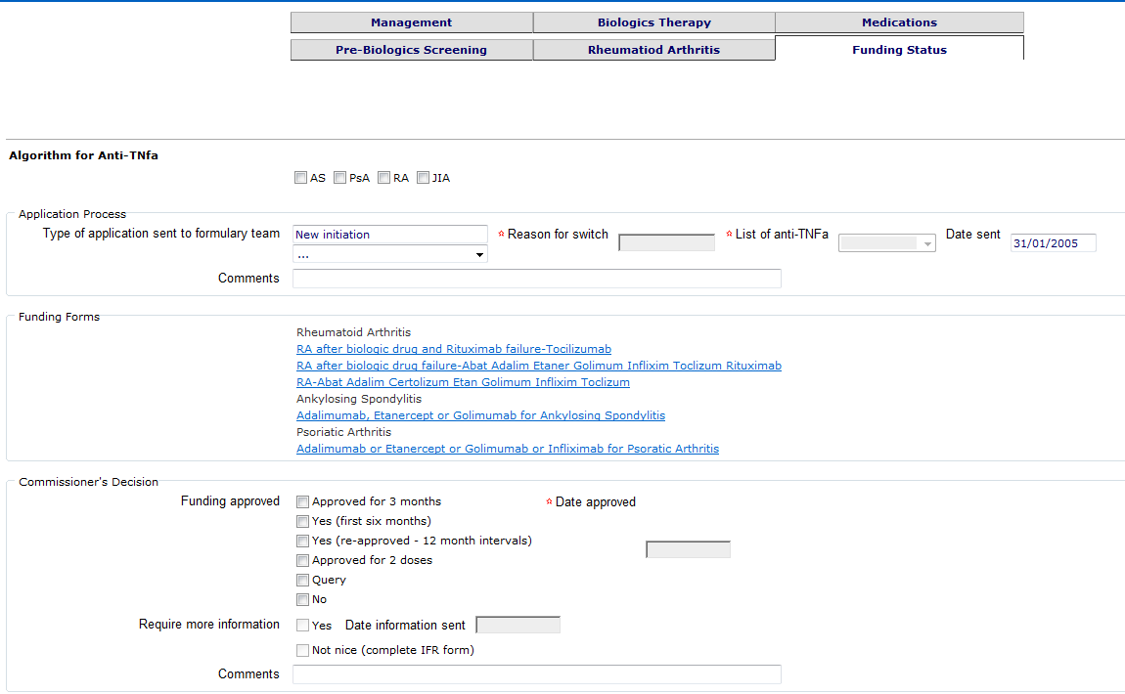
Outcome Report | An Outcome Report is generated from data entered in the dataset. This report is sent to the commissioner to provide reassurance that the biologic therapy was initiated and continued in accordance with NICE criteria.

