An audit of antibiotic prescribing:

Fylde and Wyre CCG, 20 GP practices

November 2014 – January 2015

**Audit aims**

* To identify and audit high risk antibiotic prescribing over the past twelve months across 20 GP practices in Fylde and Wyre CCG
* To reduce the prescribing of high risk antibiotics linked with C Difficile Infection (CDI)
* To promote and improve antibiotic prescribing in accordance with local guidelines

**Background**

The WHO estimates that the average human lifespan is extended by 20 years through the use of antimicrobials₁. However, this is being threatened by increasing levels of antimicrobial resistance. A recent study analysed UK primary care data for almost 11 million prescriptions for antimicrobials, used as monotherapy to treat upper and lower respiratory tract, otitis media and skin and soft tissues infections₂. It found that more than 1 in 10 treatments were ineffective (indicated by a second prescription for antimicrobials within 30 days) and overall treatment failure rates increased by 12% between 1991 and 2012.

Where an antibiotic is needed, the choice of agent and its use needs to be carefully considered in order to ensure that infections are treated effectively. This audit is underpinned by the Health Protection Agency (HPA) management of infection in primary care guidelines, adapted and agreed locally.

These can be found at: <http://www.fyldeandwyreccg.nhs.uk/about-us/medicines-optimisation/>

In addition it is recommended that the use of high risk antibiotics (broad-spectrum antibiotics such as quinolones, cefalosporins and co-amoxiclav) should be reserved for the treatment of resistant disease only.

The use of antibiotic agents is monitored by two QIPP Indicators: antibacterial items per 1,000 STAR-PU and % of cefalosporins and quinolones of all antibiotic prescribing. There are currently 9 practices whose number of items is in the bottom 25% of national prescribing and 1 practice in the bottom 25% for cephalosporin and quinolone prescribing and 5 in the 25-50% band. Whilst this has shown significant improvement since 2010, there is still more to achieve.

**National Examples**

There is much evidence to show that improvements in prescribing are still needed, and where addressed, can lead to the reduced incidence of CDI and the development of resistance:

1. **National trends in antibiotic prescribing: study suggests there is scope for improvements**

**A study looking at trends in antibiotic prescribing in UK primary care found improvement in some aspects of antibiotic prescribing between 1999 and 2011, but there remain some areas of concern and significant variation between GP practices. For uncomplicated urinary tract infection in women aged 16−74 years, use of 3-day courses of trimethoprim in line with guidance increased from 8% of cases in 1995 to 49% of cases in 2011 (with the range for GP practices 16% to 71%). The proportion of prescriptions that were for a recommended antibiotic rose from 77% to 85% for otitis media and from 64% to 69% for sore throat. However, antibiotic prescribing for coughs and colds increased from 36% in 1999 to 51% in 2011 (range 32% to 65%)₃.**

1. **Improving antimicrobial stewardship**

**NICE Quality statement**

People are prescribed antibiotics in accordance with local antibiotic formularies as part of antimicrobial stewardship.

**Rationale:** antibiotic resistance poses a significant threat to public health, particularly because antibiotics underpin routine medical practice in both primary and secondary care. To help prevent the development of current and future bacterial resistance, it is important to prescribe antibiotics according to the principles of antimicrobial stewardship, such as prescribing antibiotics only when they are needed (and not for self-limiting mild infections such as colds and most coughs, sinusitis, earache and sore throats) and reviewing the continued need for them. These principles should be set out within local antibiotic guidelines and pathways and be consistent with the local antibiotic formulary. Local antibiotic formularies should indicate a range of antibiotics for managing common infections, and permit use of other antibiotics only on the advice of the microbiologist or physician responsible for the control of infectious diseases.

1. **Vale of Leven Enquiry**

‘’An inquiry was set up in 2009 to investigate the treatment of 63 patients at Vale of Leven Hospital between 2007 and 2008 in which CDI was identified as a contributory factor in 28 deaths. The outbreak of clostridium difficile at the Vale of Leven hospital was one of several across the UK at the time. Authorities often say that much has changed, but this time it really has. Levels of C. difficile are 75% lower than they previously were. This has been achieved through better hygiene and infection control, but by far the biggest impact in Greater Glasgow was made through a change in the kind of antibiotics prescribed.’’₄

1. **CDI outbreak Edinburgh December 2014**

There is a current CDI outbreak at an Edinburgh hospital₅.

‘’Investigations are continuing into a cluster of cases of Clostridium difficile infection in wards at the Royal Infirmary of Edinburgh.The NHS said no new cases had been identified in the last 24 hours.Fourteen patients were affected by the infection, commonly known as C-diff, and two patients died from underlying conditions after also testing positive for the infection in the days before their death.Since the cluster was identified in early November, four patients have recovered and been discharged home.The eight patients who remain in hospital are being cared for in isolation, and NHS Lothian said two very seriously ill, but stressed while they had tested positive for the infection,C-diff was not the cause of their condition’’

1. **Local targets**

In relation to CDI, Fylde and Wyre CCG and Blackpool Teaching Hospitals have breached their annual trajectory of 31 cases - 14 cases in acute trusts and 18 in non-acute settings

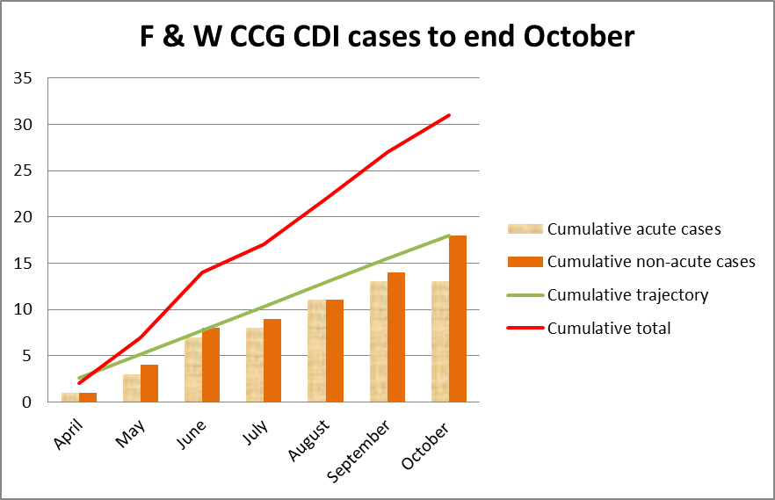

**Current performance in antibiotic prescribing**

**Volume of prescribing – items**

It can be seen from the graphs below that there is a twofold difference in the number of items prescribed by practices. In addition, 50% of practices prescribed more antibiotics than the previous year.

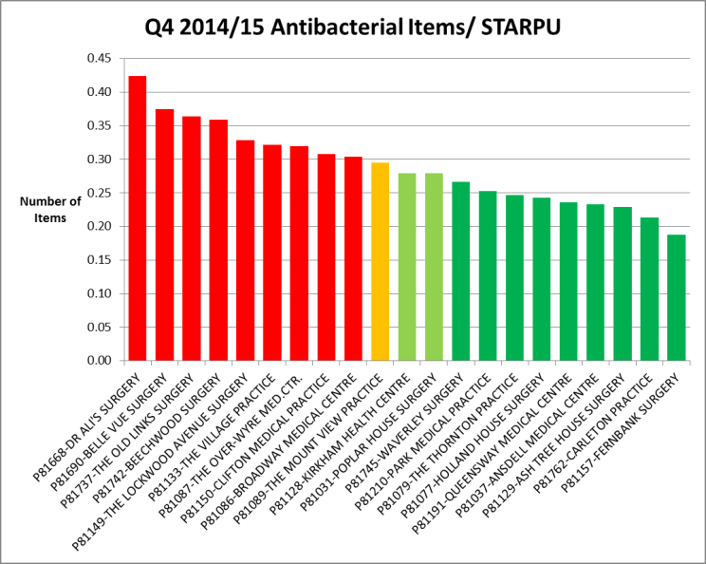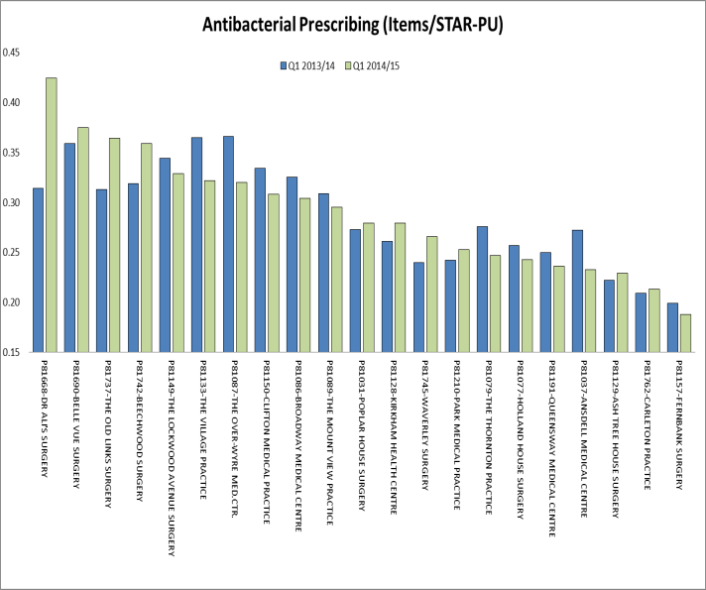

**QIPP indicators**

An increase in the number of items prescribed might be expected in Q3 &Q4 (October to March), however 9 practices appear to be prescribing at a high level throughout the year.



**High risk antibiotic prescribing**

There is an eight fold difference in the prescribing of high risk antibiotics. Again, 50% of practices prescribed more high risk antibiotics than the previous year.

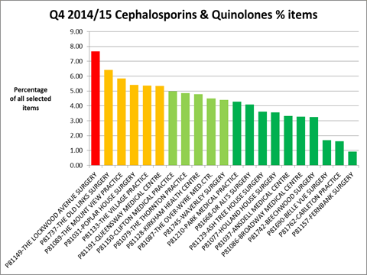 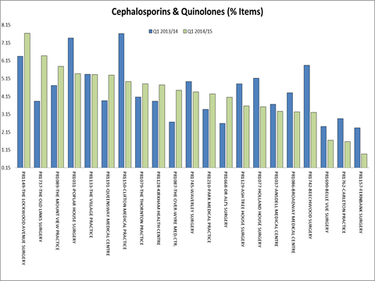

**QIPP indicators**

Some practice have shown a steady reduction in the use of high risk antibiotics, the momentum of which needs to continue.



**Audit design**

The audit was based on work done by the All Wales Strategy Group₆, identifying prescribing in the past 12 months of:

* broad-spectrum antibiotics such as quinolones, cefalosporins and co-amoxiclav
* topical antibiotics
* the number of people prescribed >5 courses of broad spectrum/high risk antibiotics

**Audit question**

**What is the quality of the prescribing of high risk antibiotics across GP practices?**

**Standards**

The standards were difficult to set due to prescribing for several conditions regularly seen in primary care, but which are not on the formulary. Since these are the accepted treatment for that condition, e.g. diverticulitis, a low standard was set. The results will try to show if this was a reasonable standard. The outcomes of the audit may indicate that wider discussion regarding appropriate prescribing is needed.

|  |  |
| --- | --- |
| **Standard** | **Target** |
| Part 1 – the prescribing of high risk antibiotics is below the 25th national centile (Q2) | Below 4.74% |
| Pat 1 – the prescribing of topical antibiotics is not carried out unless for accepted conditions not in formulary or at the request of dermatologists | 0 patients |
| Part 1 - there is minimal prescribing of high risk antibiotics for people with low co-morbidities (in younger age groups) | 30% |
| Part 2 - the prescribing of high risk antibiotic is according to formulary or lab sensitivity | 50% |

Additional recommendations:

1. The prescribing of high risk antibiotics is not on more than one occasion in 12 months, unless at the advice of microbiologists.
2. The prescribing of antibiotics should always have a diagnosis recorded.

3. The prescribing of high risk antibiotics with PPIs

**Audit method**

The audit was split into 2 parts.

Firstly, standardised searches were carried out on the practice systems to collect a standard data set. Each practice carried out their own audit, based on a sample size of 50 patients for single-handed GP practices or 100 patients for all other practices.

The data included:

* Number of patients prescribed a high risk antibiotic in the past twelve months
* Number of issues of high risk antibiotic in the past twelve months
* Age of patient
* Antibiotic prescribed
* Number of patients also prescribed a PPI as well as a high risk antibiotic in the past twelve months

Searches were also carried out to identify the numbers of people receiving prescriptions for topical antibiotics and several high risk antibiotic courses over the past twelve months (usually for COPD or recurrent UTI). The data was recorded in a spreadsheet and percentages of antibiotics prescribed and numbers of patients also prescribed a PPI were calculated.

The second part of the audit looked at a sample of 100 issues of antibiotics, to determine:

* Indication recorded
* Formulary adherence
* Infection sampling
* Prescribing linked to sensitivity reporting
* Contact with microbiologists
* Conditions being treated

A practice report was then written for each practice, tailored to the areas for improvement found in the audit.

**Results - part 1**

The first part of the audit was an overview of the prescribing of high risk antibiotics (cefalosporins, quinolones and co-amoxiclav) in the past twelve months.

Fylde and Wyre population = 150656

**5122** courses of high risk antibiotics were prescribed in the past year

**3909 (2.8%)** patients were prescribed a high risk antibiotic in the past year

**1334 (33%)** of these were also on a PPI

**194** people were prescribed high risk antibiotics for prophylaxis (usually UTI)

**2153** people were prescribed a topical antibiotic

**Information from data collection**

|  |  |
| --- | --- |
| Age group and antibiotics prescribed = 3909 | 0-4 = 73  5-14 = 135  15-29 = 416  30-44 = 517  45-59 = 720  60-74 = 1088  Over 75 = 960 |
| Courses of antibiotics prescribed total = 5122 | Cefalosporins = 1635  Co-amoxiclav = 1694  Ciprofloxacin = 1157  Others = 577 |
| No of people also prescribed a PPI | = 1334 |

1. 2.8% of patients were prescribed a high risk antibiotic in the past year = 3909 patients.

These were as shown in the table below:

|  |  |  |  |  |  |  |  |
| --- | --- | --- | --- | --- | --- | --- | --- |
| **Cefalosporins** | **% of total** | **Co-amoxiclav** | **% of total** | **Ciprofloxacin** | **% of total** | **Other quinolones** | **% of total** |
| 1635 | 34% | 1694 | 31% | 1157 | 23% | 577 | 11% |
|  | | | | | | | |

1. A low percentage of patients were prescribed high risk antibiotics as indicated in the formulary.
2. 42% of the high risk antibiotic was in the 15-60 age group, despite being likely to have the lowest co-morbidity.

1. 1745 topical antibiotics were prescribed. There is increased risk of resistance when prescribing topical antibiotics. They are especially risky to use in non-healing wounds such as leg ulcers. Systemic antibiotics should be used following swab analysis. The formulary indications for prescribing topical antibiotics are limited to impetigo and acne. An information sheet is being prepared to advised clinical staff of appropriate prescribing.
2. 251 people had prophylactic courses of high risk antibiotics in the past year, usually for UTI. Microbiologists advise that these should be stopped every 6-12 months and MSU checked for infection.
3. PPI link with CDI. Unfortunately, there is currently no strong evidence, but guidance suggests stopping or reducing PPIs if there is no clear indication for use. Many other risks of PPI use are emerging.

**Results - part 2**

The second part of the audit looked at the conditions that the antibiotics were prescribed for and whether these had been prescribed according to the formulary.

There were also other elements considered:

If a non-formulary antibiotic had been prescribed, was there some other reason why this was chosen?

e.g. a sample had been sent off and an organism identified which was sensitive to the antibiotic prescribed; microbiologists had been consulted for advice; conditions not in formulary were treated and the antibiotic chosen was the usual first line choice.

|  |  |
| --- | --- |
| **Results for 20 practices** (a sample of 50/100 issues were audited for each practice) | |
| Percentage of antibiotics in formulary | = 18 |
| Percentage of lab tests sensitive for antibiotic prescribed | = 5 |
| **Percentage of antibiotics indicated** | **= 23** |

1. Prescribing for indicated high risk antibiotics in formulary conditions such as prostatitis or when sensitivities were reported was well documented and a clear rationale was provided.
2. There were a wide range of conditions not in the formulary and where high risk antibiotic prescribing was not appropriate. Standard antibiotics should have been prescribed if treatment was needed. X practices had particularly low results
3. Lab testing was not carried out consistently where this was appropriate e.g. for UTI/LRTI.
4. From the case studies it was noted that microbiologists were not frequently contacted for UTI/LRTI as advised in the formulary. difficult to contact microbiology and also that specimen results do not list all sensitivities so GPs encouraged to ask ahead of prescribing a high risk AB
5. UTI was the most frequently identified condition that was poorly managed and where high risk antibiotics could have been avoided
6. There was evidence to suggest that: nurses may in a few cases have made assessments of patients and then asked GPs to prescribe; there was some prescribing via phone; on some occasions the patient has asked (insisted) for a particular antibiotic.
7. There was evidence to suggest that no diagnosis had been recorded for a small number of instances of prescribing.

|  |  |  |  |
| --- | --- | --- | --- |
| **Outcomes of standards** | **Target** | **Result** | **Outcome achieved** |
| Standard 1, part 1 – the prescribing of high risk antibiotics is below the 25th national centile (Q2) | Below 4.74% | 4.77% | Almost |
| Standard 2, part 1 – the prescribing of topical antibiotics is not carried out unless for accepted conditions not in formulary or at the request of dermatologists | 0 patients |  | No |
| Standard 3, part 1 - there is minimal prescribing of high risk antibiotics for people with low risk (in younger age groups) | 30% | 42% | No |
| Standard 4, part 2 - the prescribing of high risk antibiotic is according to formulary or lab sensitivity | 50% |  | No |

**Conclusion**

The CCG is performing well according to national standards. However, the overall audit results were poor, showing that there is still much scope for improvement.

There was considerable practice variation, with one practice showing outstanding results: standard 4 = 70%. This showed a greater than tenfold difference over the worst performing practice.

Continuous improvement is shown in high risk antibiotic prescribing for the majority of practices. Overall volume of all antibiotic prescribing still appears to be a challenge for nine practices.

Each practice is asked to develop an action plan to address any areas for improvement.

The audit only considered high risk antibiotics, a small percentage of antibiotic prescribing. The same principles addressed in the audit could be applied to all antibiotic prescribing and practices should consider if this is needed.

**Suggested actions following the audit**

Whilst there have been successful efforts made to reduce the prescribing of high risk antibiotics as evidenced by the indicators, there is still much room for improvement. Each practice has been asked to develop an action plan and re-audit where necessary.

1. **Supporting the improvement of antimicrobial stewardship**

[**http://www.nhs.uk/NHSEngland/ARC/Pages/AboutARC.aspx**](http://www.nhs.uk/NHSEngland/ARC/Pages/AboutARC.aspx)

1. **Agreeing individual practice clinical change**

**Suggested antibiotic practice plan**

1. 15-60 age groups - discuss in practice clinical meeting and agree strategy e.g. deferred scripts, no script leaflet
2. Share antibiotic formulary with all clinical staff
3. Agree practice policy for prescribing high risk antibiotics outside formulary
4. Discuss audit outcome with nurses and review practice protocols
5. Use a UTI template (to develop for all to use)
   1. Agree management of UTI and do in depth audit
   2. Severe, >3 symptoms - empiric treatment with trimethoprim or nitrofurantoin. Treatment failure, take sample, d/w microbiologists.
   3. Moderate 2 symptoms, dipstick – positive leucocytes, treat as above.
6. Agree management of COPD and do in depth audit
   1. 5 days pred and doxycycline 100mg bd or amox 500tds
   2. When to send sputum samples
   3. Not added to repeat
7. Agree management of skin – flucloxacillin first line
8. Agree management of leg ulcer – only if active infection send pre-treatment swab
9. No prescribing of topical antibiotics unless in specific conditions – sheet to follow
10. Re-audit of specific areas in 5 and 6 above April/May 2015 (6 months)
11. Suggested standards for re-audit
12. **Putting new management processes in place**

Use or review templates and protocols, especially for UTI.

The questions below are suggested to be worked through by each practice

|  |
| --- |
| **No prescriptions or delayed prescriptions**   1. Does the practice use the no prescription leaflets, developed by Fylde and Wyre CCG? 2. How successful have these been? 3. Does the practice have a protocol or process for addressing delayed prescriptions? 4. What methods are employed within the practice for delayed prescriptions (tick all that apply):  * None * Given directly to patient * For collection at reception * For collection at a named pharmacy  1. Does the practice monitor unused delayed prescriptions that have been given to the patient? 2. Does the practice monitor uncollected delayed prescriptions left at the reception? 3. Does the practice have an agreement with the local pharmacist to return uncollected prescriptions to the prescriber? 4. How many delayed prescriptions have been unused ?  * State time frame e.g. 6 weeks = * Uncollected from reception = * Returned from named pharmacy =  1. Is clear guidance given with a delayed script during the consultation to enable appropriate use (including clear descriptions of time and reasons) 2. Outcome of clinical discussion with colleagues regarding use of delayed prescriptions   9. Record any changes to process that have occurred following this review. |

**References**

1. WHO. Self-prescription of antibiotics boosts superbugs epidemic in the European region. Copenhagen: WHO 2012
2. Currie CJ et al. Antibiotic treatment failure in four common infections in UK primary care 1991-2012. BMJ 2014;349:g5493
3. **National trends in antibiotic prescribing:** <https://www.gov.uk/government/news/significant-scope-to-improve-antibiotic-prescribing>
4. **Vale of Leven enquiry 2014:** <http://www.valeoflevenhospitalinquiry.org/Report/j156505.pdf>
5. CDI outbreak Edinburgh December 2014 <http://www.bbc.co.uk/news/uk-scotland-edinburgh-east-fife-30580273>
6. CEPP National Audit: Focus on Antibiotic Prescribing. March 2013.