NICE International

Annual review 2020

Table of Contents
Introduction 4
Background 4
History and governance 6
History of NICE International 6
Governance 7
International enquiries and engagements 8
Service offerings 8
International enquiries 8
Engagements by country and region 12
NICE International's response to COVID-19 15
The Prosperity Fund - Better Health Programme 16
Case studies 17
Case study 1. Implementing health technology assessment: a collaborative initiative in the Latin American and Caribbean region 17
Case study 2. Prosperity Fund Better Health Programme: supporting the Philippines in implementing health technology assessment 18
Case study 3. Health technology assessment process and methods developments in the Danish healthcare system 19
Feedback from countries and funders 20
Global health: national and international groups, projects and collaborations 22
NICE International participation in national and international global health groups. 22
Collaboration with other organisations, agreements and memorandums of understanding (MoUs) 24
Presentations with an international outreach 25
Working together across NICE 26
NICE International support in NICE's activities 26
Collaboration across teams and departments at NICE 27
Online delivery 29
Communications 30
Marketing strategy 30
Social media and presence in the media 31
Monitoring, evaluation and learning plan 31
Identifying and evaluating risks 32
Conclusion and future plans 32

National Institute for Health and Care Excellence

NICE International - Annual review 2020
This report details the work of the NICE International team in the first year since its relaunch in November 2019. It also provides an overview of its work before the official relaunch to give a full picture of the international work at NICE.
The Board is asked to review the report and agree that it be published on the NICE website.
Meindert Boysen
Centre Director, Centre for Health Technology Evaluation
Pilar Pinilla Dominguez
Principal scientific adviser, NICE International
November 2020

Introduction
This report describes the work of the NICE International team in the first year since the relaunch of NICE International in November 2019. It also contains some details on its work before the official relaunch to provide a full picture of the international work at NICE.

Background
The All Parliamentary Party Group on Global Health report on 'The UK's contribution to health globally – 2020 update' describes 'the UK global vision for the UK to become a global centre for health and health science – a go-to place for all aspects of health globally' (February 2020). It argues that, as a leader in health and related sciences, 'the UK should give this role even greater priority and that further planning, collaboration and targeted investment will enable the UK to become a truly global centre for health and health science. This will bring enormous economic benefits to the UK and strengthen its influence and soft power. It will also maintain the UK’s role in promoting high standards in science and business globally and the development of global public goods in health.'
The All Parliamentary Party Group on Global Health report recommends that priority areas be identified for the UK focus on improving public health globally. It mentions NICE as a key institution to be considered for this purpose. As part of the expert interviews conducted for the report, NICE was also 'perceived as a world leading institution and as a potential model for countries in health technology assessment, recognising that there is no one-size-fits-all approach for different contexts'.
The work and strategy that NICE International has implemented since its relaunch in November 2019 have been based on these principles and have aligned with NICE's own strategic ambitions. One of the 6 strategic ambitions identified in the NICE business plan for 2020/21 is to 'support the UK’s ambition to enhance its position as a global life sciences destination', with a key deliverable being to 'maintain and further develop NICE’s global leadership role in the use of health technology assessment and guideline development processes and methods to inform decision making in health and social care systems across the world'.
NICE International's objectives are to support international organisations that are developing systems to:
- improve health and social care evidence-based decision making
- embed health technology assessment to allocate resources in a cost effective, transparent and equitable way
- improve the quality of care and reduce variation of access.
NICE International aims to contribute to improvements in health and social care on a global basis by sharing our learning and expertise with other organisations worldwide. In doing so, NICE’s strategic objectives and mission are central to the work of NICE International. NICE International maintains its integrity and objectivity when conducting any activities and ensures that it does not damage NICE’s image or reputation. NICE International aims to grow and maintain that reputation by developing international relationships, collaborations, and diplomatic activities.
The existence of NICE International should also be understood in the context of the UK commitment to delivering the United Nations Sustainable Development Goals (see figure 1). NICE International has identified that the following goals are:
- directly related to its remit: Goal 3: Good health and wellbeing and Goal 17: Partnerships for the goals
- indirectly related to its remit: Goal 5: Gender equality, Goal 10: Reduced inequalities and Goal 16: Peace, justice and strong institutions.

Figure 1: United Nations Sustainable Development Goals
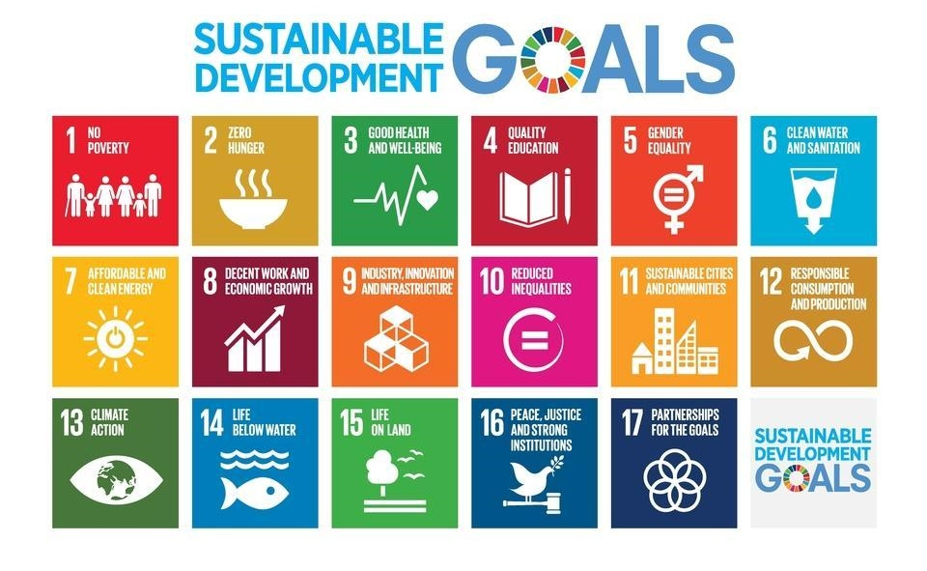
The past year has been increasingly busy for NICE International despite the significant impact of the COVID-19 pandemic on its services. Our activities have focused particularly on maintaining and building the relationships initiated during the past year and on identifying long-term opportunities for collaboration. These activities and collaborations are covered in this annual report.

History and governance

History of NICE International
NICE has provided knowledge-sharing activities to international organisations since 2008. After the transfer of the former NICE International team to Imperial College in 2016, the International Knowledge Transfer Service at NICE was developed and initially managed by the Evidence Resources team. In September 2018, the International Knowledge Transfer Service was transferred to a small sub-team within the NICE Scientific Advice programme. The aim was that it be a full cost-recovery (not-for-profit) service. The NICE International division was officially relaunched in November 2019. Figure 2 shows this evolution.

Figure 2 Evolution of NICE International from 1999 to 2020
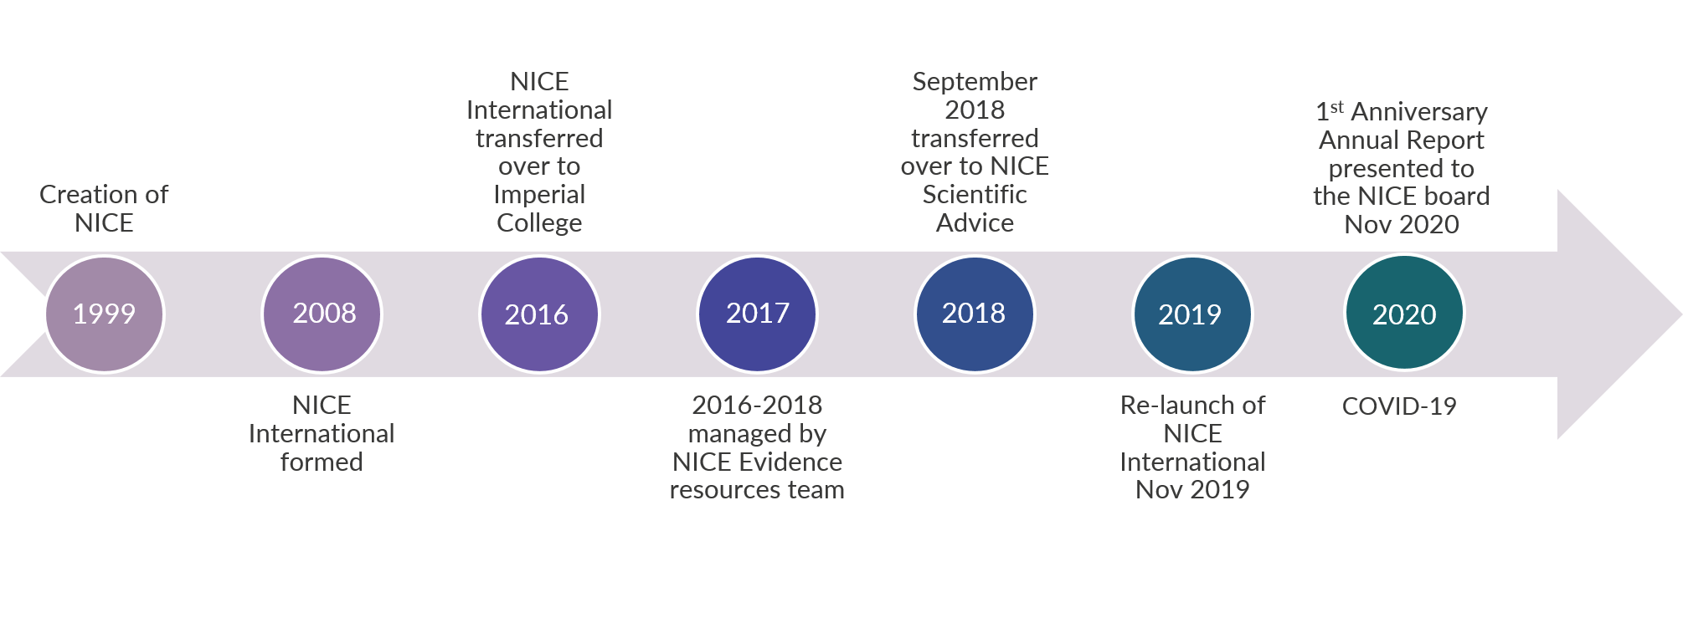

Governance
The governance structure for NICE International is presented in figure 3.

Figure 3 The governance structure for NICE International
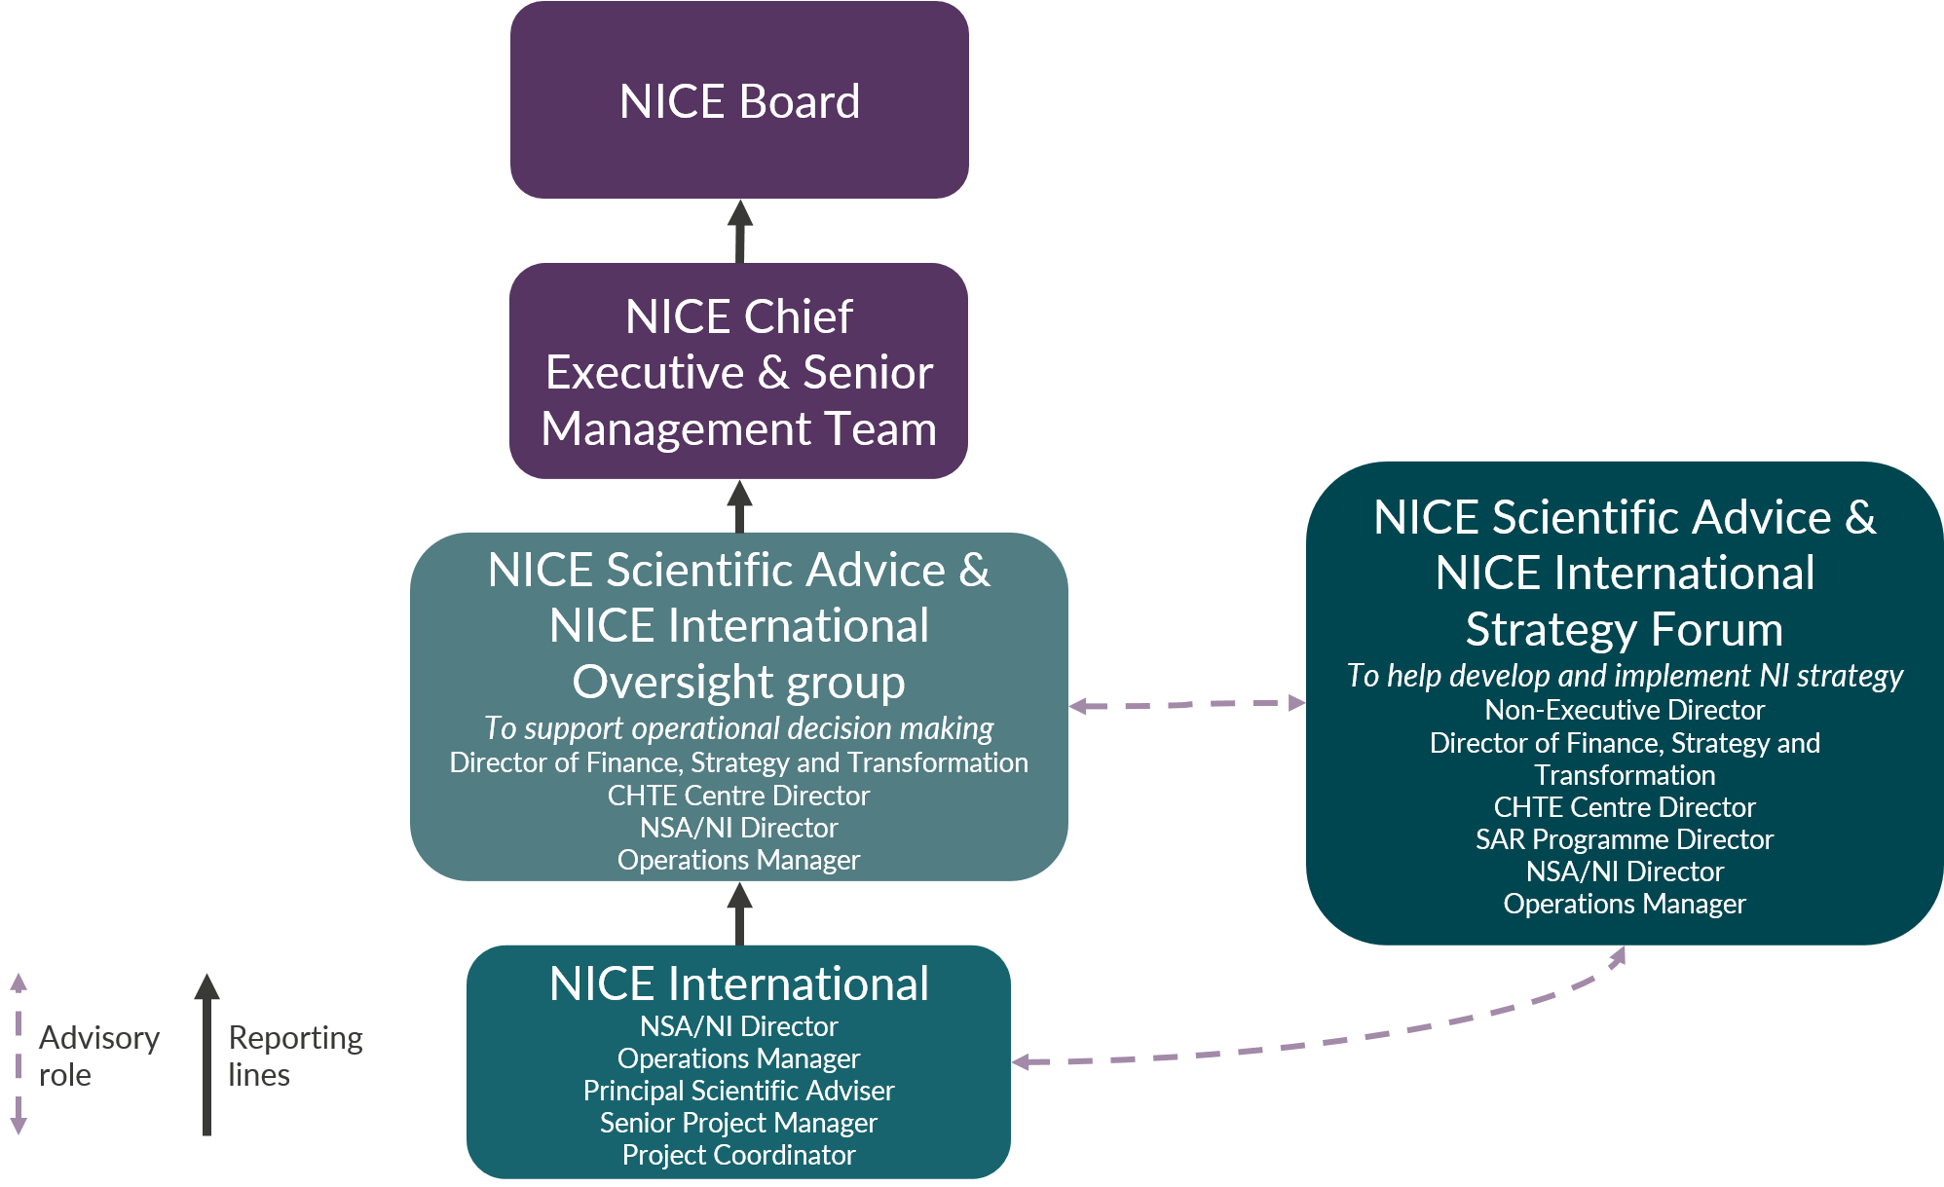

The NICE International team makes routine decisions about enquiries but uses an escalation process to accommodate opportunities that may be particularly high profile or have the potential to impact NICE in a significant way. Details of such requests are then shared with the NICE Scientific Advice and NICE International Oversight Group, who will make a judgment on whether opportunities should be accepted, rejected or escalated further to the NICE Senior Management Team. The NICE Scientific Advice and NICE International Strategy Forum acts as an advisory group to support the development and implementation of the NICE Scientific Advice and NICE International strategy.

International enquiries and engagements

Service offerings
NICE International provides a range of international service offerings including:
- Knowledge transfer services, such as international speaking engagements and seminars or workshops, hosted at the NICE offices, in the client country or via web conference.
- Consultancy services including, but not limited to, support with and advice on:
  - technical and institutional capability building
  - stakeholder identification and management, and public engagement
  - forming working groups or committees to set up new programmes
  - developing robust governance arrangements
  - developing methods and process manuals
  - implementing new health technology assessment methods
contextualising NICE guidelines to local settings.
NICE International recognises the difficulty in identifying a single optimal service to meet individual international organisations' needs. Therefore, it uses a flexible approach for its service delivery through a combination of knowledge transfer services and consultancy services.

International enquiries
Since 2018, we have received a total of 245 enquires from 60 different countries. Figure 4 shows the number of international enquiries received from when the team took over the management of international requests in 2018.

Figure 4 Number of international enquiries received by quarter calendar year since 2018
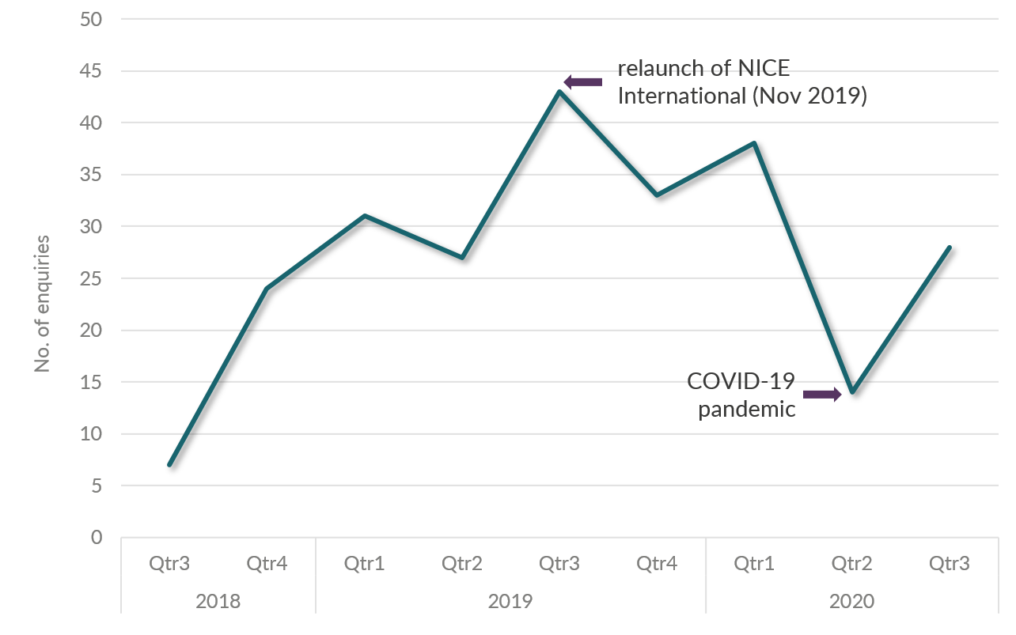

NICE International applies an initial triage system for all requests by which it assesses the strategic priority for NICE or for NICE International, the funding and resources, and the risks. Figure 5 shows the decisions made at this triage stage. Since the relaunch, we have accepted more than 70% of requests received.

Figure 5 Number, acceptance and delivery of enquiries received since 2018
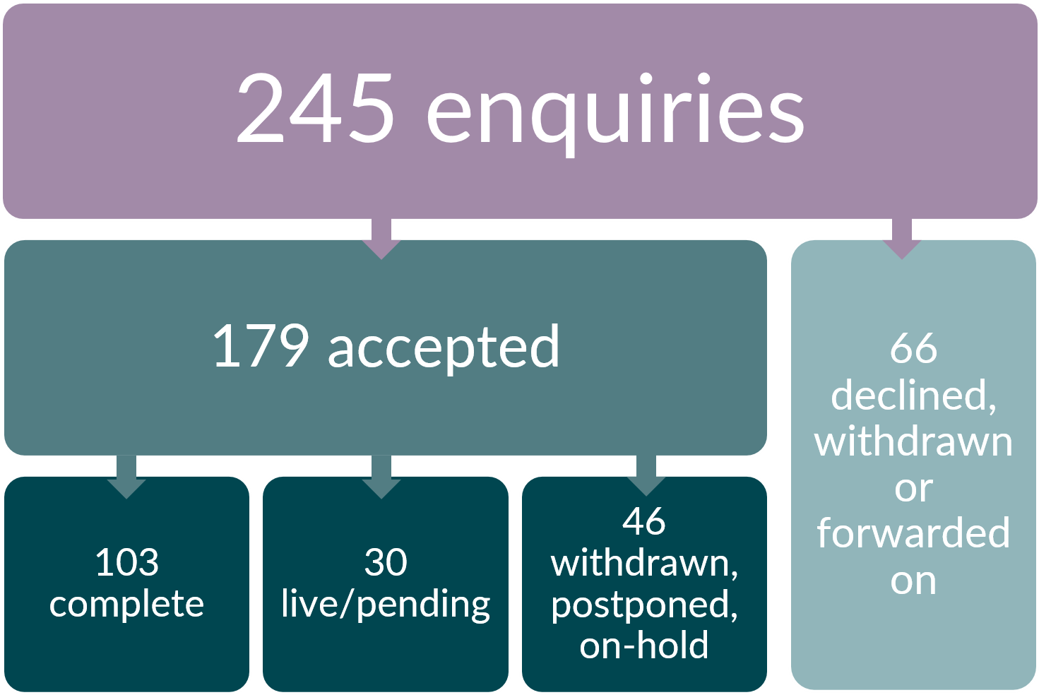

Since 2018, we have delivered more than 100 engagements from 36 different countries, of which, 37% were knowledge transfer seminars, 21% speaking engagements, and 25% consultancy services. The remaining 17% of engagements were a combination of international webinars and organised introductory meetings. Figure 6 shows the average number of engagements, according to type, that have been delivered per quarter from September 2018 to date.

Figure 6 Proportion of engagement type of pro bono and fee-based engagements between 2018-2020
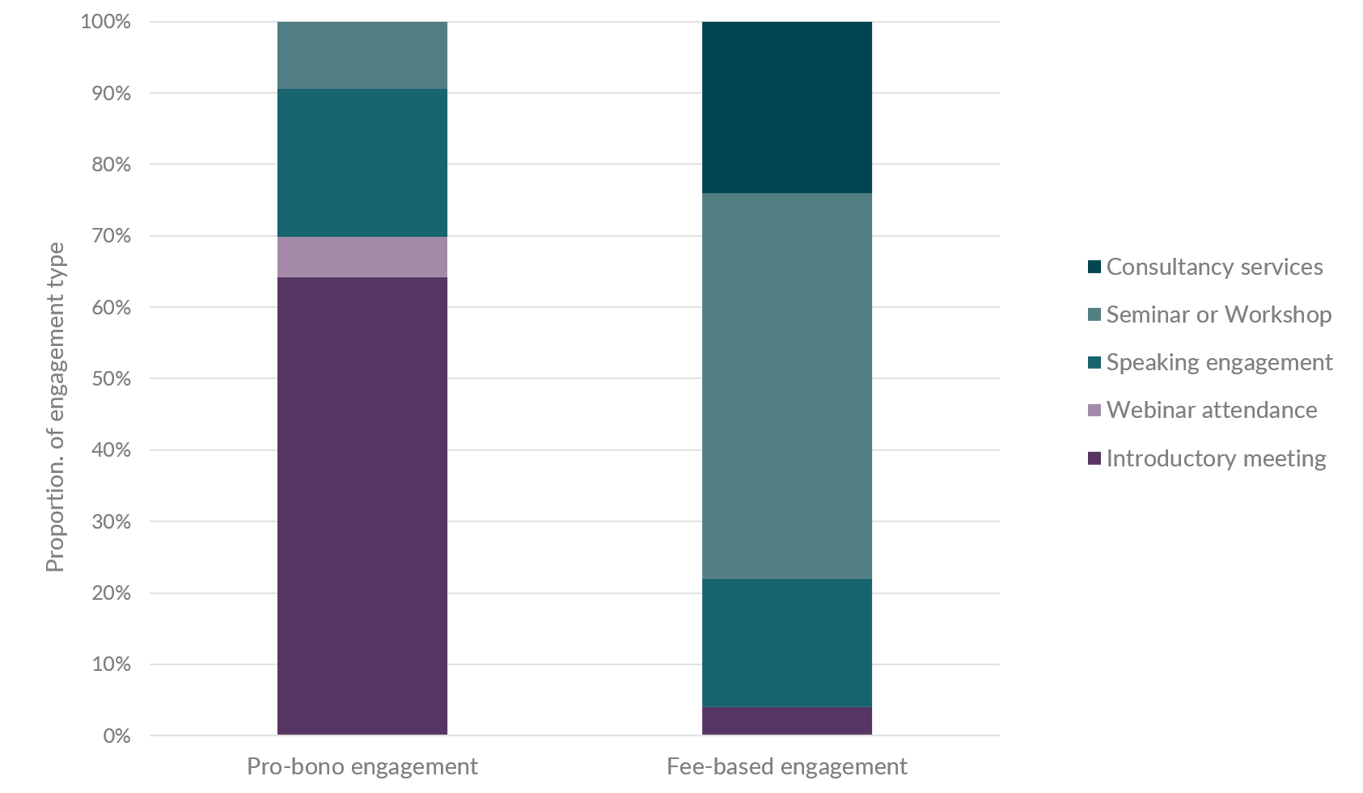
The topic area of most interest from countries and international organisations is that of health technology assessment, with more than 50% of delivered engagements solely focussed on health technology assessment topics. A further 21% of engagements have covered a full overview of NICE programmes, with a particular focus on health technology assessment, clinical guidelines, quality standards and public involvement programmes, and a further 13% solely focussed on a combination of clinical guidelines and quality standards. Figure 7 below depicts a word cloud of the topic areas of interest by popularity.

Figure 7: Word cloud of topic areas covered in delivered engagements between 2018-2020*
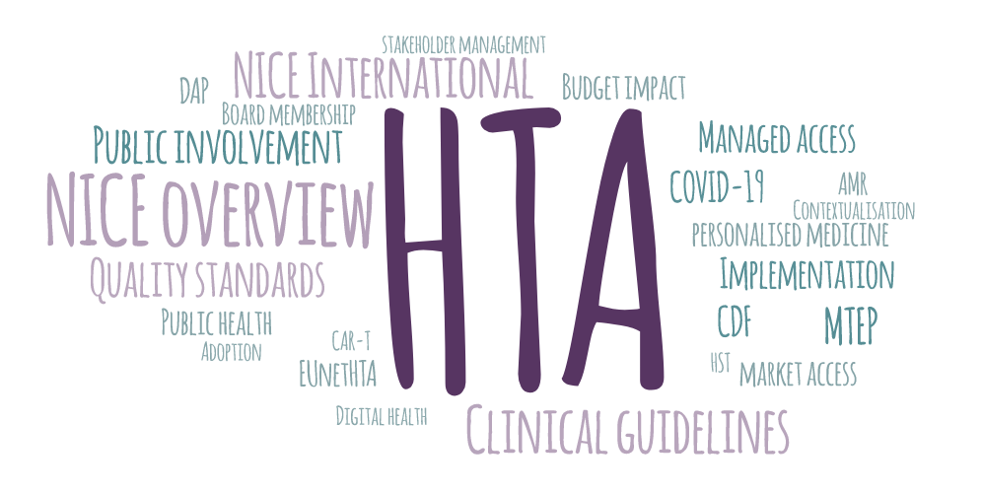
*HTA (Health Technology Assessment); HST (Highly specialised Technologies); AMR (Antimicrobial resistance); CAR-T (Chimeric antigen receptor T cells); MTEP (Medical Technologies Evaluation Programme); CDF (Cancer drugs fund); DAP (Diagnostics Assessment Programme); EUNETHTA (European Network for Health Technology Assessment)

Engagements by country and region
Although we have engaged with 36 different countries, we have developed more mature relationships and had repeated engagements with a few in particular. These are several Latin American countries, including Brazil, Uruguay and Colombia, the Philippines (as part of the work with the Foreign, Commonwealth and Development Office (FCDO) Prosperity Fund Better Health Programme - see point 24 for further details on the Better Health Programme), and Denmark. Figure 8 presents the number of delivered engagements by world region.

Figure 8 World map of number of engagements by region since September 2018 to date
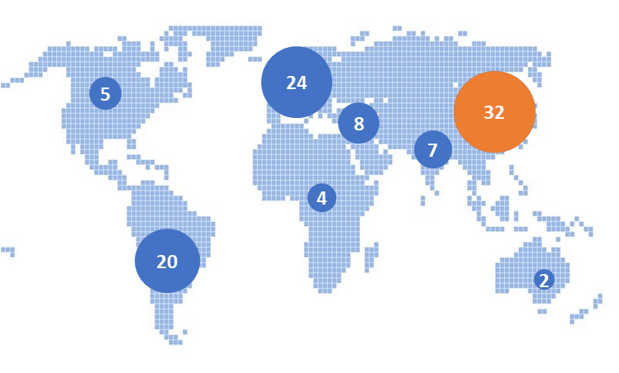
A breakdown of the different types of engagements delivered in each world region is presented in figure 9. Although most engagements have been delivered to countries within the East Asia and Pacific region, the majority of these have been short introductory meetings, often of a business development nature. We have conducted seminars and workshops across all regions but mostly in East Asia and the Pacific, Europe and Central Asia, and Latin America and the Caribbean regions. Our consultancy services have largely been taken up by East Asia and the Pacific, and Latin America and the Caribbean regions.

Figure 9 Number and engagement type by region since September 2018 to date
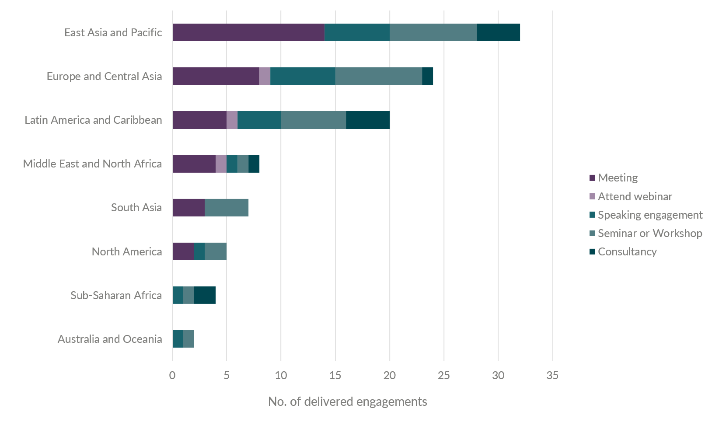
Many of our engagements result from established links with other organisations. Specifically, these include the FCDO, the Department for International Trade and the British Embassy in the different countries. They act as knowledge brokers, relationship facilitators, and as a funding source, particularly for initial engagements. Five such projects have been directly funded by them to date. This represents 10% of our paid engagements. The support from these organisations is seen as crucial because they are experts in the local area, can advise on the priorities for the country, and also align with UK priorities for global engagement.
The other sources of funding for our paid engagements have been:
- Official Development Assistance projects (for example, the Better Health Programme) - 22%
- private consultancies or public intermediaries - 18%
- directly funded from the client country - 50%.

NICE International's response to COVID-19
The impact of COVID-19 on NICE International's activities was direct and particularly important given restrictions around travel. Several significant planned engagements had to be cancelled or postponed.
In response to the COVID-19 pandemic, the NICE International team adopted a flexible and supportive approach. Being mindful of the impact of the pandemic around the world, the team developed a mitigation strategy while acknowledging that most of the organisations we engage with (that is, Ministries of Health, health technology assessment agencies and guidelines development organisations) had pressing and conflicting priorities in order to deal with COVID-19. NICE International therefore offered organisations with agreed projects in the pipeline the option of services being delivered via web conference instead of in face-to-face meetings. We also organised a webinar for international organisations on NICE's response to COVID-19. The objective of this webinar was to share NICE's efforts and learning around COVID-19 and position NICE and NICE International as a partner for international organisations in this matter.
The NICE International webinar on NICE's response to COVID-19 was a collaborative effort between different teams across NICE. It was delivered by staff from NICE International, NICE Medicines and Prescribing, the NICE Centre for Guidelines, and the NICE Centre for Health Technology Evaluation, and was supported by the Digital Services team. This webinar was attended by more than 300 participants from 42 different countries. Feedback received from attendees highlighted that the webinar was helpful and that they would recommend that other colleagues view the recording.

Figure 10 Quote from the feedback form of a person who attended the international COVID-19 webinar
"It has given me a really clear insight into how NICE works, normally and how you have to adapt yet still produce top quality advice etc and it's good to know how much collaboration goes on both in the UK and internationally."

The Prosperity Fund - Better Health Programme
The NICE International team has gained substantial traction in its participation in the FCDO Official Development Assistance funded Prosperity Fund Better Health Programme. The programme aims to support partner countries with health systems reforms, with the goal of expanding universal health coverage and improving health and related economic growth outcomes. The programme funds technical collaboration with partner governments in Brazil, Mexico, South Africa, Malaysia, Philippines, Thailand, Vietnam, and Myanmar to support their ongoing work to improve their health systems and, as a result, improve conditions for inclusive economic growth and trade.
NICE is providing support to the programme at a strategic level by being part of the steering group alongside the Department of Health and Social Care and other executive agencies and arm's length bodies. NICE is also supporting the programme at a technical level by providing direct technical advice and input as part of the consortium technical advisory service. Countries within this programme, who focus on areas considered to be of NICE's expertise (for example, health technology assessment), are Brazil, South Africa and the Philippines. NICE's involvement in the programme has grown notably during the implementation phase of the programme, which runs from January 2020 to the end of September 2022.
So far, NICE, represented by the NICE International team, has participated in the programme by providing advice on technical and quality assurance aspects for the South African and Brazilian inception and implementation plans, participated in learning sessions with Brazil, delivered presentations to incoming delegations from South Africa and the Philippines, and is currently organising and delivering a series of virtual knowledge exchange engagements with the Philippines. NICE is expected to provide advice on technical and quality assurance aspects for the deliverables captured in the implementation plan for South Africa, Brazil and the Philippines in the upcoming months.

Case studies
In this section, we have provided examples of projects in which NICE International has been involved. Feedback from these engagements is included in the next section of this report.

Case study 1. Implementing health technology assessment: a collaborative initiative in the Latin American and Caribbean region
In autumn and winter 2019/2020, NICE International conducted 7 health technology assessment workshops covering 8 Latin American and Caribbean countries (Uruguay, Colombia, Brazil, Peru, Dominican Republic, Mexico, Panama and Costa Rica). These were part of a regional mission boosted by the British Embassy and Department for International Trade.
The interactive workshops involved relevant stakeholders from the health technology assessment ecosystem from each of the countries, including government agencies, national health insurance organisations, industry representatives, academia, hospital managers, clinicians, and patient organisations.
The workshops focused on the role of each stakeholder in the health technology assessment process, compared the country’s process with NICE’s one in the UK, and explored the main areas for improvement as well as the perceived associated barriers for implementation.
The workshops aimed to identify potential areas for future collaboration between NICE and each of the countries and have led to follow-up activities.
Beyond the engagement with Ministry of Health representatives from each of these countries and their health technology assessment agencies, we have also had follow-up engagements with other stakeholders from the Latin American and Caribbean region. These include engagements with patient organisations, through the curriculum delivered by the Latin American Patients Academy, and with their life sciences' industries, through participation in events and speaking engagements.

Case study 2. Prosperity Fund Better Health Programme: supporting the Philippines in implementing health technology assessment
In February 2019, the Philippines government enacted Republic Act No. 11223, or the Universal Health Care Act. Its objectives are to progressively realise universal health coverage through a systemic approach and clear role delineation of stakeholders, and to ensure equitable access to good quality and affordable healthcare and protection against financial risk. The act stipulates health technology assessment as a priority-setting mechanism to guide coverage decisions. Health technology assessment decisions are made by the Health Technology Assessment Council, supported by a secretariat and the Health Technology Assessment Technical Unit in the Department of Health. A core research network with tight academic links to existing academic institutions in the Philippines is being planned. Health is a devolved matter in the Philippines, and therefore, local government units have the capacity to procure health interventions at the local level. Given that health technology assessment sits within an ecosystem involving different stakeholders, each stakeholder needs to understand, have capacity and training, and be committed to their role in the health technology assessment process.
NICE International, as part of its role in the Prosperity Fund Better Health Programme, delivered high-level presentations to Philippines authorities who visited the UK in November 2019. The team also held a series of virtual engagements, which started in July 2020 and are planned to continue until November 2020. These virtual engagements are taking place with different stakeholders from the Philippines health technology assessment ecosystem.
So far, the sessions have been successful, the level of interaction has been high, and engagement with the different organisations has been achieved and was well balanced. Both countries shared their knowledge and experience, compared this across the regions, and shared common objectives and aims. NICE has already learned from the Philippines teams' topics, such as their current approach to evaluating artificial intelligence technologies and COVID-19 technologies. The Philippines stakeholders have acknowledged the benefits of collaborating with NICE, recognising that the current engagement is a renewal and strengthening of a longstanding relationship, dating back to 2012. The publication of the health technology assessment methods and process guides by the Department of Health in the Philippines in September 2020 marks a crucial milestone in their health technology assessment institutionalisation journey. The Secretary of Health acknowledges in the guides' prefaces that global partnerships, such as those achieved through the support from NICE, are a crucial step to ensuring methods and processes implemented in the country meet international standards.

Case study 3. Health technology assessment process and methods developments in the Danish healthcare system
In September 2019, NICE International delivered a workshop for Amgros, the Danish medicines procurement agency, on current challenges in the evaluation and reimbursement of high-cost medicines.
In November 2019, the Danish Medicines Council contacted NICE International to obtain support in preparation for a change in the methods of health technology assessment to be applied in Denmark. Specifically, the Danish Regions was considering incorporating an assessment based on the quality-of-life years gained and using cost–utility analysis as the basis for the economic evaluations considered within the Danish Medicines Council.
In December 2019, NICE International was also approached by the Danish Regions, who wanted to understand NICE's methods and processes for the evaluating medical devices, diagnostics and digital health technologies. NICE was also invited to participate in speaking engagements organised by Danish academic institutions and life sciences industry organisations.
Through these engagements, NICE International has provided comprehensive input to different Danish stakeholders on their objectives to change and improve their health technology assessment process and methods following the policy change in the country. NICE has also learned from the Danish approach to specific methodological challenges, which have provided a useful context for the ongoing NICE health technology evaluation methods review.

Figure 11 Quote from Madina Saidj, Specialist Health Science Consultant, Danish Medicines Council
"We were really happy [with the seminar], we were almost 10 people from Danish Medicines Council. It was a good starting point to have our discussions and to get an idea for how you are working with it in practice and to relate it to a Danish context. It was useful to understand what is behind what you can read on a website, all the more subjective choices that are made and all the discussion that are behind the ways that you do it."

All these initiatives have positioned NICE International as a relevant partner and have added value for each of the countries in their objectives of improving their health technology assessment and guidelines processes and implementation. They have also provided opportunities for NICE to learn from different approaches that can inform methods and processes developments in-house, as well as providing staff with further development opportunities.

Feedback from countries and funders
NICE International has developed a feedback form to collect input from attendees and participants in our services. To date, all respondents who have completed the feedback survey have reported finding their engagement useful and that it met or exceeded their expectations. All respondents have also expressed interest in engaging with NICE International again in the future.

Figure 12 Quote taken from feedback after a 2-day seminar
"The 2-day program was packed with interesting presentations and good discussions. It was very giving for us to get insights into how NICE is working and especially insights into the reasons/discussions behind the decisions taken, which we definitely can bring along in our work of changing our methods and process later this year."
We also try to obtain informal feedback from organisations that facilitate our international connections, such as FCDO or the Department for International Trade.
The marketing and communications team has recently begun a stakeholder engagement exercise to inform our future marketing and communications strategy. The feedback received to date through interviews conducted by this team has been extremely positive regarding both the quality of the services delivered and the approachability and professionalism of the NICE International team.
System partners’ perceptions of NICE International are that the team delivers an excellent service and adds a great deal of value. Primarily, they achieve this by facilitating knowledge exchange and helping to build relationships. Relationship building is reported as effective because of NICE's trusted, credible reputation and strong, highly respected expertise.

Figure 13 Quote from Arly Belas do Santos, Head of Life Sciences and Healthcare, Latin America, Department of International Trade
“I’m very very happy and I think enthusiastic on what’s coming next. I think we just started something, like an ignition. I feel that this has a future. I feel that NICE has made a strong bridge with some governments. It’s good. There is a legacy. I’m excited to see what’s coming next.”

Figure 14 Quote from Liz Bautista, Programme Advisor for Prosperity Fund (Better Health Programme), British Embassy Manila, Philippines
“[This work] demonstrates the breadth of impact of the system-to-system engagement (…), and the impact of BHP engagement to wider health diplomacy between the UK and the Philippines.”
Early themes and observations emerging from the stakeholder engagement exercise show that system partners believe NICE International could add more value by raising its profile internationally and within relevant health technology assessment networks, and clearly communicating its offer. The team could also make better use of embassies to promote their services in country.

Global health: national and international groups, projects and collaborations

NICE International participation in national and international global health groups.
We have continued to support and promote the work of NICE as a whole, and NICE International, at a national and international level through our presence and participation in relevant groups and forums including:
- The NHS International Health Group attended by senior representatives from the NHS and UK health-related organisations. Through participation in this group, we have gained:
  - exposure to all relevant UK health-related stakeholders, given presentations to and made links with international organisations
  - invitations to participate in the FCDO Prosperity Fund Better Health Programme and other Prosperity Fund projects
invitations to participate in and provide input on the development of the NHS Export collaborative.
- The NHS International Special Interest Group organised by the NHS Confederation International team. The engagement in this group has resulted in:
  - relationships with NHS trusts and Academic Health Science Networks and discussions around international commercial activities such as eLearning
participation in an NHS Confederation report on NHS international commercial activities: successes and barriers.
- The Department of Health and Social Care, Executive Agencies and Arm's Length Bodies International group, a senior group that provides a forum for sharing and coordinating international activities, with an opportunity to learn from each other and provide leverage on different opportunities.
- The ongoing development of the NHS Export Collaborative by Healthcare UK and NHS England and NHS Improvement. We have been involved in several conversations and meetings regarding this initiative.
In this way, NICE International is securing a joined-up approach to representing NICE in relevant forums and groups with international interest. NICE International has also represented NICE by attending and presenting at a range of national and international conferences and events. Members of the team also sit on boards of directors of various international associations.

Collaboration with other organisations, agreements and memorandums of understanding (MoUs)
NICE International seeks to collaborate with national and international organisations with common objectives to support each other in their respective work and achieve broader benefits, and impact on global health. These collaborations benefit NICE because they provide a framework for experience sharing. For example, NICE can learn from international approaches to advancements in methods and processes in areas within NICE's remit, such as health technology assessment, guideline development or using data analytics to support evidence-based guidance.
MoUs are recognised as a useful tool to show commitment to work in partnership with other organisations, particularly in the international context. Although these documents are not legally binding, they are commonly used because they support international diplomacy and are a helpful step when setting up relationships with international organisations.
The NICE International team has experienced the benefits of using MoUs in its work. The team reports to the Department of Health and Social Care Global Health team on MoUs signed with international organisations, and also checks whether there are overarching government-to-government MoUs already in place on global health matters that would cover the intent of the collaboration.
Since the relaunch of NICE International, NICE has signed MoUs with 3 organisations on matters related to NICE International:
- The International Decision Support Initiative through its secretariat at Imperial College London, to collaborate on activities linked to key issues in the field of evidence-based health policy, including health technology assessment, clinical guidelines, and related activities.
- Health Education England in relation to working together on the Prosperity Fund Better Health Programme work.
- The Colombian Instituto de Evaluacion Tecnologica en Salud (IETS), to share knowledge, methodologies and experience on developing health technology evaluations and guidelines, and other related activities.
NICE has also signed agreements to formalise its involvement through NICE International in other events, such as the organisation of the World Evidence-Based Health Care Day.

Presentations with an international outreach
NICE International has delivered presentations in several forums, events and conferences with an international outreach, showcasing the work of NICE and also promoting NICE International's services. Some of these events include participation and presentations in UK Department for International Trade webinars, events with international organisations, and international conferences such as:
- ISPOR Asia Pacific 2020
- The 10th Anniversary Symposium of South Korea's National Evidence-based Healthcare Collaborating Agency (NECA)
- the South Korean Health Insurance Review & Assessment Service's (HIRA's) 2018 International Symposium on pricing new drugs and new health technology
- the Global Health and Longitude Prize Accelerator Programme (2018) organised by NESTA (National Endowment for Science, Technology and the Arts) in India
- the Tropical Health and Education Trust (THET) annual conference in 2020
- the symposium on Prioritization with quality-adjusted life years organised by the Danish Center for Healthcare Improvements, Danish Center for Clinical Health Services Research and Aalborg University
- the 2019 China Summit of Evidence-based Pricing and Health Policy in a New Era, organised by the Health Technology Assessment and Policy Evaluation Group of Renmin University of China and the Health Security Branch of China International Exchange and Promotion Association for Medical and the Healthcare Center for Medical Service Administration
- the launch event for the Mexico Valuation of EQ-5D-5L Health States using the International EuroQol Protocol.
By participating in these events, NICE International has contributed to positioning NICE as a global partner and enhanced its reputation as a leading institution in health technology assessment and guidelines development.

Working together across NICE

NICE International support in NICE's activities
NICE International has taken the lead in developing an international strategic engagement plan for NICE. The plan aims to establish a strategy on why NICE engages internationally, specifying the objectives for international engagement by the NICE directorates and teams, and coordinating efforts for these engagements.
Earlier this year, NICE was approached to support the inaugural World Evidence-Based Healthcare Day as an official partner. This global initiative aims to raise awareness of the need for better evidence to inform healthcare policy, practice and decision making to improve health outcomes globally. NICE International represented NICE on the steering group for the event that took place on 20 October 2020. Our role as an official partner was to help raise awareness of the initiative through several communications-led activities, peer review evidence-based ‘impact stories’, and support the overall organisation of the event, up to and including the day itself. NICE International worked closely with other teams across NICE to organise the activities and communications required to make this event a success.
NICE International has also supported NICE as a whole in several other activities, such as contributing to NICE's response to COVID-19 with oversight on international efforts. For example, the team helped to establish a knowledge-sharing collaboration between the health technology assessment agencies of the Canadian Agency for Drugs and Technologies in Health (CADTh), the Australian Pharmaceutical Benefits Advisory Committee (PBAC), and the Scottish Medicines Consortium (SMC). NICE International organised a webinar for international stakeholders on NICE's response to COVID-19. The team has also co-hosted and supported NICE's Science, Policy and Research team in organising an international roundtable with ISPOR (the Professional Society for Health Economics and Outcomes Research), the University of Melbourne, and the University of Sheffield. The team has also helped to organise the upcoming Health Technology Assessment international's (HTAi's) 2021 conference, co-hosted by NICE, and supported NICE's participation in the international scientific programme committee.

Collaboration across teams and departments at NICE
NICE International is located within the NICE Scientific Advice team, as a not-for-profit, cost-recovery team. NICE International staff currently include the Director for Scientific Advice, Principal Scientific Adviser and Senior Project Manager. The Principal Scientific Adviser and the Senior Project Manager oversee setting up the direction, management and delivery of NICE International services, with support from the Director. We rely on support from the NICE Scientific Advice team for project management and delivery of some of the projects, and also on the involvement of the individual teams and directorates from the rest of NICE for specific areas of expertise. We trust in the individual teams' commitment to support the work of NICE International, while acknowledging capacity issues and conflicting priorities.
NICE International has gained support from directorates at NICE to deliver its work. An example is the collaboration with the Centre for Guidelines in developing a NICE International and Centre for Guidelines shared vision document.
Through the NICE International and the Centre for Guidelines' shared vision document, the teams have devised a plan to work together, with a particular emphasis on the Contextualisation of NICE Guidelines service. Both NICE International and the Centre for Guidelines consider that this service adds value to international institutions and NICE.
The added value for international organisations includes:
- the ability to produce high-quality, evidence-based guidelines at reduced costs and time
- aligning with internationally recognised methodological and process standards for guideline development
- promotion of local ownership and relevance to their context
- where appropriate, NICE co-badging the resulting guideline with beneficial reputational implications.
The added value for NICE includes:
- collaboration with international institutions on methodological development work to ensure that our guidelines are developed and updated to internationally recognised standards of best practice
- establishing a role for NICE in contributing to global health improvements through the adoption and contextualisation of high-quality guidelines
- demand for further NICE International services and longer-term collaborations with international governments and institutions aimed at producing overall improvements in healthcare outcomes, and efficiency and sustainability of healthcare systems
- supporting NICE's positioning as a world leading institution in guideline development and thus, enhancing our visibility and reputation
- personal development opportunities for NICE staff participating in the contextualisation.
NICE International and the Centre for Guidelines are both keen to continue and expand the guidelines contextualisation service, capacity permitting. The Centre for Guidelines has supported NICE International with initial conversations around guidelines development and contextualisation work with countries such as Greece, Saudi Arabia, Colombia and Egypt. For example, a scoping meeting with representatives from the Egyptian Ministry of Health took place in Cairo in March 2020, supported by the British Embassy and the Department for International Trade in Egypt.
An increasing number of international engagements are also being supported by the Public Involvement Programme. These include speaking engagements, participation in workshops and seminars with international organisations, and support in response to specific advisory services requests. The Public Involvement Programme and NICE International are committed to working together and supporting each other in their respective objectives. Acknowledging the increasing international requests on topics related to the Public Involvement Programme, the teams will be discussing a shared vision document in the upcoming month, to devise ways for successful collaboration, and consider capacity issues and conflicting priorities.
Of the total number of NICE International engagements, 43% have been delivered solely by the NICE International team, 35% have relied on support from NICE Scientific Advice, and 42% have had support from across NICE. External experts, such as previous NICE staff, and NICE committee chairs and academics, were involved in 6% of engagements. More than 70 people have participated in the work of NICE International to date, showing cross-team collaboration. Overall, feedback from NICE staff involved in NICE International projects has been extremely positive. Staff members' comments have highlighted the benefits of the learning opportunity: 'an eye-opening experience', 'interesting work' and 'it is always good to get another perspective on what we all do'. Experts involved in NICE International work have also provided very positive feedback, with one describing their involvement as 'a fascinating and rewarding experience'.

Online delivery
Being mindful of the impact of the COVID-19 pandemic, the NICE International team adopted a flexible and supportive approach, and adapted its service offering to deliver these via web conference to international organisations.
Overall, the results have been very positive with most organisations welcoming the opportunity to engage virtually. Some clear advantages of hosting virtual engagements include the ability to involve more staff from NICE and experts with a wider range of expertise, and reduced travel time and costs. This makes some of our services more affordable while also reducing our carbon footprint and contributing to our commitment to sustainability. The difficulties we have encountered include software incompatibility, internet connectivity issues, or engagement difficulties when no prior relationship existed with attendees.

Communications

Marketing strategy
The Brand, marketing and communications team recently started drafting a new marketing and communications strategy for NICE International. This work will be developed alongside NICE's 5-year strategic plan to ensure alignment. Initial scoping work is focused on gathering audience insight, identifying priority audiences or stakeholders, and mapping available marketing and communications channels.
Adopting a strategic approach to marketing and communications aims to ensure our activity is focused, impactful and measurable. The Brand, marketing and communications team seeks to capitalise on well-established international marketing communication channels and networks where possible. They also plan to develop a strategic approach to search engine optimisation and social media, and development of engaging content (for example, through editorial input, and inclusion of videos and infographics). This approach will allow NICE International to deliver its services in line with our marketing communication objectives. The team is also seeking audience insight on how visible the NICE International webpage is internationally, and how it is currently used and perceived by its users. This insight will be used to inform how the webpage is marketed in future, and to improve a user's experience while on the page.

Social media and presence in the media
We have continued to increase our presence on social media using NICE Scientific Advice and NICE official Twitter and LinkedIn accounts. This has helped us to reach wider international audience and organisations, and work and communicate more effectively with our stakeholders.
We use Twitter and LinkedIn to promote the work of NICE and NICE International and to recognise our relationships with international organisations. By using social media, we can reach international audiences, and promote the work of international organisations and NICE to achieve common objectives in terms of improving healthcare outcomes and strengthening health and social care systems.

Figure 15 The Head of the Health Technology Assessment Unit in the Philippines Department of Health recognised the importance of health partnerships and how NICE supports these in a Twitter post
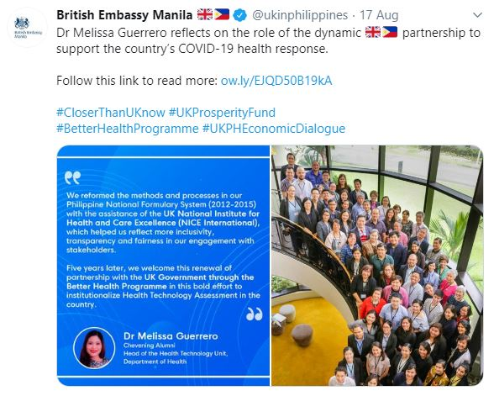

Monitoring, evaluation and learning plan
The NICE International team is keen to devise and implement a monitoring, evaluation and learning plan that allows us to:
- Measure, using pre-agreed indicators, our activities to ensure they align with the strategic objectives of NICE and NICE International, and that they are having the intended impact for both the partner international organisation and NICE.
- Amend or adapt activities as necessary, in an agile manner.
- Facilitate and promote a mutual exchange of knowledge between NICE and international organisations, as well as facilitating links between international organisations.
This plan will be an essential part of the NICE International strategy to be developed in the upcoming months.

Identifying and evaluating risks
The NICE International team has developed a risk register to pro-actively identify, record, manage and evaluate risks. The risks are categorised according to those related to the programme and its objectives, and those related to specific projects.
The risks are identified by the NICE International team, who regularly review the register. When required, they are escalated through the appropriate routes according to the team governance.

Conclusion and future plans
Despite the difficult global situation resulting from the emergence of the COVID-19 pandemic, the past year for NICE International has been one of new initiatives, strategic planning, and further development of our more established relationships with international organisations. We expect that the coming year will deliver many more opportunities for international collaboration, and we look forward to embracing them and adding value for international partners and NICE. We will continue to work with different teams across NICE and with experts from international organisations to facilitate sharing of learning between international organisations and NICE. We will also continue to re-affirm our position as an international partner, increase our visibility through participation in events and forums such as an upcoming event hosted by the All Parliamentary Party Group on global health, and align with UK initiatives for international partnerships and collaborations, such as the NHS Export collaborative and the UK partnership scheme. Finally, we look forward to continuing to work with international organisations committed to improving health and social care services and outcomes for all.

© NICE 2020. All rights reserved. Subject to Notice of rights

