AUDIT FOR OLDER PEOPLE
(TO BE COMPLETED BY PATIENT OR ASSESSOR)
Questions |  |  |  | Scoring system |  |  |  |  | Your  score
 |  |  |  | 0 | 1 | 2 | 3 | 4
1. How often do you have a drink containing alcohol? |  |  |  | Never  Go to Q9&10 | Monthly  or less | 2 - 4 times per month | 2 - 3 times per week | 4+ times per week
2. How many units of alcohol do you drink on a typical day when you are drinking? |  |  |  | 1 -2 | 3 - 4 | 5 - 6 | 7 - 8 | 10+
3. How often have you had 6 or more units if female, or 8 or more if male, on a single occasion in the last year? |  |  |  | Never | Less than monthly | Monthly | Weekly | Daily or almost daily
If total for 2 + 3=0 Skip to Q9 & 10
4. How often during the last year have you found that you were not able to stop drinking once you had started? |  |  | Never |  | Less than monthly | Monthly | Weekly | Daily or almost daily
5. How often during the last year have you failed to do what was normally expected from you because of your drinking? |  |  | Never |  | Less than monthly | Monthly | Weekly | Daily or almost daily
6. How often during the last year have you needed an alcoholic drink in the morning to get yourself going after a heavy drinking session? |  |  | Never |  | Less than monthly | Monthly | Weekly | Daily or almost daily
7. How often during the last year have you had a feeling of guilt or remorse after drinking? |  |  | Never |  | Less than monthly | Monthly | Weekly | Daily or almost daily
8. How often during the last year have you been unable to remember what happened the night before because you had been drinking? |  |  | Never |  | Less than monthly | Monthly | Weekly | Daily or almost daily
9. Have you or somebody else been injured as a result of your drinking? |  |  | No |  |  | Yes, but not in the last year |  | Yes, during the last year
10. Has a relative or friend, doctor or other health worker been concerned about your drinking or suggested that you cut down? |  |  | No |  |  | Yes, but not in the last year |  | Yes, during the last year
Total
Score | Drinking categorisation | Intervention
0-6 (men)  0-4 (women) | Lower risk | No specific intervention. Consider offering information and promote continued drinking within ‘lower risk’ levels. If working towards abstinence encourage continued reduction.
8-15 | Hazardous/increasing risk | Simple brief advice – Provide information. Encourage to reduce.
16-19 | Harmful/higher risk | Extended brief intervention. Offer sessions to help reduce drinking and risk-taking behaviour. Focus on enhancing motivation to change.
20+ | Possible/dependence | Community - Complete SADQ (Severity of Alcohol Dependence Questionnaire)  Inpatient – Monitor using CIWA-Ar (withdrawal assessment scale)  Consider seeking specialist advice and referral to alcohol service if person wants to stop drinking.

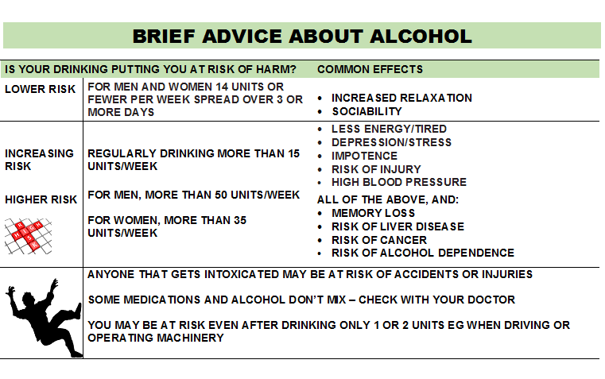

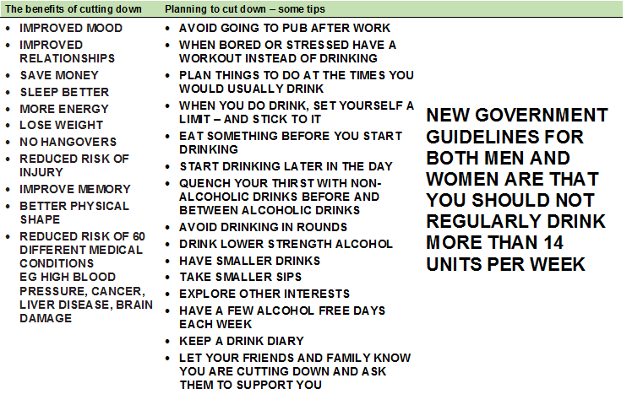

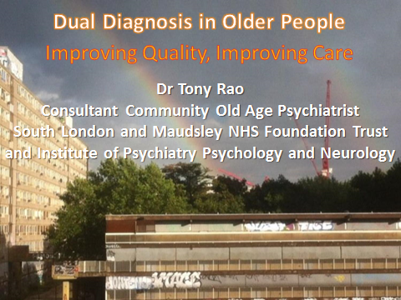

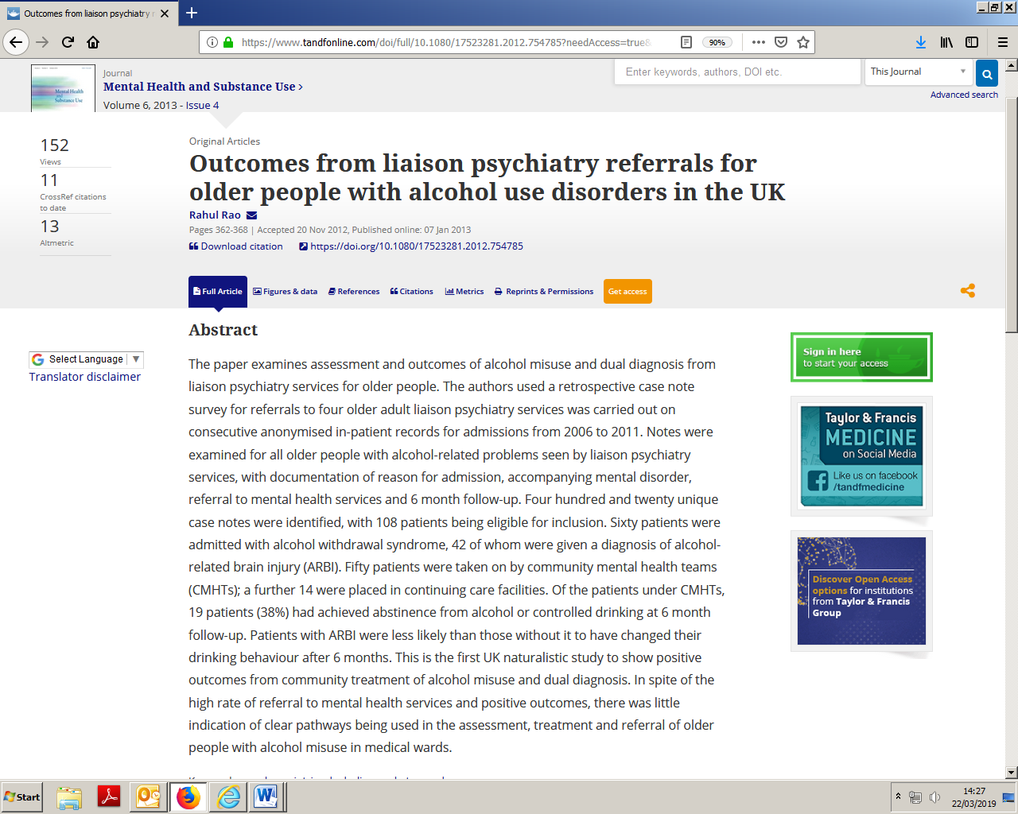

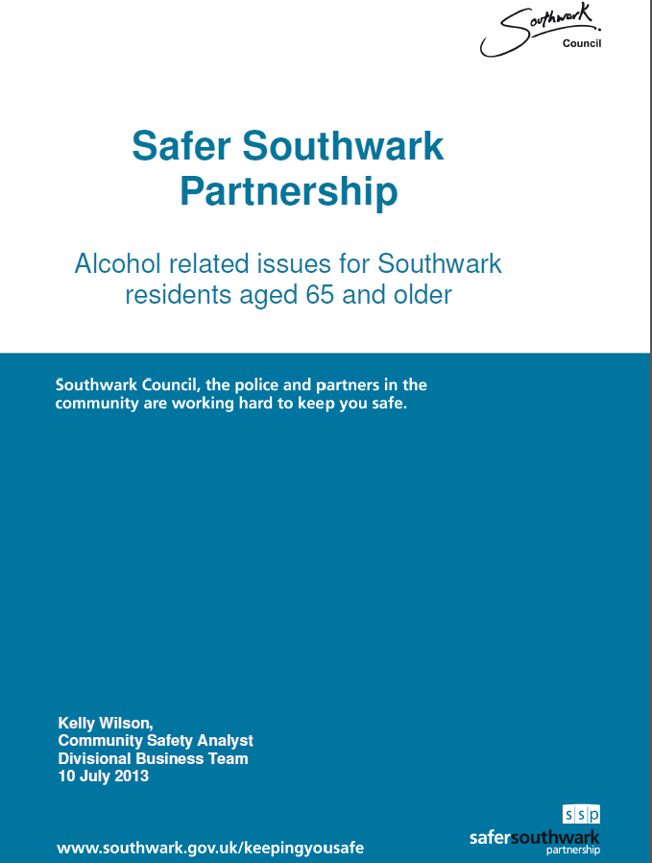

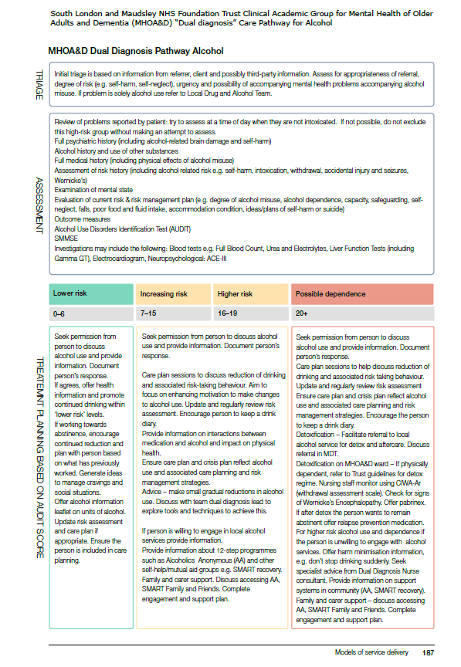

Alcohol CQUIN 2017-19: Summary Information

Who Everyone admitted to an inpatient bed aged 18+

What Complete AUDIT (Alcohol Use Disorders Identification Test)
NB if this has been completed by another team in the acute pathway (eg HTT) in the 2 weeks prior to admission it does not need to be completed again.

Deliver appropriate interventions:
- for people scoring 8-19 – offer brief advice
A brief advice sheet to support delivery is available – see your DD lead or the DD
intranet page
- for people scoring 20+ - offer referral to substance misuse service
Local care pathways are in place (or in development) to describe the referral
process in each borough. The CQUIN is explicit about making a referral (not
merely ‘signposting’).
Recording on EPJ AUDIT is under the assessment tab on EPJ

Interventions should be recorded in the ward progress note:
Additional detail should be included in the free text section
(eg given brief advice sheet, discussed units of alcohol, suggested options for reducing
eg offered referral to Turning Point but not interested

From pull down menu
Alcohol brief advice

Type - inpatient
From pull down menu
Offered referral to specialist alcohol/drug service

See screen shots over the page

Staff Training The CQUIN requires staff to receive training so that they are equipped to carry
out the screening and interventions. A target of 60% of qualified nurses and
60% of team dual diagnosis leads has been agreed with commissioners. Other
staff are encouraged to complete the training. The more staff that are equipped,
the more likely that appropriate care (and our targets) will be delivered.
People that have completed the level 2 dual diagnosis course within the past
three years will be counted as having received training as this course covers the
relevant knowledge and skills.

A training package has been developed for other staff: Alcohol Screening and
Interventions for Inpatient Staff. This is a ½ day course. It can be booked using
LEAP.

Monitoring Data will be extracted from EPJ to monitor the screening and interventions.
Education and development will record the training.

Recording Substance Misuse Interventions in ‘Events’ (mainly for community services)

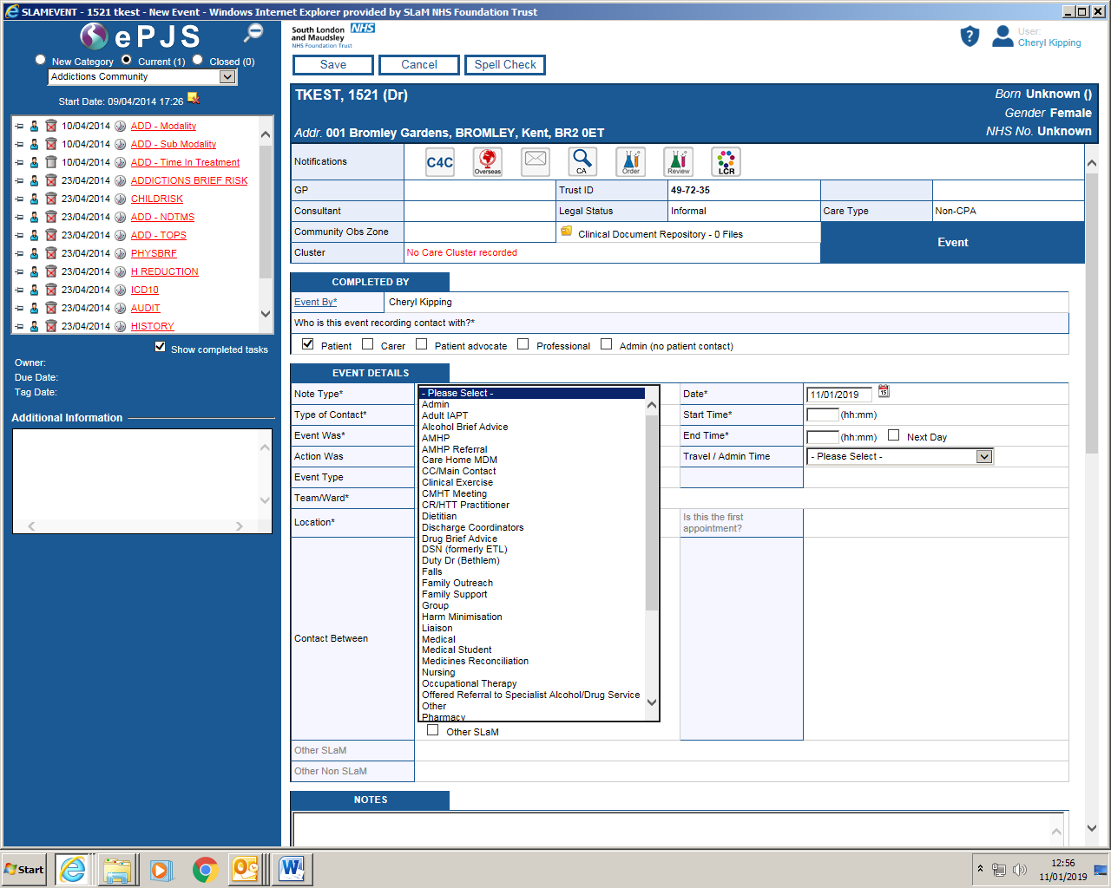
Go to ‘Note type’ then click on appropriate intervention (eg alcohol brief advice, harm minimisation, offered referral to specialist SM service)
Include additional information in the notes e.g. “given information about substance misuse service and says he has been there before and didn’t find it helpful”.
Also “given information about AA and he says he would like to find out about local meetings”.

Recording Interventions on EPJ - Inpatient
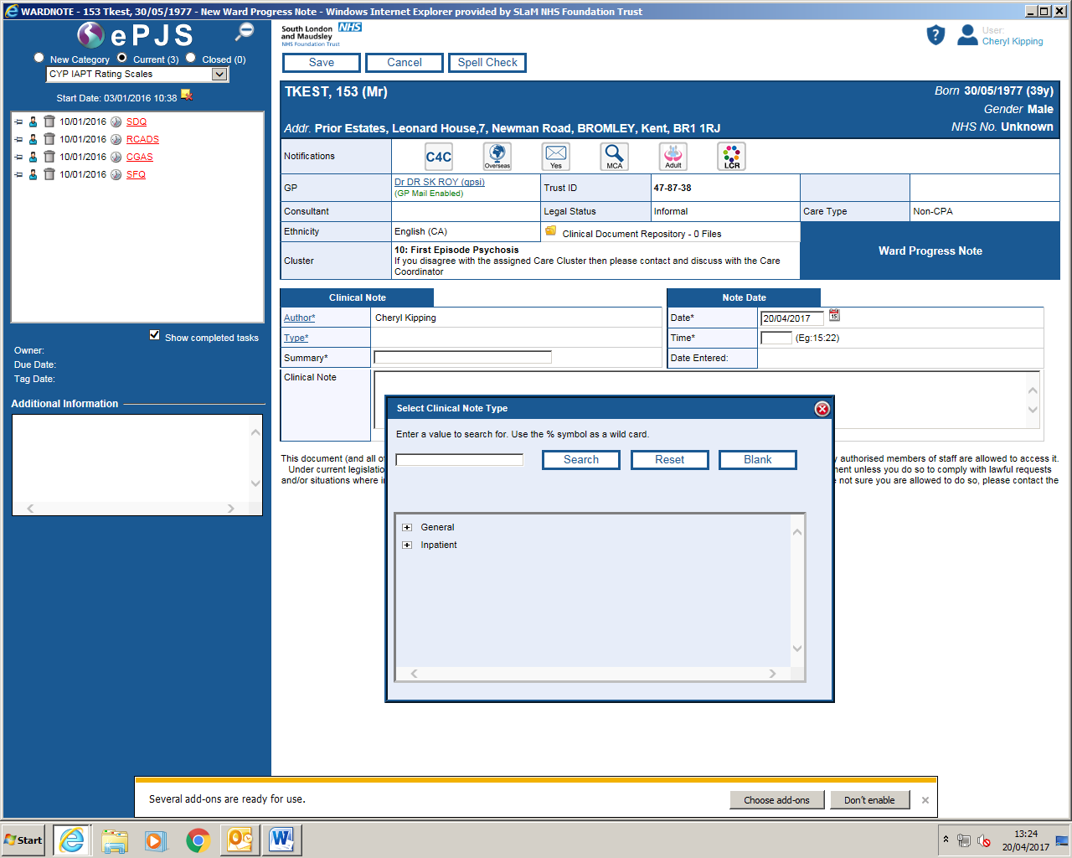
Go to ward progress note
Click on inpatient
Click on: Offered referral to specialist alcohol/drug service

