Appendix 1

Web Link to the Cerebral Palsy Integrated Pathway manual and assessments.

http://apcp.csp.org.uk/documents/cpip-uk-training-manual-dvd

Appendix 2

Results from TSDFT audit of NICE CG 145 Physiotherapy Pathway
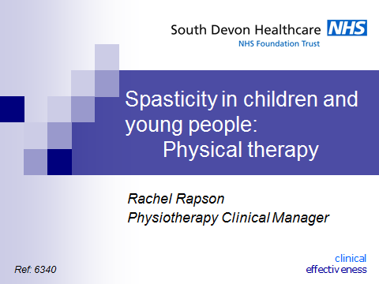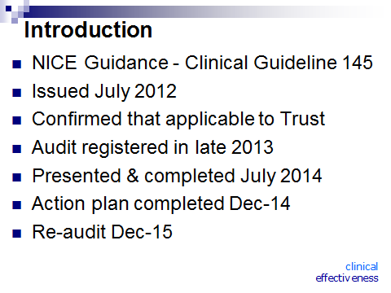
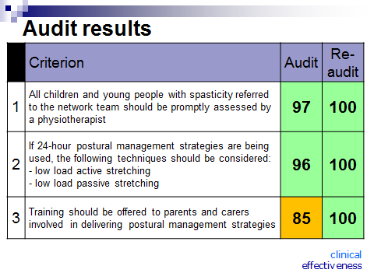
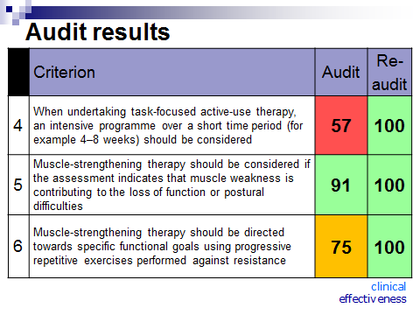

Appendix 3

Web link to TSDFT Health and Care Videos with postural management and equipment advice for parents and carers.
https://vimeopro.com/healthandcarevideos/torbay-and-south-devon-paediatric-physiotherapy/page/2

