

Community Health Services
Business Case

Case for the funding of an Enteral feeding dietitian at Blackpool Teaching Hospitals NHS Trust (BTH)

Author | Emma Shepherd, SLT and Dietetic Services Manager (Adults)
Action | Approval of funding for the business case.
Executive Summary | Historically, enterally fed patients have been discharged from BTH and other regional hospitals into the local community without review of their care plan. BTH currently funds the equipment needed for the enteral feed in the community, and the GPs fund the feed itself. However no-one is monitoring the patient’s progress with the enteral feed or progress with the nutritional care plan. A trouble shooting only service has been operated by the hospital dietetic department. This leaves the organisation non-compliant with NICE clinical guideline 32 and NICE quality standard 24, resulting in escalating health care costs.  An initial six month pilot dietetic post has been running investigating further this area, cost savings achieved for 16 patients were in the region of £42-£50,000 in the first six months, it is anticipated that savings of £100K could be achieved if the entire caseload of 101 patients were adequately reviewed. Should this post continue the savings would be recurrent year on year, if the post is discontinued these cost savings would be lost and clinical safety deteriorate as quality standards would not be maintained.

Background Information

This business case was developed by the Service Manager for Dietetics and Speech and Language Therapy in conjunction with clinical colleagues. Discussion also took place with pharmacy colleagues in primary care, the Nutrition Nurse Specialist at BTH, the Nutrition Steering Committee (NSC)and the Procurement department at Blackpool Teaching Hospitals (BTH).

Providing good nutritional care is a matter of quality. Ensuring that malnourished individuals or those at risk of developing malnutrition are identified and treated, clearly delivers against safety, effectiveness, equality and the patient experience and indeed, organisations must now ensure high quality nutritional care if they are to meet the national standards set by the Care Quality Commission (CQC). (British Association of Parenteral and Enteral Nutrition (BAPEN) 2012).

Good nutritional care also makes sound financial sense. BAPEN has estimated that public expenditure on malnutrition in the UK in 2007 was over £13 billion and so improved nutritional care could result in substantial financial returns; with even a 1% saving amounting to about £130 million per year. It is therefore no surprise that recent guidance from NICE has identified better nutritional care as the fourth largest potential source of cost saving to the NHS, and that nutrition and hydration are identified as one of the SHA Chief Nurse’s eight ‘high impact’ clinical areas yielding ‘huge cost savings’ if performance is improved.

Enteral feeding refers to the delivery of a nutritionally complete feed, containing protein, carbohydrate, fat, water, minerals and vitamins, directly into the stomach, duodenum or jejunum via a feeding tube. It plays a major role in the management of patients with poor voluntary intake, chronic neurological or mechanical dysphagia or gut dysfunction and in patients who are critically ill.

Locally there are 101 adult patients on the Abbott hospital to home e-registration system ie. in receipt of an enteral feed. This register is updated via the dietetic department or Abbott nurse as part of the trusts enteral feeding contract. The e-registration system provides information on which feed prescriptions are recommended and the equipment needs to support this method of delivery.

The dietetic service sits within the ALTC division at BTH, and is both a community and acute service provider. This allows for a seemless transfer of patients between settings and along a care pathway.

Current Position

In July 2017, enterally fed adult patients are known to the dietetic department via the following routes

- Identified on a ward at BTH and referred to dietetics
- Phone calls from dietetic departments outside of BTH to notify the department that a patient is moving into the area
- Phone calls from care homes, community nursing and district nursing teams, speech therapy colleagues or the Abbott company employed nurse, that a patient is resident within the area of Blackpool, Wyre and Fylde and registered locally with a GP.

Once in receipt of this information, the dietetic team within the hospital arrange for the equipment to be delivered to the patient via the Abbott hospital to home delivery system, and write to the GP requesting that the feed be prescribed on an FP10. Review of this prescription and nutritional care plan would not currently take place unless some-one contacts the dietetic department with a concern. The feeding equipment is paid for by BTH on the high dependency budget, of which dietetics has no oversight. The Abbott nurse is funded via the enteral feeding contract held by BTH and is due for renewal.

STRENGTHS  Integrated dietetics team (acute and community) to ensure seemless transfer between settings  Both Dietetics and Speech and Language Therapy (SLT) within same division and enable better decisions re tube feeding and feeding at risk decisions  Working relations with partners eg ward staff, district and community nursing, nutrition specialist nurse all employed by BTH  Agreement via Nutrition Steering Committee (NSC) that home enteral feeding is a priority to improve clinical safety and the patient experience | WEAKNESSES  Recruitment problems- dietetic team not fully staffed  Dietetics profile within the organisation is poor  Unclear accountability for costs of enteral feeding between hospital and GP care  Clinical safety of enterally fed patients is currently compromised  Patient experience is currently poor  Unnecessary admissions for feeding tube related problems
OPPORTUNITIES  Chance to improve the experience of patients receiving an enteral feed across settings  Chance to effectively quantify costs of enteral nutrition and achieve cost savings for the local health economy  Foster closer working relations between acute and community and establish robust governance around enteral feeding within the organisation via the NSC | THREATS  Organisational focus on healthier lifestyles and obesity  Public perception that weight loss is good even when acutely ill  Costs of enteral feeding can escalate without robust monitoring process in place.  Clinical safety of patient remains compromised as currently partially compliant with NICE QS 24 and NICE CG 32

This SWOT analysis reveals the local picture with regard to enteral feeding. The dietetic service covers the hospital and community in Blackpool, Wyre and Fylde and is a team of clinicians, support staff and clerical officers providing various separately commissioned services. Dietitians are the only regulated health care professional with the skills to assess and advise on the nutritional requirements of enteral feeding. However the local dietetic service has no capacity to do this effectively across the acute and community setting. NICE guidance CG32 recommends that artificial nutrition should be reviewed and monitored every 6 months by a multi-disciplinary team.

A recent cost effectiveness review by BAPEN revealed the large cost savings that could be achieved by tackling nutrition, but that an investment needed to be made before that saving could be realised. For more information please refer to the BAPEN website at http://www.bapen.org.uk/resources-and-education/publications-and-reports/malnutrition

Proposed Service / Service Change

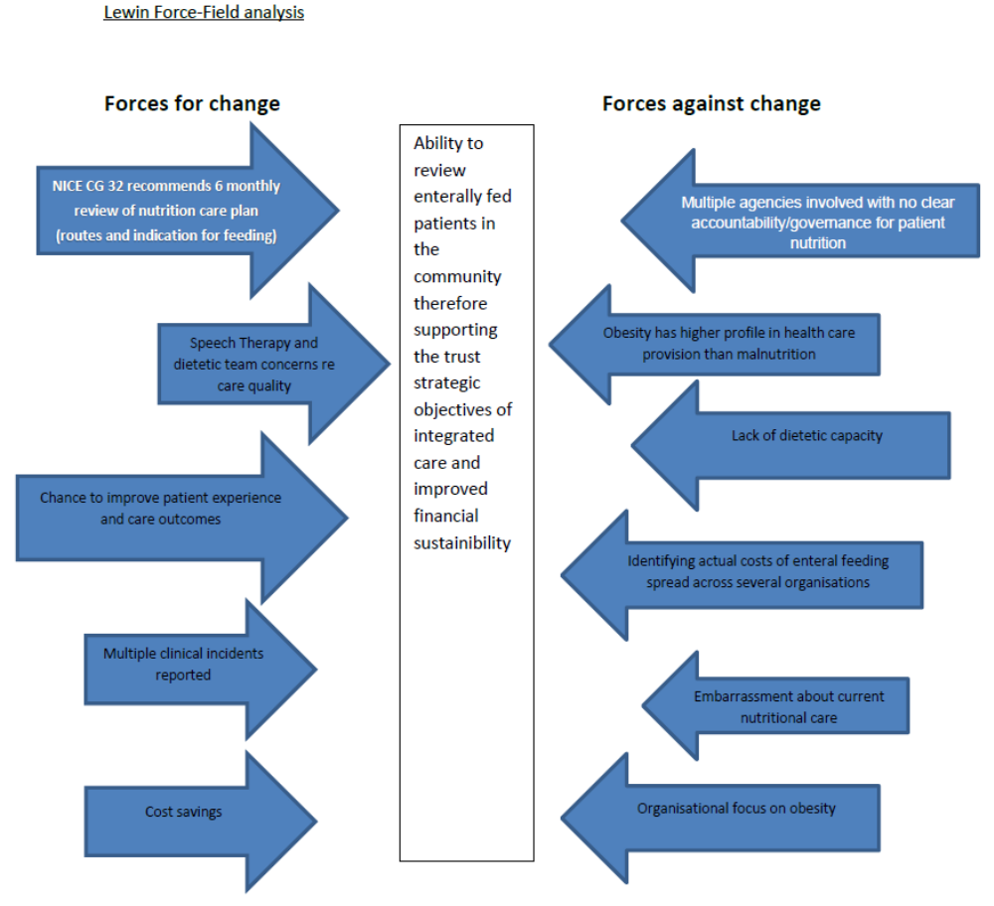

This picture shows there are many drivers for change but current capacity does not lend itself well to addressing all the complexities which exist.

Therefore in October 2017, vacancy money was identified for a six month project to investigate this situation. The milestones agreed were ;

- Quantify the current spend on plastics within the HD budget each month and maintain a system which enables regular monitoring of spend
- Gather the current patient experience about the service received by dietetics before there was a dedicated post in place, and afterwards by working with the patient experience team at BTH.
- Review the nutritional care plans of each adult enterally fed patient in the community, working with the practice pharmacists where possible.

Additional duties undertaken within the project included;

- Scoping the need for training around tube care in the community as currently the district nurses across Blackpool, Wyre and Fylde are not contracted to undertake this.
- Training of practice pharmacists in Blackpool to include dietetics in the review of enteral feed prescriptions in the community
- Visibility of nutritional care plans on EMIS for enterally fed patients in the community
- Evidencing the clinical risks around tube care in the community
- Understanding the BTH contract with respect to Enteral feeding and its management in the hospital and the community

This project post ends in June 2018. The CCG is asked to consider supporting the continuation of such to achieve adequate governance around enteral feeding.

Please see Appendix 1 for a report of the project findings.

Options appraisal

The following options are proposed.

Option 1

- wte band 7 community enteral feeding dietitian for Blackpool, Wyre and Fylde

This post would enable the discharge of patients from BTH onto the caseload of a dietitian who would review the care plans of patient’s discharged to the area. The postholder would liaise with community pharmacists and GPS re the appropriateness of the prescription, liaise with the Abbott company nurse re tube care and review progress every 3-6 months depending on clinical need (as per NICE CG 32 and NS QS 24).

Projected cost savings | Maintenance £100k saving per annum
52 week service provision | No
Continuation of service for annual leave or sickness | No
NICE QS 24 compliant with standard 4 and 5 | Yes
COST | BAND 7 plus ON COSTS = £57,136.25

Option 2

1.0 wte band 7 enteral feeding team leader
1.0 wte band 6 clinical specialist dietitian
1.0 wte band 4 assistant practitioner

This would deliver all that is outlined in option 1 plus the capacity to review those transitioning from enteral nutrition onto oral nutritional supplements (ONS) in a seemless manner between settings. This option would be able to provide services across 52 weeks of the year and develop pathways of care for tube fed patients between primary and secondary care.

The team outlined in option 2 would scope the provision of adequate enteral tube and nutritional care for people in the community who are under the care of consultants from out of the area eg. ENT cases, MND. The team would be part of the multi-disciplinary decision making in placing tubes initially at BTH, and identify the current costs of admission to hospital for patients experiencing difficulties with their feeding tubes. Having assistant support on the team will enable systematic review of the caseload whilst maximising the clinical capacity of the clinical staff.

Projected cost savings | Maintenance £100k saving per annum, plus further savings from reduced admission rates to hospital and inappropriate tube placement
52 week service provision | Yes
Continuation of service for annual leave or sickness | Yes
NICE QS 24 compliant with standard 4 and 5 | Yes
COST | BAND 7+ 6+ 4 plus ON COSTS = £141,503.33

Why Community Health Services/ALTC?

Community Dietetics is an integrated service with a track record of establishing partnership working. Malnourished patients are identified across the care setting with widespread use of a malnutrition screening tool (MUST), some of these patients need enteral or parenteral nutrition, others oral nutritional supplementation (ONS) and some can manage with a food first approach. Dietetics has a unique insight into this area and is ideally placed to monitor such patients across the local health economy.

There have been 5 reported incidents via the BTH UIR system since November 2017 related to mismanagement of enteral feeding tubes, however it is suspected there are more than this. Anecdotally there have been 28 urgent tube change requests received by the nutrition nurse at BTH in the last 12 months. These patients are referred to hospital and treated as an out-patient or in-patient depending on the severity of their need. This costs a minimum of £600 per admission. Investigation into tracking these admissions is being undertaken with the BTH ALTC informatics team.

Performance & Activity

Performance will continue to be monitored via;

- patient experience on Meridian (see Appendix 2)
- HDU budget spend on plastics via finance and informatics (see appendix 3)
- Internal audit of MUST screen and actions (registered with corporate governance)
- CQC inspection- (safe, effective, well-led)
- Compliance with NICE guidance/quality standards
- Patient outcomes on EMIS (nexus report in development)
- Hospital admission rates for tube complications (nexus intelligence)

Implementation Timeline

4 months to advertise and recruit clinical staff
12 months to identify impact measured by above

Conclusions

Compliance with NICE QS 24 can be achieved at BTH by supporting option 1 or 2. This will help achieve the cost savings needed across the Fylde coast, improve patient experience and clinical outcomes as cited by BAPEN in a climate of financial austerity.

Preferred Option

Option 2

Appendix 1

Blackpool Teaching Hospitals NHS Trust
Adult & Long Term Conditions Network

Home Enteral Feeding Project – 6 Month Report
February 2018

Georgina Dalton (Dietitian)

Executive Summary
All patients receiving enteral feeding across the Blackpool, Fylde and Wyre locality have historically received no formal dietetic review. An ad-hoc, troubleshooting mechanism has been in place to provide advice over the telephone from the hospital dietetic team. Patients receiving a tube feed are discharged into the community from both local and other regional hospitals. All enteral feeding products, both feed and ancillaries are funded by either BTH or the CCG. With no dietetic review available, appropriate changes to feeding regimes and review of ancillary needs cannot be provided. The trust historically failed in its compliance with NICE clinical guideline 32 to provide support to all enterally fed patients in the community.

Introduction
The provision of a Dietetic Home Enteral Feeding Service was created following the development of a business case by Emma Shepherd (SLT and Dietetic Services Manager), supported by Speech Therapy, Primary Care and Nutrition Nurse. A lack of specialist dietetic expertise in the community has increased clinical incidents, reduced safe practice and impacted upon enteral feed spends. Ad hoc support being provided from the acute trust, with no ability to provide domicillary support has prevented gold standard patient care from being achieved. With a continuing increase in numbers of individuals receiving tube feeds, increasing complexity of clinical conditions and the developments in technology with regards to feeding devices, it is essential we remain able to provide support for tube fed patients in the community.

The initial project plan was based around review of the caseload, with the following methodology
- Complete at least 1 review of all enterally fed clients in their own home
- Complete 2 to 3 reviews of a small, specific cohort, in order to measure specific outcomes
- Review of current prescribing practices in the local area
- Review current contractual agreement

Current Position and Progress
In October 2017, when the 6 month Home Enteral Feeding project began, the caseload had never received any formal review. The caseload is ever changing, for a number of reasons
- New patients following placement of a feeding tube
- Adults transitioning from paediatrics
- Patients who have undergone cancer treatment and are discharged from oncology services
- Tube removals/patients dying
- Patients moving into the area with existing tube feeding regime
- Patients with a prophylactic device in situ, who may begin to require feed via the tube

Blackpool Teaching Hospitals currently holds the enteral feeding contract with Abbott Nutrition, who offer a delivery service for ancillaries and feeds. All feeds are prescribed by the GP on an FP10 and the ancillaries are funded via the CCG High Dependency budget, of which dietetics has no management. There has been no review process, from which appropriate alterations to provision of feed and ancillaries can be based. During the 6 month period, there has been a process of review for the caseload, in order to ensure supplies of both feeds and ancillaries are appropriate. Areas of overspend have been highlighted, with alterations to feed prescriptions and ancillaries made (Appendix 1). Closer links with practice pharmacists have been developed in order to support appropriate prescribing and reduce wastage. Following placement of a feeding tube, a patient is currently discharged from hospital with 7 days’ supply of feed, with an initial months’ supply delivered to the discharge address soon after. Following discharge, the suitability of the chosen feeding regime can often alter, requiring consideration of differing feeds and associated products. Without a pathway for review, these patients may not receive suitable alternatives and prescriptions may be wasted. The process of review should follow a formal pathway, based around NICE Clinical Guideline 32, which recommends 3-6 monthly review, in order to ensure the patient remains stable and in receipt of appropriate feeds and supplies.
During the 6 month project period there have been a number of risks highlighted, both relating to patients and professionals alike. Numerous cost savings have been achieved, along with improvements in quality of life outcomes and the development of support mechanisms, aimed at ensuring patients and carers are supported (NICE CG 32 - Close liaison between the multidisciplinary team and patients and carers regarding diagnoses, prescription, arrangements and potential problems is essential).
At present there are around 30 patients with a balloon retained device in situ. These devices require a 7 day check of the volume of water retained in the balloon. The project has enabled risks to be highlighted with regards to gaps in provision of this service, along with a lack of competency and understanding of the task required.
The development of a training package has been undertaken, in order to offer support to nursing staff and carers with regards to troubleshooting and care of feeding tubes. The provision of regular education and updating knowledge is an essential part of supporting tube fed patients safely.
Future Opportunities
The 6 month project has raised a number of further development opportunities, should the role be continued. These are;
- Participate in the planning of discharge for patients undergoing tube insertion within acute hospital
- Provide initial review within 7 working days of discharge, in order to ensure initial prescription of feed is appropriate
- Develop pathway of care for all enterally fed clients
- Support further work on current High Dependency budget, providing expertise around spends
- Provide rolling programme of training around enteral feeding
- Undertake the 7 day balloon volume check for all patients with a balloon retained device in the community
- Continue to review caseload, ensuring both feed and ancillaries are appropriate
- Provide expertise to support colleagues from GP practice, Pharmacy, Allied Health Professionals and Acute Trusts
- Development of pathways and procedures, supporting national agendas around enteral feeding
- Continued cost saving potential and risk reduction

Identified Risks
Should the Home Enteral Feeding Role not continue, there will be ongoing risks which would impact upon patient care, staff safety, professional colleagues (e.g General Practitioners), the Teaching Hospitals Trust and the CCG. These risks include:
- Lack of ongoing patient review
- Lack of troubleshooting in order to reduce hospital admissions
- Lack of training for healthcare colleagues
- Lack of support for practice pharmacy colleagues
- Lack of assessment for new tube feeding discharges
- Increased workload for hospital dietitians in returning to trouble-shooting the caseload
- Lack of expertise available to provide support around budget queries
- Increased risks for district nursing in area where expertise is lacking

Case Study – The benefits of MDT working in HEF
Background
Mr X is a 24yr old male, feeding via a gastrostomy and receiving nil oral nutrition. Placement of feeding tube was undertaken at the age of 10yrs, following a long period of food refusal and worsening nutritional status. Mr X has foetal alcohol syndrome, which presents with significant behavioural difficulties, often impacting upon intake of diet and fluids.
Weight History: 09/2016 – 37kg, 03/2017 – 36.3kg, 09/2017 – 39.1kg, Current – 39.4kg
Assessment
The feeding regime Mr X was receiving on initial assessment by myself was Ensure TwoCal x 3 daily, Ensure Plus Fibre x 3 daily and Fresubin 5kcal (30ml) x 3 daily via a bolus system. This regime provided a total of 2580kcal and 89g protein via 6 episodes of feeding across the 24hr period. On initial assessment, it became clear that there was no evidence based guidance with regards to his swallow, though staff were following a ‘no oral diet’ plan. Staff appeared to have ‘differing’ recommendations for oral intake, from “mum and dad will give chocolate pudding, though we do not”, to “he can have hot chocolate when he goes out, but at home we only allow him to have water”. There was evidence Mr X was hungry, giving verbal queues regularly between feed times. Mr X was pulling feeding tubes out, on average each day, with some days there being removal of 1-3 tubes. These devices have a balloon, which is inflated once in the stomach in order to retain position. Removal of the feeding tube whilst the balloon is inflated risks significant trauma to the site and patient themselves. The cost of replacement feeding tubes provided to Mr X between the months of January and October 2017 was £7152, compared with an average cost for a tube fed client who requires tube changes every 3 months being ~£548 per year. The frequency of Mr X removing tubes was increasing, potentially costing £7000-£15000 annually.
Numerous attempts to resolve the issues with tube removal and feeding had been attempted, trying PEG belts, onesies and differing feed regimes, all with no positive impact. His swallow function had not been reassessed, which was of vital importance in the ability for staff to provide safe diet and fluid intake and for the potential of improved quality of life.
From a behavioural perspective, Mr X was becoming increasingly more challenging to manage, with significantly reduced sleeping and associated aggression and agitation. Although foetal alcohol syndrome is known to present with behavioural issues, though it was clear the feeding tube was adding to these.
On-going care
Following assessment it was deemed necessary to request an urgent swallow assessment. A joint visit between myself and Speech Therapy was agreed and undertaken on 9th November, though assessment was unable to take place due to the need for hospital admission due to further removal of a feeding tube.
On this admission to hospital it was decided there was not to be further replacement of the gastrostomy feeding and he would be fed via the oral route. An MDT meeting was undertaken at the hospital, in order to co-ordinate a plan for providing his nutrition and hydration. As Mr X was deemed safe to swallow fluids, his supplementation was to be given orally, with further swallow assessment to be undertaken in order to clarify his safety for diet. As his energy expenditure is high, it was essential the supplementation provided via the tube was maintained via the oral route. His maintenance prescription for supplementation included:
Ensure TwoCal x 5 per day = £11.10 per day
Fresubin 5Kcal Shot 3 x 30ml per day = £2.14 per day
Total = £13.24 per day
On discharge home, further swallow assessment took place and guidance was provided in order to commence blended foods, both savoury and sweet. Staff required support and guidance from a Dietetic and Speech Therapy perspective, in order to ensure they felt confident with this new concept of feeding. Regular home visits were provided by both Dietetics and Speech and Language Therapy, some of which were on a joint basis.
A further MDT meeting was undertaken on 19th December, in order to review progress with oral intake and formulate a further plan of action. At this time the prescribed supplementation was deemed a priority to staff, and oral diet was being given as an addition. Staff required confidence building with regards to providing meals, and how to develop and increased intake of ‘normal’ foods. The benefits of progressing to a breakfast, lunch, tea and supper approach, whilst continuing to provide necessary supplementation was discussed. Staff felt confident to move forward with this plan, having noted a positive response to savoury flavours.
Food fortification was also discussed, with staff being encouraged to enrich foods and fluids where possible, in order to provide essential energy and protein.
Current Situation
Mr X has progressed well with oral intake, now managing regular meals which are fortified in order to increase the energy and protein content. He is receiving energy dense fruit smoothies and desserts, which incorporate his medications, though not ‘covertly’. He is no longer receiving oral sip feeds, receiving energy and protein only, in the form of the following:
Fresubin 5kcal Shot 3 x 30ml per day = £2.14 per day
Polycal 200ml per day = £1.75 per day
Prosource Plus 3 x 30ml per day = £4.32 per day
Total = £8.21 per day
Mr X has gained weight, with significant improvement in his behaviour. Staff have reported improved sleep patterns, reduced aggression and agitation and a generally improved quality of life. His risks relating to tube removal have reduced, the need for hospital admissions reduced and associated costs of feeds and costs of ancillaries either eliminated or reduced. From tubes and feeds alone, the cost savings are, on average:
£8836 - £16836 per year
The potential quality of life and risk reduction benefits are likely to be even more significant
Without the ability to provide regular review of this enterally fed patient, this outcome would have been unlikely

Appendix 2
HEF DIETETIC REVIEW EVALUATION SURVEY/Patient experience

21 patient questionnaire’s completed. Results are:

1. Since discharge from hospital with a feeding tube, have you/your relative/service user received review by a dietitian?

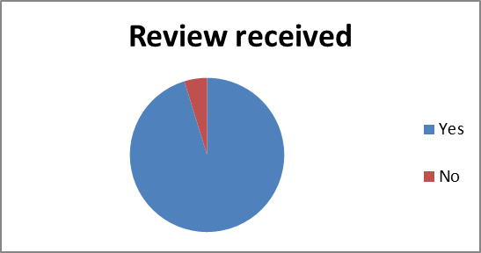
1a. If Yes, was this initiated by yourself or the dietitian?

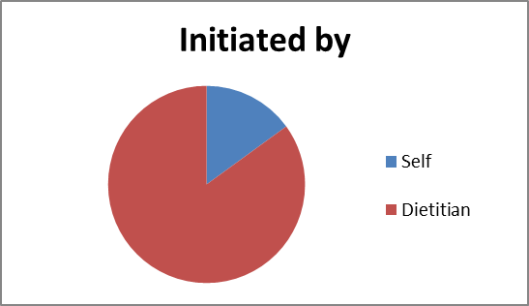
2. Following placement of the feeding tube, have there been times when a review from a dietitian would have helped, but you have not accessed this?

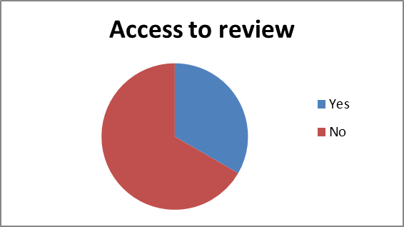
3. Have you always felt confident to make manage your feeding regime and/or feeding tube?
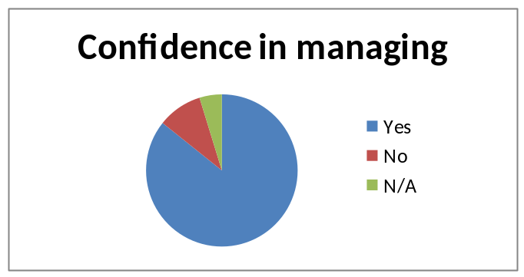

4. Since the tube was placed have you had any reason to feel your feeding regime requires a review?
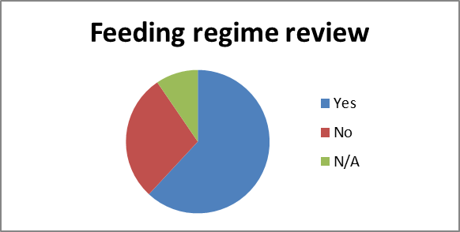
5. Prior to meeting the HEF Dietitian for review, did you feel supported in your feeding regime and the management of your feeding tube?
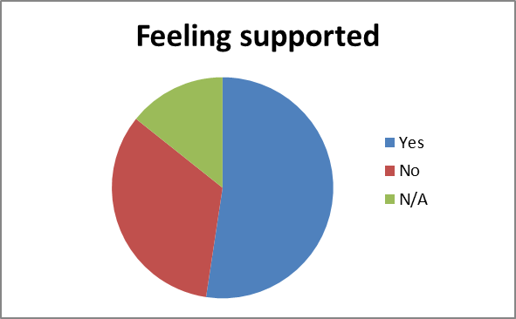

6. Did you find the review with the HEF dietitian beneficial?
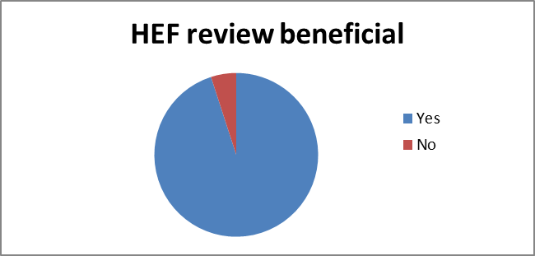
7. Did you feel the review with the HEF Dietitian met your needs?
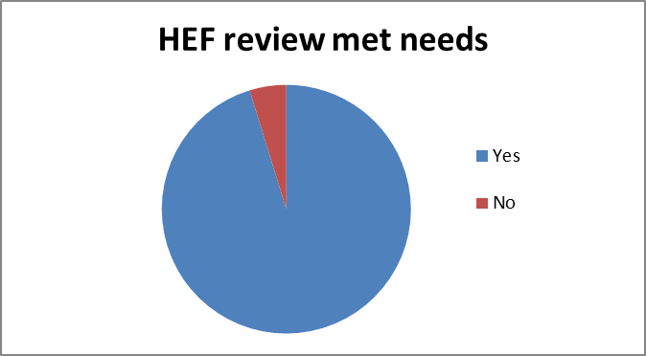
8. Did you find a face to face review at home beneficial?
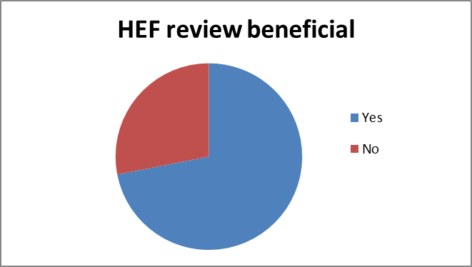

9. During your review with the HEF Dietitian, were there any ongoing issues you needed to discuss?
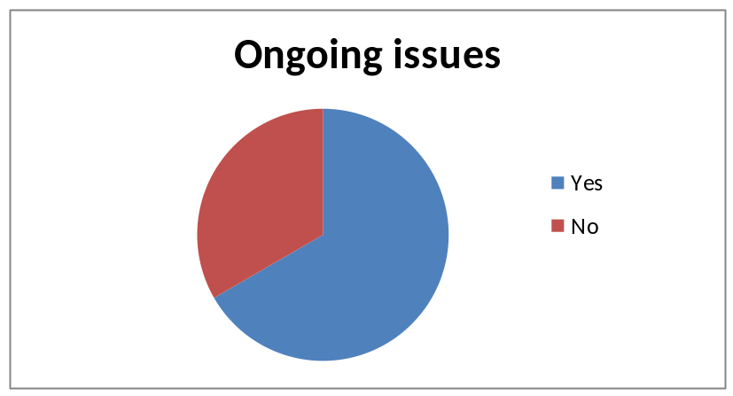
10. Were any problems listened to and dealt with effectively by the HEF Dietitian?

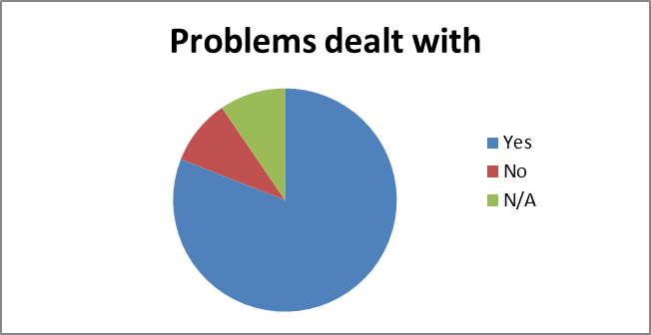

10a. Examples of narrative responses:
- I would like to say thank you to Georgina as without her help & letter a referral to renal team would never have happened
- Controlled my overnight feed to reduce waste
- Feed changed to Jevity Plus and Ensure rather than Osmolite
- Advice about diet given
- Syringes are now reusable
- The dietitian who came out was brilliant, offering help and advice, made me ringing her with some concerns easy as she had met us at home
- Changed diet
- Your HEF dietitian was extremely helpful. We have not had any face to face discussion for some years. Arrangements in hand to weigh on wheelchair scales
- Questions were answered, good advice given, fibre feed added (after many years). Much easier in face to face meeting with son
- What the dietitian suggested was duly done
- She offered good advice with my specific problem

11. Could the service be improved?

- Do not discontinue it
- The dietitian offers a great service & feel more supported knowing we can contact her
- Everything was fine, dietitian is very good
- For this service to continue with 12 monthly face to face visit
- Nothing requires improvement, a vital link for those using a feeding tube at home
- Access to a weekend service
- Nothing, very satisfied
- Georgina, the dietetic nurse who visited was excellent, she listened to my needs/problems & acted on them promptly
- Good service – I feel we can always access the specialist if we are having difficulties
- I think they are a superb service
- Could we keep the service! Much easier to discuss problems than trying to reach someone by phone and then having to speak to someone who has never met and doesn’t understand son’s needs

Appendix 3 - Reduction in spend on the budget

 | Enteral Feeds Savings
Patient Name | CLINIC/VISIT DATE | PRACTICE | LOCATION | Annual projected Saving
1 | 25.10.17 | Holland House | Nursing Home | £7.30
2 | 02.11.17 | Parr-Burman | Nursing Home | £7.30
3 | 01/11/2017 | St Pauls M/C | Supported Living | £7000-£15,000
4 | 02.11.17 | Bloomfield M/Centre | Nursing Home | £7.30
5 | 03.11.17 | Abbey-Dale | Nursing Home | £7.30
6 | 17.11.17 | Broadway M/Centre | Supported Living | £7.30
7 | 17.11.17 | Broadway M/Centre | Supported Living | £2,288.55
8 | 29.11.17 | Marton Health centre | Nursing Home | £1,715.00
9 | 22.11.17 | Bloomfield M/Centre | Care Home | £1,767.00
10 | 15.12.17 | Over Wyre M/Centre | Own Home | £1,968.00
11 | 08.01.18 | Whitegate Drive | Own Home | £3,380.00
12 | 17.01.18 | Over Wyre M/Centre | Nursing Home | £3,431.00
13 | 25.01.18 | Cleveleys H/C | Own Home | £806.00
14 | 25.01.18 | Cleveleys H/C | Own Home | £1,609.65
15 | 26.01.18 | St Pauls M/C | Supported Living | £1,836.00
16 | 07.02.18 | South King Street | Own Home | £1,620.00
17 | 09.02.18 | Lockwood Surgery | Nursing Home | £956.30
18 | 23.02.18 | N/A | Own Home | £13,738.00
Red - Blackpool
Blue - Fylde & Wyre |  |  | Savings | £42152 - £50152

Appendix 4 NICE QS 24

List of quality statements
Statement 1. People in care settings are screened for the risk of malnutrition using a validated screening tool.
Statement 2. People who are malnourished or at risk of malnutrition have a management care plan that aims to meet their nutritional requirements.
Statement 3. All people who are screened for the risk of malnutrition have their screening results and nutrition support goals (if applicable) documented and communicated in writing within and between settings.
Statement 4. People managing their own artificial nutrition support and/or their carers are trained to manage their nutrition delivery system and monitor their wellbeing.
Statement 5. People receiving nutrition support are offered a review of the indications, route, risks, benefits and goals of nutrition support at planned intervals.

