Project CARe
COVID-impact Assessment & REsponse project

By

Team

Dr Olukayode Adeeko (Newton Medical Centre)
&
Students of University of Liverpool
(on GP placements)

(December 2020 to February 2021)

Rationale
The COVID-19 pandemic has had huge impacts on people around the globe. Elderly people and those with pre-existing chronic conditions including cardiovascular disease, cancer, hypertension, respiratory conditions and diabetes appear to be at a higher risk of developing complications and are at high risk of death ¹.
NICE published a new guidance on the 18th December 2020. COVID-19 rapid guideline: managing the long-term effects of COVID-19 [NG188]. This guideline covers identifying, assessing and managing the long-term effects of COVID-19, often described as ‘long COVID’. It makes recommendations about care in all healthcare settings for adults, children and young people who have new or ongoing symptoms 4 weeks or more after the start of acute COVID-19. It also includes advice on organising services for long COVID ².
Patients with Sickle Cell Disease (SCD) often have underlying cardiopulmonary co-morbidities that may predispose them to poor outcomes if they become infected with SARS-CoV-2. It was recommended that SCD patients infected with Covid-19 should be followed very closely, applying a low threshold for admission and frequent outpatient check-ins via telemedicine or in person as appropriate, particularly following hospital discharge ³.

The homelessness response to COVID-19 has seen extraordinary action taken across Great Britain to get everyone into safe accommodation during the pandemic.
There was recognition of the positive effect government policies have had on levels of homelessness during the pandemic, particularly the pause in evictions and temporary uplift in local housing allowance. However, there were concerns across all areas about the temporary nature of these changes and the impact these may have on homelessness in the future. Local authorities across each nation were concerned about the newly emerging need for their services as they started to see the impacts of the wider economic context and the cumulation of rent arrears in their local area ⁴.
People experiencing homelessness have been struggling to meet their basic needs during the COVID-19 pandemic. Many factors influence how people have been impacted by the pandemic including access to appropriate accommodation, adequate healthcare, sufficient food supplies and welfare benefits. All these factors can be directly affected and compounded by a person’s immigration status ⁴.
The impact of COVID-19 on people who are in the asylum system, refugees or those who have no recourse to public funds (NRPF) can be enormous. NRPF is a condition imposed on an individual based on their immigration status which means they cannot access welfare benefits, public housing and some healthcare. This might include people who have limited leave to remain, refused asylum-seekers who are ‘appeal rights exhausted’, those with no status or no documents to prove their status or European Economic Area (EEA) citizens unable to pass the right to reside test ⁵.
A study in US found that ‘Americans who don't speak English are nearly FIVE TIMES more likely to test positive for coronavirus but are less likely to get tested in the first place’ ⁶

There are also fears over access to coronavirus guidance for non-English speakers ⁷; this may put them in precarious position.

Aims & Objectives

- To identify those patients who have tested positive for Covid-19 and who are deemed vulnerable by virtue of their age, health conditions or their ethnicity (see Group 1 below)
- To offer supports and practical help to those with ongoing post-covid symptoms in Group 1
- To render help to those that might have been indirectly impacted by Covid-19 pandemic (see Group 2 below)

Group 1
Vulnerable Covid-19 positive patients
- Long Term Conditions (LTC) with covid
- Over 65s with covid
- Sickle Cell Disease (SCD) family
- Those positive but whose 1st language may not be English (covid +ve BAMEs & other minority ethnic groups)

Group 2

Indirectly impacted by Covid-19
- Asylum seekers & Refugees
- Homeless & NFAs (No Fixed Abode)

(Those in the Blind spot, not on QoF register, neither covered by KPIs, DES, LES nor other quality markers) in General Practice

Methodology
- A search of positive Covid-19 cases amongst the over 65s, those with LTCs, on DMARDs & BAME who tested Covid-19 first in early in December 2020, then in January 2021 and finally in early February 2021 was carried out.
- A search of patients who statuses were asylum seekers, refugee, homeless and NFA (no fixed abode) was conducted.
- A weekly mid-week dedicated virtual clinic was set up from December 2020 to early February 2021 to provide supports for the cohorts of patients.

Key findings
- Total number of patients who tested Covid-19 (as at 2/2/21) = 271

- Number of over 65s, those with LTCs, on DMARDs & BAME who tested Covid-19 (as at 2/2/21) = 112 i.e. 41%

- Therefore these patients with vulnerabilities constitute more than 4 in 10 of the Covid-19 positive cases in the practice.

- Regarding post-covid symptoms, out of the these 112:

- 54 people reported NO post-covid symptoms
- 51 patients reported one or more lingering symptoms (see table 1 for details)
- 7 patients were unreachable after several attempts

- Regarding Ongoing concerns , Of the 51 with post-covid symptoms

- 12 people answered YES (i.e. 23.5%)
- 39 patients said NO (76.5%)
- So, more than 3 out of 4 cases improved or resolved spontaneously or with some supports.

- Outcomes

- Some or most of the 39 above were offered supports regarding the management of their LTC during Covid-19 pandemic, some needed signposting to relevant services in the community, emotional support & reassurances provided, and practical help in a few cases.
- 9 patients were referred to the newly established home oximetry monitoring service in the area
- 1 case continued to receive home case via the community matron
- 2 patients were referred for counselling

Overall achievement of the project:
All the over 65s, those with LTCs, on DMARDs & BAME who tested Covid-19 as at 2/2/21 (with the exemption of 7 patients were unreachable after several attempts) were assessed virtually after their covid-19 diagnosis for their needs, offered supports where indicated and practical help as required.
Those in the ‘blind spot’ and the family with SCD were offered supports and received help as required.

Table 1
Post Covid Symptoms/ Long Covid | Number of patients
Chest tightness | 1
cough | 2
Cough & SOB | 1
Cough, fatigue & diarrhoea | 1
Cough, SOB, loss of smell & taste | 2
fatigue | 13
Fatigue & SOB (or cough) | 2
headache | 1
Loss of smell and/or taste | 7
Cough, anxiety & insomnia | 1
Muscle ache (+/- chest symptoms) | 3
Nausea | 1
Pneumonia still in hospital | 1
SOB | 12
SOB, dizziness, headache, fatigue | 1
Worsening depression | 2

Key learning points
A significant proportion of the elderly people and those with pre-existing chronic conditions who tested positive for Covid-19 infection do require additional support. So it is important to contact them and do needs assessment and offer necessary supports.
Proactive care, early interventions and supports helped in improving post-covid symptoms in many instances.
The needs of those in the ‘blind spot’ groups could inadvertently be overlooked during this pandemic, so their NEEDs assessment should be conducted and supports should be provided where indicated.
Patients do appreciate these extra supports as noted in the feedback from the virtual clinics (see below).
Feedback

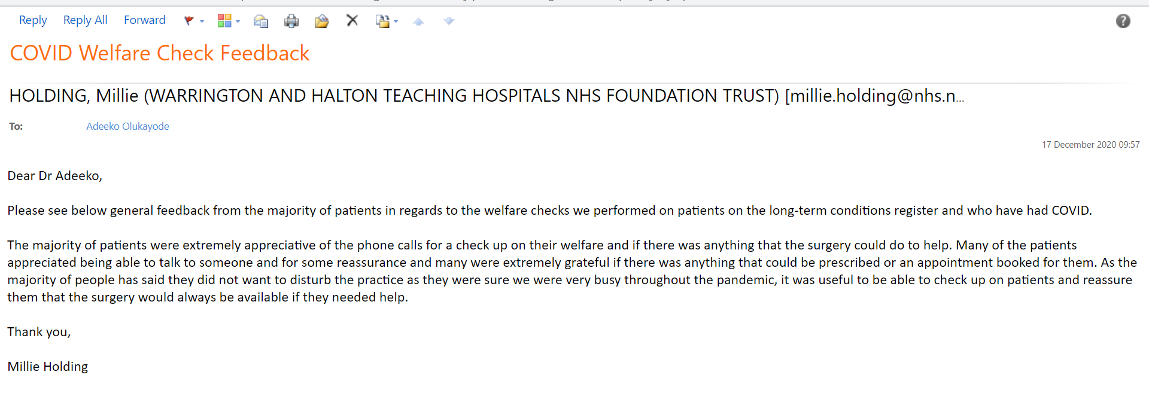

References:
- https://www.lshtm.ac.uk/research/centres/centre-global-chronic-conditions/covid-19-and-people-chronic-conditions

- https://www.nice.org.uk/guidance/ng188/chapter/6-Follow-up-and-monitoring

- https://www.hematology.org/covid-19/covid-19-and-sickle-cell-disease

- https://www.crisis.org.uk/ending-homelessness/homelessness-knowledge-hub/services-and-interventions/the-impact-of-covid-19-on-people-facing-homelessness-and-service-provision-across-great-britain-2020/

- https://groundswell.org.uk/monitoring-covid-19/
- https://www.dailymail.co.uk/health/article-8768687/Americans-dont-speak-English-nearly-FIVE-TIMES-likely-test-positive-coronavirus.html

- https://www.expressandstar.com/news/uk-news/2020/07/28/fears-over-access-to-coronavirus-guidance-for-non-english-speakers/

