Islington population | 206,100
65 years or over | 18,000 (9%)
65 years or over & Long term health problem of disability | 10,800 (60%)
Table A: London Borough of Islington resident demographics ^{(1 & 2)}

Table 2: Interventions made during domiciliary reviews

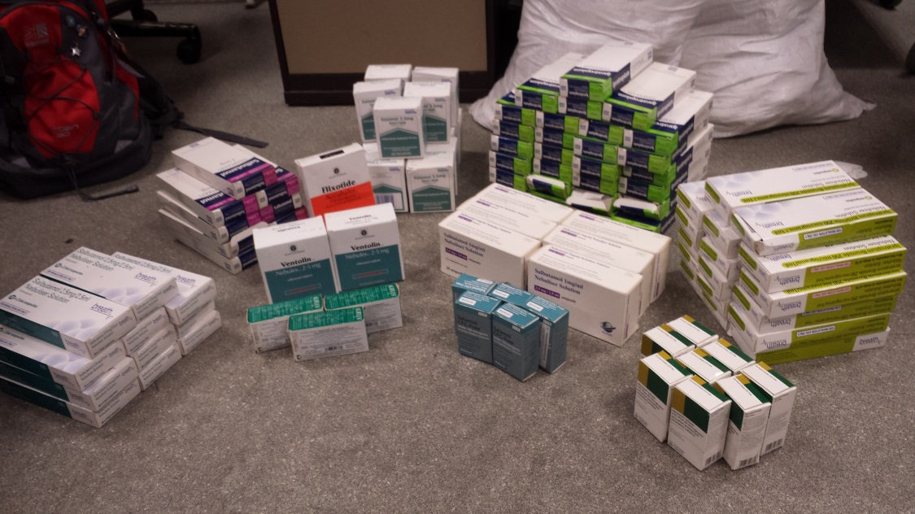
Figure 1: Respiratory medications removed from Mrs X’s home

